1. 从采样的图采样颜色，然后混合到主图

Shader "Unlit/Gradient_1"  
{  
 Properties  
 {  
 _MainTex("Main Tex",2D)= "white" {}  
 _SampleTex("Sample Tex",2D) = "white"{}  
 }  
  
 SubShader  
 {  
  
 Tags  
 {  
 "RenderType" = "Opaque"  
 }  
  
 Pass  
 {  
 CGPROGRAM  
 #pragma vertex vert  
 #pragma fragment frag  
 #include "UnityCG.cginc"  
  
 sampler2D _MainTex;  
 float4 _MainTex_ST;  
   
 sampler2D _SampleTex;  
 float4 _SampleTex_ST;  
  
 struct data  
 {  
 float4 pos:POSITION;  
 float2 uv:TEXCOORD0;  
 };  
  
 struct v2f  
 {  
 float4 pos:SV_POSITION;  
 float2 uv:TEXCOORD0;  
 };  
  
 v2f vert(data o)  
 {  
 v2f f;  
 f.pos = UnityObjectToClipPos(o.pos);  
 f.uv = TRANSFORM_TEX(o.uv, _MainTex);  
 return f;  
 }  
  
  
 fixed4 frag(v2f f):SV_Target  
 {  
 fixed4 col = tex2D(_MainTex, f.uv);  
 *//点乘获得灰度（先采样得到主图的像素颜色，然后点乘灰度，得到灰度的采样）* float gray = dot(col.rgb, float3(0.3, 0.6, 0.1));  
 *//用灰色作为U轴坐标，获取对应的颜色值，从中间轴获取颜色  
 //12344  
 //12345  
 //31234  
 //例如矩阵一样的贴图从12345中采样渐变色从左到右边的* fixed4 sample_Col = tex2D(_SampleTex, float2(gray, 0.5));  
 sample_Col.a = 1;  
   
 return sample_Col;  
 }  
 ENDCG  
 }  
 }  
}

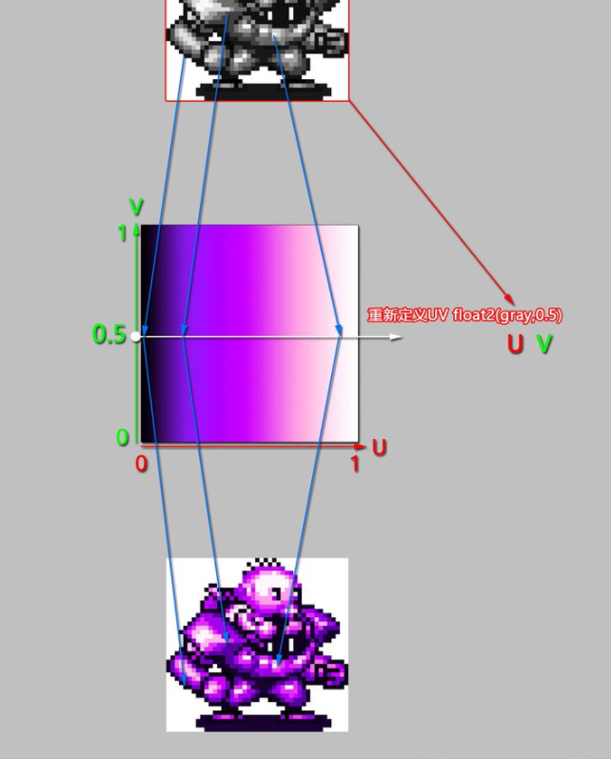

<https://www.zhihu.com/people/cromputer/posts>

## **[UnityShader 基础（5）-图像-渐变色着色](https://zhuanlan.zhihu.com/p/385399796" \t "https://www.zhihu.com/people/cromputer/_blank)**