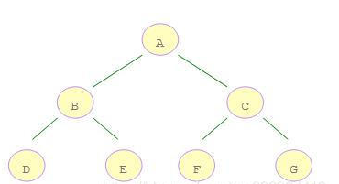

BFS:

ABCDEFG

Note

{

List<Note> childs

}

BFS()

{

Queue q;

1. Enqueue(root)

While(q.count>0)

{

Note A=Q.Dequeue()

For(A.childs)

{

Print(child[i])

Q.Enqueue(Child[i])

}

}

}

DFS:ABDECFG

DFS( Note n)

{

Print(n)

For(n.childs)

{

DFS(childs[i])

}

}