https://mp.weixin.qq.com/s?__biz=MzIxMzgzMzQxOA==&mid=2247484240&idx=1&sn=83fb5e319bdd2c6887812b04705864de&chksm=97b180f5a0c609e3a5cddf32f89bf09bfecac1dc5453f3077d02a327b4ece259999310afc4cb&cur_album_id=1745805597083549701&scene=189#wechat_redirect
multi_compile_fog,
FOG_LINEAR，FOG_EXP和FOG_EXP2
UNITY_CALC_FOG_FACTOR_RAW
unityFogFactor
unity_FogColor
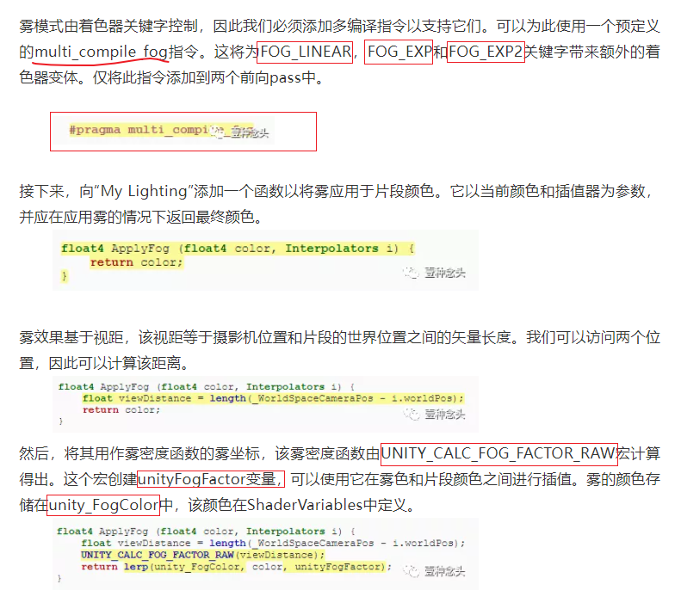
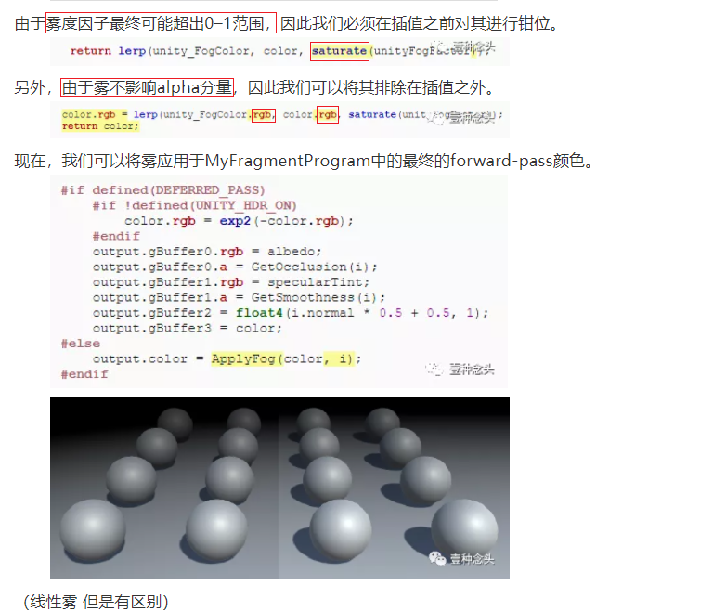

_CameraDepthTexture
SAMPLE_DEPTH_TEXTURE
Linear01Depth
_ProjectionParams
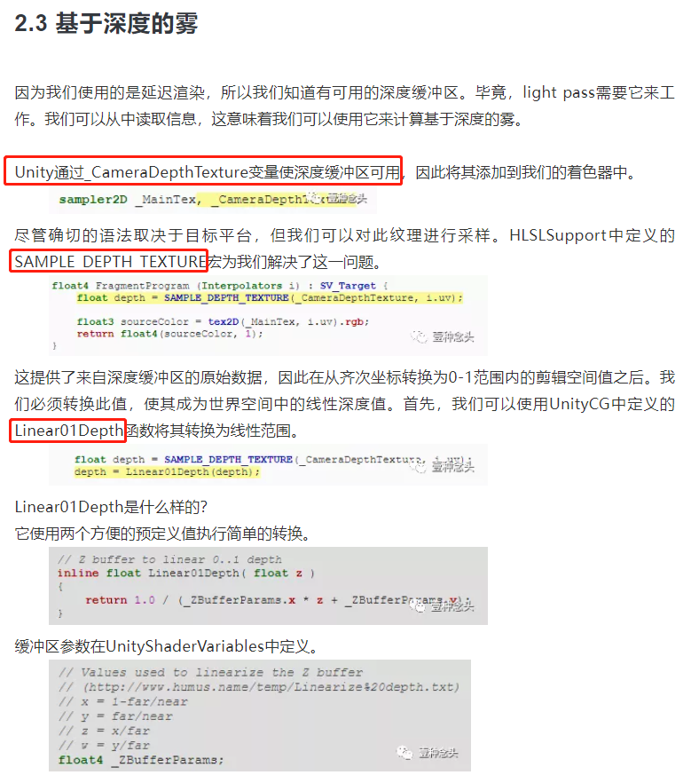
基于深度的雾
