https://zhuanlan.zhihu.com/p/390842215作者：Coder
链接：https://zhuanlan.zhihu.com/p/390842215
来源：知乎
著作权归作者所有。商业转载请联系作者获得授权，非商业转载请注明出处。

一、打包
1、首先我们需要把资源打包成asset,我们需要先创建一个AssetBundleConfig文件，使用该文件来配置我们打包单个资源和打包文件夹资源的路径以及AB名。
using System.Collections;using System.Collections.Generic;using UnityEngine;[CreateAssetMenu(fileName = "ABconfig",menuName = "Create ABConfig",order = 0)]public class ABConfig : ScriptableObject{
//保证文件夹下Prefab名称的唯一性 public List<string> m_AllPrefabPath = new List<string>();
public List<FileDirABName> m_AllFileDirAB = new List<FileDirABName>(); [System.Serializable]
public struct FileDirABName
{
public string ABName;
public string Path;
}
}

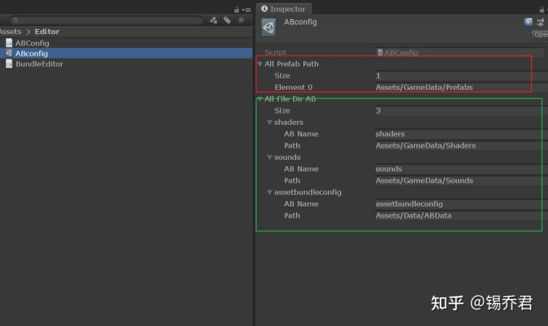
2、创建Editor目录并创建编辑器脚本，BuildEditor.cs,这个代码有点长，主要做以下事情
- 读取AssetBundle的配置文件存储到字典
- 过滤AB包，避免重复打包
- 按照配置来设置AB包的名称，单个prefab或者其他资源按照资源名称作为AB包名称
- 打包，并序列化成xml可以交给策划转成Excel，序列成二进制文件方便在游戏中使用
- 移除AB包名称，避免造成meta文件改变
主要认识以下的字典就可以，代码其实没有多难
//key是AB包名，value是路径，存储基于文件夹打包的信息 private static Dictionary<string, string> m_File = new Dictionary<string, string>();

//用来过滤AB包，避免重复打包 private static List<string> m_All = new List<string>();

//单个Prefab所依赖资源的所有路径，key是prefab的名称 private static Dictionary<string, List<string>> m_Prefab = new Dictionary<string, List<string>>();

//会被直接加载的ab路径 private static List<string> m_Load = new List<string>();
完整的代码会在文章最后放。
这样我们就可以通过Unity编译器按照配置打包我们的文件啦。来看看效果
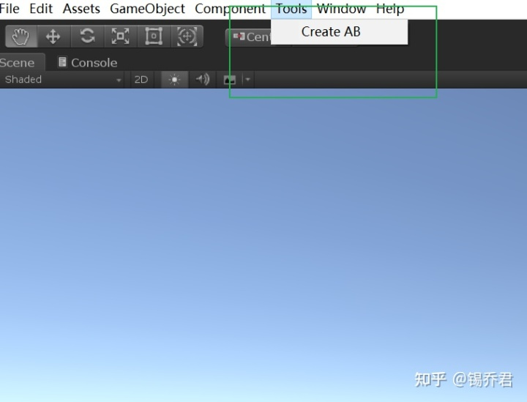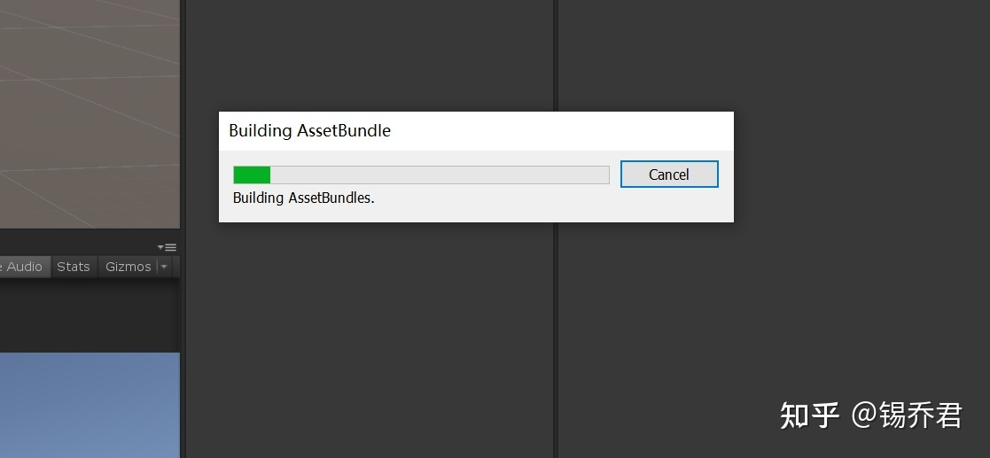

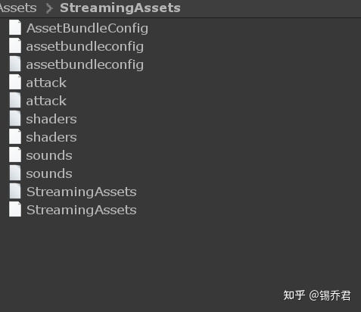
这样我们的ab包就打出来了，只要是unity做的游戏没有不用ab包的吧？？？
那么接下来我们就要去工程里面使用这些资源了，使用之前先把基础框架搭一下。

二、对象池
一个小框架，对象池设计的比较简单，单例代码就不放了，懂得都懂，对象池支持泛型，获取和回收对象。
using System.Collections;using System.Collections.Generic;using UnityEngine;
public class ClassObjectPool<T> where T:class,new(){
//对象池 protected Stack<T> pool = new Stack<T>();
//对象池大小，超过则回收 protected int maxCount = 0;
//没有回收的对象个数 protected int noRecycleCount = 0;

public ClassObjectPool(int max)
{
maxCount = max;
for (int i = 0; i < maxCount; i++)
{
pool.Push(new T());
}
}

/// <summary> /// 从对象池中取出对象 /// </summary> /// <param name="force">是否强制生成</param> /// <returns></returns> public T Get(bool force)
{
T t = null;
if (pool.Count > 0)
{
t = pool.Pop();
}

if (force&&t==null)
{
t = new T();
noRecycleCount++;
}

return t;
}
/// <summary> /// 回收对象，放进池中 /// </summary> /// <param name="t">回收对象</param> /// <returns></returns> public bool Recycle(T t)
{
if (t == null)
{
return false;
}

noRecycleCount--;

if (pool.Count > maxCount && maxCount > 0)
{
t = null;
return false;
}

pool.Push(t);
return true;

}
}
很简答的代码啦，主要就是Get和Recycle两个函数用来获取和回收对象。

三、资源加载
加载资源？支持缓存？支持释放资源？支持对象池？安排！
首先还是要读取配置，然后根据配置进行读取，如果已经加载过就直接使用，未加载的资源首先加载依赖，再加载自身。
using System.Collections;using System.Collections.Generic;using System.IO;using System.Runtime.Serialization.Formatters.Binary;using System.Xml.Serialization;using UnityEngine;
public class AssetBundleManager : Singleton<AssetBundleManager>{
private Dictionary<uint, ResourceItem> m_configItems = new Dictionary<uint, ResourceItem>();
private Dictionary<uint, AssetBundleItem> m_assetBundle = new Dictionary<uint, AssetBundleItem>();
private ClassObjectPool<AssetBundleItem> abPool = ObjectManager.Instance.GetClassObjectPool<AssetBundleItem>(500);
/// <summary> /// 根据路径和名称，读取ab包配置的二进制文件并存入字典 /// 这里我们将配置表也打包成了ab /// </summary> /// <param name="path">配置表包路径</param> /// <param name="name"></param> public void LoadAssetBundleConfig(string path, string name)
{
m_configItems.Clear();
AssetBundle ab = AssetBundle.LoadFromFile(path);
TextAsset textAsset = ab.LoadAsset<TextAsset>(name);
if (textAsset != null)
{
MemoryStream ms = new MemoryStream(textAsset.bytes);
BinaryFormatter bf = new BinaryFormatter();
AssetBundleConfig config = (AssetBundleConfig) bf.Deserialize(ms);
foreach (var configItem in config.abList)
{
ResourceItem item = new ResourceItem();
item.path = configItem.path;
item.crc = Crc32.GetCRC32(configItem.abName);
item.abName = configItem.abName;
item.assetName = configItem.assetName;
item.dpList = configItem.dpList;
if (!m_configItems.ContainsKey(item.crc))
{
m_configItems.Add(item.crc, item);
}
}
}
}

/// <summary> /// 提供给ResourcecManager调用，加载资源块 /// 根据资源名称，查询ResourceItem,如果为空，直接返回null，说明名称错误或不存在 /// 如果资源块中的AB包字段为空，则需要重新加载，判断依赖项是否已经加载，未加载则加载 /// </summary> /// <param name="name">ab包名称</param> /// <returns></returns> public ResourceItem LoadRecourceAssetBundle(string name)
{
uint key = Crc32.GetCRC32(name);
if (!m_configItems.TryGetValue(key, out ResourceItem item) || item == null)
{
return item;
}

if (item.ab != null)
{
return item;
}

item.ab = LoadAssetBundle(item.abName);
if (item.dpList != null)
{
for (int i = 0; i < item.dpList.Count; i++)
{
LoadAssetBundle(item.dpList[i]);
}
}

return item;
}

/// <summary> /// 内部调用，用于加载AB包，加载前需要判断是否已经加载过资源避免重复加载 /// </summary> /// <param name="abName">AB包名称</param> /// <returns></returns> private AssetBundle LoadAssetBundle(string abName)
{
AssetBundleItem abItem = null;
uint key = Crc32.GetCRC32(abName);
if (!m_assetBundle.TryGetValue(key, out abItem) || abItem == null)
{
AssetBundle ab = null;
string path = Application.streamingAssetsPath + "/" + abName;
if (File.Exists(path))
{
ab = AssetBundle.LoadFromFile(path);
}

if (ab != null)
{
abItem = abPool.Get(true);
abItem.refCount++;
abItem.ab = ab;
}

m_assetBundle.Add(key, abItem);
}
else
{
abItem.refCount++;
}

return abItem.ab;
}

public ResourceItem FindResourcecItem(uint crc)
{
return m_configItems[crc];
}

public void ReleseAsset(ResourceItem item)
{
if (item == null)
{
return;
}

if (item.dpList!=null && item.dpList.Count > 0)
{
for (int i = 0; i < item.dpList.Count; i++)
{
UnLoadAssetBundle(item.dpList[i]);
}
}
UnLoadAssetBundle(item.abName);
}

public void UnLoadAssetBundle(string name)
{
uint key = Crc32.GetCRC32(name);
if (m_assetBundle.TryGetValue(key, out AssetBundleItem item) && item != null)
{
item.refCount--;
if (item.refCount <= 0 && item.ab != null)
{
item.ab.Unload(true);
item.Reset();
abPool.Recycle(item);
m_assetBundle.Remove(key);
}
}
}}
public class AssetBundleItem{
public AssetBundle ab;
public int refCount;

public void Reset()
{
ab = null;
refCount = 0;
}}
public class ResourceItem{
public string path { get; set; }
public uint crc { get; set; }
public string abName { get; set; }
public string assetName { get; set; }
public List<string> dpList { get; set; }
public AssetBundle ab { get; set; }}
尽量对底层代码进行封装，上层调用就会非常简单啦。
哦对了，上面的字典的键大部分都使用了uint，主要是我们使用了CRC校验产生的唯一值。
CRC代码可以百度啦，这里不放了。其实还可以加一层ResourceManager，封装的更完善一点。

四、使用代码
既然做完了，我们就加载一个资源。
using UnityEngine;
public class GameStart : MonoBehaviour{
public string configPath = Application.streamingAssetsPath + "/assetbundleconfig";

public string configName = "AssetBundleConfig";
// Start is called before the first frame update void Awake()
{
AssetBundleManager.Instance.LoadAssetBundleConfig(configPath, configName);
}

void Start()
{
ResourceItem item = AssetBundleManager.Instance.LoadRecourceAssetBundle("attack");
AssetBundle ab = item.ab;
GameObject obj = ab.LoadAsset<GameObject>("Attack");
Instantiate(obj);
}}

一行代码就能完成读取配置文件加载资源，美妙！lsp们看图！

其实稍微有点难度的就是BuildEditor.cs,可以看看。
using System;using System.Collections;using System.Collections.Generic;using System.IO;using System.Linq;using System.Runtime.Serialization.Formatters.Binary;using System.Text;using System.Xml.Schema;using System.Xml.Serialization;using UnityEditor;using UnityEngine;
public class BundleEditor{
private static string ABCONFIG = "Assets/Editor/ABconfig.asset";

private static string ASSETPATH = "Assets/StreamingAssets";

private static string XMLPATH = Application.dataPath + "/AssetBundleConfig.xml";

private static string BINARYPATH = Application.streamingAssetsPath + "/AssetBundleConfig.bytes";

//key是AB包名，value是路径，存储基于文件夹打包的信息 private static Dictionary<string, string> m_File = new Dictionary<string, string>();

//用来过滤AB包，避免重复打包 private static List<string> m_All = new List<string>();

//单个Prefab所依赖资源的所有路径，key是prefab的名称 private static Dictionary<string, List<string>> m_Prefab = new Dictionary<string, List<string>>();

//会被直接加载的ab路径 private static List<string> m_Load = new List<string>(); [MenuItem("Tools/Create AB")]
public static void Build()
{
//加载数据初始化 LoadData();
//设置AB包名称 SetAssetBundleName();
//打包所有AB包 BuildAssetBundle();
//删除所有的ABName RemoveAssetBundleName();
//刷新文件 AssetDatabase.Refresh();
EditorUtility.ClearProgressBar();
}

/// <summary> /// 删除无用的AB包，如果存在AB包已经改名或者不在配置文件中立刻删除 /// </summary> static void DeleteUselessAB()
{
string[] bundleList = AssetDatabase.GetAllAssetBundleNames();
DirectoryInfo info = new DirectoryInfo(ASSETPATH);
FileInfo[] fileInfos = info.GetFiles("*", SearchOption.AllDirectories);
for (int i = 0; i < fileInfos.Length; i++)
{
for (int j = 0; j < bundleList.Length; j++)
{
if (fileInfos[i].Name == bundleList[j] || fileInfos[i].Name.EndsWith(".meta"))
{
continue;
}
else
{
if (File.Exists(fileInfos[i].FullName))
{
File.Delete(fileInfos[i].FullName);
}
}
}
}
}

/// <summary> /// 按照配置，给资源设置ABName /// </summary> static void SetAssetBundleName()
{
foreach (var name in m_File.Keys)
{
SetABName(name, m_File[name]);
}

foreach (var name in m_Prefab.Keys)
{
SetABName(name, m_Prefab[name]);
}
}

/// <summary> /// 资源加载初始化 /// </summary> static void LoadData()
{
m_File.Clear();
m_All.Clear();
m_Prefab.Clear();
m_Load.Clear();
ABConfig abConfig = AssetDatabase.LoadAssetAtPath<ABConfig>(ABCONFIG);
foreach (ABConfig.FileDirABName fileDir in abConfig.m_AllFileDirAB)
{
if (!m_File.ContainsKey(fileDir.ABName))
{
m_File.Add(fileDir.ABName, fileDir.Path);
m_All.Add(fileDir.Path);
m_Load.Add(fileDir.Path);
}
}

string[] allPrefabPath = AssetDatabase.FindAssets("t:Prefab", abConfig.m_AllPrefabPath.ToArray());
for (int i = 0; i < allPrefabPath.Length; i++)
{
string path = AssetDatabase.GUIDToAssetPath(allPrefabPath[i]);
EditorUtility.DisplayProgressBar("Find Prefab", path, i * 1.0f / allPrefabPath.Length);
m_Load.Add(path);
List<string> temp = new List<string>();
if (!m_All.Contains(allPrefabPath[i]))
{
temp.Clear();
m_All.Add(allPrefabPath[i]);
GameObject obj = AssetDatabase.LoadAssetAtPath<GameObject>(path);
string[] dp = AssetDatabase.GetDependencies(path);
for (int j = 0; j < dp.Length; j++)
{
if (!PrefabDpIsBePacked(path) && !dp[j].EndsWith(".cs"))
{
m_All.Add(dp[j]);
temp.Add(dp[j]);
}
}

if (!m_Prefab.ContainsKey(obj.name))
{
m_Prefab.Add(obj.name, temp);
}
}
}
}

/// <summary> /// 设置ABName会引起meta文件的改变，最后移除所有的ABName，只根据字典加载数据 /// </summary> static void RemoveAssetBundleName()
{
string[] oldABName = AssetDatabase.GetAllAssetBundleNames();
for (int i = 0; i < oldABName.Length; i++)
{
AssetDatabase.RemoveAssetBundleName(oldABName[i], true);
EditorUtility.DisplayProgressBar("Remove ABName", oldABName[i], 1.0f * i / oldABName.Length);
}
}

/// <summary> /// 打包 /// </summary> static void BuildAssetBundle()
{
string[] abName = AssetDatabase.GetAllAssetBundleNames();
Dictionary<string, string> res = new Dictionary<string, string>();

for (int i = 0; i < abName.Length; i++)
{
string[] dp = AssetDatabase.GetAssetPathsFromAssetBundle(abName[i]);
for (int j = 0; j < dp.Length; j++)
{
if (dp[j].EndsWith(".cs"))
{
continue;
}

if (isUsefulPath(dp[j]))
{
res.Add(dp[j], abName[i]);
}
}
}

DeleteUselessAB();
WriteDataToXML(res);
BuildPipeline.BuildAssetBundles(ASSETPATH, BuildAssetBundleOptions.ChunkBasedCompression,
EditorUserBuildSettings.activeBuildTarget);
}

/// <summary> /// 将AB包信息序列化 /// </summary> /// <param name="res"></param> static void WriteDataToXML(Dictionary<string, string> res)
{
AssetBundleConfig config = new AssetBundleConfig {abList = new List<ABBase>()};
foreach (string path in res.Keys)
{
ABBase abBase = new ABBase
{
path = path,
abName = res[path],
assetName = path.Remove(0, path.LastIndexOf("/", StringComparison.Ordinal) + 1),
crc = Crc32.GetCRC32(res[path]),
dpList = new List<string>()
};

//查询此资源依赖的资源 string[] dp = AssetDatabase.GetDependencies(path);
for (int i = 0; i < dp.Length; i++)
{
string tempPath = dp[i];
//遍历依赖项，先判断是否依赖自己 if (tempPath == path || path.EndsWith(".cs"))
{
continue;
}

if (res.TryGetValue(tempPath, out string abName))
{
if (abName == res[path])
{
continue;
}

if (!abBase.dpList.Contains(abName))
{
abBase.dpList.Add(abName);
}
}
}

config.abList.Add(abBase);
}

//xml WriteXML(config);
//二进制 WriteBinary(config);
}

/// <summary> /// 打包信息序列化成二进制 /// </summary> /// <param name="config"></param> static void WriteBinary(AssetBundleConfig config)
{
if (File.Exists(BINARYPATH))
{
File.Delete(BINARYPATH);
}

FileStream fs = new FileStream(BINARYPATH, FileMode.Create, FileAccess.ReadWrite, FileShare.ReadWrite);
BinaryFormatter bf = new BinaryFormatter();
bf.Serialize(fs, config);
fs.Close();
}

/// <summary> /// 打包信息序列化成XML /// </summary> /// <param name="config">AB信息</param> static void WriteXML(AssetBundleConfig config)
{
if (File.Exists(XMLPATH))
{
File.Delete(XMLPATH);
}

FileStream fs = new FileStream(XMLPATH, FileMode.Create, FileAccess.ReadWrite, FileShare.ReadWrite);
StreamWriter sw = new StreamWriter(fs, System.Text.Encoding.UTF8);
XmlSerializer xs = new XmlSerializer(config.GetType());
xs.Serialize(sw, config);
sw.Close();
fs.Close();
}

/// <summary> /// 设置单个资源的ABName /// </summary> /// <param name="abName"></param> /// <param name="path">资源路径</param> static void SetABName(string abName, string path)
{
AssetImporter ai = AssetImporter.GetAtPath(path);
if (ai != null)
{
ai.assetBundleName = abName;
}
}

/// <summary> /// 设置Asset的ABName /// </summary> /// <param name="abName">ab名称</param> /// <param name="list">需要设置同一abName的资源列表</param> static void SetABName(string abName, List<string> list)
{
for (int i = 0; i < list.Count; i++)
{
SetABName(abName, list[i]);
}
}

/// <summary> /// 是否资源中直接加载的资源，一些资源是不会被直接加载使用的，而是作为其他资源的材质出现 /// </summary> /// <param name="path"></param> /// <returns></returns> static bool isUsefulPath(string path)
{
for (int i = 0; i < m_Load.Count; i++)
{
if (path.Contains(m_Load[i]))
{
return true;
}
}

return false;
}

/// <summary> /// 资源是否已经被打包在其他ab中 /// </summary> /// <param name="path">资源路径</param> /// <returns></returns> static bool PrefabDpIsBePacked(string path)
{
for (int i = 0; i < m_All.Count; i++)
{
if (path == m_All[i] || path.Contains(m_All[i])&&path.Replace(m_All[i],"")[0]=='/')
{
return true;
}
}

return false;
}}

