Zhao Yi 2009853G-I011-0067

Computing PERT

OS: macOS Arm64 Monterey 12.6

Language: Python 3.9.12

Additional libraries: Numpy, Pandas

Numpy is used for calculation, and Pandas is used for import and export from/to excel

*To run the source code, you must have Numpy and Pandas both installed on your computer.

I strongly recommend installing these libraries using Anaconda Distribution or Miniconda.

For more details, please visit <https://www.anaconda.com/>

*If you are using an arm64 version of macOS:

The current ARM64 installer for macOS does not install Anaconda Navigator. After you have completed the Anaconda Distribution install process for your M1/M2 Mac, you will need to install Navigator separately using your command line interface. Open your Terminal application, type **conda install anaconda-navigator**.

Usage:

In Input.xlsx, you can input different values like Predecessors, Optimistic time, Most likely time, Pessimistic time, and keep Column from G to N empty.

Before: (Input.xlsx)

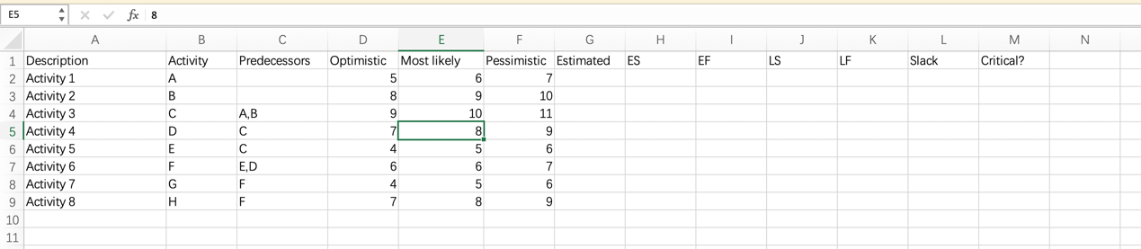

After: (Output.xlsx)

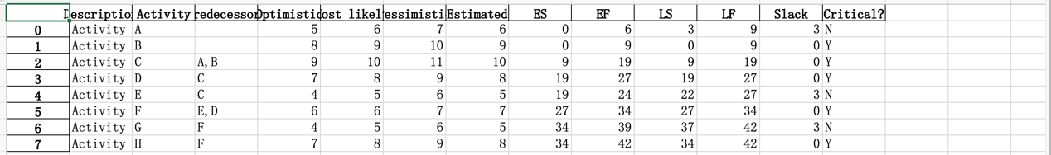

Or in Terminal:

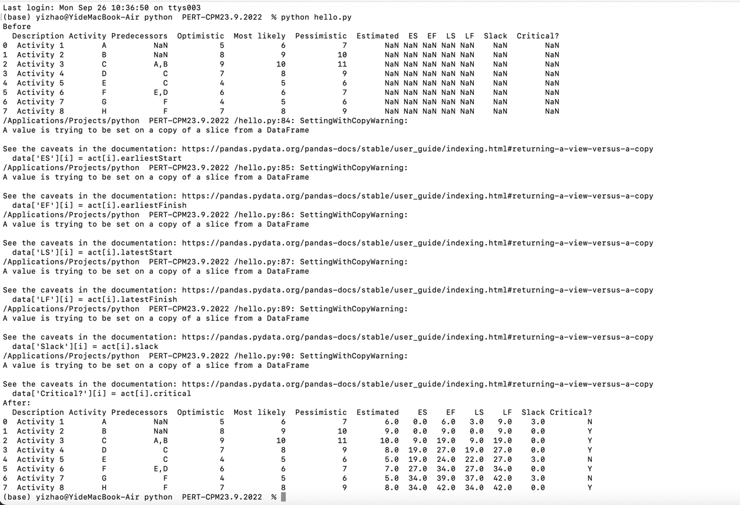

Code:

Import libraries

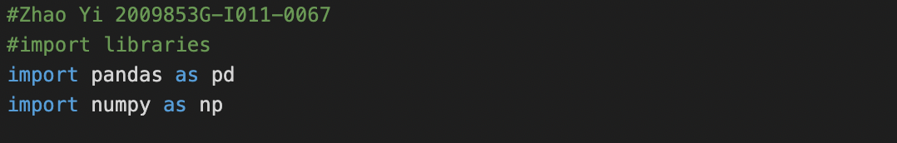

Define a class that takes in every value from each activity.

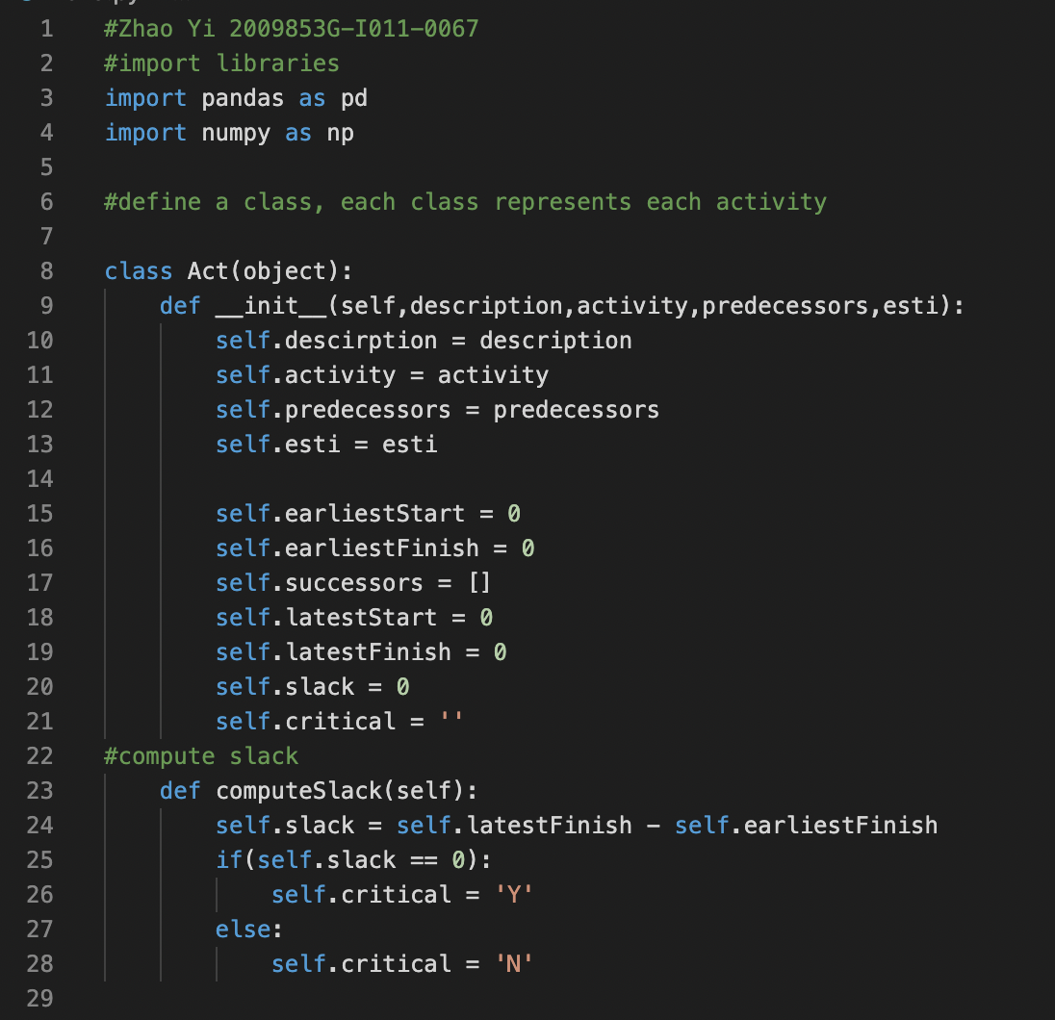

Read excel using Pandas

mydata variable is a Dataframe

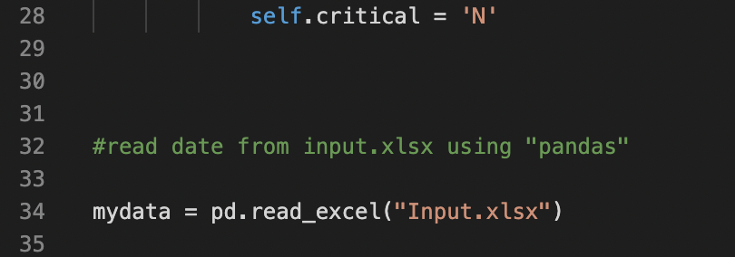

Compute estimated time, if the answer is not an integer, take the upper one.

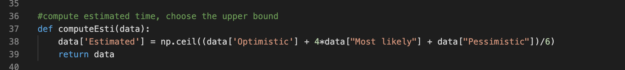

Create an instance for Class Act:

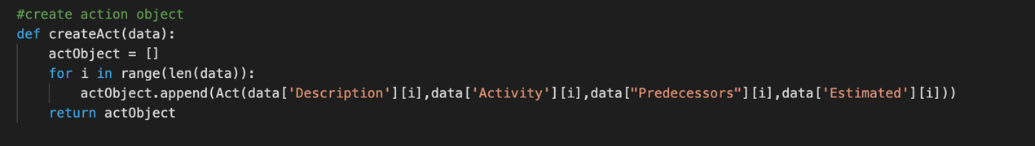

Initialize and compute (core part)

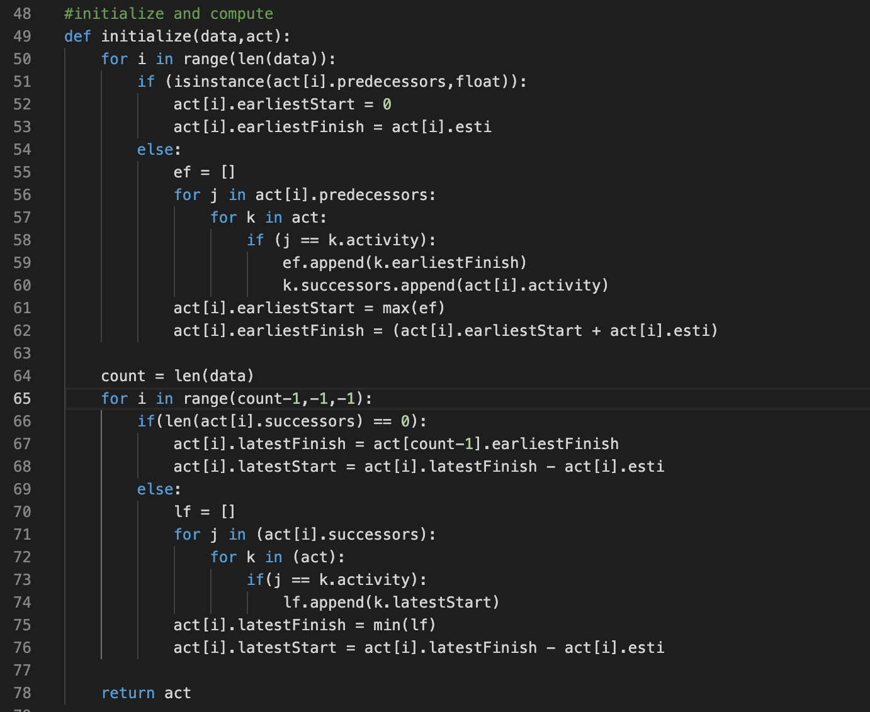

Data structure used: Linked-List (in Python List):

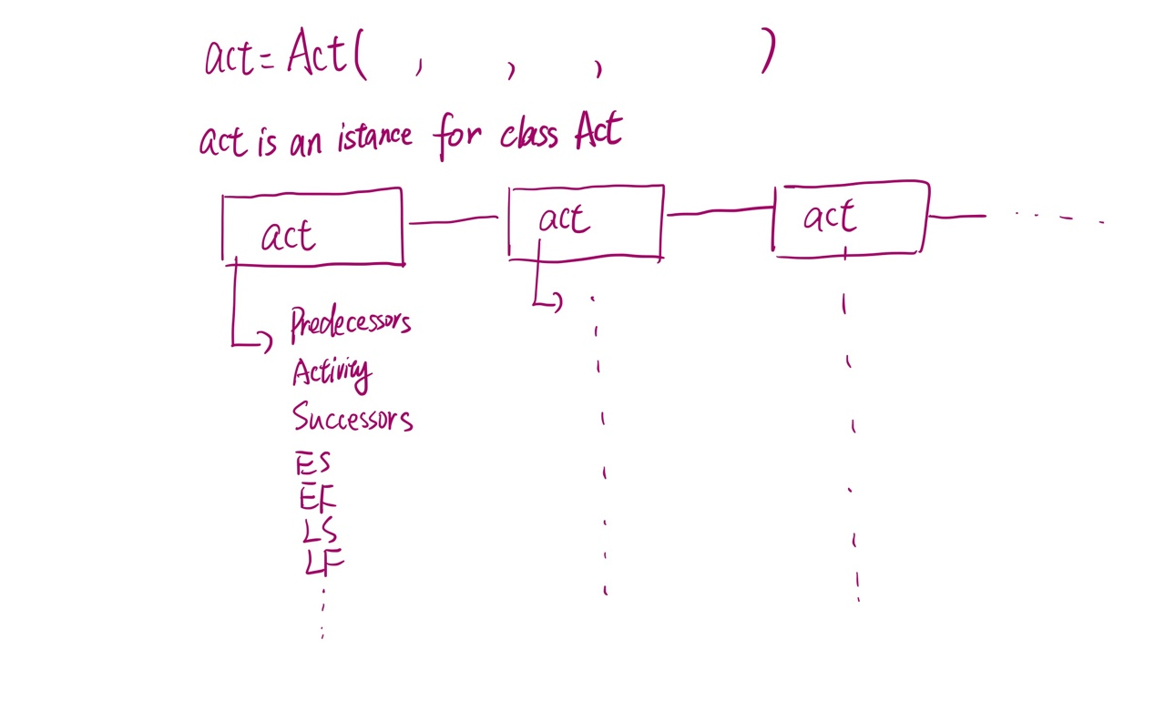

Store ef lf and successors, then calculate.

Output function and function runner part:

