Module 5 Activity

Stephenie Clontz

Rasmussen College

CIS3801C: Fundamentals of Mobile Web Application Development

Christopher Mattie

May 2, 2020

Table of Contents

Website information 3

GITHUB information 3

Screenshots 4

Issues 6

# Website information

This is a website that I will created is:

URL: <http://webdesign2020.centralus.cloudapp.azure.com/CoffeeShopPage.index.html>

# GITHUB information

<https://github.com/Rasmussen-MobileWeb-Spr20/module-4-Stephenie-Clontz>

# Screenshots

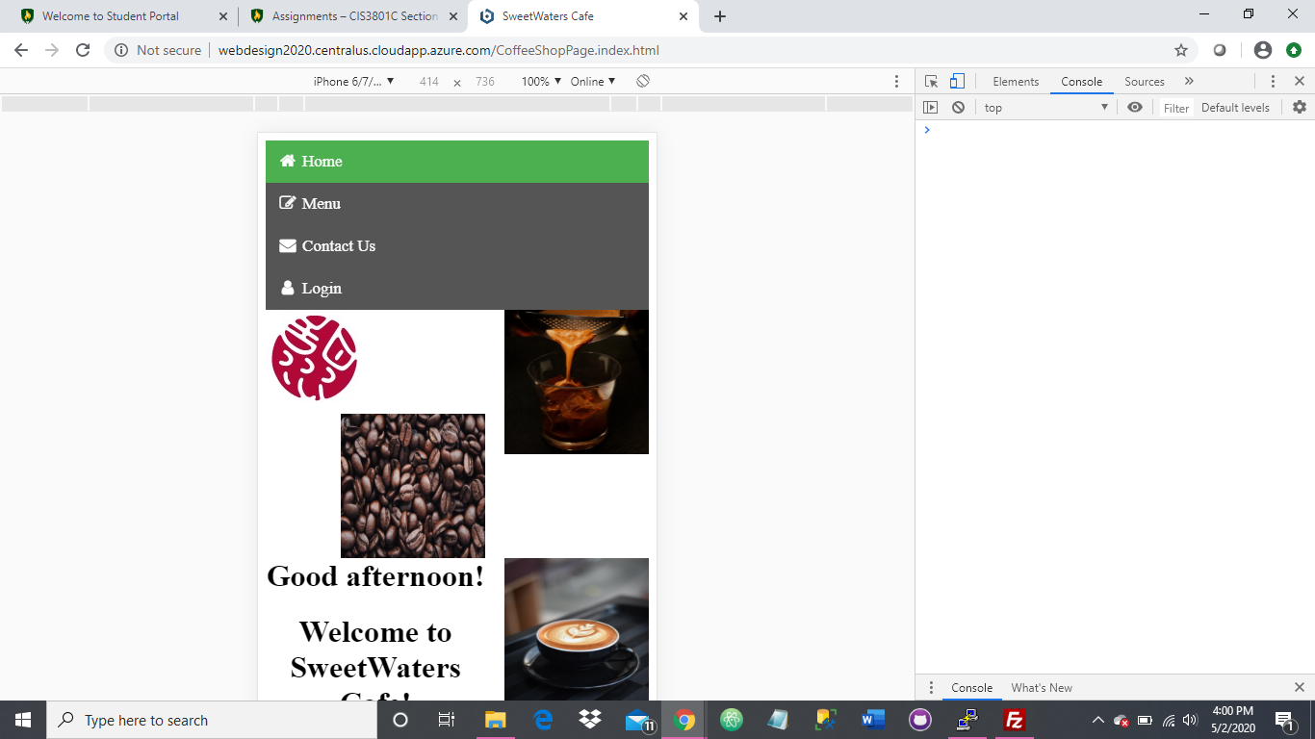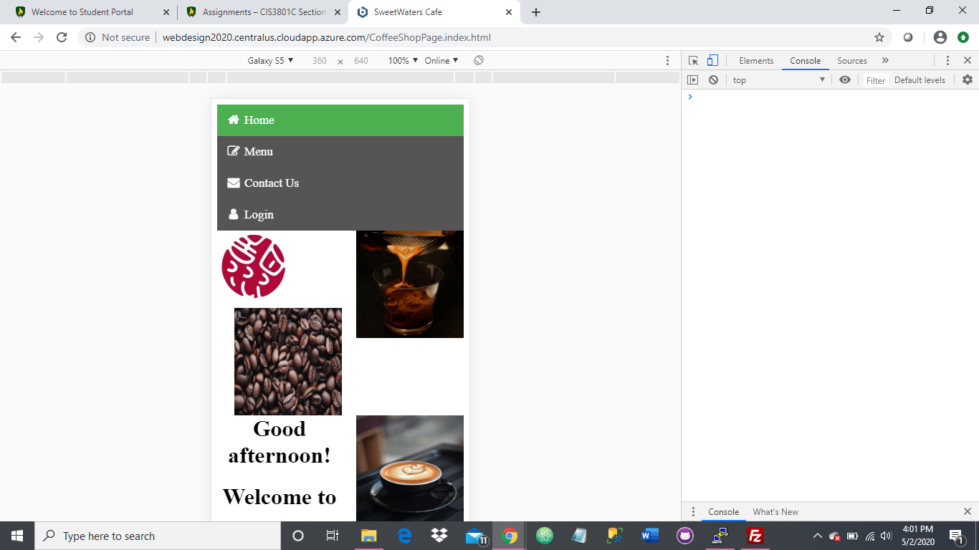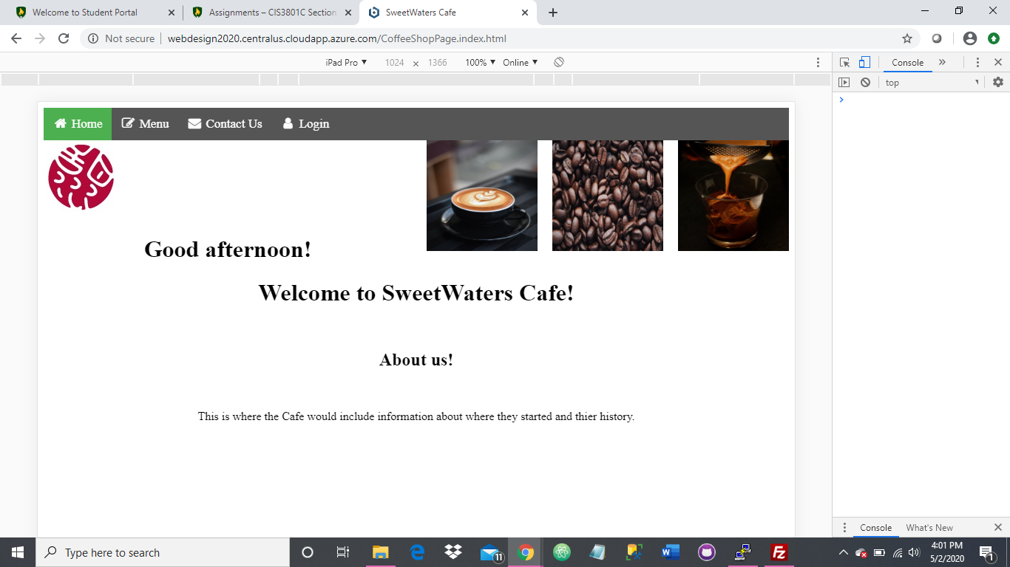

# Issues

When I was looking at the layout on the Galaxy 5, iPhone 6/7/8, and the iPad Pro, the main thing that I noticed was the layout of the images versus the text. I had issues getting the images to float. None of the coding that I tried made them align correctly. This was a frustration. I did not know why the stylesheets were not being called. The other thing that I do not like is the navigation bar. I would prefer the hamburger style navigation but that coding as well was not working. I could get the hamburger icon to show but I could not get the menus to drop down from it.