Module 5 Project

Stephenie Clontz

Rasmussen College

CIS3801C: Fundamentals of Mobile Web Application Development

Christopher Mattie

May 2, 2020

Table of Contents

Website information 3

GITHUB information 3

Screenshots 4

Changes 5

# Website information

This is a website that I will created is:

URL: <http://webdesign2020.centralus.cloudapp.azure.com/CoffeeShopPage.index.html>

# GITHUB information

<https://github.com/Rasmussen-MobileWeb-Spr20/module-4-Stephenie-Clontz>

# Screenshots

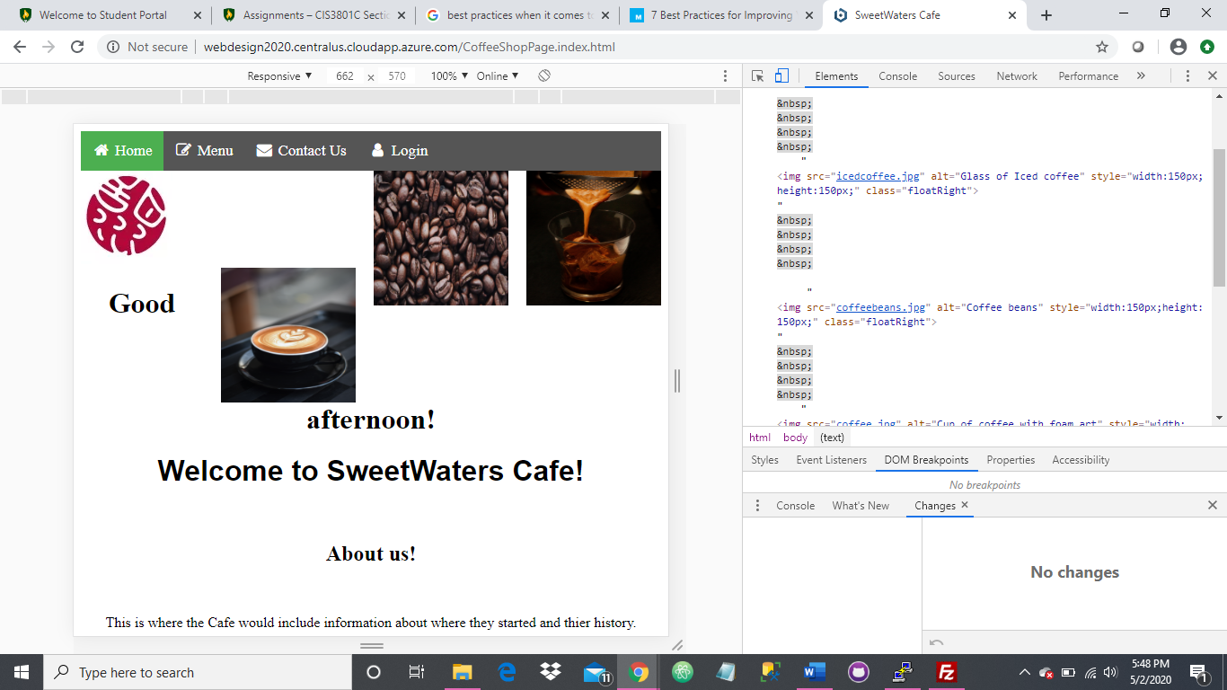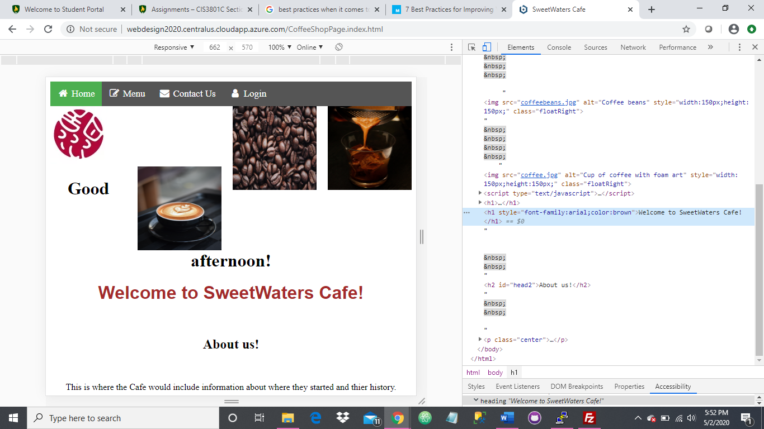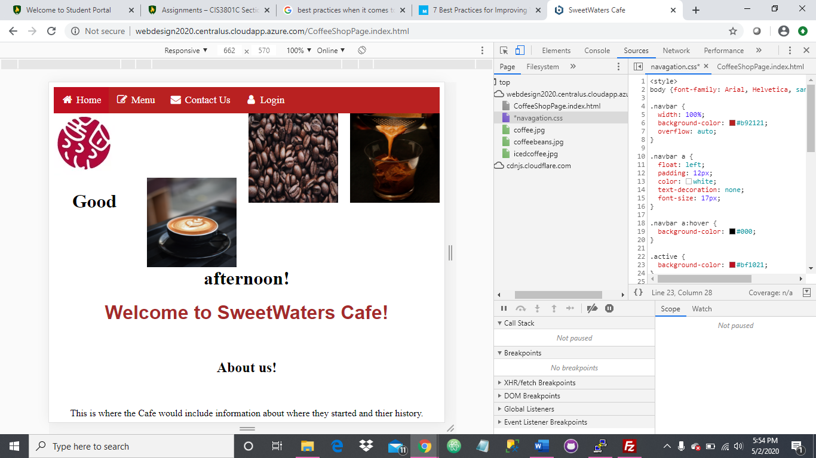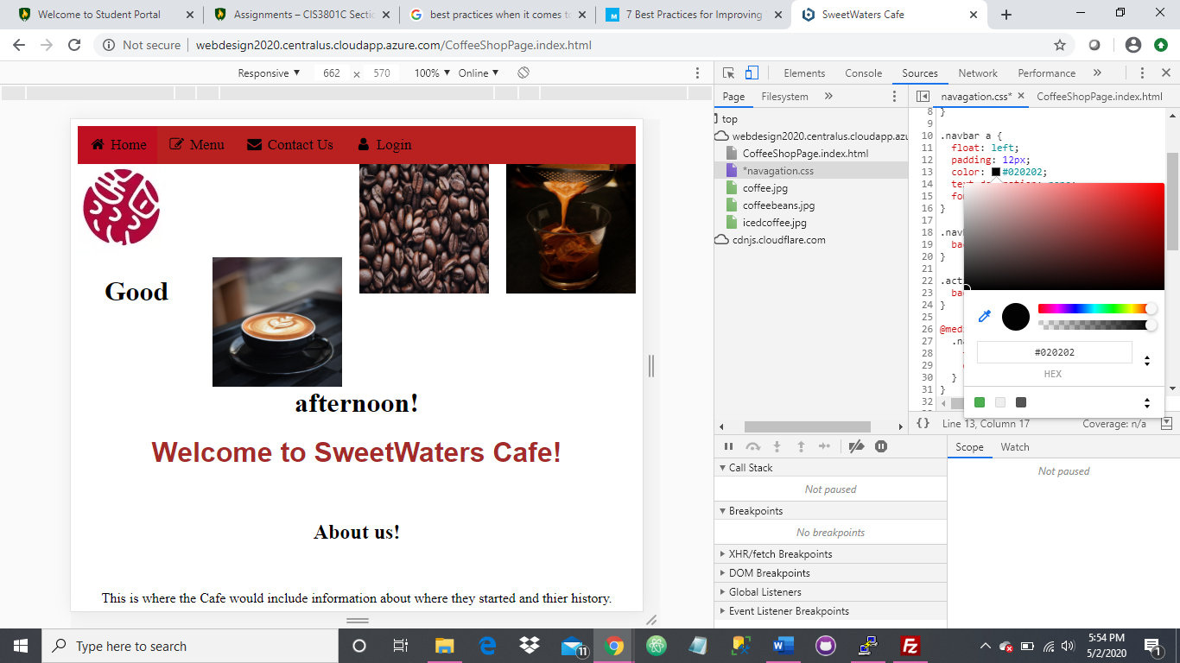

# Changes

I made a total of 4 css changes. The first change that I made was to change the font on the home page from Times New Roman to Arial. I did like that change a lot. It made the text look cleaner. That is a change I would keep. The second change was to change the color of the font on the home page. I am ambivalent on that change. If I changed the background color, then I would want to keep the change in the font color. I would possibly change the back ground to a light coffee brown and then change the font to an off white to bring the image of expresso art to mind to the visitor. The third change I made was to change the color on the navigation bar. I would definitely do this. The fourth change was to make the home portion of the navigation bar match the rest of the navigation bar. I am not sure if the navigation bar changes were a change I like just because I have seen the current layout so much. I think I would like to make the navigation bar closer to a rich expresso color.