###### A

Mini Project On

**AGE ESTIMATION FROM FACIAL EXPRESSION USING VIDEOS**

(Submitted in partial fulfillment of the requirements for the award of Degree)

BACHELOR OF TECHNOLOGY

In

###### COMPUTER SCIENCE AND ENGINEERING

By

###### BHUPATHIRAJU GEETHA SUPRIYA (197R1A05J9)

###### YOGITHA POTLAPALLY (197R1A05Q0)

###### KATEPOGU STEPHEN KUMAR (177R1A05F1)

Under the Guidance of

**J. NARASIMHARAO**

(Associate Professor)



##### DEPARTMENT OF COMPUTER SCIENCE AND ENGINEERING

**CMR TECHNICAL CAMPUS UGC AUTONOMOUS**

(Accredited by NAAC, NBA, Permanently Affiliated to JNTUH, Approved by AICTE, New Delhi) Recognized Under Section 2(f) & 12(B) of the UGCAct.1956, Kandlakoya (V), Medchal Road, Hyderabad-501401.

**2019-2023**

**DEPARTMENT OF COMPUTER SCIENCE AND ENGINEERING**



#### CERTIFICATE

This is to certify that the project entitled **“AGE ESTIMATION FROM FACIAL EXPRESSIONS USING VIDEOS”** being submitted by **BHUPATHIRAJU GEETHA SUPRIYA(197R1A05J9), YOGITHA POTLAPALLY(197R1A05Q0) & KATEPOGU STEPHEN KUMAR(177R1A05F1)** in partial fulfillment of the requirements for the award of the degree of B.Tech in Computer Science and Engineering to the Jawaharlal Nehru Technological University Hyderabad, is a record of bonafide work carried out by them under our guidance and supervision during the year 2022-23.

The results embodied in this thesis have not been submitted to any other University or Institute for the award of any degree or diploma.

**J. Narasimharao Dr. A. Raji Reddy**

(Associate Professor) DIRECTOR

INTERNAL GUIDE

**Dr. K. Srujan Raju EXTERNAL EXAMINER**

HOD

**Submitted for viva voice Examination held on**

##### ACKNOWLEDGEMENT

Apart from the efforts of us, the success of any project depends largely on the encouragement and guidelines of many others. We take this opportunity to express our gratitude to the people who have been instrumental in the successful completion of this project.

We take this opportunity to express my profound gratitude and deep regard to my guide **J. Narasimharao,** Associate Professor for his exemplary guidance, monitoring and constant encouragement throughout the project work. The blessing, help and guidance given by him shall carry us a long way in the journey of life on which we are about to embark.

We also take this opportunity to express a deep sense of gratitude to the Project Review Committee (PRC) **Dr. Punyaban Patel, Ms. Shilpa, Dr. M . Subha Mastan Rao & J. Narasimharao** for their cordial support, valuable information and guidance, which helped us in completing this task through various stages.

We are also thankful to **Dr. K. Srujan Raju,** Head, Department of Computer Science and Engineering for providing encouragement and support for completing this project successfully.

We are obliged to **Dr. A. Raji Reddy,** Director for being cooperative throughout the course of this project. We also express our sincere gratitude to Sri. **Ch. Gopal Reddy,** Chairman for providing excellent infrastructure and a nice atmosphere throughout the course of this project.

The guidance and support received from all the members of **CMR Technical Campus** who contributed to the completion of the project. We are grateful for their constant support and help.

Finally, we would like to take this opportunity to thank our family for their constant encouragement, without which this assignment would not be completed. We sincerely acknowledge and thank all those who gave support directly and indirectly in the completion of this project.

BHUPATHIRAJU GEETHA SUPRIYA (197R1A05J9)

**YOGITHA POTLAPALLY (197R1A05Q0)**

**KATEPOGU STEPHEN KUMAR (177R1A05F1)**

##### ABSTRACT

The main challenges of age estimation from facial expression videos lie not only in the modeling of the static facial appearance, but also in the capturing of the temporal facial dynamics. Traditional techniques to this problem focus on constructing handcrafted features to explore the discriminative information contained in facial appearance and dynamics separately. This relies on sophisticated feature-refinement and framework-design. In this project, we present an end-to-end architecture for age estimation, called Spatially-Indexed Attention Model (SIAM), which is able to simultaneously learn both the appearance and dynamics of age from raw videos of facial expressions. Specifically, we employ convolutional neural networks to extract effective latent appearance representations and feed them into recurrent networks to model the temporal dynamics. More importantly, we propose to leverage attention models for salience detection in both the spatial domain for each single image and the temporal domain for the whole video as well.

We design a specific spatially-indexed attention mechanism among the convolutional layers to extract the salient facial regions in each individual image, and a temporal attention layer to assign attention weights to each frame. This two-pronged approach not only improves the performance by allowing the model to focus on informative frames and facial areas, but it also offers an interpretable correspondence between the spatial facial regions as well as temporal frames, and the task of age estimation. We demonstrate the strong performance of our model in experiments on a large, gender-balanced database with 400 subjects with ages spanning from 8 to 76 years. Experiments reveal that our model exhibits significant superiority over the state-of-the-art methods given sufficient training data.

##### FIGURE NO FIGURE NAME PAGE NO

###### Figure 3.1 Project Architecture for Age 7

###### Estimation From Facial Expressions

###### Using Videos

###### Figure 3.2 Use Case Diagram for Age 8

###### Estimation From Facial Expressions

###### Using Videos

###### Figure 3.3 Class Diagram for Age 9

###### Estimation From Facial Expressions

###### Using Videos

###### Figure 3.4 Sequence diagram for Age 10

###### Estimation From Facial Expressions

###### Using Videos

###### Figure 3.5 Activity diagram for Age 11

###### Estimation From Facial Expressions

###### Using Videos

|  |  |  |
| --- | --- | --- |
| **SCREENSHOT NO.** | **SCREENSHOT NAME** | **PAGE NO**. |
| Screenshot 5.1 | Student Recognised | 16 |
| Screenshot 5.2 | Recognised and Displayed With a Message | 16 |
| Screenshot 5.3 | Student Face Recognised | 17 |
| Screenshot 5.4 | Camera Dialogue Box | 17 |
| Screenshot 5.5 | Data stored in log file | 18 |

ABSTRACT i

LIST OF FIGURES ii

LIST OF SCREENSHOTS iii

1. INTRODUCTION 1
   1. PROJECT SCOPE 1
   2. PROJECT PURPOSE 1
   3. PROJECT FEATURES 1
2. SYSTEM ANALYSIS 2
   1. PROBLEM DEFINITION 2
   2. EXISTING SYSTEM 2
      1. LIMITATIONS OF THE EXISTING SYSTEM 3
   3. PROPOSED SYSTEM 3
      1. ADVANTAGES OF PROPOSED SYSTEM 4
   4. FEASIBILITY STUDY 5
      1. ECONOMIC FEASIBILITY 5
      2. TECHNICAL FEASIBILITY 5
      3. SOCIAL FEASIBILITY 5
   5. HARDWARE & SOFTWARE REQUIREMENTS 6
      1. HARDWARE REQUIREMENTS 6
      2. SOFTWARE REQUIREMENTS 6
3. ARCHITECTURE 7
   1. PROJECT ARCHITECTURE 7
   2. DESCRIPTION 7
   3. USE CASE DIAGRAM 8
   4. CLASS DIAGRAM 9
   5. SEQUENCE DIAGRAM 10
   6. ACTIVITY DIAGRAM 11
4. IMPLEMENTATION 12
   1. SAMPLE CODE 12
5. RESULTS 16
6. TESTING 19
   1. INTRODUCTION TO TESTING 19
   2. TYPES OF TESTING 19
      1. UNIT TESTING 19
      2. INTEGRATION TESTING 20
      3. FUNCTIONAL TESTING 20
   3. TEST CASES 21
      1. CLASSIFICATION 21
7. CONCLUSION & FUTURE SCOPE 22
   1. PROJECT CONCLUSION 22
   2. FUTURE SCOPE 22
8. REFERENCES 23
   1. REFERENCES 23
   2. GITHUB LINK 23

# INTRODUCTION

#### INTRODUCTION

##### PROJECT SCOPE

###### This project is titled “Age Estimation From Facial Expression Using Videos”. Human age estimation from faces is an important re- search topic due to its extensive applications ranging from surveillance monitoring to forensic art and social networks. The widely-used discriminative features for age estimation are appearance-related, such as wrinkles in the face, skin texture and luster, hence plenty of prevalent methods focus on modeling the appearance information from the static face.

##### PROJECT PURPOSE

This project has been developed to identify Deep learning based methods that can extract more complicated face features. Deep learning is making crucial advances in solving problems that have restricted the best attempts of the artificial intelligence community for many years. It has proven to be excellent at revealing complex structures in high-dimensional data and is therefore applicable to lots of domains of science, business and government.

##### PROJECT FEATURES

The main features of this project are that this model classifies the It addresses the problem of learning hierarchical representations with a single algorithm or a few algorithms and has mainly beaten records in image recognition, natural language processing, semantic segmentation and many other real world scenarios. There are different deep learning approaches like Convolutional Neural Network(CNN), Spatially-Indexed Attention Model (SIAM). CNN mostly used algorithms in image and face recognition.

## SYSTEM ANALYSIS

##### SYSTEM ANALYSIS

**SYSTEM ANALYSIS**

System Analysis is the important phase in the system development process. The System is studied to the minute details and analyzed. The system analyst plays an important role of an interrogator and dwells deep into the working of the present system. In analysis, a detailed study of these operations performed by the system and their relationships within and outside the system is done. A key question considered here is, “what must be done to solve the problem?” The system is viewed as a whole and the inputs to the system are identified. Once analysis is completed the analyst has a firm understanding of what is to be done.

##### PROBLEM DEFINITION

A general statement of Age estimation problem can be formulated as the given still or video images of a scene, identify or verify the age of one or more persons in the scene or in any live capturing devices using a stored database of those authorized faces.

.

##### EXISTING SYSTEM

Automatic age estimation from facial images is an exciting machine learning topic that has attracted researchers’ attention over the past several years. Numerous human–computer interaction applications, such as targeted marketing, content access control, or soft-biometrics systems, employ age estimation models to carry out secondary tasks such as user filtering or identification. Despite the vast array of applications that could benefit from automatic age estimation, building an automatic age estimation system comes with issues such as data disparity, the unique ageing pattern of each individual and facial photo quality.

* + 1. DISADVANTAGES OF EXISTING SYSTEM

Following are the disadvantages of existing system:

* In contrast to regression and multi-class classification, some studies approach age estimation as an ordinal ranking problem. For instance, presents a deep (category-based) ranking model that combines deep scattering transform and ordinal ranking.
* Formulates the problem as ordinal regression using a series of binary classification tasks which are jointly optimized by a multiple output CNN architecture.

##### PROPOSED SYSTEM

We propose to leverage attention models for salience detection in both the spatial domain for each single image and the temporal domain for the whole video as well. We design a specific spatially-indexed attention mechanism among the convolutional layers to extract the salient facial regions in each individual image, and a temporal attention layer to assign attention weights to each frame. This two-pronged approach not only improves the performance by allowing the model to focus on informative frames and facial areas, but it also offers an interpretable correspondence between the spatial facial regions as well as temporal frames, and the task of age estimation. We demonstrate the strong performance of our model in experiments on a large, gender-balanced database with 400 subjects with ages spanning from 8 to 76 years. Experiments reveal that our model exhibits significant superiority over the state-of-the-art methods given sufficient training data.

2.3.1 ADVANTAGES OF THE PROPOSED SYSTEM

* Our model has the capacity to learn and it could do even better on more data while other models potentially saturate and do not get better no matter how much data you give them.
* The potential advantages of using recurrent networks are that they learn relevant dynamics feature to the aimed task (age estimation) smoothly and progressively over time, all modules in our model can be trained jointly in an end-to-end manner to be compatible with each other.
* We first investigate the different mechanisms to implement spatial attention and validate the advantages of our proposed spatially-indexed mechanism over other options.

##### 2.4 FEASIBILITY STUDY

The feasibility of the project is analyzed in this phase and business proposal is put forth with a very general plan for the project and some cost estimates. During system analysis the feasibility study of the proposed system is to be carried out. This is to ensure that the proposed system is not a burden to the company. For feasibility analysis, some understanding of the major requirements for the system is essential.

Three key considerations involved in the feasibility analysis are

* ECONOMICAL FEASIBILITY
* TECHNICAL FEASIBILITY
* SOCIAL FEASIBILITY

* + 1. ECONOMIC FEASIBILITY

This study is carried out to check the economic impact that the system will have on the organization. The amount of fund that the company can pour into the research and development of the system is limited. The expenditures must be justified. Thus the developed system as well within the budget and this was achieved because most of the technologies used are freely available. Only the customized products had to be purchased.

2.4.2 TECHNICAL FEASIBILITY

This study is carried out to check the technical feasibility, that is, the technical requirements of the system. Any system developed must not have a high demand on the available technical resources. This will lead to high demands on the available technical resources. This will lead to high demands being placed on the client. The developed system must have a modest requirement, as only minimal or null changes are required for implementing this system.

2.4.3 SOCIAL FEASIBILITY

The aspect of study is to check the level of acceptance of the system by the user. This includes the process of training the user to use the system efficiently. The user must not feel threatened by the system, instead must accept it as a necessity. The level of acceptance by the users solely depends on the methods that are employed to educate the user about the system and to make him familiar with it. His level of confidence must be raised so that he is also able to make some constructive criticism, which is welcomed, as he is the final user of the system

##### 2.5 HARDWARE & SOFTWARE REQUIREMENTS

2.5.1 HARDWARE REQUIREMENTS:

Hardware interfaces specify the logical characteristics of each interface between the software product and the hardware components of the system. The following are some hardware requirements.

* **System :** Pentium IV 2.4 GHz.
* **Hard Disk :** 40 GB.
* **Floppy Drive :** 1.44 Mb.
* **Monitor** : 14’ Colour Monitor.
* **Mouse :** Optical Mouse.
* **Ram :** 512 Mb.

##### SOFTWARE REQUIREMENTS:

Software Requirements specifies the logical characteristics of each interface and software components of the system. The following are some software requirements

* **Operating system :** Windows 7 Ultimate.
* **Coding Language :** Python.
* **Tools :** Numpy, Pandas, matplotlib

## ARCHITECTURE

##### 3.ARCHITECTURE

##### 3.1 PROJECT ARCHITECTURE

This project architecture shows the procedure followed for classification, starting from input to final prediction.

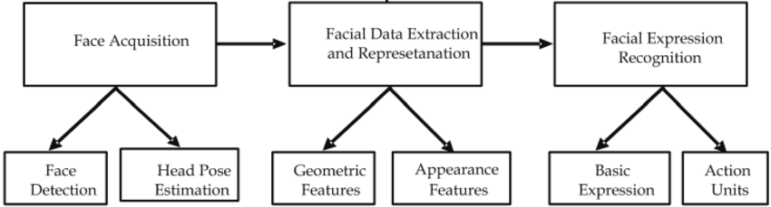

Figure 3.1: Project Architecture of Age estimation from facial expressions using videos

* 1. DESCRIPTION

This project is totally based upon identifying the age of recognised face. As can be seen from the figure, the original picture may be subjected to image augmentation operations before entering the neural network. There will be multiple sets of comparative experiments to compare and analyze the effectiveness of this image augmentation operation. The architecture of the neural network is based on the ShuffleNetV2 network, but the last output layer of the original ShuffleNetV2 has 1000 neurons. We first transformed it into 101 neurons, and then added an output with only one neuron behind this layer.

3.3 USE CASE DIAGRAM

In the use case diagram, we have basically one actor who is the user in the trained model.

A use case diagram is a graphical depiction of a user's possible interactions with a system. A use case diagram shows various use cases and different types of users the system has. The use cases are represented by either circles or ellipses. The actors are often shown as stick figures.

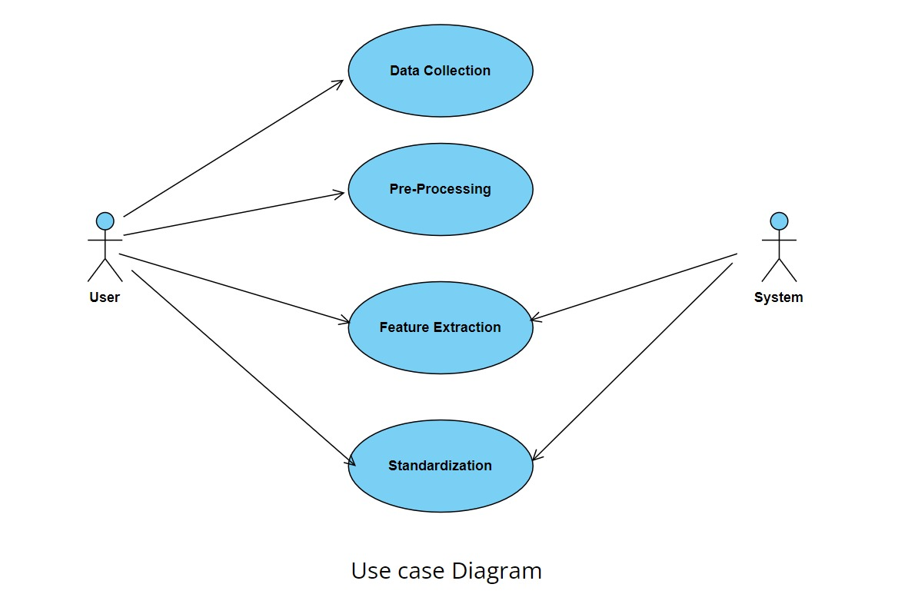

Figure 3.2: Use Case Diagram for Age estimation from facial expressions using videos

##### CLASS DIAGRAM

Class diagram is a type of static structure diagram that describes the structure of a system by showing the system’s classes, their attributes, operations(or methods), and the relationships among objects.

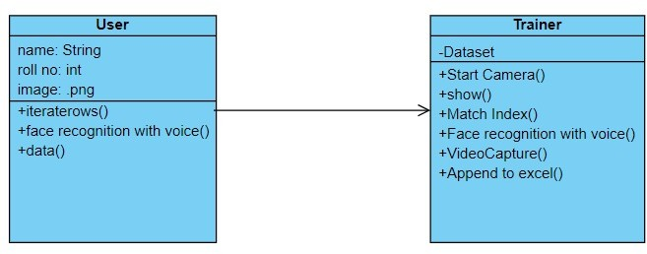

Figure 3.3: Class Diagram for Age estimation from facial expressions using videos

##### 3.5 SEQUENCE DIAGRAM

A sequence diagram shows object interactions arranged in time sequence. It depicts the objects involved in the scenario and the sequence of messages exchanged between the objects needed to carry out the functionality of the scenario. Sequence diagrams are typically associated with use case realizations in the logical view of the system under development.

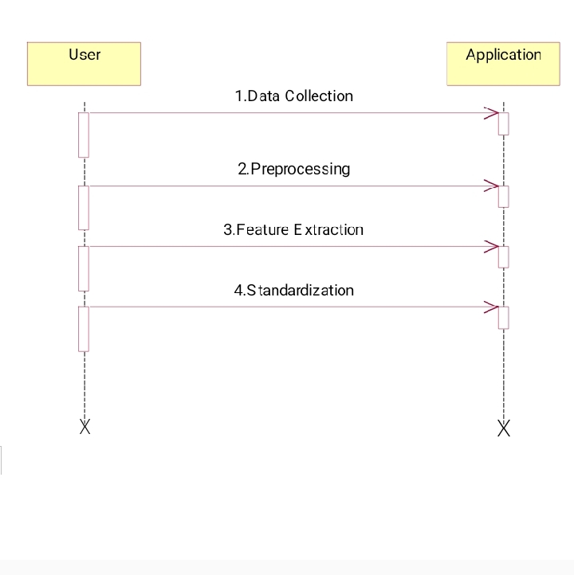

Figure 3.4: Sequence Diagram for Age estimation from facial expressions using videos

* 1. ACTIVITY DIAGRAM

Activity diagrams are graphical representations of workflows of stepwise activities and actions with support for choice, iteration and concurrency. They can also include elements showing the flow of data between activities through one or more data stores.

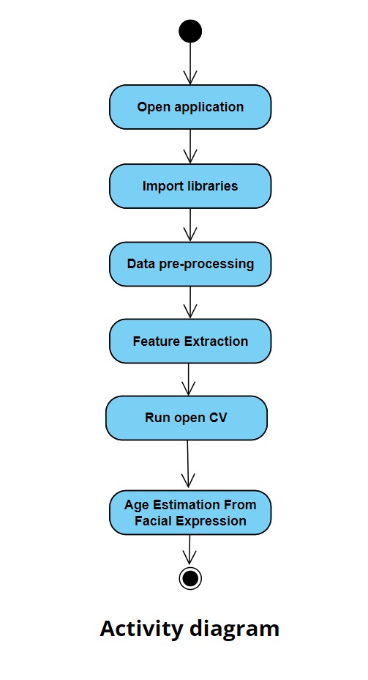

Figure 3.5: Activity Diagram for Age estimation from facial expressions using videos

## 4.IMPLEMENTATION

##### 4.1 SAMPLE CODE

import sys

import argparse

import cv2

from libfaceid.detector import FaceDetectorModels, FaceDetector

from libfaceid.encoder import FaceEncoderModels, FaceEncoder

from libfaceid.pose import FacePoseEstimatorModels, FacePoseEstimator

from libfaceid.age import FaceAgeEstimatorModels, FaceAgeEstimator

from libfaceid.gender import FaceGenderEstimatorModels, FaceGenderEstimator

from libfaceid.emotion import FaceEmotionEstimatorModels, FaceEmotionEstimator

# Use flask for web app

from flask import Flask, render_template, Response

app = Flask(__name__)

# Set the input directories

INPUT_DIR_DATASET = "datasets"

INPUT_DIR_MODEL_DETECTION = "models/detection/"

INPUT_DIR_MODEL_ENCODING = "models/encoding/"

INPUT_DIR_MODEL_TRAINING = "models/training/"

INPUT_DIR_MODEL_ESTIMATION = "models/estimation/"

# Set width and height

RESOLUTION_QVGA = (320, 240)

RESOLUTION_VGA = (640, 480)

RESOLUTION_HD = (1280, 720)

RESOLUTION_FULLHD = (1920, 1080)

def cam_init(cam_index, width, height):

cap = cv2.VideoCapture(cam_index)

if sys.version_info < (3, 0):

cap.set(cv2.cv.CV_CAP_PROP_FPS, 60)

cap.set(cv2.cv.CV_CAP_PROP_FRAME_WIDTH, width)

cap.set(cv2.cv.CV_CAP_PROP_FRAME_HEIGHT, height)

else:

cap.set(cv2.CAP_PROP_FPS, 60)

cap.set(cv2.CAP_PROP_FRAME_WIDTH, width)

cap.set(cv2.CAP_PROP_FRAME_HEIGHT, height)

return cap

def label_face(frame, face_rect, face_id, confidence):

(x, y, w, h) = face_rect

cv2.rectangle(frame, (x, y), (x+w, y+h), (255, 255, 255), 1)

if face_id is not None:

cv2.putText(frame, "{} {:.2f}%".format(face_id, confidence),

(x+5,y+h-5), cv2.FONT_HERSHEY_SIMPLEX, 0.5, (255, 255, 255), 1, cv2.LINE_AA)

def process_facedetection():

cam_index = 0

cam_resolution = RESOLUTION_QVGA

model_detector=FaceDetectorModels.HAARCASCADE

model_poseestimator=FacePoseEstimatorModels.DEFAULT

model_ageestimator=FaceAgeEstimatorModels.DEFAULT

model_genderestimator=FaceGenderEstimatorModels.DEFAULT

model_emotionestimator=FaceEmotionEstimatorModels.DEFAULT

# Initialize the camera

camera = cam_init(cam_index, cam_resolution[0], cam_resolution[1])

try:

# Initialize face detection

face_detector = FaceDetector(model=model_detector, path=INPUT_DIR_MODEL_DETECTION)#, optimize=True)

# Initialize face pose/age/gender estimation

face_pose_estimator = FacePoseEstimator(model=model_poseestimator, path=INPUT_DIR_MODEL_ESTIMATION)

face_age_estimator = FaceAgeEstimator(model=model_ageestimator, path=INPUT_DIR_MODEL_ESTIMATION)

face_gender_estimator = FaceGenderEstimator(model=model_genderestimator, path=INPUT_DIR_MODEL_ESTIMATION)

face_emotion_estimator = FaceEmotionEstimator(model=model_emotionestimator, path=INPUT_DIR_MODEL_ESTIMATION)

except:

print("Warning, check if models and trained dataset models exists!")

(age, gender, emotion) = (None, None, None)

while (True):

# Capture frame from webcam

ret, frame = camera.read()

if frame is None:

print("Error, check if camera is connected!")

break

# Detect and identify faces in the frame

faces = face_detector.detect(frame)

for (index, face) in enumerate(faces):

(x, y, w, h) = face

# Detect age, gender, emotion

face_image = frame[y:y+h, h:h+w]

age = face_age_estimator.estimate(frame, face_image)

gender = face_gender_estimator.estimate(frame, face_image)

emotion = face_emotion_estimator.estimate(frame, face_image)

# Detect and draw face pose locations

shape = face_pose_estimator.detect(frame, face)

face_pose_estimator.add_overlay(frame, shape)

# Display age, gender, emotion

cv2.putText(frame, "Age: {}".format(age),

(x, y-45), cv2.FONT_HERSHEY_SIMPLEX, 0.5, (255, 255, 255), 1, cv2.LINE_AA)

cv2.putText(frame, "Gender: {}".format(gender),

(x, y-30), cv2.FONT_HERSHEY_SIMPLEX, 0.5, (255, 255, 255), 1, cv2.LINE_AA)

cv2.putText(frame, "Emotion: {}".format(emotion),

(x, y-15), cv2.FONT_HERSHEY_SIMPLEX, 0.5, (255, 255, 255), 1, cv2.LINE_AA)

# Display updated frame to web app

yield (b'--frame\r\nContent-Type: image/jpeg\r\n\r\n' + cv2.imencode('.jpg', frame)[1].tobytes() + b'\r\n\r\n')

# Release the camera

camera.release()

cv2.destroyAllWindows()

# Initialize for web app

@app.route('/')

def index():

return render_template('index.html')

# Entry point for web app

@app.route('/video_viewer')

def video_viewer():

return Response(process_facedetection(), mimetype='multipart/x-mixed-replace; boundary=frame')

if __name__ == '__main__':

# Run flask for web app

app.run(threaded=True, debug=True)

## RESULTS

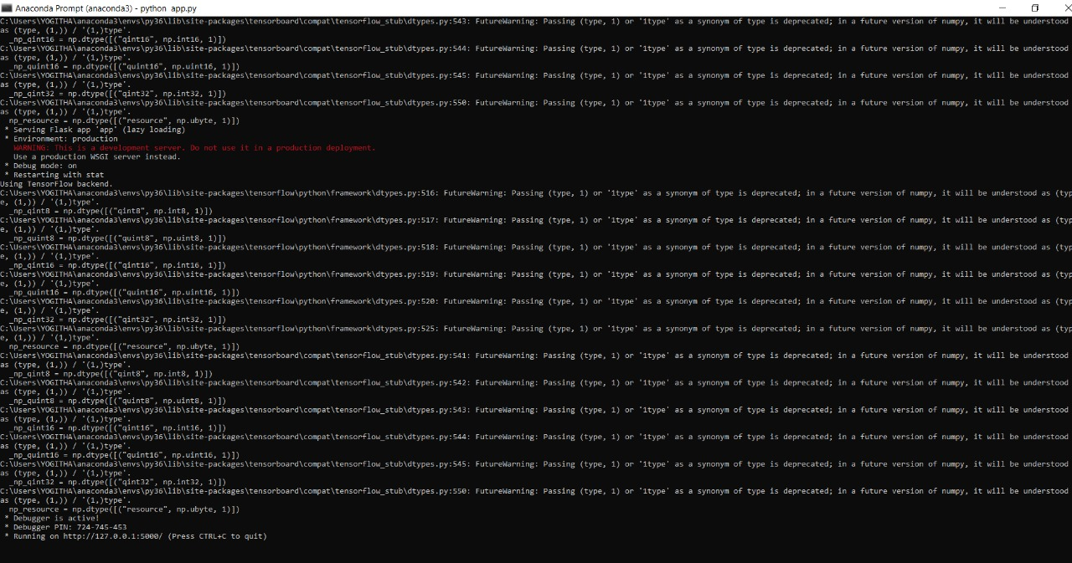

Screenshot 5.1: Student recognised

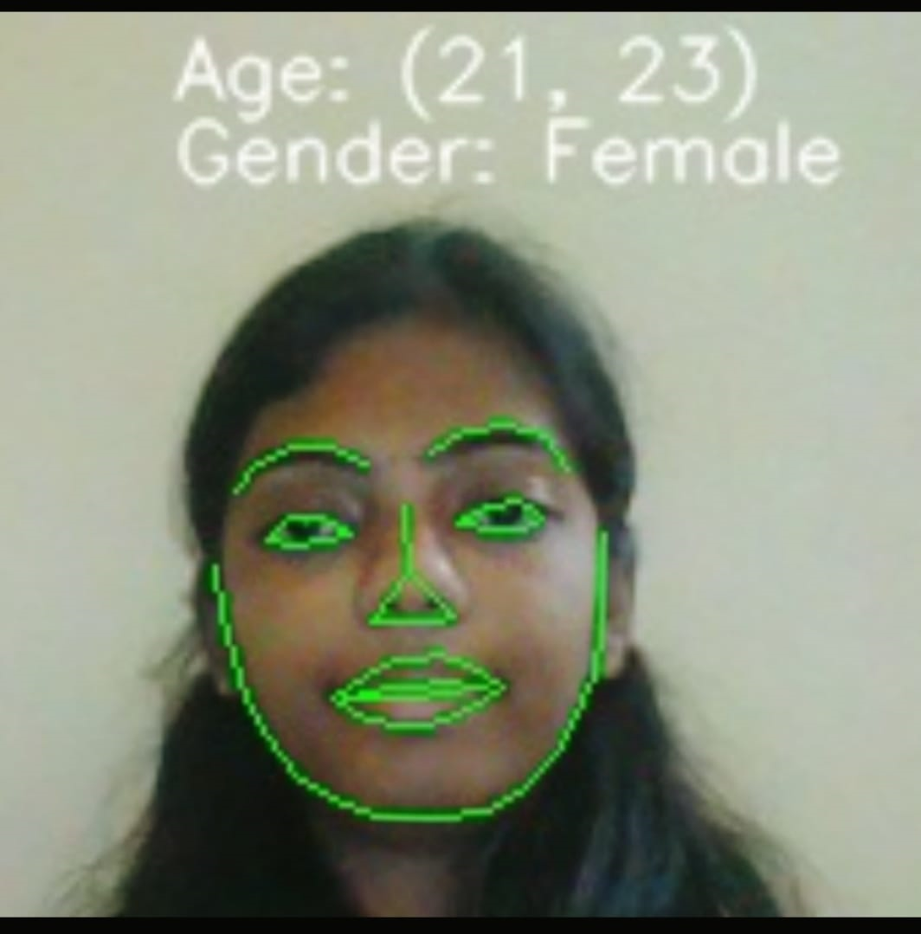

Screenshot 5.2: Student recognised and displayed with a message

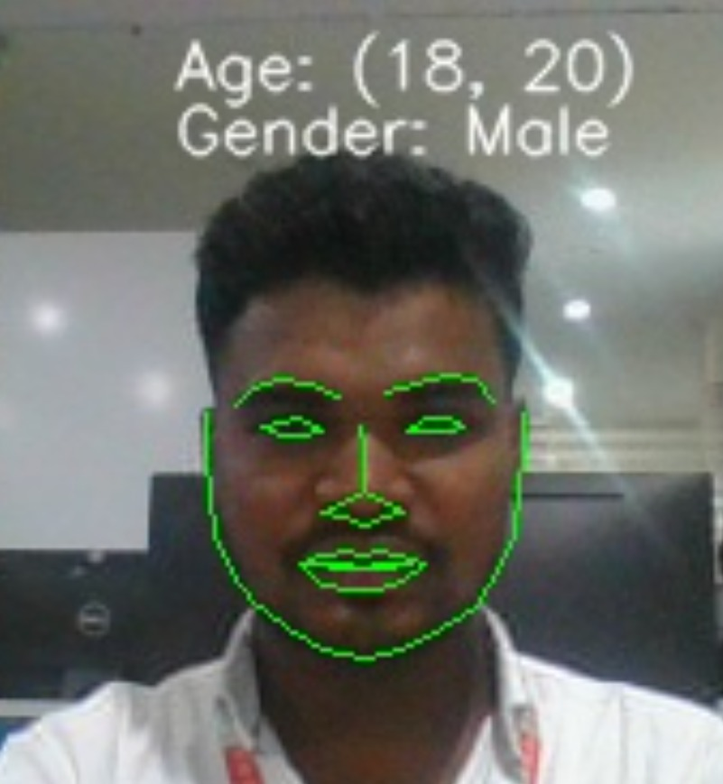

Screenshot 5.3: Student face recognised

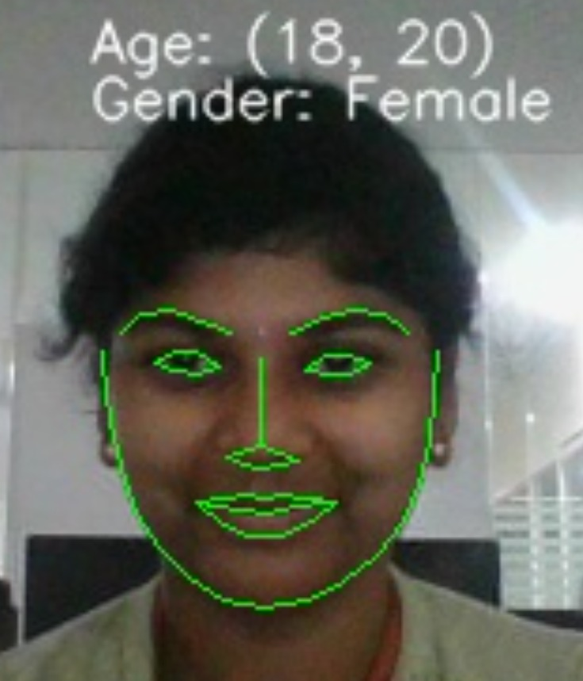

Screenshot 5.4: Camera Dialogue Box

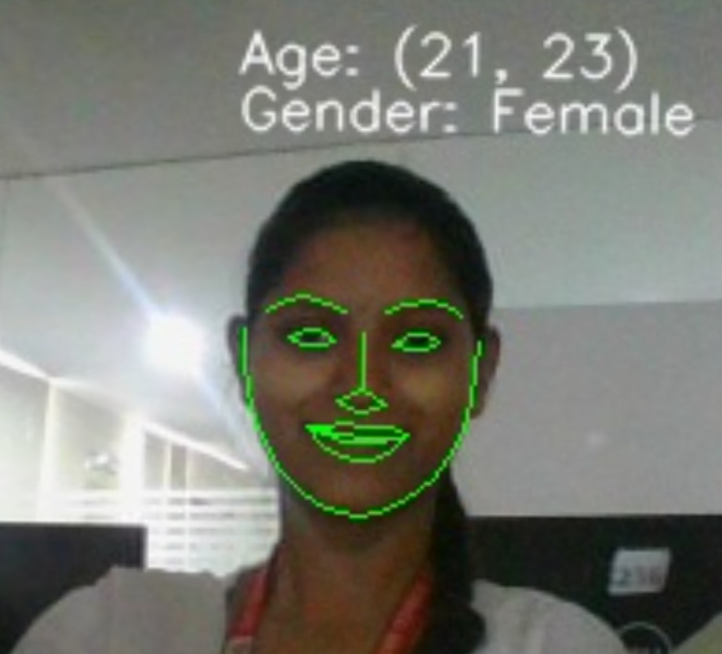

Screenshot 5.5: Data stored in log file

## TESTING

#### 6.TESTING

##### INTRODUCTION TO TESTING

The purpose of testing is to discover errors. Testing is the process of trying to discover every conceivable fault or weakness in a work product. It provides a way to check the functionality of components, subassemblies, assemblies and/or a finished product. It is the process of exercising software with the intent of ensuring that the Software system meets its requirements and user expectations and does not fail in an unacceptable manner. There are various types of tests. Each test type addresses a specific testing requirement.

##### TYPES OF TESTING

* + 1. UNIT TESTING

Unit testing involves the design of test cases that validate that the internal program logic is functioning properly, and that program inputs produce valid outputs. All decision branches and internal code flow should be validated. It is the testing of individual software units of the application .It is done after the completion of an individual unit before integration. This is a structural testing that relies on knowledge of its construction and is invasive. Unit tests perform basic tests at component level and test a specific business process, application and/or system configuration. Unit tests ensure that each unique path of a business process performs accurately to the documented specifications and contains clearly defined inputs and expected results.

* + 1. INTEGRATION TESTING

Integration tests are designed to test integrated software components to determine if they actually run as one program. Integration tests demonstrate that although the components were individually satisfactory, as shown by successfully unit testing, the combination of components is correct and consistent. Integration testing is specifically aimed at exposing the problems that arise from the combination of components.

* + 1. FUNCTIONAL TESTING

Functional tests provide systematic demonstrations that functions tested are available as specified by the business and technical requirements, system documentation, and user manuals.

Functional testing is centered on the following items:

Valid Input : identified classes of valid input must be accepted.

Invalid Input

: identified classes of invalid input must be rejected.

Functions : identified functions must be exercised.

Output : identified classes of application outputs must be exercised.

Systems/Procedures: interfacing systems or procedures must be invoked. Organization and preparation of functional tests is focused on requirements, key functions, or special test cases.

##### TEST CASES

* + 1. CLASSIFICATION

|  |  |  |  |  |
| --- | --- | --- | --- | --- |
| Test case ID | Test case name | Purpose | Input | Output |
| 1 | Age Estimation | To detect Age of the person. | The user gives the input in the form of a video using open cv. | An output is Age Estimation using video |

1. **CONCLUSION**

##### 7. CONCLUSION & FUTURE SCOPE

##### PROJECT CONCLUSION

In this work, we present an attended end-to-end model for age estimation from facial expression videos. The model employs convolutional networks to learn the effective appearance features and feed them into recurrent networks to learn the temporal dynamics. Furthermore, both a spatial attention mechanism and a temporal attention mechanism are added to the model. The spatial attention can be integrated seamlessly into the convolutional layers to capture the salient facial regions in each single image, while the temporal attention is incorporated in recurrent networks to capture the salient temporal frames. The whole model can be trained readily in an end-to-end manner.

##### FUTURE SCOPE

The potential idea behind the idea of the project is the additional feature, we aim to leverage the pre-trained convolutional neural networks on large image data for the appearance learning instead of training our convolutional appearance module from scratch. This would not only accelerate the training speed but also allows employing quite deeper architectures and abundant existing image data to improve the performance of the appearance learning.

### 8. BIBLIOGRAPHY

##### 8. BIBLIOGRAPHY

##### REFERENCES

1. G. Guo, Y. Fu, C. R. Dyer and T. S. Huang, "Image-based human age estimation by manifold learning and locally adjusted robust regression", IEEE Trans. Image Process., vol. 17, no. 7, pp. 1178-1188, Jul. 2008.
2. A. Lanitis, C. Draganova and C. Christodoulou, "Comparing different classifiers for automatic age estimation", IEEE Trans. Syst. Man Cybern. B Cybern., vol. 34, no. 1, pp. 621-628, Feb. 2004.
3. A. M. Albert, K. Ricanek and E. Patterson, "A review of the literature on the aging adult skull and face: Implications for forensic science research and applications", Forensic Sci. Int., vol. 172, no. 1, pp. 1-9, 2007.
4. Y. Fu, G. Guo and T. S. Huang, "Age synthesis and estimation via faces: A survey", IEEE Trans. Pattern Anal. Mach. Intell., vol. 32, no. 11, pp. 1955-1976, Nov. 2010.

##### GITHUB LINK