**ABLEKUMA CENTRAL MUNICIPAL ASSEMBLY**

**ENVIRONMENTAL HEALTH AND SANITATION UNIT**

**REPORT ON CLEAN UP EXERCISE CARRIED OUT IN AGBOGBLOSHIE (FORMER ONION MARKET) ON THURSDAY, THE 20TH DAY OF APRIL 2023**

**INTRODUCTION**

Cleanliness is important for it builds up a healthy environment that facilitates physical and mental growth and well-being. Therefore, it’s individuals as well as collective importance cannot be denied.

The clean-up exercise attracted a large number of people who participated in distilling choked gutters, sweeping and weeding of their environment. The clean-up exercise was introduced to the people to encourage the adoption of practices like owning the responsibility of their frontages and immediate environment that can have a profound effect on waste management in the community. This can also bring about a sense of community responsibility to keep our homes, businesses and common areas clean and safe.

Cleanliness is not just limited to personal hygiene but also hold within all aspects of our daily lives including household, workplace and surroundings

**OBJECTIVES**

1. To help improve neighbourhood health
2. To enhance neighbourhood quality of life
3. To make business environment more conducive

**CONCLUSION**

It was all joy, excitement and educative as we took turns to clean and cracked jokes during the exercise.

Cleaning the environment is the key to existence and survival of life on earth as the saying goes Cleanliness is next to Godliness.

There should be proper provision and arrangements for the collection of silt since compaction truck cannot collect silt

**ACTIVITY**

On 20th of April, Environmental Health and Sanitation Unit organized massive clean-up exercise within Agbogbloshie and its enclave. The clean-up was carried out in collaboration with stake holders within the enclave.

Stake holders de-silted their frontages whilst the Assembly did major de-silting and collection of silt and rubbish to allow free flow of waste water through the drains.

The program was successfully carried out and result achieved.

Below are some pictures to that effect:

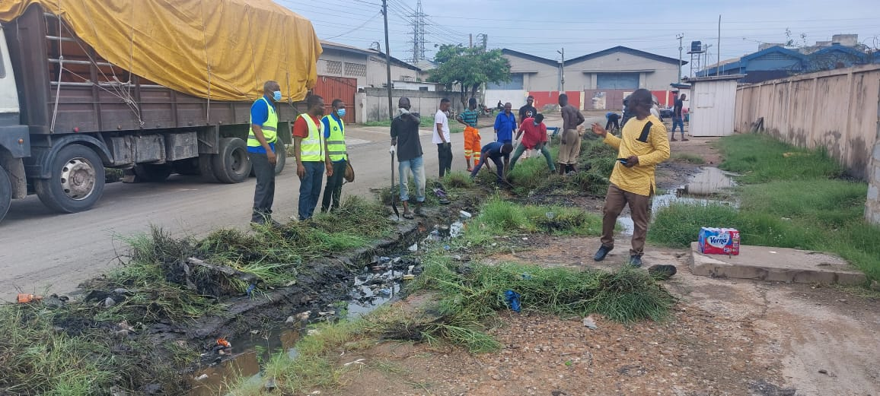

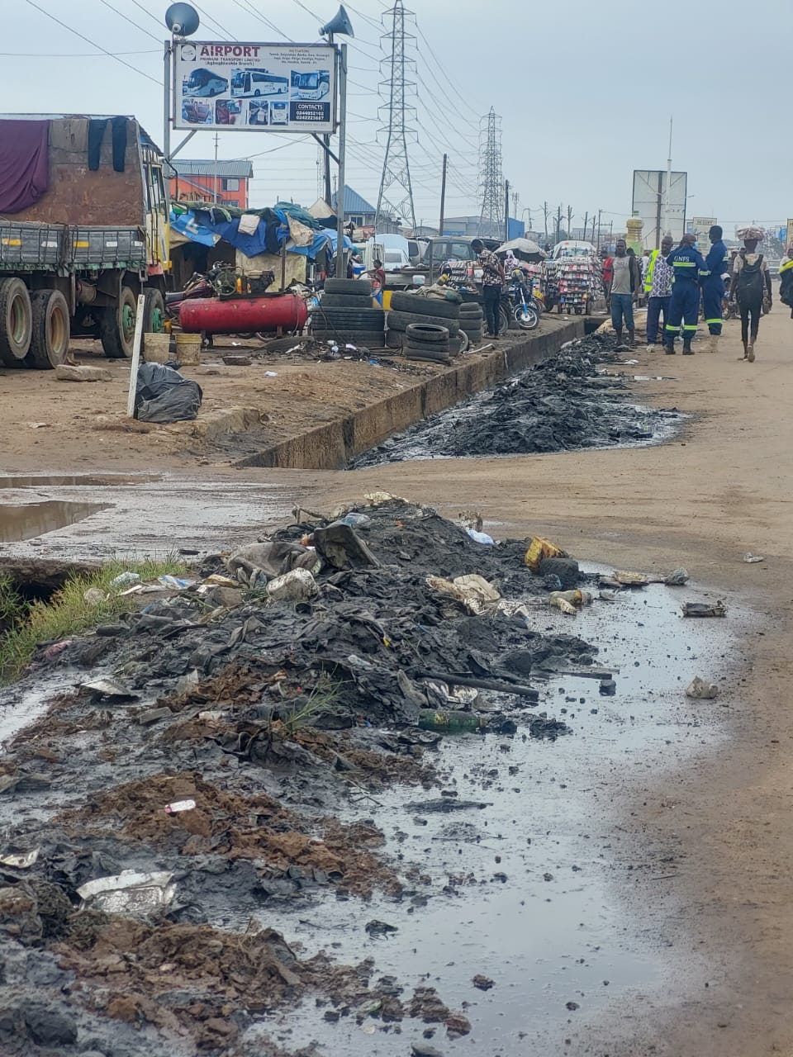

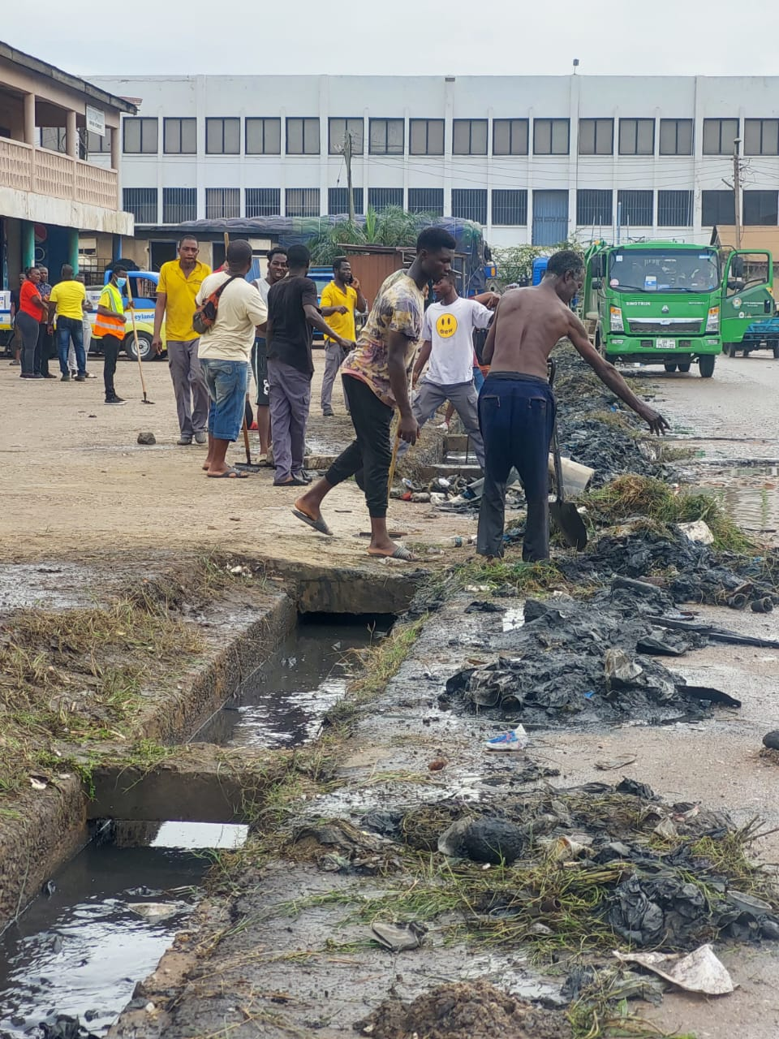

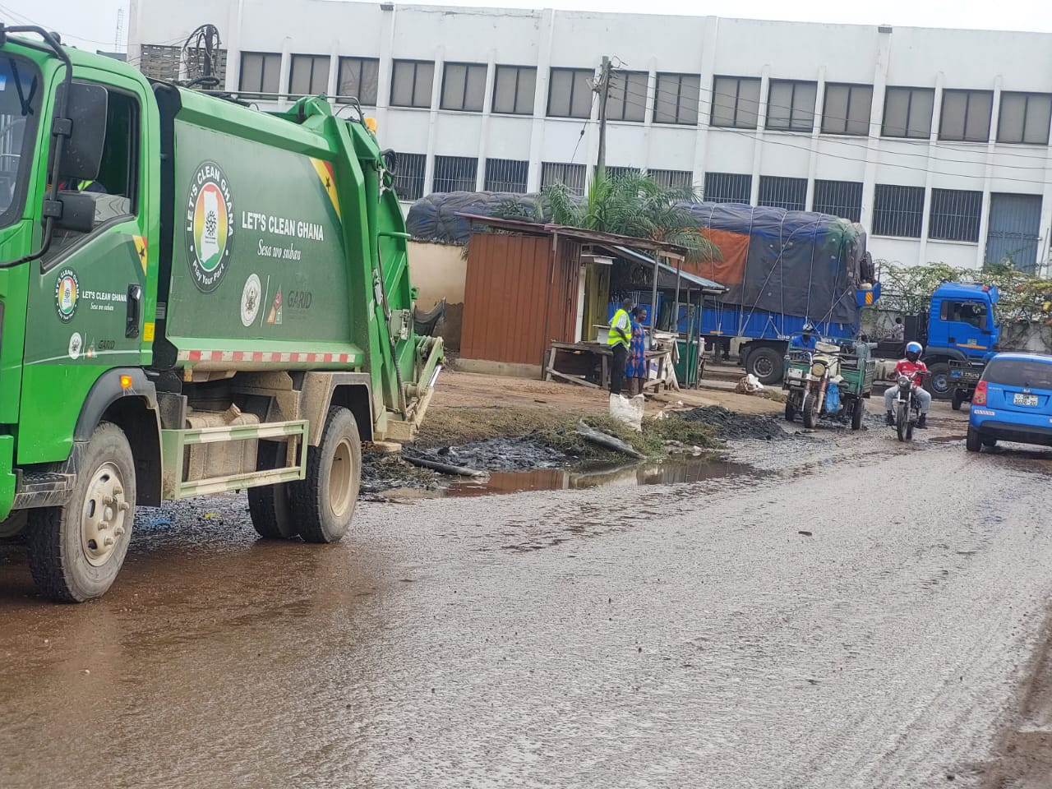

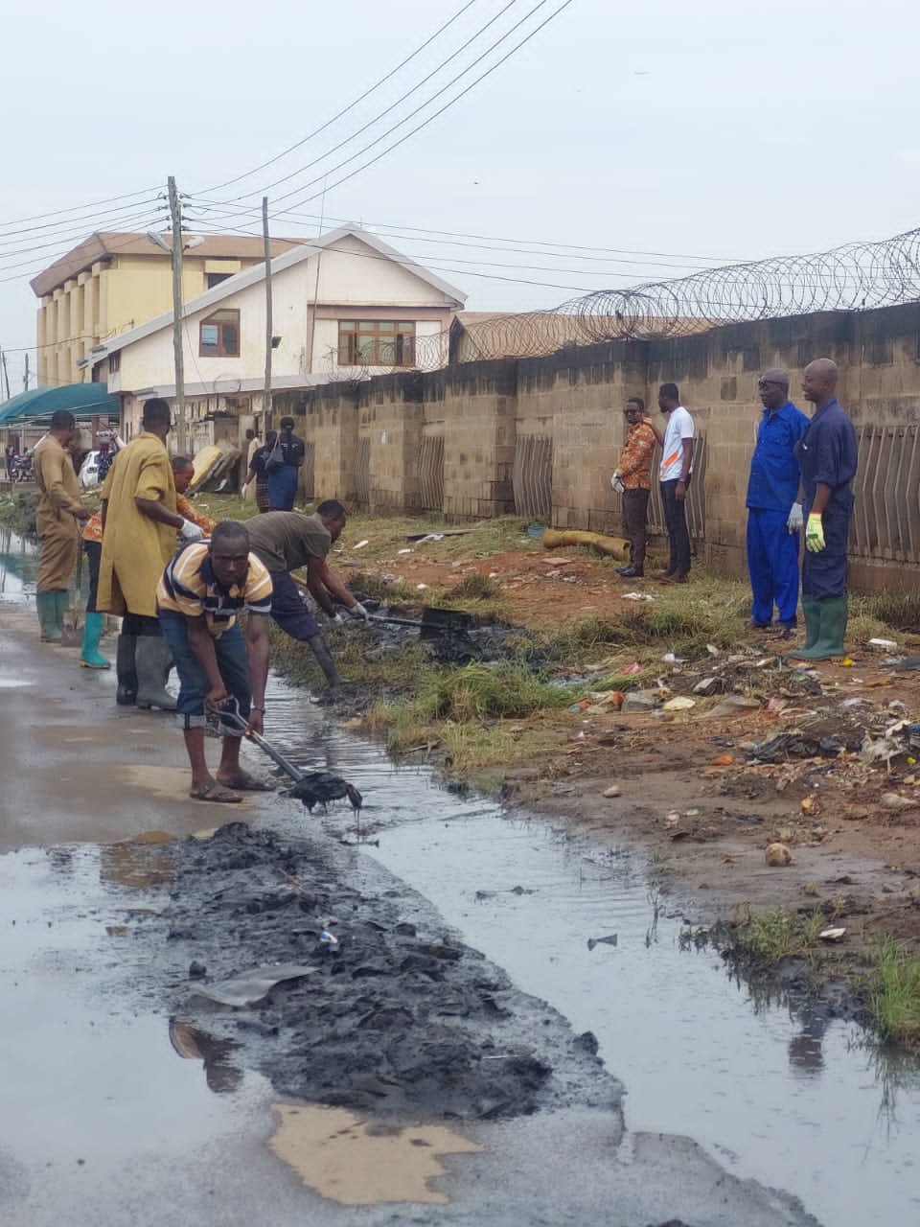

Compiled by

BRIDGET SEYRAM DIAPIM