

**PROJECT ASSIGNMENT/LAB**

**User Requirement Document (URD)**

– Hanoi, Sep 2024 –

**Table of Contents**

I. Record of Changes 3

II. Software Requirement Specification 4

1. Overall Requirements 4

1.1 Context Diagram 4

1.2 User Requirements 4

1.3 Data Flow Diagram 6

1.4 Business Workflows 6

1.6 State Transition Diagrams 7

1.7 System Screen Flow 7

2. Use Case Specifications 8

2.1 <<Feature Name1>> 8

2.2 Common Feature 9

2.3 Xyz Feature 9

3. Requirement Appendix 10

3.1 Business Rules 10

3.2 System Messages 10

3.3 Other Requirements… 11

# I. Record of Changes

|  |  |  |  |
| --- | --- | --- | --- |
| **Date** | **A* M, D** | **In charge** | **Change Description** |
|  |  |  |  |
|  |  |  |  |
|  |  |  |  |
|  |  |  |  |
|  |  |  |  |
|  |  |  |  |
|  |  |  |  |
|  |  |  |  |
|  |  |  |  |
|  |  |  |  |
|  |  |  |  |
|  |  |  |  |
|  |  |  |  |

*A - Added M - Modified D - Deleted

# II. Software Requirement Specification

## 1. Overall Requirements

### 1.1 Context Diagram

*[Gives the overall description about the product with some introduction and the context diagram. The context diagram presents the boundary and connections between the system you’re developing and everything else in the universe. This identifies external entities (or terminators – software, hardware, human components, and other systems) outside the system that interface to it in some way, as well as data, control, and material flows between the terminators and the system.]*

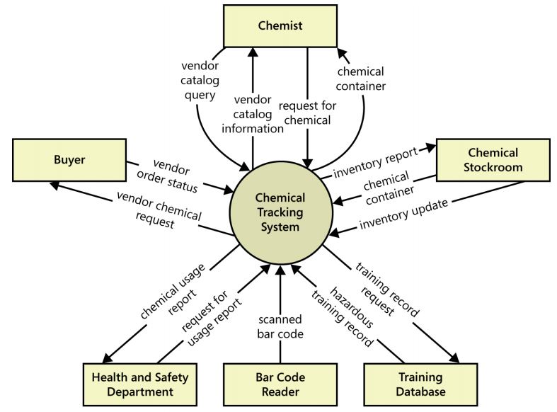

### 1.2 User Requirements

#### 1.2.1 Actors

*[An actor is someone/something that interacts with the system.*

* *The only external entities that interact with the system*
* *﻿Actors are outside the system and not part of it*
* *﻿A user is an individual, whereas an actor represents the role played by all users of the same type*
* *There are other types of actors in addition to or in place of human actors: external systems, I/O devices, or timers*

*Following are some questions you might ask to help user representatives identify actors*

* *Who (or what) is notified when something occurs within the system?*
* *Who (or what) provides information or services to the system?*
* *Who (or what) helps the system respond to and complete a task?*

*This part gives the description of system actors, you can follow the table form as below]*

|  |  |  |
| --- | --- | --- |
| **#** | **Actor** | **Description** |
| 1 | Administrator | Actor description here.. |
| 2 | Menu Manager | .. |
| 3 | … |  |

#### 1.2.2 Diagrams

*[A use case (UC) describes a sequence of interactions between a system and an external actor that results in the actor being able to achieve some outcome of value. The names of use cases are always written in the form of a verb followed by an object. Select strong, descriptive names to make it evident from the name that the use case will deliver something valuable for some user.*

*Following are some questions you might ask to help user representatives identify use cases*

* *What will the actor use the system for?*
* *Will the actor create, store, change, remove, or read data in the system?*
* *Will the actor need to inform the system about external events or changes?*
* *Will the actor need to be informed about certain occurrences in the system?*

*In this section, you need to provide the UC diagram(s) to show the actor-UCs and UC-UC relationships like the sample below. You can have multiple UC diagrams for the system, each diagram is for one human actor or one workflow]*

##### 1.2.2.1 UCs for Guest

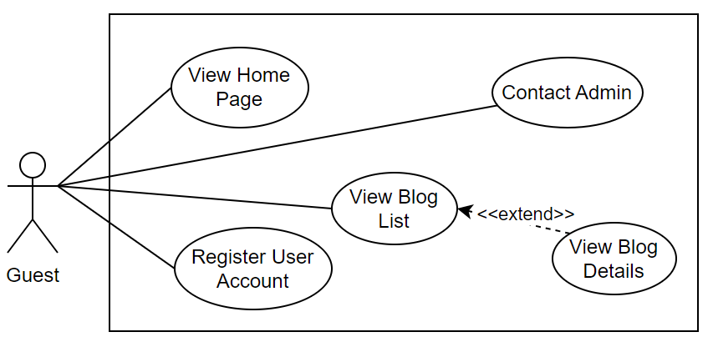

##### 1.2.2.2 UCs for Student

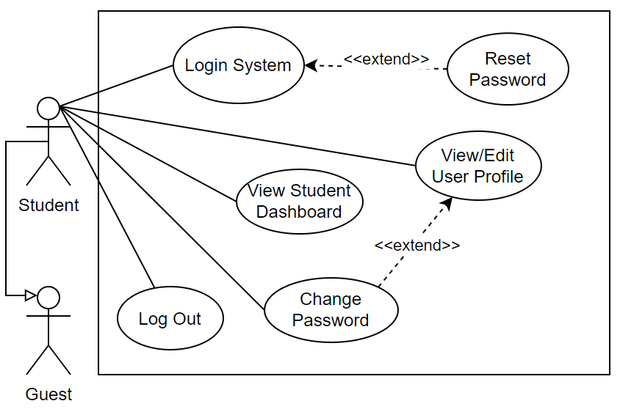

##### 1.2.2.3 …

#### 1.2.3 Descriptions

*[This part describes the use cases, you can follow the table form as below]*

|  |  |  |  |
| --- | --- | --- | --- |
| **ID** | **Use Case** | **Actors** | **Use Case Description** |
| 01 | View Menu | Patron |  |
| 02 | Order a Meal | Patron |  |
| 03 | … |  |  |

### 1.3 Data Flow Diagram

*[Provide system-related data flow diagram like the sample below]*

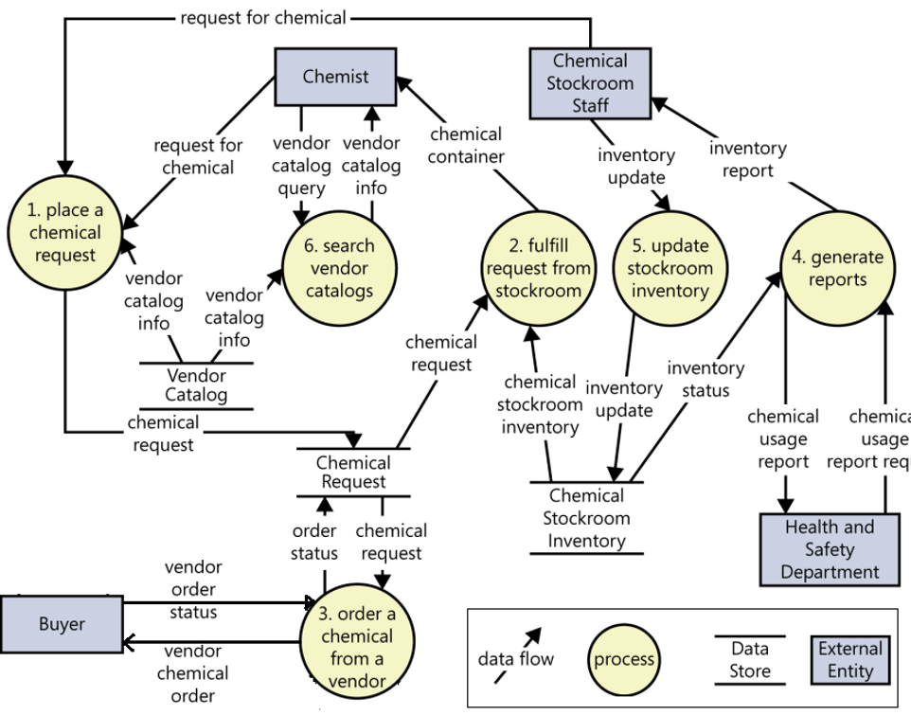

### 1.4 Business Workflows

*[Provide workflows (business processes) for the processes mentioned in the data flow diagram above using the swim-lane diagrams like the sample below]*

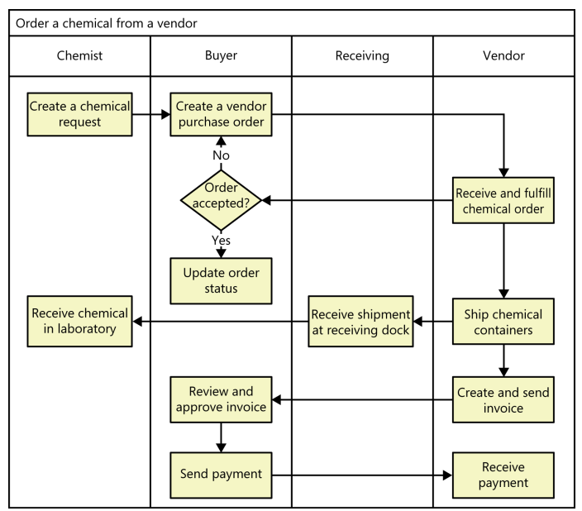

**1.5 Entity Relationship Diagram**

*[Provide the entity relationship diagram and the entity descriptions in the table format as below]*

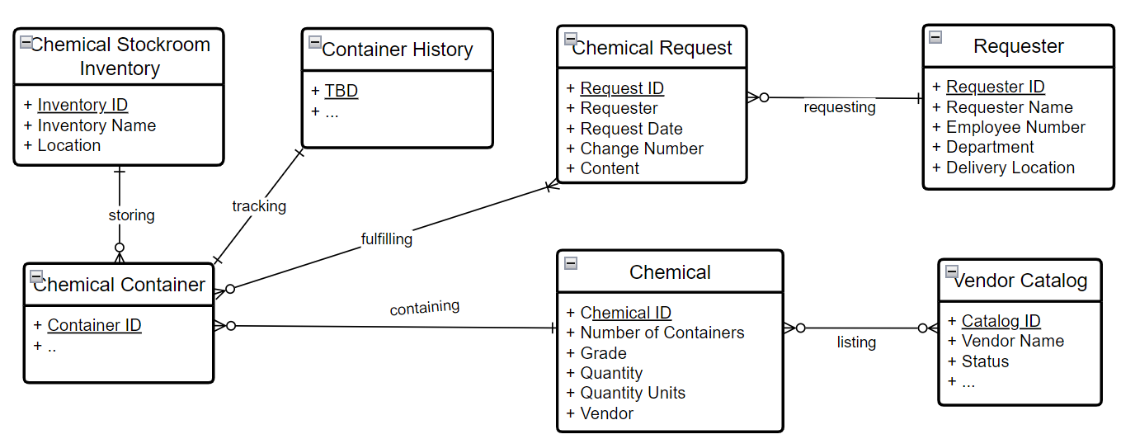

**Entities Description**

|  |  |  |
| --- | --- | --- |
| **#** | **Entity** | **Description** |
| 1 | Chemical | <<Entity Description>> |
| 2 | … |  |

### 1.6 State Transition Diagrams

*[Provide state transition diagrams for the system’s business objects like below diagram for a chemical request in the Chemical Tracking System]*

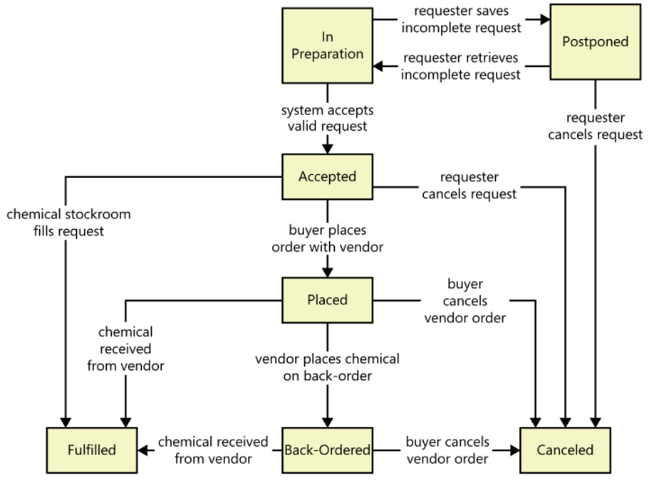

### 1.7 System Screen Flow

*[This part shows the system screens and the relationship among screens. You can draw different Screen Flows, each flow is for one feature, like below provided screen flow for the Common Pages feature]*

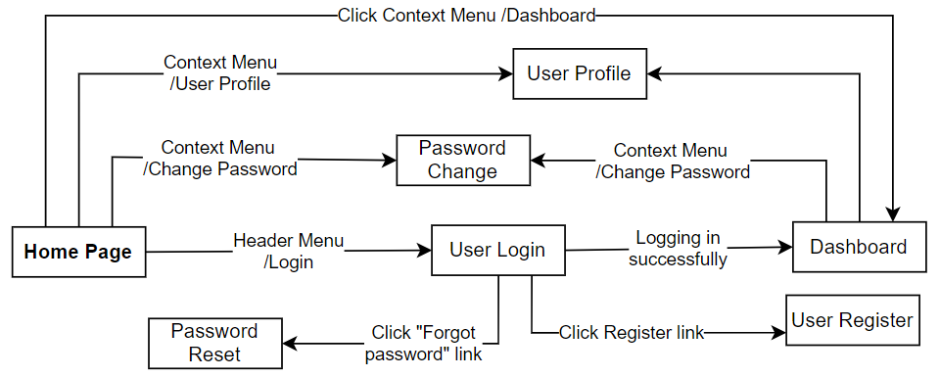

**Screen Descriptions**

|  |  |  |  |
| --- | --- | --- | --- |
| **#** | **Feature** | **Screen** | **Description** |
| 1 | <<Feature Name>> | <<Screen Name1>> | <<Function Name1 Description>> |
| 2 | … |  |  |

## 2. Use Case Specifications

*[Provide specifications for the use cases (UCs) those are covered in the system. The UCs are grouped by the system features and even sub features.* ***You just need to provide UC specifications for UCs involving in the main workflows (business processes) or the complex ones****. Other UCs (i.e CRUD or data-viewing UCs) are simple, and you just need to refer the descriptions in the Functional Requirement (part 3) below)]*

### 2.1 <<Feature Name1>>

#### 2.1.1 UC Name1

|  |  |  |  |
| --- | --- | --- | --- |
| Primary Actors |  | Secondary Actors |  |
| Description |  | | |
| Preconditions |  | | |
| Postconditions |  | | |
| Normal Sequence/Flow |  | | |
| Alternative Sequences/Flows |  | | |

***Primary and Secondary Actors***

An actor is a person or other entity external to the software system being specified who interacts with the system and performs use cases to accomplish tasks. Name the primary actor that will be initiating this UC and any other secondary actors who will participate in completing execution of the UC.

***Description***

Provide a brief description of the reason for and outcome of this use case, or a high-level description of the sequence of actions and the outcome of executing the use case. The description can be in the form of a user story (As a **<type of user>**, I want **<some goal>** so that **<some reasons>**)

***Preconditions***

List any activities that must take place, or any conditions that must be true, before the use case can be started.

***Postconditions***

Describe the state of the system at the successful conclusion of the use case execution.

***Normal Flow***

Provide a description of the user actions and corresponding system responses that will take place during execution of the use case under normal, expected conditions.

***Alternative Flows***

Describe below two information if any:

* Other successful usage scenarios that can take place within this use case. State the alternative flow, and describe any differences in the sequence of steps that take place.
* Any anticipated error conditions that could occur during execution of the use case and how the system is to respond to those conditions.

#### 2.1.2 UC Name2

…

### 2.2 Common Feature

#### 2.2.1 Login System

|  |  |  |  |
| --- | --- | --- | --- |
| Primary Actors | Customer | Secondary Actors | None |
| Description | As a user, I want to be able to log into the system so that I can use the system’s authenticated features and access my personalized account. | | |
| Preconditions | User account has been created & authorized | | |
| Postconditions | * User logs in the system successfully * The system tracked successful login into the Activity Log | | |
| Normal Sequence/Flow | ***Login System***   1. User clicks Login button from the page header or accesses an authenticated feature (from a link or type the page URL directly into the address bar) 2. System show the User Login screen 3. User types in the login details (email, password) 4. User clicks the Login button 5. System validates the login details (BR-01, BR-02) 6. System allows user to access 7. System tracks user’s success login to the Activity Log 8. System directs user to the Home Page (or the previous calling page if any) | | |
| Alternative Sequences/Flows | ***Step 2.1_Google Login***   1. User clicks Google Login button to login system using Google account 2. System redirects the user to the Google’s Login screen 3. User types in the Google account details and chooses to login 4. Google validates user’s login information successfully and redirect him/her back to the system 5. Return to step 5 of normal flow.   ***Step 4_System can’t authenticate the user***  User can’t be authenticated & get relevant error message in one of below cases   1. He/she leaves the Email and/or Password field blank (MSG10) 2. Input Email or Password are incorrect (MSG09) 3. Input Email/Password are correct but email has not been verified (MSG11) 4. The user account is blocked / inactive (MSG12)   If user inputs wrong logging-in details 5 times continuously, system will lock his/her account in 30 minutes (with relevant warning message - MSG13) | | |

#### 2.2.2 …

### 2.3 Xyz Feature

…

## 3. Requirement Appendix

*[Provide business rules, common requirements, or other extra requirements information here]*

### 3.1 Business Rules

*[Provide common business rules that you must follow. The information can be provided in the table format as the sample below]*

|  |  |
| --- | --- |
| **ID** | **Rule Definition** |
| BR-01 | Delivery time windows are 15 minutes, beginning on each quarter hour. |
| BR-02 | Deliveries must be completed between 10:00 A.M. and 2:00 P.M. local time, inclusive. |
| BR-03 | All meals in a single order must be delivered to the same location. |
| BR-04 | All meals in a single order must be paid for by using the same payment method. |
| BR-11 | If an order is to be delivered, the patron must pay by payroll deduction. |
| BR-12 | Order price is calculated as the sum of each food item price times the quantity of that food item ordered, plus applicable sales tax, plus a delivery charge if a meal is delivered outside the free delivery zone. |
| BR-24 | Only cafeteria employees who are designated as Menu Managers by the Cafeteria Manager can create, modify, or delete cafeteria menus. |
| BR-33 | Network transmissions that involve financial information or personally identifiable information require 256-bit encryption. |
| BR-86 | Only regular employees can register for payroll deduction for any company purchase. |
| BR-88 | An employee can register for payroll deduction payment of cafeteria meals if no more than 40 percent of his gross pay is currently being deducted for other reasons. |

### 3.2 System Messages

|  |  |  |  |  |
| --- | --- | --- | --- | --- |
| **#** | **Message code** | **Message Type** | **Context** | **Content** |
| 1 | MSG01 | In line | There is not any search result | *No search results.* |
| 2 | MSG02 | In red, under the text box | Input-required fields are empty | *The * field is required.* |
| 3 | MSG03 | Toast message | Updating asset(s) information successfully | *Update asset(s) successfully.* |
| 4 | MSG04 | Toast message | Adding new asset successfully | *Add asset successfully.* |
| 5 | MSG05 | Toast message | Confirming email of asset hand-over is sent successfully | *A confirmation email has been sent to {email_address}.* |
| 6 | MSG06 | Toast message | Resetting asset information successfully | *Return asset(s) successfully.* |
| 7 | MSG07 | Toast message | Deleting asset information successfully | *Delete asset(s) successfully.* |
| 8 | MSG08 | In red, under the text box | Input value length > max length | *Exceed max length of {max_length}.* |
| 9 | MSG09 | In line | Username or password is not correct when clicking sign-in | *Incorrrect user name or password. Please check again.* |
| 10 | .. |  |  |  |

### 3.3 Other Requirements…