

**PROJECT ASSIGNMENT/LAB**

**Software Requirement Specification (SRS)**

– Hanoi, Sep 2024 –

**Table of Contents**

I. Record of Changes 3

II. Overall Requirements 4

1. Business Workflows 4

2. System Functionalities 4

2.1 Screens Flow 4

2.2 Screen Descriptions 5

2.3 Screen Authorization 5

3. Functional Decompositions 5

II. Functional Requirements 6

1. Feature Name1 6

1.1 SubFeature Name1.1 6

1.2 SubFeature Name1.2 6

2. User Authentication 6

2.1 User Register 6

2.2 User Login 7

2.3 Password Reset 7

2.4 User Profile 7

3. System Administration 7

3.1 Master Data 7

3.2 User Management 8

# I. Record of Changes

|  |  |  |  |
| --- | --- | --- | --- |
| **Date** | **A* M, D** | **In charge** | **Change Description** |
|  |  |  |  |
|  |  |  |  |
|  |  |  |  |
|  |  |  |  |
|  |  |  |  |
|  |  |  |  |
|  |  |  |  |
|  |  |  |  |
|  |  |  |  |
|  |  |  |  |
|  |  |  |  |
|  |  |  |  |
|  |  |  |  |

*A - Added M - Modified D - Deleted

# II. Overall Requirements

## 1. Business Workflows

*[Provide workflows (business processes) for the processes mentioned in the data flow diagram above using the swim-lane diagrams like the sample below]*

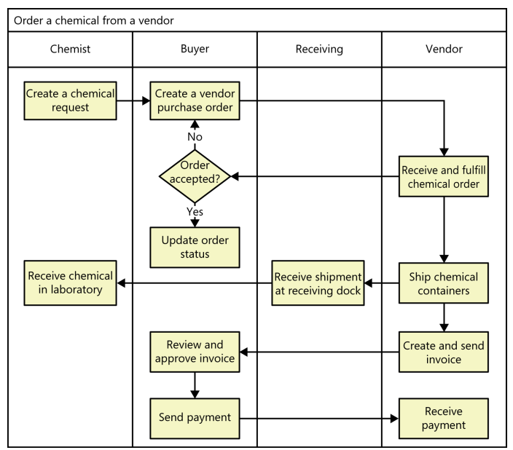

## 2. System Functionalities

*[Provide functionality overview of software system: screen flow, screen descriptions, system user roles, screen authorization, non-screen functions, ERD]*

### 2.1 Screens Flow

*[This part shows the system screens and the relationship among screens. You can draw the Screens Flow for the system in the form of diagram as below.]*

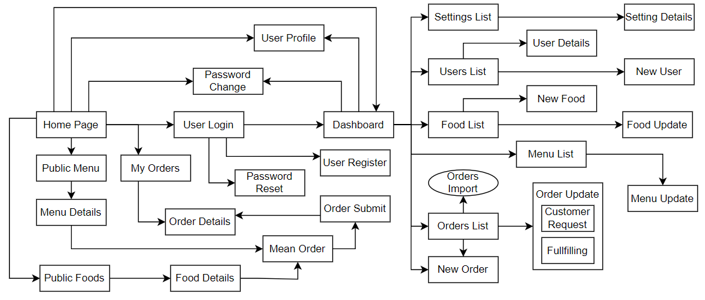

### 2.2 Screen Descriptions

|  |  |  |  |
| --- | --- | --- | --- |
| **#** | **Feature** | **Screen/Function** | **Description** |
| 1 | <<Feature Name>> | <<Screen Name1>> | <<Function Name1 Description>> |
| 2 | … |  |  |

### 2.3 Screen Authorization

*[Provide the system roles authorization to the system features (down to screens, and event to the screen activities if applicable) in the table form as below – replace Role-Name1, Role-Name2,… with your specific system user role names]*

|  |  |  |  |  |
| --- | --- | --- | --- | --- |
| **Screen** | **Role-Name1** | **Role-Name2** | **Role-Name3** | **…** |
| <<Screen Name1>> | X |  | X | X |
| <<Screen Activity>> |  |  | X | X |
| <<Screen Name2>> | X |  | X |  |
| Query All Data | X |  |  |  |
| Query Own Data |  |  | X |  |
| Add New Data |  |  | X | X |
| Update All Data |  |  |  | X |
| Update Own Data |  |  |  | X |
| Delete Data |  |  |  |  |
| … |  |  |  |  |

## 3. Functional Decompositions

*[This part shows the functional decomposition diagram (DFD) of the system where you split they system into features, sub features, etc. and screens/functions (like the sample below)]*

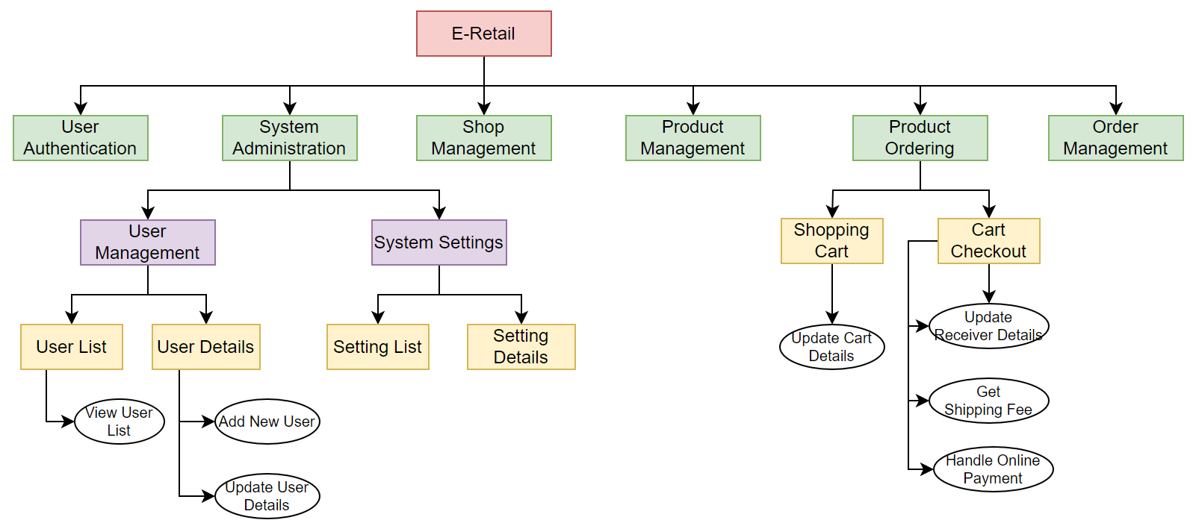

# III. Functional Requirements

*[Provide descriptions about the system’s functions/screens. The functions/screens are grouped by the system features, and even sub-features if needed. For the screens, you need to provide the screen layouts (mock-up screens) and relevant specifications if needed]*

*[Provide descriptions about the system’s functions/screens. The functions/screens are grouped by the system features, and even sub-features if needed. For the screens, you need to provide the screen layouts (mock-up screens) and relevant specifications if needed]*

## 1. Feature Name1

### 1.1 SubFeature Name1.1

#### 1.1.1 Screen Name1

*[Content #1: UI layout (Mockup screen prototype)]*

*[Content #2: brief descriptions of the screen/function, mapped to the relevant sub use cases]*

*[Content #3: provide further descriptions for the screen’s components/fields using table format below]*

|  |  |
| --- | --- |
| **Field Name** | **Description** |
| Field Name1 | Field description: data type min/max length or value, initial data, etc. |
| Field Name2 | … |
| ***Field Group-Name1*** | |
| Field Name3 | … |
| Field Name4 | … |
| ***Field Group-Name2*** | |
| … | … |

#### 1.1.2 Screen Name2

…

### 1.2 SubFeature Name1.2

…

## 2. User Authentication

### 2.1 User Register

…

### 2.2 User Login

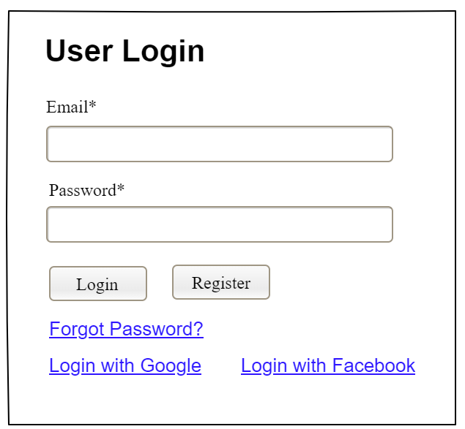

This screen allows system member to:

* Login System: provide email and password to be authenticated to access the system.

### 2.3 Password Reset

..

### 2.4 User Profile

…

***2.5 Password Change***

…

## 3. System Administration

### 3.1 Master Data

#### 3.1.1 Setting List

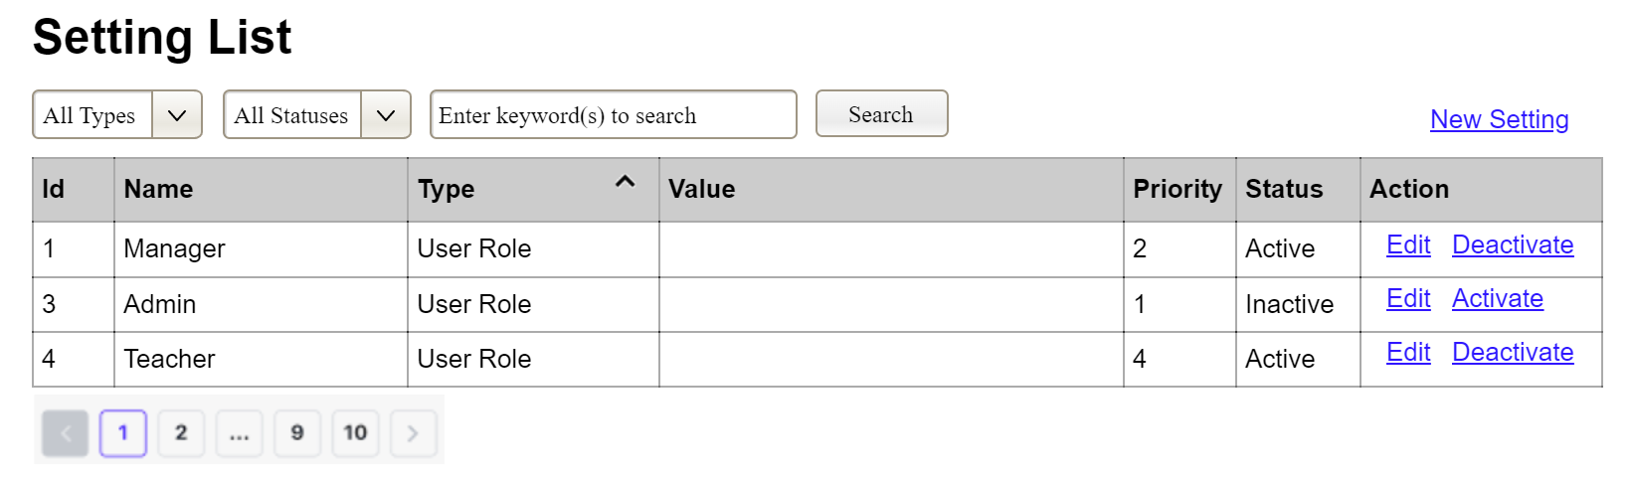

(3)

(2)

(1)

This screen allows the Administrator to:

* View Setting List: view list of current master data.
* Filter Setting List: filter master data by data types, statuses
* Search Settings: enter keyword(s) to search master data by their names or values
* Sort Setting List: sort mater data list (ascending, descending) by clicking column headers

On the screen, s/he can also

* Activate/Deactivate Setting: change status of a specific inactive/active master data
* Choose to go to the Setting Details screens for adding new or updating an existing master data by clicking the New Setting or Edit link.

**Field Description**

|  |  |
| --- | --- |
| **Field Name** | **Description** |
| (1) | Initial values: all the active setting names with null or blank type  Hover the mouse to show the field name: “Setting Type” |
| (2) | Initial values: All Statuses, Active, Inactive (default value “All Status”)  Hover the mouse to show the field name: “Setting Status” |
| (3) | The change-status action is Activate or Deactivate depending on the current status of the relevant setting (Inactive or Active, respectively). |

#### 3.1.2 Setting Details

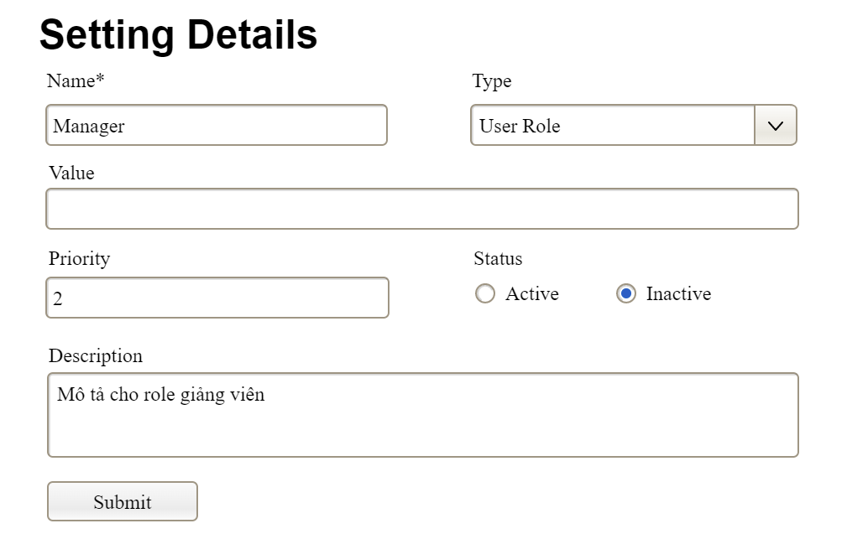

This screen allows the Administrator to:

* Add New Setting: add new master data.
* Update Setting Details: update details of a specific master data

**Field Description**

|  |  |
| --- | --- |
| **Field Name** | **Description** |
| Name | Data type: non-digit string, max length of 20 characters |
| Type | Initial data values: all active setting names (with null or blank type) |
| Value | Data type: any string, max length of 100 characters |
| Priority | Data type: a positive integer |
| Description | Data type: any string, max length of 200 characters |

### 3.2 User Management

#### 3.2.1 User List

…

#### 3.2.2 User Details

…