**EXPERIMENT NO : 10**

Create Table Bank(Bankid Number(5) Primary Key , Bankname Varchar(30),Headoffice Varchar(20),Branch Varchar(20) , Branchcode Number(5));



Insert Into Bank Values(1,'Canara Bank','Delhi','Manarcadu',10);

Insert Into Bank Values(2,'Axis Bank','Mumbai','Ayarkunam',25);

Insert Into Bank Values(3,'State Bank Of India','Kolkata','Kottayam',50);

select * from Bank;

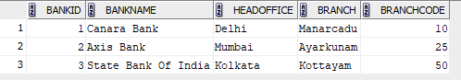

commit;



Savepoint A;



Delete From Bank Where Bankid=2;



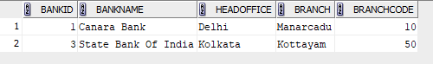

Rollback To Savepoint A;



select * from Bank;

