**EXPERIMENT NO: 12**

1) Create Table Bank_60(Bankcode Varchar(3) Primary Key , Bankname Varchar(50) Not Null , Headoffice Varchar(50), Branches Int Check (Branches > 0));

Insert Into Bank_60 Values('CBK','Canara Bank','Mumbai',5);

Insert Into Bank_60 Values('SBI','State Bank Of India','Delhi',10);

Insert Into Bank_60 Values('HDF','HDFC Bank','Kolkata',6);

Insert Into Bank_60 Values('ICI','ICICI Bank','Chennai',18);

Insert Into Bank_60 Values('AXI','Axis Bank','Bangalore',22);

Select * From Bank_60;

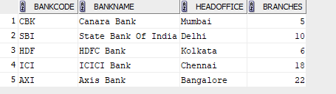

2) Create Table Branch_60(Branchid Int Primary Key , Branchname Varchar(25) Default 'New Delhi', Bankid Varchar(3) ,Foreign Key (Bankid) References Bank_60 (Bankcode) On Delete Cascade);

Insert Into Branch_60 Values(1,'Manarcadu','CBK');

Insert Into Branch_60 Values(2,'Ayarkunam','HDF');

Insert Into Branch_60 Values(3,'Kottayam','SBI');

Insert Into Branch_60 Values(4,'Oravackal','AXI');

Insert Into Branch_60 Values(5,'Kidangoor','ICI');

Insert Into Branch_60 Values(6,Default,'SBI');

Select * From Branch_60;

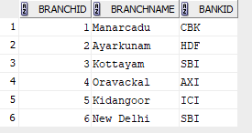

3) Delete From Bank_60 Where Bankcode='SBI';

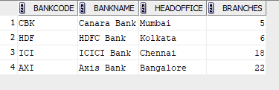

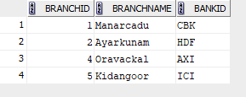

4) Alter Table Branch_60 Drop Primary Key;

desc Bank_60;

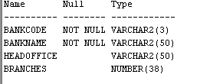

5) Create View Bank_Head_Office As Select * From Bank_60 Where Headoffice = 'Mumbai';

select * from bank_head_office;



6) Create View Bank_Branch As Select * From Branch_60 Where Branchname='Manarcadu';

select * from Bank_Branch;

