**EXPERIMENT NO:13**

1) PL/SQL Program to find Factorials of a Number

SQL> set serveroutput on;

SQL> declare

2 f number:= 1;

3 n number:=&n;

4 begin

5 while n>0

6 loop

7 f:=n*f;

8 n:=n-1;

9 end loop;

10 dbms_output.put_line('factorial is '||f);

11 end;

12 /

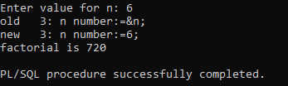

2) PL/SQL Program to find Greatest of 3 Numbers

1 DECLARE

2 num1 NUMBER:=&num1;

3 num2 NUMBER:=&num2;

4 num3 NUMBER:=&num3;

5 greatest NUMBER;

6 BEGIN

7 greatest := num1;

8 IF num2 > greatest THEN

9 greatest := num2;

10 END IF;

11 IF num3 > greatest THEN

12 greatest := num3;

13 END IF;

14 DBMS_OUTPUT.PUT_LINE('The greatest number is: ' || greatest);

15* END;

16 /

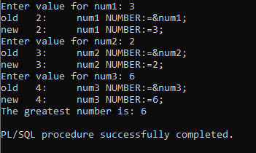

3) PL/SQL Program to Implement a Calculator

1 DECLARE

2 num1 NUMBER := 0;

3 num2 NUMBER := 0;

4 OPERATOR CHAR(1);

5 result NUMBER;

6 BEGIN

7 DBMS_OUTPUT.PUT_LINE('Simple Calculator');

8 DBMS_OUTPUT.PUT_LINE('-----------------');

9 num1 := &num1;

10 OPERATOR := '&operator';

11 num2 := &num2;

12 CASE OPERATOR

13 WHEN '+' THEN

14 result := num1 + num2;

15 WHEN '-' THEN

16 result := num1 - num2;

17 WHEN '*' THEN

18 result := num1 * num2;

19 WHEN '/' THEN

20 IF num2 = 0 THEN

21 DBMS_OUTPUT.PUT_LINE('Error: Division by zero is not allowed.');

22 ELSE

23 result := num1 / num2;

24 END IF;

25 ELSE

26 DBMS_OUTPUT.PUT_LINE('Error: Invalid operator');

27 END CASE;

28 IF OPERATOR IN ('+', '-', '*', '/') THEN

29 DBMS_OUTPUT.PUT_LINE('Result: ' || num1 || ' ' || operator || ' ' || num2 || ' = ' || result);

30 END IF;

31* END;

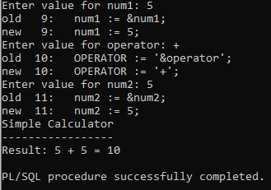

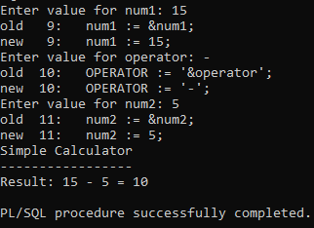

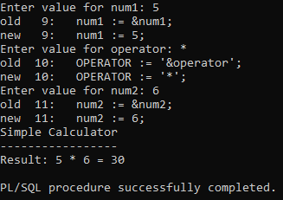

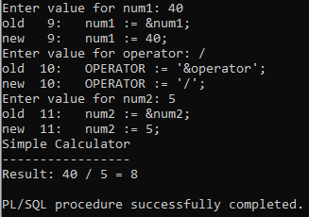

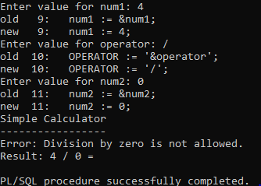

4) PL/SQL Program to generate Fibonacci Series

1 DECLARE

2 FIRST NUMBER:=0;

3 SECOND NUMBER:=1;

4 third NUMBER;

5 n NUMBER:=&n;

6 i NUMBER;

7 BEGIN

8 dbms_output.put_line('Fibonacci series is:');

9 dbms_output.put_line(FIRST);

10 dbms_output.put_line(SECOND);

11 FOR i IN 3..n

12 loop

13 third:=FIRST+SECOND;

14 FIRST:=SECOND;

15 SECOND:=third;

16 dbms_output.put_line(third);

17 END loop;

18* END;

19 /

