**EXPERIMENT : 8**

CREATE TABLE Customer_60 ( CustomerID INT PRIMARY KEY, CustomerName VARCHAR(255), ContactNumber VARCHAR(255), Address VARCHAR(255), City VARCHAR(255), PostalCode VARCHAR(20), Country VARCHAR(255) );

table Customer_60 created.

CREATE TABLE Employees_60 ( EmployeeID INT PRIMARY KEY, LastName VARCHAR(255), FirstName VARCHAR(255), BirthDate DATE, Photo BLOB );

table Employees_60 created.

CREATE TABLE Orders_60 ( OrderID INT PRIMARY KEY, CustomerID INT, EmployeeID INT, OrderDate DATE, ShipperID INT, FOREIGN KEY (CustomerID) REFERENCES Customer_60 (CustomerID), FOREIGN KEY (EmployeeID) REFERENCES Employees_60 (EmployeeID) );

table Orders_60 created.

INSERT INTO Customer_60 (CustomerID, CustomerName, ContactName, Address, City, PostalCode, Country)

VALUES

(1, 'John Doe', 'John', '123 Elm St', 'Springfield', '62701', 'USA');

INSERT INTO Customer_60 (CustomerID, CustomerName, ContactName, Address, City, PostalCode, Country)

VALUES

(2, 'Jane Smith', 'Jane', '456 Oak St', 'Riverside', '92501', 'USA');

INSERT INTO Customer_60 (CustomerID, CustomerName, ContactName, Address, City, PostalCode, Country)

VALUES

(3, 'Jim Brown', 'Jim', '789 Pine St', 'Greenwood', '12345', 'USA');

INSERT INTO Customer_60 (CustomerID, CustomerName, ContactName, Address, City, PostalCode, Country)

VALUES

(4, 'Emily Davis', 'Emily', '321 Maple St', 'Lakewood', '54321', 'Canada');

INSERT INTO Customer_60 (CustomerID, CustomerName, ContactName, Address, City, PostalCode, Country)

VALUES

(5, 'Michael Johnson', 'Michael', '654 Cedar St', 'Hilltown', '67890', 'USA');

INSERT INTO Employees_60 (EmployeeID, LastName, FirstName, BirthDate, Photo)

VALUES

(1, 'Taylor', 'Alex', TO_DATE('1985-02-15', 'YYYY-MM-DD'), NULL);

INSERT INTO Employees_60 (EmployeeID, LastName, FirstName, BirthDate, Photo)

VALUES

(2, 'Miller', 'Sarah', TO_DATE('1978-11-23', 'YYYY-MM-DD'), NULL);

INSERT INTO Employees_60 (EmployeeID, LastName, FirstName, BirthDate, Photo)

VALUES

(3, 'Wilson', 'Ethan', TO_DATE('1990-06-09', 'YYYY-MM-DD'), NULL);

INSERT INTO Employees_60 (EmployeeID, LastName, FirstName, BirthDate, Photo)

VALUES

(4, 'Moore', 'Olivia', TO_DATE('1982-05-30', 'YYYY-MM-DD'), NULL);

INSERT INTO Employees_60 (EmployeeID, LastName, FirstName, BirthDate, Photo)

VALUES

(5, 'Anderson', 'James', TO_DATE('1995-07-19', 'YYYY-MM-DD'), NULL);

INSERT INTO Orders_60 (OrderID, CustomerID, EmployeeID, OrderDate, ShipperID)

VALUES

(1, 1, 2, TO_DATE('2024-01-10', 'YYYY-MM-DD'), 1);

INSERT INTO Orders_60 (OrderID, CustomerID, EmployeeID, OrderDate, ShipperID)

VALUES

(2, 2, 3, TO_DATE('2024-02-15', 'YYYY-MM-DD'), 2);

INSERT INTO Orders_60 (OrderID, CustomerID, EmployeeID, OrderDate, ShipperID)

VALUES

(3, 1, 4, TO_DATE('2024-03-20', 'YYYY-MM-DD'), 1);

INSERT INTO Orders_60 (OrderID, CustomerID, EmployeeID, OrderDate, ShipperID)

VALUES

(4, 3, 5, TO_DATE('2024-01-25', 'YYYY-MM-DD'), 3);

INSERT INTO Orders_60 (OrderID, CustomerID, EmployeeID, OrderDate, ShipperID)

VALUES

(5, 4, 1, TO_DATE('2024-04-05', 'YYYY-MM-DD'), 2);

SELECT * FROM Customer_60;

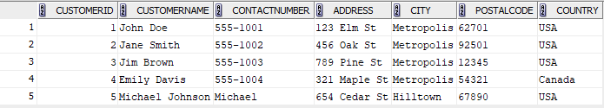

SELECT * FROM Orders_60;

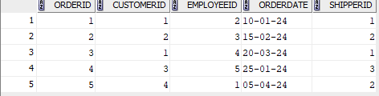

SELECT * FROM Employees_60;

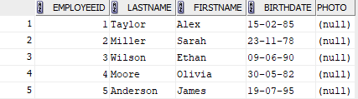

**QUESTIONS**

SELECT CustomerID, CustomerName, ContactName, Address, City, PostalCode, CountryFROM Customer_60 ORDER BY CustomerName ASC;

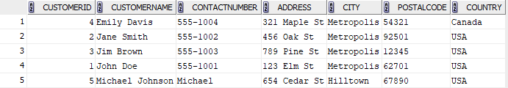

SELECT * FROM Orders_60 ORDER BY OrderDate ASC;

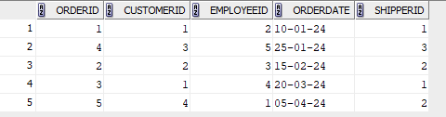

SELECT EmployeeID, LastName, FirstName, BirthDate, Photo FROM Employees_60 WHERE BirthDate > TO_DATE('1980-01-01', 'YYYY-MM-DD') ORDER BY BirthDate DESC;

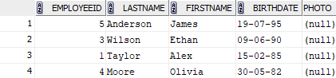

SELECT o.OrderID, o.CustomerID, o.EmployeeID, o.OrderDate, o.ShipperID FROM Orders_60 o JOIN Customer_60 c ON o.CustomerID = c.CustomerID WHERE c.Country = 'USA' ORDER BY o.OrderDate DESC;

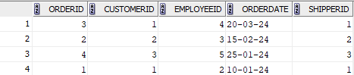

SELECT c.CustomerID, c.CustomerName, COUNT(o.OrderID) AS TotalOrders FROM Customer_60 c LEFT JOIN Orders_60 o ON c.CustomerID = o.CustomerID GROUP BY c.CustomerID, c.CustomerName ORDER BY TotalOrders DESC;

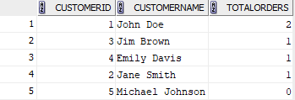

SELECT City, COUNT(CustomerID) AS TotalCustomers FROM Customer_60 GROUP BY City ORDER BY TotalCustomers DESC;

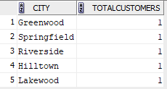

SELECT c.CustomerID, c.CustomerName, COUNT(o.OrderID) AS TotalOrders FROM Customer_60 c JOIN Orders_60 o ON c.CustomerID = o.CustomerID GROUP BY c.CustomerID, c.CustomerName HAVING COUNT(o.OrderID) >= 2 ORDER BY c.CustomerName ASC;



SELECT City, COUNT(CustomerID) AS TotalCustomers FROM Customer_60 GROUP BY City HAVING COUNT(CustomerID) > 3 ORDER BY TotalCustomers DESC;

