ToDoList

Module Java Mobile

Proposé par :

stephane.galibert@epitech.eu



Promotion 2019

ToDoList is an application which allows the user to program his own tasks.

Tasks are defined by :

* A title
* A description
* A due date

The user can add extra informations like :

* The number of reminder and interval
* Task priority
* Illustrations

The application remind the user, with an alarm, when the due date has been exceeded.

More than a simple to do list application, this one allow the user to sort or filter the existing task for a better tasks management.

(1) Here is the main page of the application.

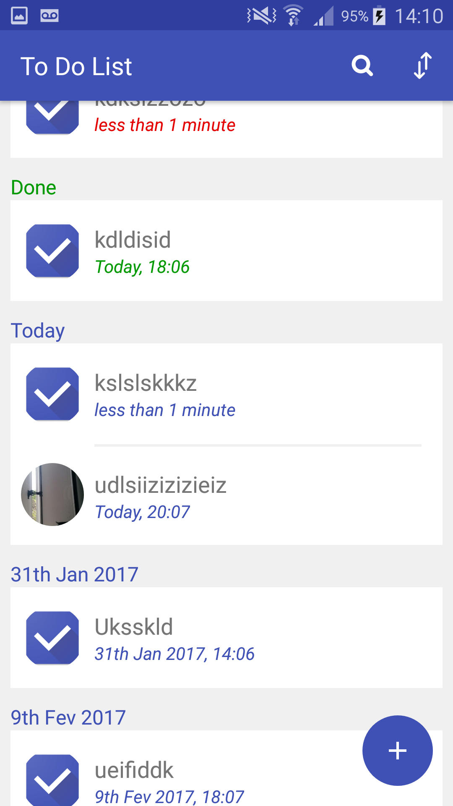

The tasks are categorized in 3 main category :

Overdue, in red,  
Done, in green,  
To do, in blue.

The to do item are itself categorized by the date.



If the user click on the button, you will access to the add task item page. See screen number 2.

If the user click on the button, you will access to the search page. See the screen number 3.

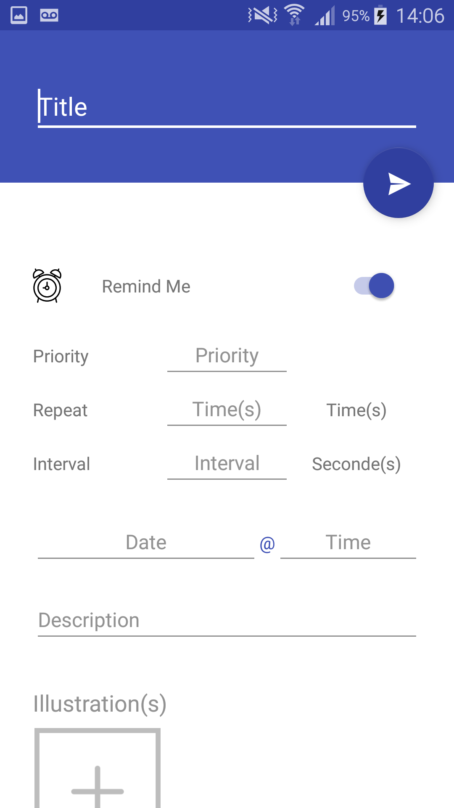

(2) Here is the add item page.

In this page the user must fill the form for adding a new task item with the button .



He can add illustration with a click on the add illustration button.

(3) Here is the search page.

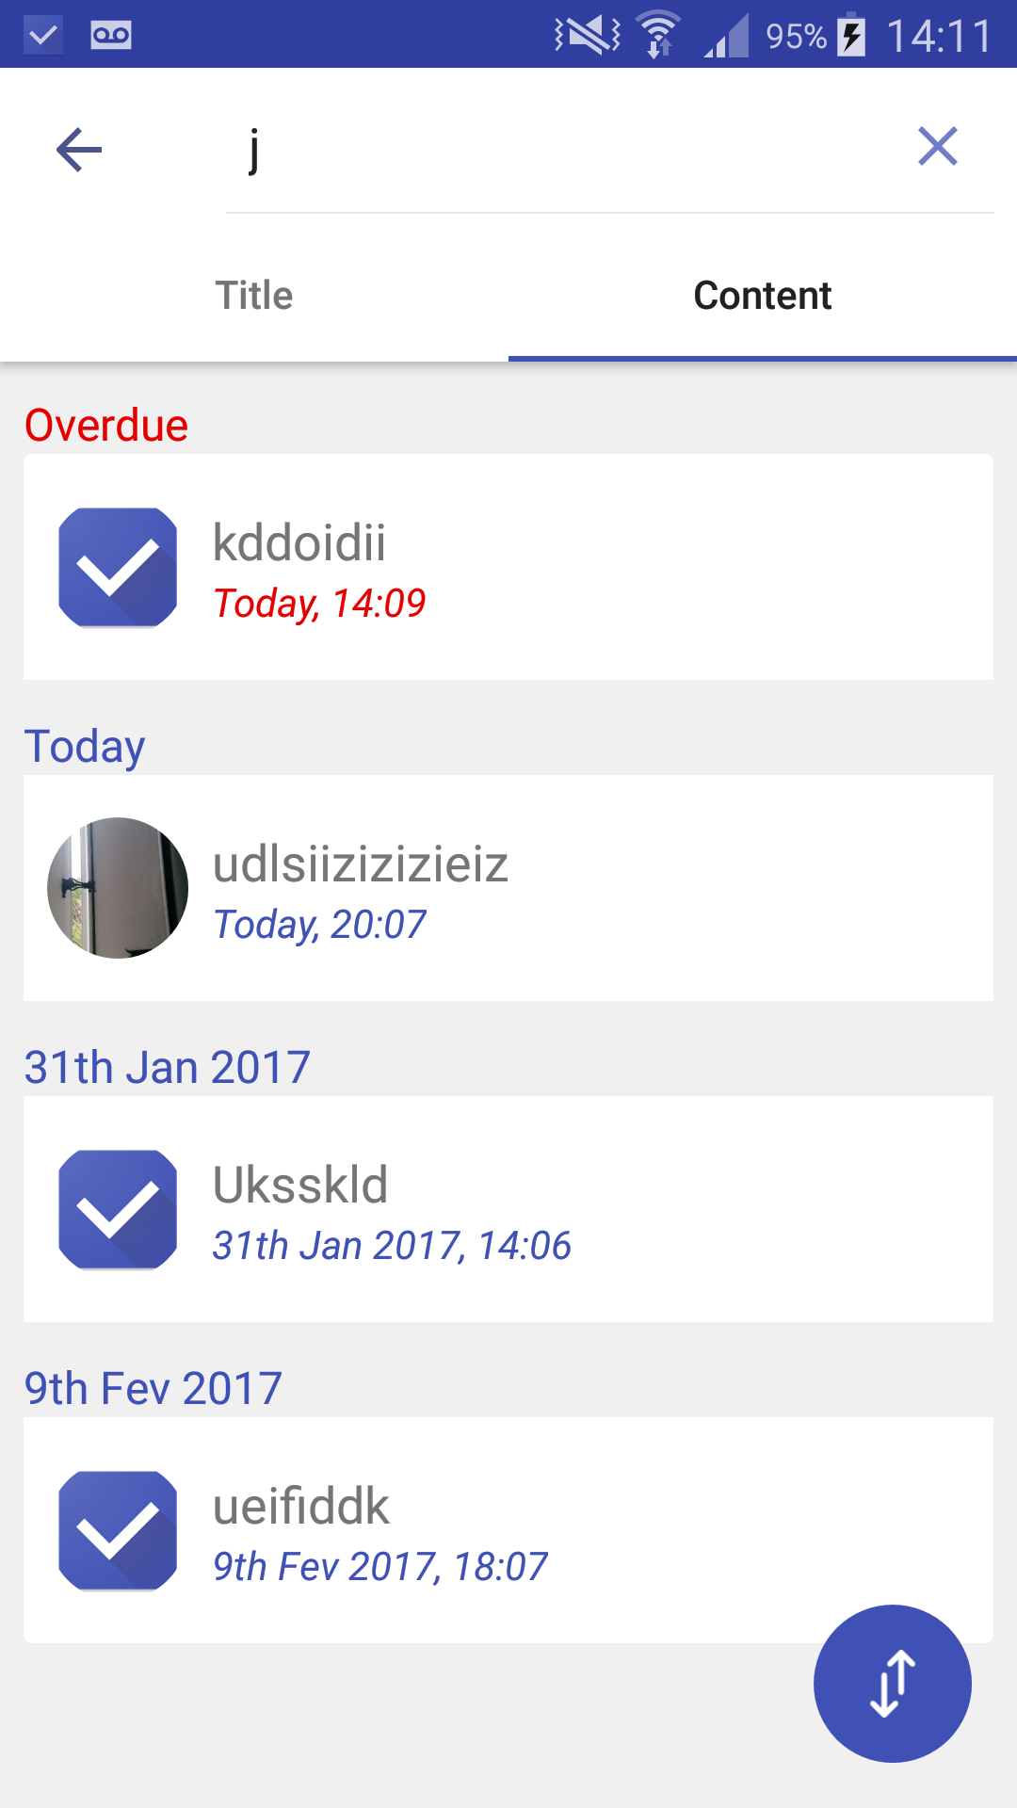

The search page is divised in 2 parts :  
The title and the content page.

The search return all item which have the research string in the title or in the content.

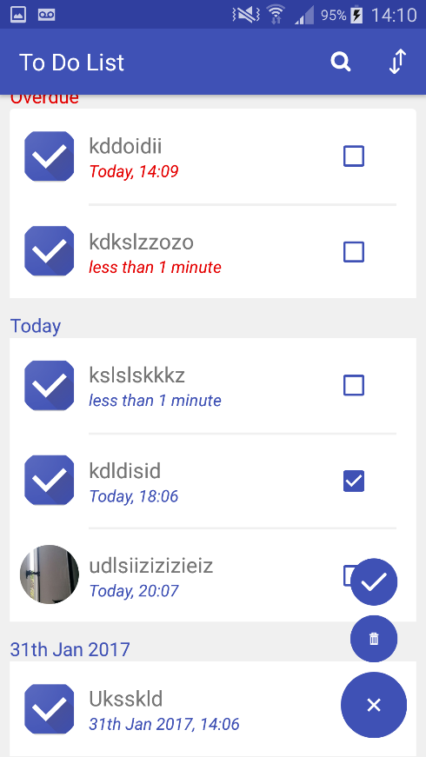(4) Here is the main page in selection mode.

The user can add an item to the selection by clicking on the checkbox.

With that selection, he can done or remove them.