CMSY 172 – Lab 8 Requirements

You are currently working as a developer at a small web development firm. The design team has developed a prototype interface for numeric input that needs to be tested. You have been assigned to write a test script that validates the numeric input.

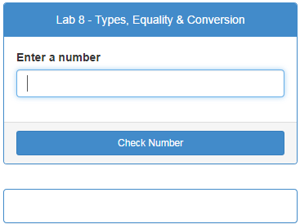

Figure 1 - Prototype Interface

The design team has provided you with a project folder that includes all of the necessary resource files. Use the **lab8.js** file located in the js sub-folder to write your test script. **Do not modify any other resource files**.

The test script has the following processing requirements:

1. It must verify that the document form element used for input exists before further processing.
   1. Display an error message if the form element cannot be found. (Page2 - figure 2)
   2. Use the document.write method to display this message.
2. It must verify that the user has input a value before further processing.
   1. Display an error message if there is no input value. ( Page 3 - figure 3)
3. The value entered must then be tested to ensure it is a number.
4. Based on the result of the number test: display a message that states whether or not the input is a valid number. (Page 3 - figure 4 & 5)

The script must employ the following JavaScript & DOM functions, methods, and properties:

- getElementById() method (DOM)

🡪 Use the element with the id **valueToCheck** to get the input value.

🡪 Use the element with the id **output** to display your valid/invalid message.

- Number function (JS)

- String trim method (JS)

- isNaN() function (JS)

- innerHTML property (DOM)

The script must include the following functions for processing (stubs are provided in the lab8.js file):

* getValue() form event handler function that will manage all processing and any necessary function calls to the validInput function, and the outputMessage function.
* validInput() - validate input
  + Has one parameter: the input value to verify
  + Called from the getValue() function.
* outputMessage() - Display valid/invalid input message
  + Has one parameter: the message to display (valid or invalid).
  + Called from the getValue() function.

Figure 2 - No form element found error

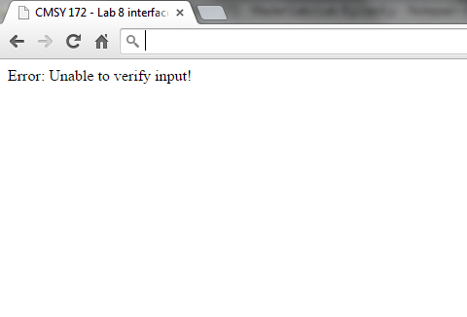

Figure 3

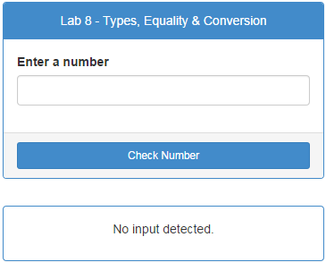

Error message: No Input

Figure 4

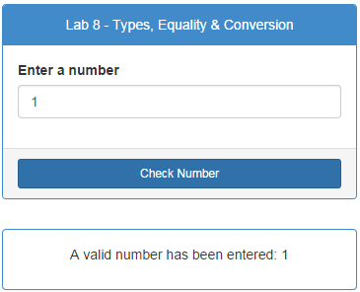

Valid input message

Figure 5

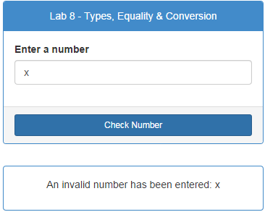

Invalid input message