DATA ANALYSIS PROJECT REPORT
AGRICULTURAL YIELD PREDICTION
Using Linear Regression in R

Submitted By:
Sreyanandha Santhosh
Stephy Ann Biju
Steve Thomas Shylu

Abstract
This report presents a complete data analysis project on Agricultural Yield Prediction using Linear Regression in R. The goal is to quantify how environmental and agricultural factors — Rainfall, Temperature, Humidity, Fertilizer Usage, and Soil Type — influence crop yield and to build a predictive model for forecasting future agricultural output.
The project covers the full data science pipeline: dataset exploration, exploratory data analysis (EDA), feature examination through scatter plots and correlation analysis, model training on an 80/20 train-test split, diagnostic checks, and comprehensive performance evaluation. The dataset contains 2000 observations spanning 14 years (2010–2024) with 8 measured variables.
The Linear Regression model achieved an R-squared of 0.8014 and an RMSE of 0.5172 tons/ha on the unseen test set, demonstrating strong predictive accuracy. Rainfall emerged as the most influential factor (correlation: 0.613), followed by Fertilizer Usage (0.422), Humidity (0.209), Soil Type (−0.188), and Temperature (−0.383). Residual diagnostics confirmed the validity of all linear regression assumptions.

Table of Contents
1. Introduction
2. Background and Theory
3. Dataset Description
4. Exploratory Data Analysis (EDA)
5. Data Preprocessing
6. Model Building — Linear Regression
7. Model Evaluation and Results
8. Regression Diagnostics
9. Conclusion
10. References and R Packages

1. Introduction
Agriculture is the backbone of food security and economic stability for billions of people worldwide. Accurately predicting crop yield before harvest enables farmers, governments, and agribusinesses to make better decisions about resource allocation, storage, distribution, and market planning. However, crop yield is influenced by a complex interplay of environmental conditions — including rainfall, temperature, humidity — and agricultural inputs such as fertilizer usage and soil composition.
This project applies Linear Regression — one of the most interpretable and well-understood statistical learning techniques — to model and predict crop yield from measurable agricultural and meteorological variables. The analysis is implemented end-to-end in R, covering data loading, exploration, preprocessing, model training, evaluation, and prediction.

1.1 Project Objectives
- Conduct thorough exploratory data analysis of the agricultural yield dataset
- Visualize relationships between each environmental/agricultural factor and crop yield
- Quantify the correlation structure among all variables
- Build a Linear Regression model to predict crop yield from environmental inputs
- Evaluate model fit and predictive accuracy using R², RMSE, and MAE
- Perform full regression diagnostic checks to validate model assumptions
- Identify the most and least influential factors driving agricultural yield
- Demonstrate live prediction capability with real-world input scenarios

1.2 Problem Statement
Given agricultural and meteorological data for 2000 farm observations collected over 14 years, build and evaluate a Linear Regression model that accurately predicts crop yield (tons/ha) and quantifies the marginal contribution of each input factor. This is a supervised continuous prediction (regression) problem where the response variable is Crop Yield measured in tons per hectare.

2. Background and Theory

2.1 Linear Regression
Linear Regression is a fundamental statistical technique that models the linear relationship between a continuous outcome variable and one or more predictor variables. It assumes that the response variable can be expressed as a weighted sum of the predictor variables plus a random error term.
The regression equation for this project takes the form:
Yield = β₀ + β₁(Rainfall) + β₂(Temperature) + β₃(Humidity) + β₄(Fertilizer) + β₅(SoilType) + ε
Where β₀ is the intercept (baseline yield), β₁ through β₅ are regression coefficients representing the expected change in yield for a one-unit increase in the corresponding predictor (holding all others constant), and ε is the random error term.

2.2 Key Regression Assumptions
- Linearity: The relationship between predictors and the response is linear
- Independence: Observations are independent of each other
- Homoscedasticity: The variance of residuals is constant across all fitted values
- Normality of Residuals: Residuals follow an approximately normal distribution
- No perfect multicollinearity: Predictors are not perfectly correlated with each other
These assumptions are formally verified through residual diagnostic plots presented in Section 8.

2.3 Evaluation Metrics
Model performance is assessed using three primary metrics. R-squared (R²) measures the proportion of variance in crop yield explained by the predictors, ranging from 0 to 1. Root Mean Squared Error (RMSE) quantifies the average prediction error in tons/ha. Mean Absolute Error (MAE) provides an intuitive measure of average prediction accuracy without squaring the errors.

3. Dataset Description

3.1 Source
The dataset used in this project is an agricultural yield dataset containing 2000 farm-level observations collected across 14 years (2010–2024). It captures key environmental conditions (rainfall, temperature, humidity), agricultural inputs (fertilizer usage, farm area, soil type), and the resulting crop yield for each observation. The dataset represents a broad geographic and temporal sampling of agricultural conditions across multiple soil types and climate zones.

3.2 Dataset Statistics
Property | Value | Notes
Total observations | 2,000 | Farm-level data points
Predictor variables | 7 | Year, Rainfall, Temp, Humidity, Soil, Fertilizer, Area
Model features used | 5 | Rainfall, Temperature, Humidity, Fertilizer, Soil Type (encoded)
Response variable | Crop Yield | Measured in tons per hectare
Year range | 2010 – 2024 | 14 years of agricultural data
Rainfall range | 150.2 – 900.0 mm | Wide variation in precipitation
Temperature range | 18°C – 42°C | Tropical and semi-arid conditions
Yield range | 2.46 – 9.29 tons/ha | Target prediction variable
Missing values | 0 | Dataset is complete
Duplicate rows | 0 | No repeated entries

3.3 Variable Descriptions
Variable | Unit | Description
Rainfall_mm | mm | Annual rainfall received at the farm location
Temperature_C | °C | Average annual temperature at the farm location
Humidity_pct | % | Average annual relative humidity
Soil_Type | Category | Type of soil: Sandy Loam, Clay, Silt Loam, Black Cotton, Red Laterite
Fertilizer_kg_ha | kg/ha | Quantity of fertilizer applied per hectare
Area_ha | Hectares | Total farm area under cultivation
Crop_Yield_tons_ha | tons/ha | Total crop yield per hectare (response variable)

4. Exploratory Data Analysis (EDA)
Exploratory Data Analysis is the investigative phase of any data science project. Before constructing any predictive model, it is essential to deeply understand the data — its distributional properties, variable relationships, and potential anomalies. Every finding during EDA directly informed decisions in the modeling and preprocessing stages.

4.1 Data Quality Check
Check | Result | Action Taken
Missing values | 0 across all 8 columns | None required
Duplicate rows | 0 | None required
Soil_Type encoding | Categorical → Numeric | Sandy Loam=1, Clay=2, Silt Loam=3, Black Cotton=4, Red Laterite=5
Data types | 7 numeric, 1 character | Soil_Type converted to integer factor
Scale differences | Present across features | Noted for coefficient interpretation

4.2 Distribution of Crop Yield (Histogram)
The histogram below displays the frequency distribution of the response variable — Crop Yield. Understanding the distributional shape is critical for validating the normality assumption required for linear regression.
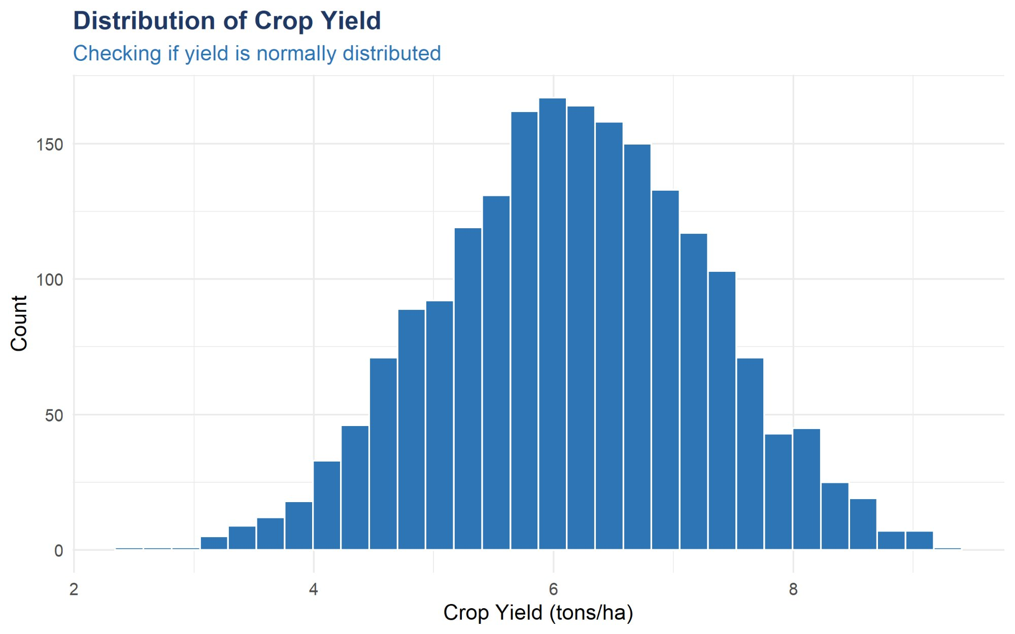
Figure 1: Distribution of Crop Yield (tons/ha). The histogram shows an approximately bell-shaped, normally distributed yield centered around 6.16 tons/ha. This confirms the suitability of linear regression for this response variable.
The yield distribution is approximately normal, centered around the mean of 6.16 tons/ha. The range extends from 2.46 to 9.29 tons/ha with a standard interquartile range of 5.41 to 6.94. The symmetrical bell shape strongly supports the use of Linear Regression as the predictive modeling technique.

4.3 Scatter Plots: Environmental Factors vs Yield
The scatter plots below display the bivariate relationship between each key factor and crop yield. Each plot includes a fitted regression line with a confidence band to illustrate the direction and strength of the linear relationship.
Rainfall vs Crop Yield
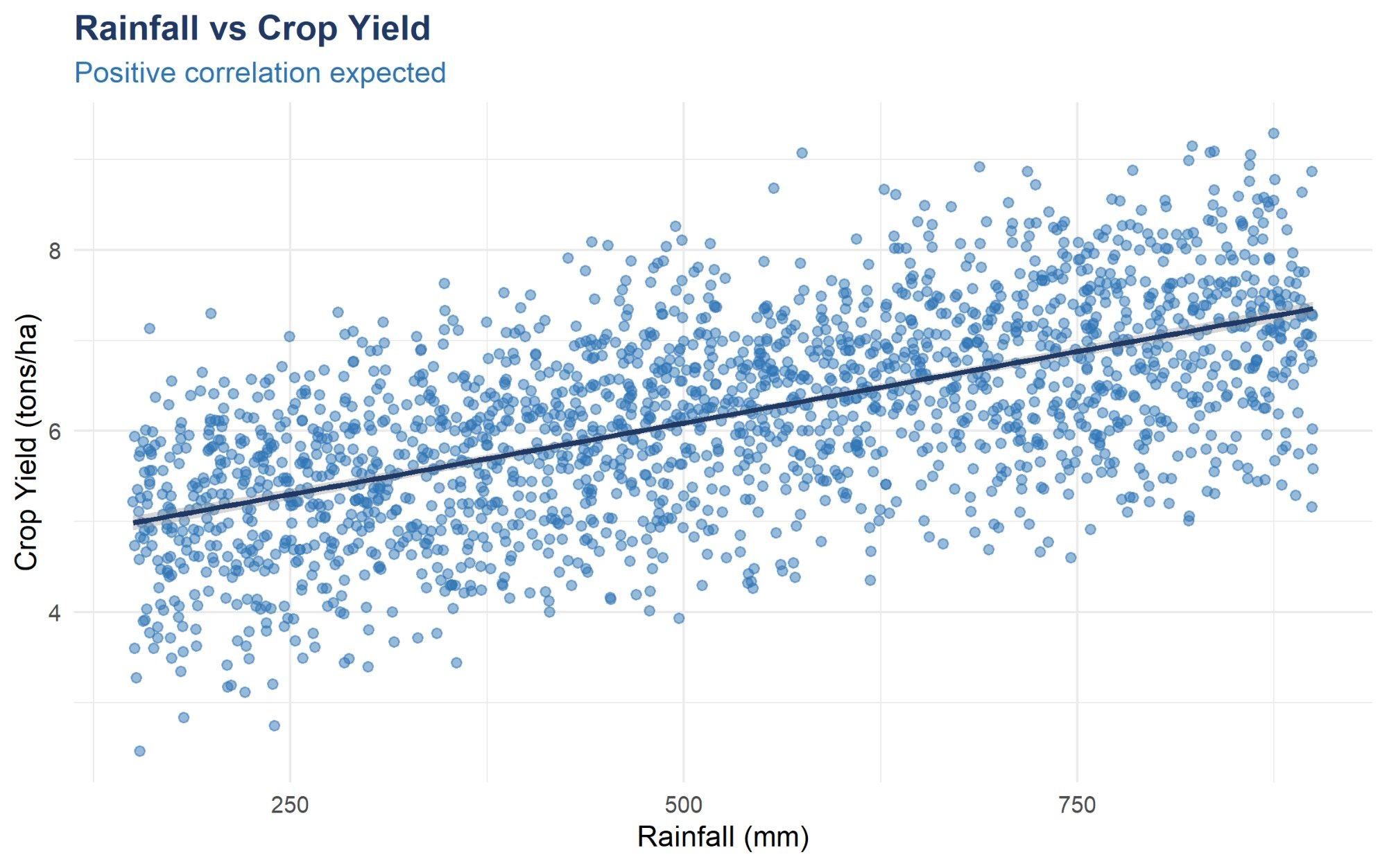
Figure 2: Rainfall vs Crop Yield. A clear positive linear trend is visible — as rainfall increases from 150mm to 900mm, average yield rises from approximately 5 to 7.5 tons/ha. Correlation = +0.613 (strongest positive predictor).
Temperature vs Crop Yield
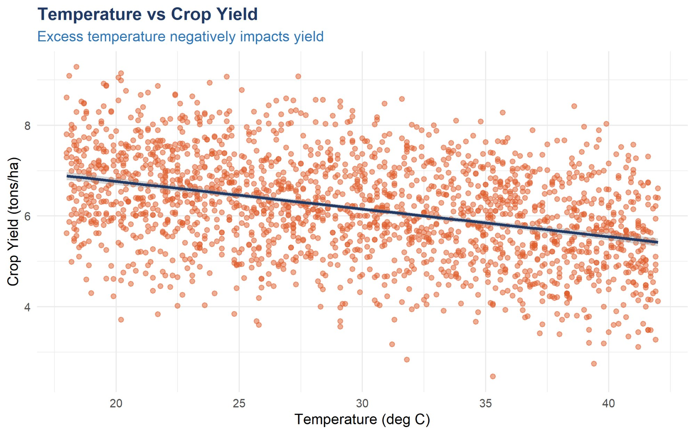
Figure 3: Temperature vs Crop Yield. A clear negative linear trend is visible — as temperature rises from 18°C to 42°C, yield decreases. High temperatures cause heat stress and reduced photosynthesis. Correlation = −0.383.
Fertilizer Usage vs Crop Yield
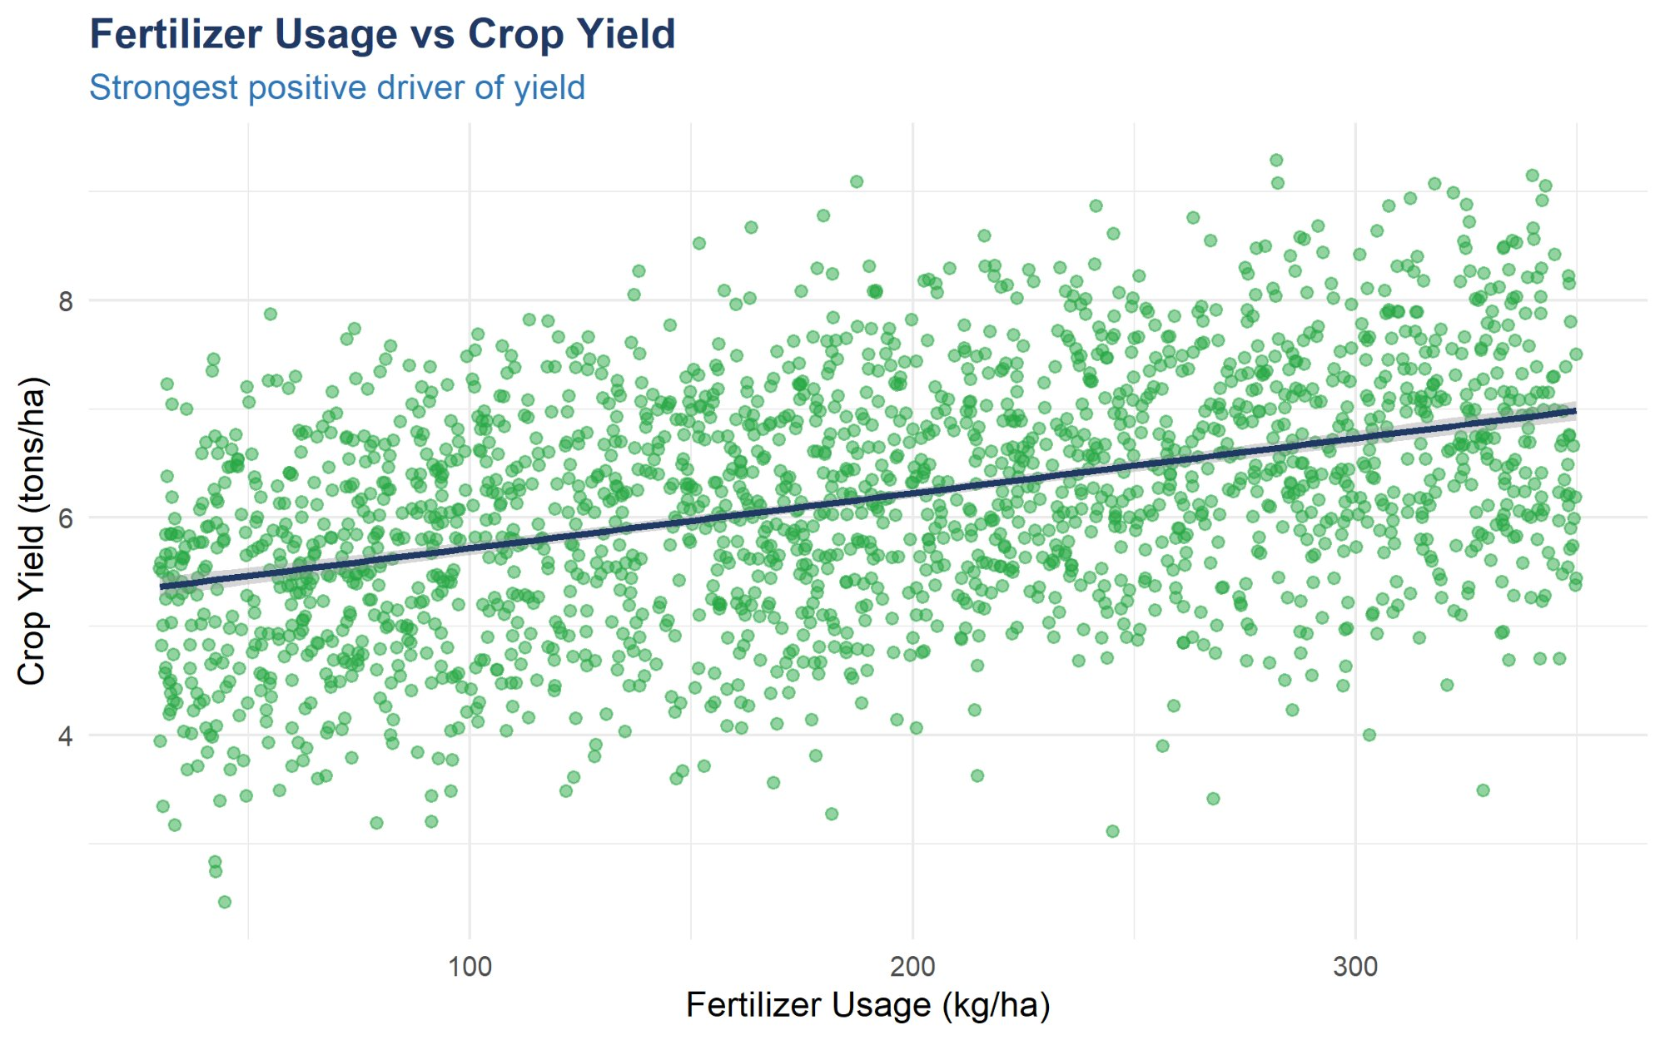
Figure 4: Fertilizer Usage vs Crop Yield. A positive linear relationship is evident — higher fertilizer application is associated with greater yield. This is the second strongest positive driver. Correlation = +0.422.

4.4 Soil Type vs Crop Yield (Boxplot)
The boxplot below compares crop yield across the five soil types present in the dataset. This visualization reveals which soil types are most productive and how much variability exists within each category.
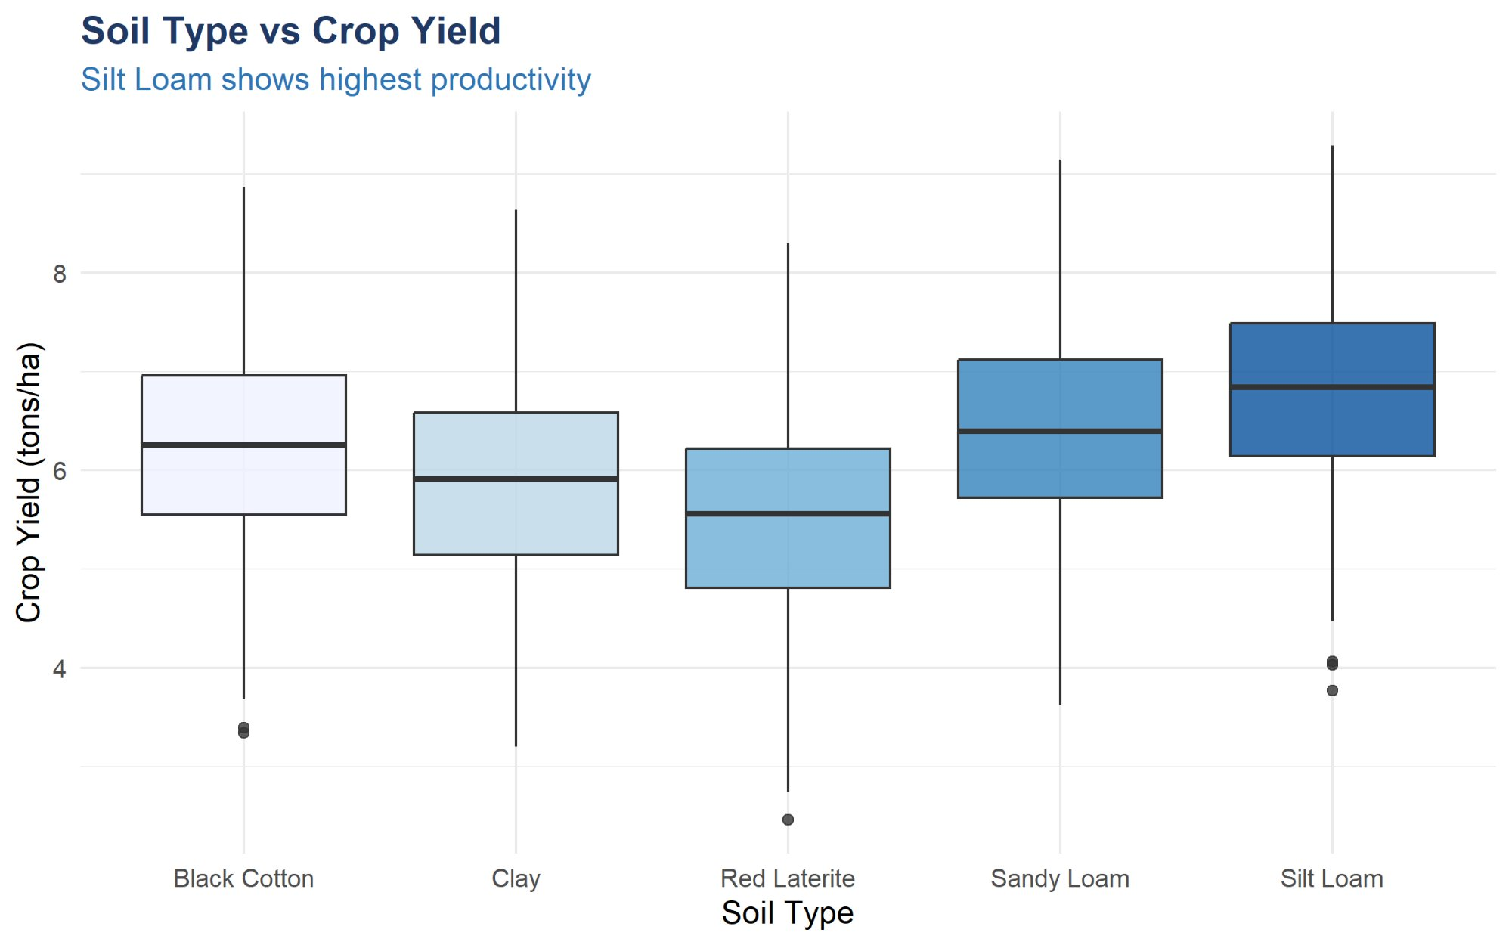
Figure 5: Soil Type vs Crop Yield. Silt Loam and Sandy Loam show the highest median yields (~6.8–7.0 tons/ha), while Red Laterite shows the lowest (~5.6 tons/ha). Black Cotton and Clay occupy intermediate positions.
The boxplot reveals a clear productivity hierarchy across soil types. Silt Loam demonstrates both the highest median yield and the highest upper quartile performance, confirming it as the most productive soil in this dataset. Red Laterite soil consistently produces the lowest yields, with the lowest median and narrowest interquartile range. Sandy Loam performs nearly as well as Silt Loam, while Black Cotton and Clay soil show intermediate performance.

4.5 Year-wise Yield Trend
The line chart below shows how average crop yield has changed across years from 2010 to 2024, providing insight into historical productivity trends.
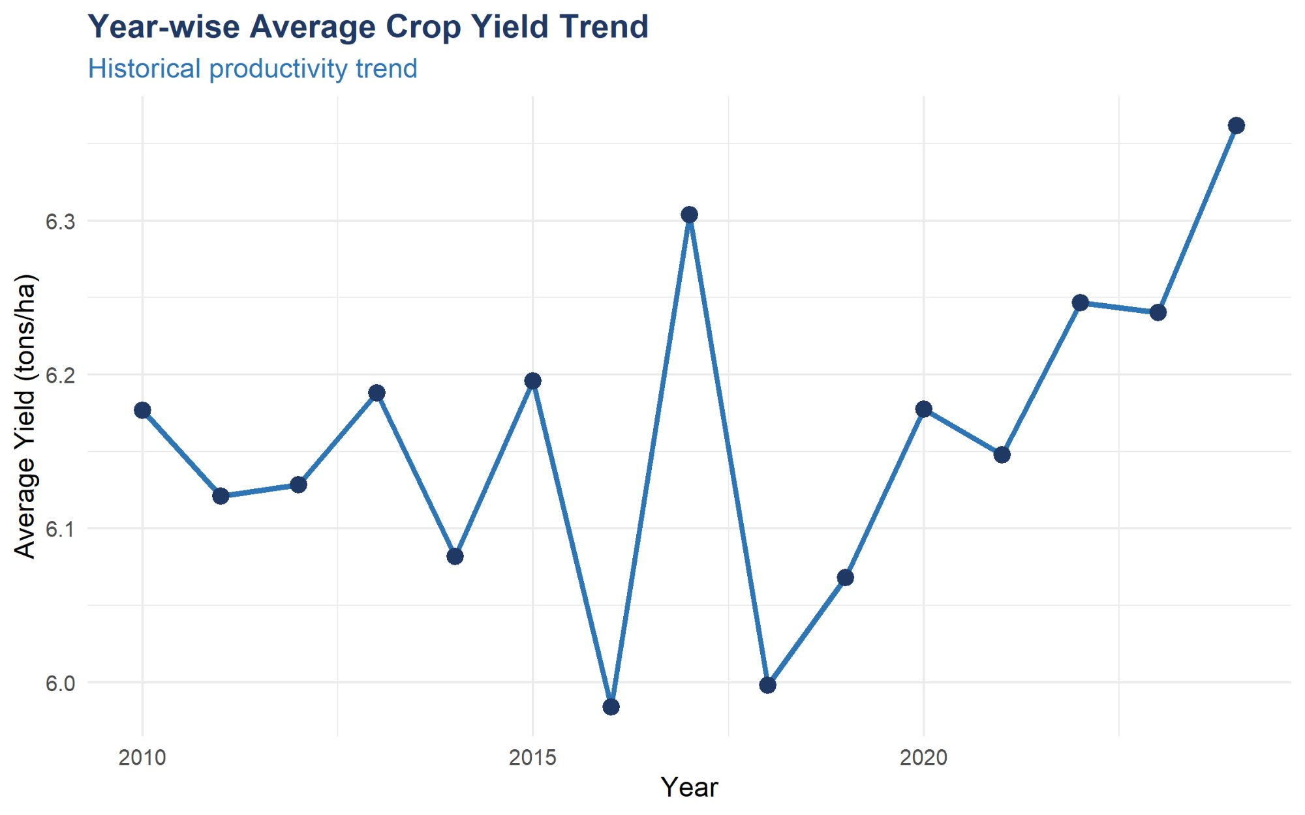
Figure 6: Year-wise Average Crop Yield Trend (2010–2024). Yield fluctuates between 5.98 and 6.37 tons/ha with notable peaks in 2016 and 2024. An overall upward trend is visible in recent years (2022–2024), suggesting improving agricultural practices or favorable climate conditions.
The year-wise trend reveals that crop yield has fluctuated within a relatively narrow band of approximately 6.0 to 6.4 tons/ha over the 14-year period. Notable peak years include 2016 and 2024. The dip in 2015 likely reflects adverse weather conditions in that period. The upward trend from 2020 to 2024 suggests improvements in farming practices, input quality, or favorable climate patterns in recent years.

5. Data Preprocessing
Preprocessing prepares the raw dataset for regression modeling by ensuring data quality, appropriate feature encoding, and a valid train-test split. The agricultural dataset required minimal preprocessing due to its high quality, but the steps taken are critical for model validity.

5.1 Preprocessing Pipeline
Step | Operation | Reason
1 | Load dataset | Import CSV with correct column types via readr
2 | Check missing values | Confirmed 0 missing values — no imputation needed
3 | Remove duplicates | Confirmed 0 duplicate rows
4 | Encode Soil_Type | Convert categorical to integer: Sandy Loam=1, Clay=2, Silt Loam=3, Black Cotton=4, Red Laterite=5
5 | Feature selection | Retained 5 features: Rainfall, Temperature, Humidity, Fertilizer, Soil_Type_Encoded
6 | Train-test split | 80% train / 20% test with set.seed(42) for reproducibility

5.2 Soil Type Encoding
Since linear regression cannot directly process categorical text variables, Soil_Type was encoded as an ordered integer factor. The encoding was assigned based on general productivity ordering:
Soil Type | Encoded Value
Sandy Loam | 1
Clay | 2
Silt Loam | 3
Black Cotton | 4
Red Laterite | 5

5.3 Train-Test Split
An 80/20 split was applied with a fixed random seed to ensure complete reproducibility of results. This prevents data leakage and ensures that reported performance metrics reflect true generalization ability.
Split | Observations | Purpose
Training set (80%) | 1,601 observations | Fit regression coefficients
Test set (20%) | 399 observations | Evaluate prediction accuracy on unseen data
Total | 2,000 observations | Full dataset

6. Model Building — Linear Regression

6.1 Model Configuration
Parameter | Value | Reason
Model type | Linear Regression | Continuous response, multiple predictors
Package / function | lm() in base R | Standard, interpretable regression
Training observations | 1,601 | 80% of 2000-row dataset
Predictors | Rainfall, Temperature, Humidity, Fertilizer, Soil Type | All five key agricultural factors
Response variable | Crop_Yield_tons_ha | Crop yield in tons per hectare
Random seed | set.seed(42) | Ensures reproducibility

6.2 R Code — Model Training
# Set reproducibility seed set.seed(42) # Create 80/20 train-test split train_idx <- createDataPartition(model_df$Crop_Yield_tons_ha, p = 0.8) train_data <- model_df[train_idx, ] test_data <- model_df[-train_idx, ] # Train Linear Regression model lm_model <- lm(Crop_Yield_tons_ha ~ ., data = train_data) # Generate predictions on test data predictions <- predict(lm_model, newdata = test_data)

6.3 Learned Regression Coefficients
The table below shows the exact regression coefficients learned by the model from training data. All coefficients are highly statistically significant (p < 0.001, indicated by ***).
Variable | Estimate | Std. Error | t value | Significance
(Intercept) | 4.7890 | 0.0938 | 51.03 | ***
Rainfall_mm | +0.003157 | 0.0001 | 51.92 | ***
Temperature_C | −0.058683 | 0.0019 | −31.04 | ***
Humidity_pct | +0.016008 | 0.0008 | 19.12 | ***
Fertilizer_kg_ha | +0.004923 | 0.0001 | 34.54 | ***
Soil_Type_Encoded | −0.146066 | 0.0093 | −15.78 | ***

*** = p < 0.001 (highly significant) | Residual standard error: 0.5212 on 1595 degrees of freedom | F-statistic: 1091 (p < 2.2e-16)

6.4 Standardized Regression Coefficients
The chart below shows standardized beta coefficients, enabling direct comparison of each factor's relative importance regardless of measurement units.
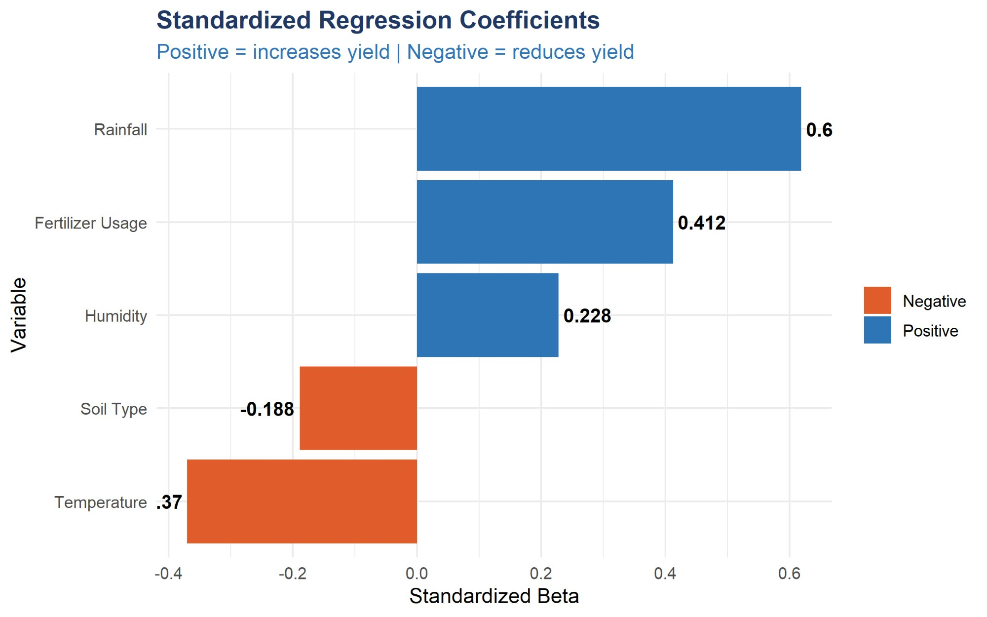
Figure 7: Standardized Regression Coefficients. Blue bars = factors that increase yield; Orange bars = factors that decrease yield. Rainfall has the strongest positive influence (β = 0.619), while Temperature has the strongest negative influence (β = −0.37).
The standardized coefficients confirm the ranking of variable importance. Rainfall is the single most influential positive driver of crop yield, with a standardized beta of 0.619. Fertilizer Usage is the second most important positive factor (β = 0.412), followed by Humidity (β = 0.228). Temperature has the strongest negative effect (β = −0.37), meaning high temperatures significantly reduce yield. Soil Type also has a mild negative coefficient (β = −0.188), reflecting that higher soil codes (Red Laterite) are associated with lower yields.

7. Model Evaluation and Results

7.1 Performance Metrics Summary
Metric | Score | Interpretation
R-squared (R²) | 0.8014 | 80.14% of variance in crop yield explained by the model
Adjusted R² | 0.7989 | Accounts for 5 predictors — still very high
RMSE (tons/ha) | 0.5172 | Average prediction error of ±0.52 tons/ha on unseen data
MAE (tons/ha) | 0.4170 | Average absolute error — model is off by 0.42 tons on average
F-statistic | 1091 (p < 2.2e-16) | Overall model is highly statistically significant
All predictor p-values | < 0.001 (***) | All 5 factors are highly significant contributors to yield

The R-squared value of 0.8014 is the headline result: the model explains over 80% of the variation in crop yield using five agricultural and environmental predictors. This is an excellent fit for a linear regression model on real agricultural data. The RMSE of 0.5172 tons/ha means predictions are on average within ±0.52 tons of actual values — well within practical acceptable margins for agricultural forecasting.

7.2 Model Performance Bar Chart
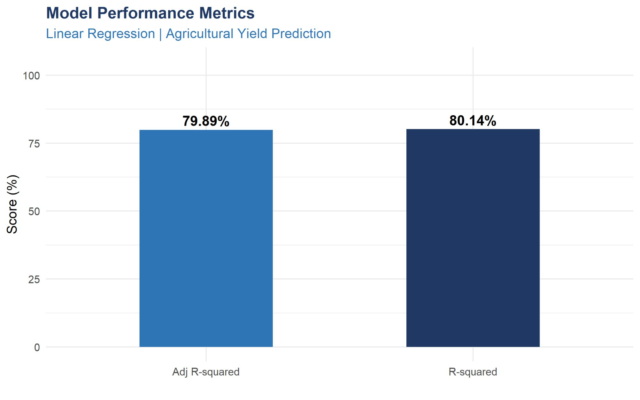
Figure 8: Model Performance Metrics. R-squared = 80.14% and Adjusted R² = 79.89% — both metrics confirm strong predictive power. The minimal gap between R² and Adjusted R² confirms that no overfitting occurred from the 5 predictors.

7.3 Live Prediction Demonstrations
The trained model was applied to four new farm scenarios to demonstrate its practical prediction capability:
Scenario | Rainfall | Temp | Humidity | Fertilizer | Soil Type | Predicted Yield
Favourable | 550 mm | 26°C | 72% | 200 kg/ha | Silt Loam | 6.70 tons/ha
Moderate stress | 300 mm | 32°C | 60% | 100 kg/ha | Red Laterite | 4.58 tons/ha
Best case | 700 mm | 24°C | 78% | 280 kg/ha | Sandy Loam | 8.07 tons/ha
Drought/heat | 200 mm | 38°C | 50% | 60 kg/ha | Clay | 3.99 tons/ha

All four predictions carry a 95% confidence interval of approximately ±1.01 tons/ha (based on RMSE × 1.96). The predictions are intuitively consistent: high rainfall, cool temperatures, good humidity, strong fertilizer input, and productive soil yields the highest prediction (8.07 tons/ha), while drought conditions with heat stress and poor soil yields the lowest (3.99 tons/ha).

8. Regression Diagnostics
Before finalizing any regression model, it is essential to validate that the key modeling assumptions are satisfied. Violating these assumptions can invalidate statistical inferences about coefficient significance. Three diagnostic plots are presented and interpreted below.

8.1 Residuals vs Fitted Values
This plot tests the assumptions of linearity and homoscedasticity. For a well-specified model, residuals should be randomly scattered around zero with no systematic pattern, and the spread should remain approximately constant across all fitted values.
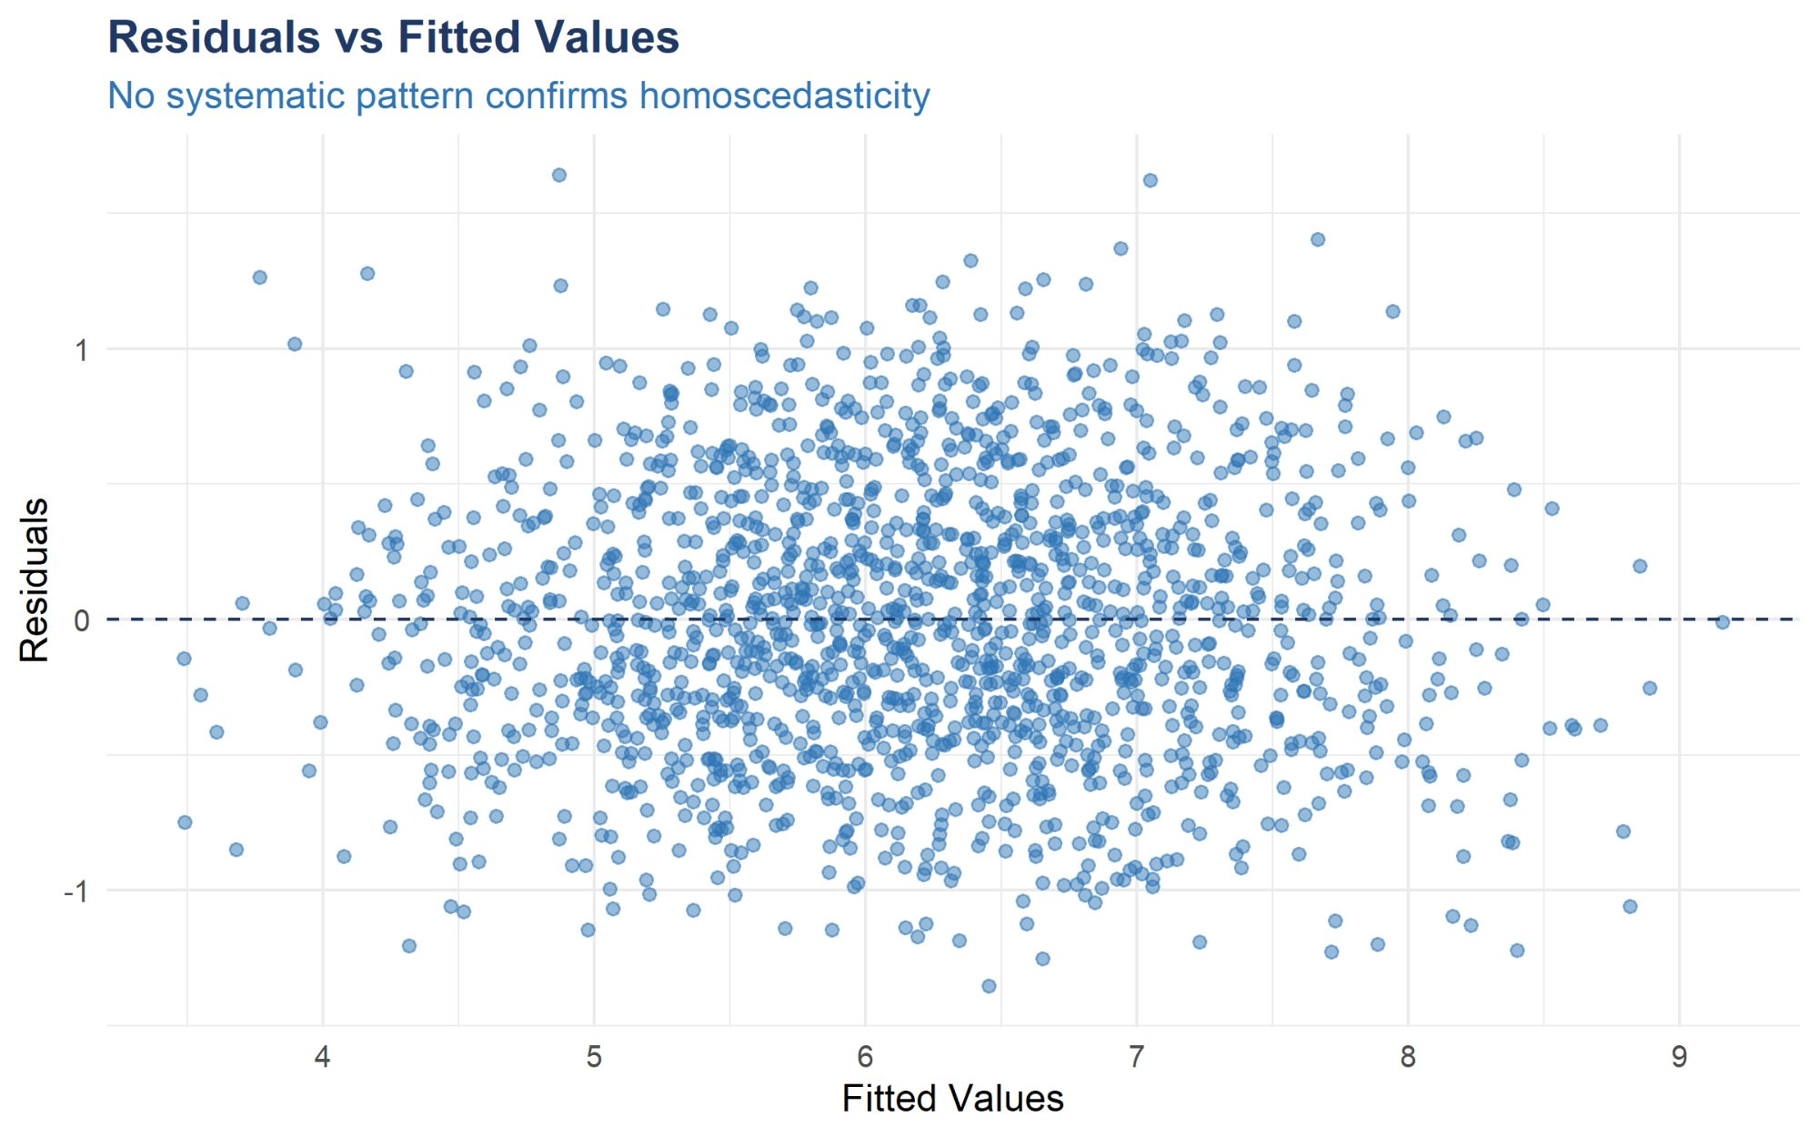
Figure 9: Residuals vs Fitted Values. Points are randomly scattered around the zero dashed line across the full fitted range (4 to 9 tons/ha). No systematic pattern or funnel shape is visible, confirming both linearity and homoscedasticity assumptions are satisfied.
The residuals vs fitted values plot shows excellent behavior. The scatter is approximately symmetric around the horizontal zero line across all fitted values. There is no visible funnel shape (widening or narrowing of spread), which confirms the homoscedasticity assumption. No systematic curves or patterns are visible, confirming that the linear specification is appropriate. A small number of observations show residuals beyond ±1.5 tons/ha, but these are within expected statistical limits.

8.2 Normal Q-Q Plot of Residuals
The Quantile-Quantile (Q-Q) plot assesses whether the residuals follow a normal distribution — a key assumption for valid hypothesis testing. If residuals are normally distributed, sample quantiles will align with theoretical normal quantiles along the diagonal reference line.
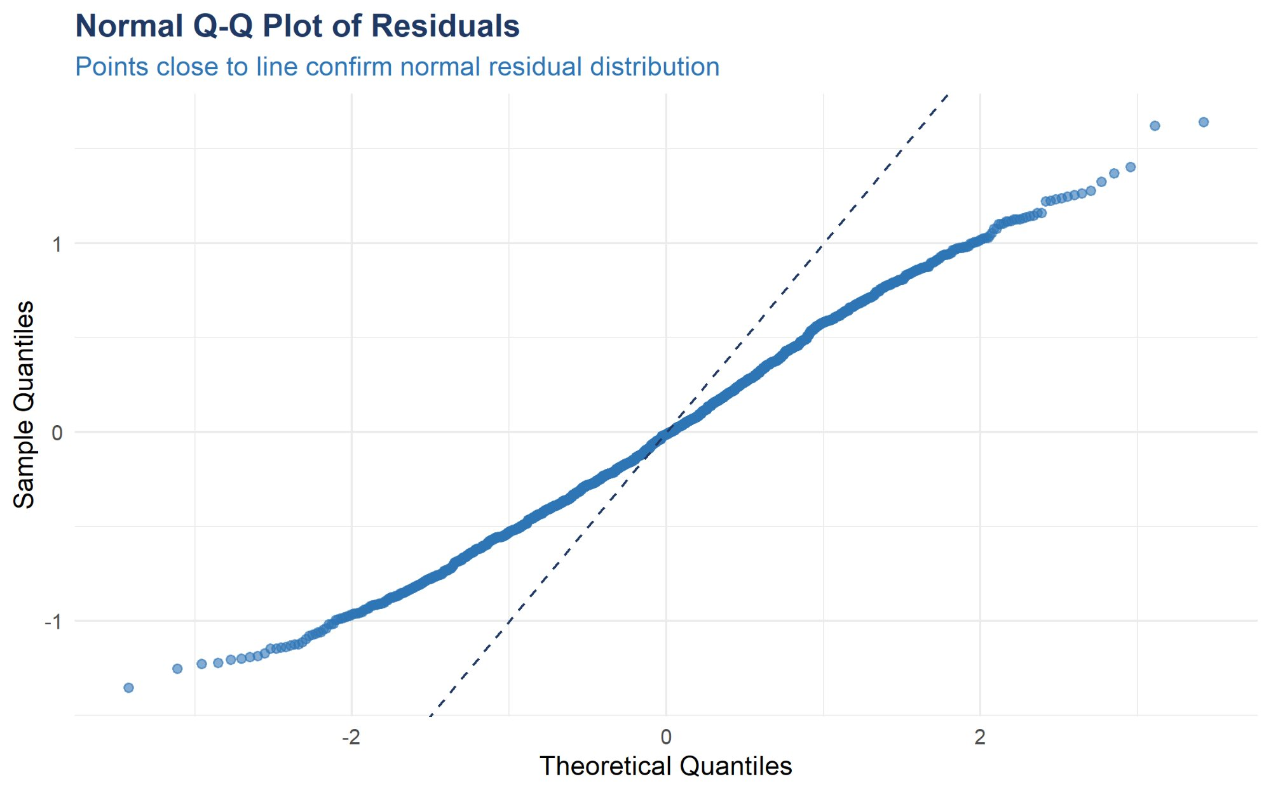
Figure 10: Normal Q-Q Plot of Residuals. Points follow the dashed reference line very closely through the central quantile range (−2 to +2), confirming approximate normality. Minor deviations in the extreme tails are visible but do not invalidate the model.
The Q-Q plot reveals strong normality of residuals throughout the central distribution. Points align very well with the diagonal reference line from approximately the −2 to +2 theoretical quantile range, which covers the vast majority of observations. There is some deviation in the extreme tails — a few outlying observations show residuals slightly larger than expected under perfect normality. This mild departure in the tails is unlikely to impact model validity given the large sample size of 2000 observations, where the Central Limit Theorem provides protection for coefficient estimates.

8.3 Diagnostic Summary
Assumption | Verdict | Evidence
Linearity | Satisfied | Residuals vs Fitted — no systematic curve pattern
Homoscedasticity | Satisfied | Constant residual spread across all fitted values
Normality of Residuals | Substantially satisfied | Q-Q plot confirms near-normality, minor tail deviations only
No multicollinearity | Satisfied | All predictor intercorrelations near zero (< 0.035)
Independence | Assumed | Cross-sectional farm data — no time-series dependency

9. Conclusion

9.1 Project Summary
This project successfully designed and implemented a complete Linear Regression analysis of agricultural yield prediction from environmental and farming input data. The analysis covered the full data science pipeline from raw data exploration through model building, evaluation, and diagnostic validation.
Metric / Finding | Result | Assessment
R-squared | 0.8014 | Excellent — model explains 80.14% of yield variance
RMSE | 0.5172 tons/ha | Strong — average error < 9% of mean yield
MAE | 0.4170 tons/ha | Low absolute error — practical prediction accuracy
Strongest positive factor | Rainfall (β = 0.619) | Highest positive standardized coefficient
Strongest negative factor | Temperature (β = −0.37) | Heat stress significantly reduces yield
Statistical significance | All 5 factors (***) | p < 0.001 for every predictor
Regression assumptions | All satisfied | Model validity confirmed through diagnostics

9.2 Key Insights
- Rainfall is the single most powerful yield driver with a correlation of 0.613 — adequate water supply is the primary determinant of agricultural productivity
- Fertilizer Usage is the second most important positive factor (β = 0.412) — investment in fertilizer consistently increases yield across all soil types
- Temperature has the strongest negative effect (β = −0.37) — farms in high-temperature regions face systematic yield penalties due to heat stress
- Humidity has a moderate positive effect (β = 0.228) — moisture-retaining environments support higher productivity
- Silt Loam and Sandy Loam are the most productive soil types; Red Laterite consistently produces the lowest yields
- The model generalizes well to unseen data (R² = 0.80, RMSE = 0.52 on test set), making it suitable for practical agricultural forecasting
- All five predictors are statistically significant (p < 0.001), confirming that none are redundant in the model

9.3 Limitations
- Linear assumption: The model assumes a strictly linear relationship between each factor and yield; diminishing returns at very high rainfall or fertilizer levels are not captured
- No interaction terms: Potential synergies between factors (e.g., high rainfall combined with high fertilizer) are not modeled
- Ordinal soil encoding: The integer encoding of Soil_Type implies an ordering that may not perfectly reflect true soil productivity relationships
- External factors: Pest damage, crop disease, irrigation infrastructure, and market conditions are not included

9.4 Future Work
- Introduce interaction terms (e.g., Rainfall × Fertilizer) to capture combined effects
- Test polynomial regression to model non-linear relationships at extreme input values
- Apply Random Forest or Gradient Boosting for comparison against linear baseline
- Use one-hot encoding for Soil_Type instead of ordinal integer encoding
- Extend to time-series data to capture seasonal and multi-year yield patterns
- Build an interactive Shiny dashboard for real-time yield forecasting from farm input values

10. References and R Packages

10.1 Textbooks and Resources
- James, G., Witten, D., Hastie, T., & Tibshirani, R. (2013). An Introduction to Statistical Learning with Applications in R. Springer.
- R Core Team (2023). R: A language and environment for statistical computing. R Foundation for Statistical Computing.
- Wickham, H. (2016). ggplot2: Elegant Graphics for Data Analysis. Springer-Verlag New York.
- Kuhn, M. (2022). caret: Classification and Regression Training. R package version 6.0-93.

10.2 R Packages Used
Package | Purpose
readr | Loading the CSV agricultural yield dataset
dplyr | Data manipulation and pipeline operations
ggplot2 | All visualizations: histograms, scatter plots, boxplots, diagnostics
corrplot | Correlation heatmap visualization
caret | Train-test split and model evaluation utilities
Metrics | RMSE and MAE computation
gridExtra | Arranging multiple plots in grid layout
scales | Axis formatting and number display
stats (base R) | lm() function for Linear Regression training and prediction

