Day 1 : Task 1 Build Your Own Knowledgebase for RAG
●Objective 1: IPSR Courses Knowledgebase
○ n8n Workflow Screenshot:
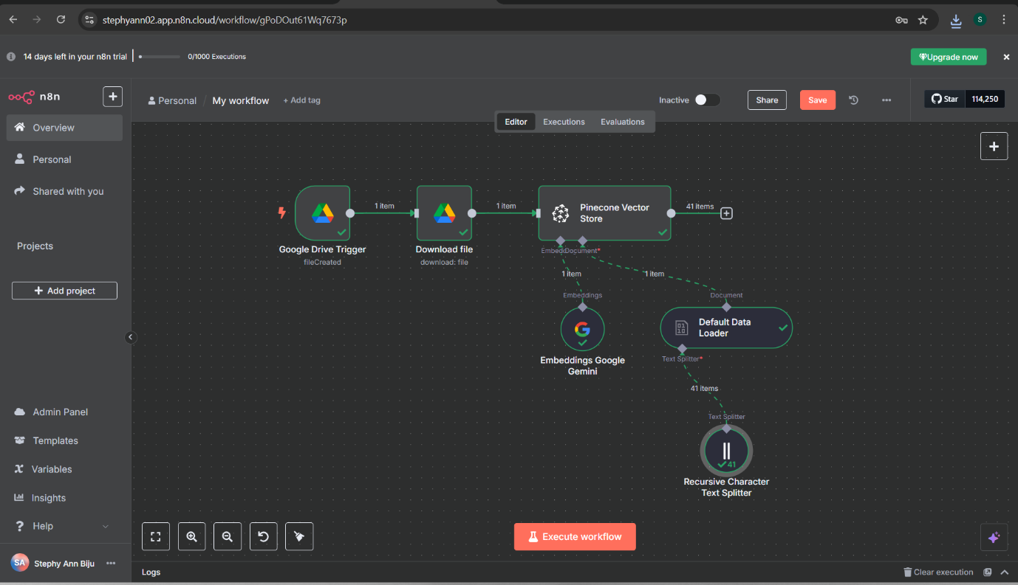

○ Pinecone Index Screenshot:
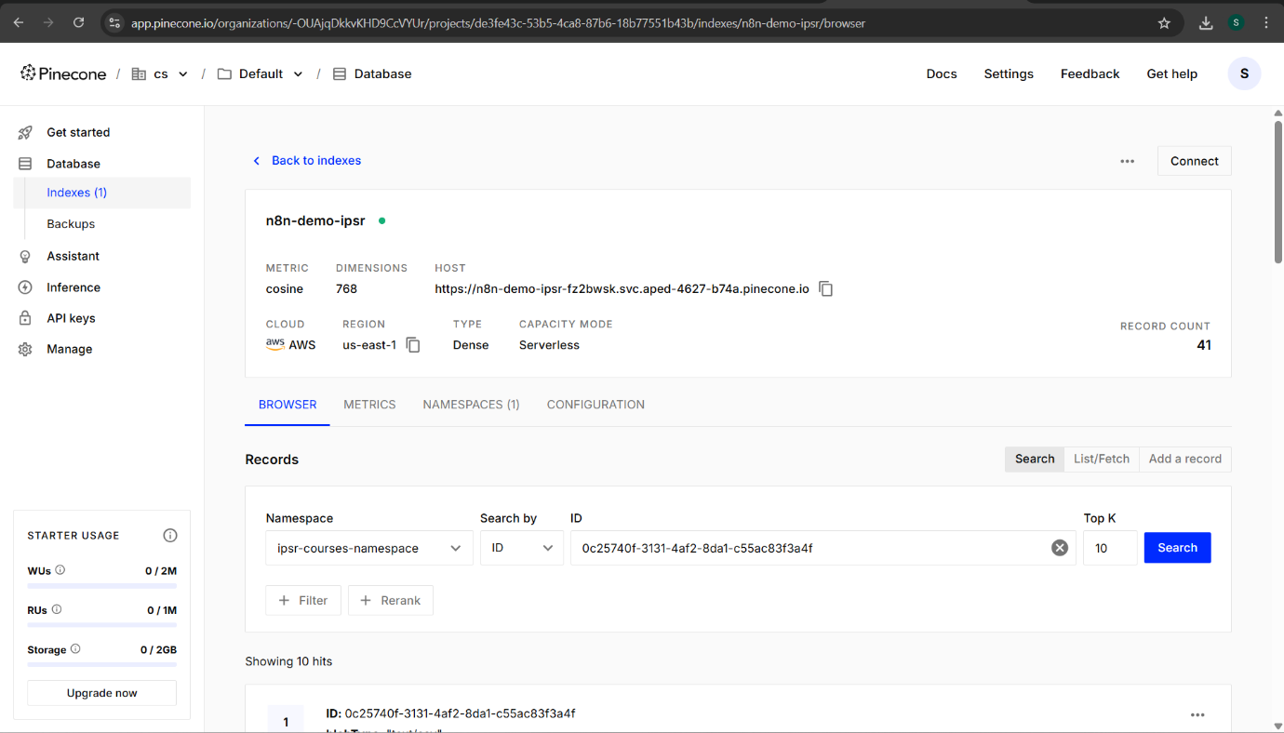
● Objective 2: Create Knowledgebase for Union Budget Analysis
○ n8n Workflow Screenshot:
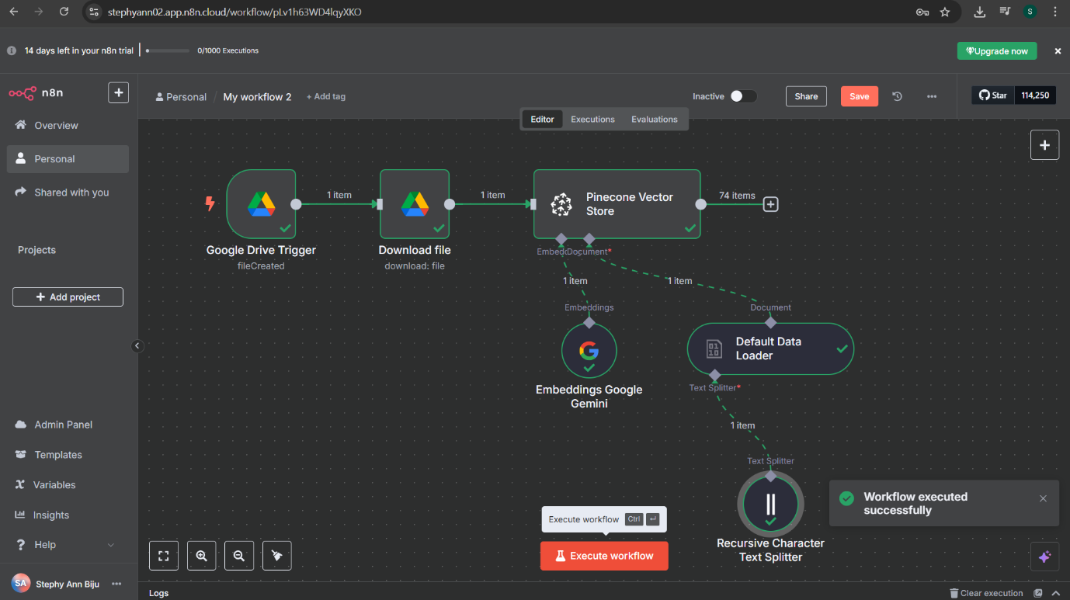

○ Pinecone Index Screenshot:
