./

Report – Tic Tac Toe Game

Course Code: <CODE>



Submitted by:

Vinti Sai Pranitha

SF ID: 105083

Course Code: <CODE>

Version Number:

Team Members :

Team No:

Module: Model Based System Engineering

|  |  |  |  |  |  |
| --- | --- | --- | --- | --- | --- |
| **Ver. Rel. No.** | **Release Date** | **Prepared. By** | **Reviewed By** | **Approved By** | **Remarks/Revision Details** |
| 1.0 | 07-11-2020 | Vinti Sai Pranitha |  |  |  |
|  |  |  |  |  |  |
|  |  |  |  |  |  |
|  |  |  |  |  |  |
|  |  |  |  |  |  |

**Document History**

TABLE OF CONTENTS

INTRODUCTION 4

PROBLEM STATEMENT 5

DESCRIPTION 6

RESEARCH 7

REQUIREMENTS 8

DESIGN 10

TEST PLAN 12

TEST CASES 13

EXPECTED RESULTS 16

CONCLUSION 16

INTRODUCTION

Along with the progress of globalization, competitive nuances are getting thicker in people's daily lives. At the same time, activities tend to be dominated by activities that consume more brain stamina. The depletion of brain stamina is felt by most modern humans, and along with getting some physical rest, there is a vital need for entertainment as well in today’s world. Along with the advancement of the entertainment world, one of the entertainment areas that involved quite a lot of scientists and artists was the gaming industry. Previously, games were a minor aspect of entertainment. The classic computer games that we played in the past are now turning into several online games that connect millions of people from different parts of the world.

So, for this mini project I have chosen to create a simple classic Tic Tac Toe game in C language. In my project both the players will be humans and we will get one winner in case of a win and in case there is no winner, the game will be a tie.

PROBLEM STATEMENT

To create a Tic Tac Toe game with a 3 x 3 grid with two Players (Player 1 and Player 2). One player’s move will be taken as “X” and another player’s is considered as “O”. The aim is to create a simple Tic- Tac- Toe game which takes input from both players consecutively and continues the game till we get a winner. If there is a winner, it will let us know which player won the game. If there is no winner, it should let us know that the game is a tie.

# 

DESCRIPTION

The project name is Tic-Tac-Toe game. Tic tac toe is one of the classic games that can only be played by two players. This game is very popular and is simple by itself. It is a two-player game. There is a board with n x n squares. In my project, I have considered 3 x 3 squares. The two players take turns filling in different marks (usually a cross and a circle) in a 3 x 3 grid. The goal of Tic-Tac- Toe is to be one of the players to get three same symbols in a row - horizontally, vertically or diagonally - on a 3 x 3 grid. The player who gets the same symbol in same row – horizontally, vertically or diagonally will be the winner of the game. Suppose if neither of them gets their respective symbol in same row, the it will be a tie. A player can choose between two symbols with his opponent, usual games use “X” and “O”. If first player chooses “X” then the second player have to play with “O” and vice versa. A player marks any of the 3x3 squares with his symbol (may be “X” or “O”) and his aim is to create a straight line horizontally or vertically or diagonally with two intensions:

1. Create a straight line before his opponent to win the game.
2. Restrict his opponent from creating a straight line first.

In case logically no one can create a straight line with his own symbol, the game results a tie. Hence there are only three possible results – Player 1 Wins, Player 2 Wins or it’s a tie.

RESEARCH

Tic-Tac-Toe is a long beloved classic pen and paper or board game for two players. Variations of Tic Tac Toe have been played since the Roman Empire and 3 in a row games can be traced all the way back to ancient Egypt. The simplicity of this game makes it very easy to understand. With the help of direct computer program calculations, it can be implemented easily as a program for playing the game. Tic Tac Toe is known by a few other names around the world. The most common of these is "Noughts and Crosses" and it is sometimes simply referred to as the “XO game”.

REQUIREMENTS

# HARDWARE REQUIREMENTS:

Operating System: Windows XP or above

Processor: Intel Core - 32 bit or above

RAM: 4GB or above

# SOFTWARE REQUIREMENTS:

MinGW compiler

Code blocks 20.03

# FUNCTIONAL REQUIREMENTS:

* 1. A function is needed for creating a board for the Tic Tac toe game and display the board.
  2. Should be able to handle a turn. It should take an input from the user and put that move on the board and display the board with filling up that position.
  3. A function to flip the player turn.
  4. A Function to check if any of the player won the game.
     + Should be able to check rows and check if there is a win
     + Should be able to check the columns and check if there is a win
     + Should be able to check the diagonals for a win.
  5. To check whether the entire board is filled and if the game is a tie.
  6. To be able to go back and repeat the game until there is a winner or if there’s a tie.
  7. If the user has given a number which is not in the range of 1-9, then it should be able to tell that it’s an invalid move.
  8. If the user is trying to make a move in the place which is already occupied, it should tell that it’s an invalid move.

DESIGN

# UML DIAGRAM:

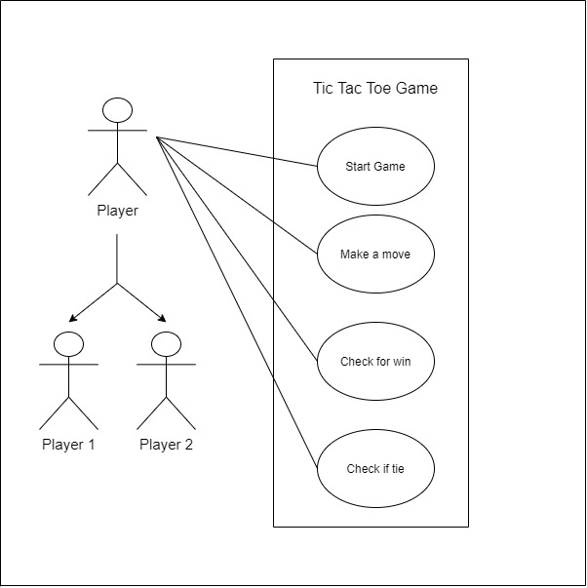

# FLOWCHART:

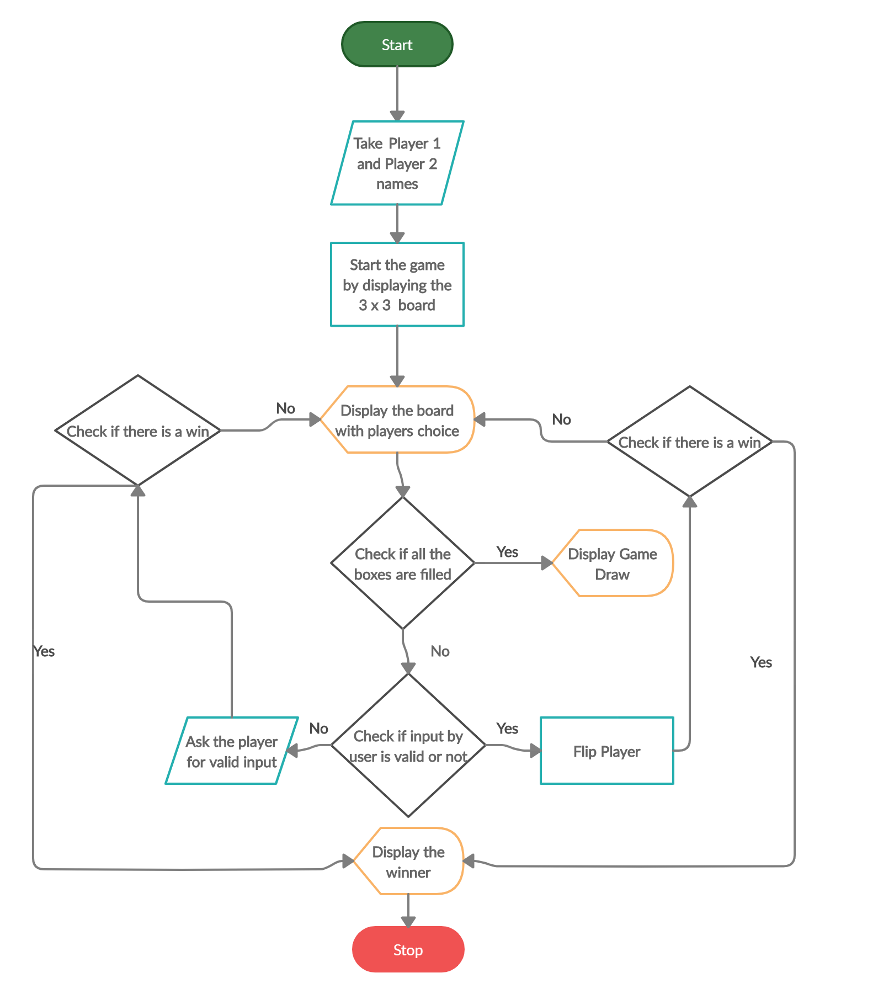

TEST PLAN

|  |  |
| --- | --- |
| S.No | Objective |
| 1. | To check if the Tic Tac Toe board game is displayed  with all the vacant positions with the respective number. |
| 2. | To verify whether the user asked to enter a position where he/she wants to make a move and if the input  is taken from the user |
| 3. | To check if the input given by the user is a valid input  or not. |
| 4. | In case the user gives an invalid input, check if the  user is asked to select from available spots or not. |
| 5. | To check if the player turn is flipped to player 2 in  case if player 1 has given a valid input. |
| 6. | To check if the player turn is flipped to player 2 in  case if player 1 has given a valid input. |
| 7. | To verify if the rows are checked for a win. |
| 8. | To verify if the columns are checked for a win. |
| 9. | To verify if the diagonals are checked for a win. |
| 10. | To verify if any of the player is declared as winner in  case of a win. |
| 11. | To check whether in case of no winner, if the code is  telling that the game is a tie. |

TEST CASES

|  |  |  |  |  |
| --- | --- | --- | --- | --- |
| S.No | Test case scenario | Test  Data | Expected  Result | Test result |
| 1. | To check if the Tic Tac Toe board game is displayed with all the vacant positions with the respective number. | Run the program | Should Display a heading “TIC TAC TOE” and game board with each block indicated by its respective block  number | Tic Tac Toe Game board with designated block numbers is displayed after running the program. |
| 2. | To verify whether the user asked to enter a position where he/she wants to make a move and if the input is taken from the user | Run the program | After displaying  the board, it should ask the player 1 to enter a position number. | A message asking the user to enter a position number and input from Player 1 is taken. |
| 3. | To check if the input given by the user is a valid input or not. | 3 | If block  indicated by  number 3 is vacant, Player 1’S symbol (I.e., X) should be put in place of 3 in the board and the board should be  displayed. | Since block 3 is vacant, X symbol is put in place of 3 and the board is displayed with the move made by player 1. |
| 4. | In case the user gives an invalid input, check if the user is asked to make a selection from available spots or not. | 10 | Should show a message that it is an invalid move and display the board again and ask player 1 to enter a number  again. | As 10 is not in the range, it shows invalid move and Board is displayed again and player 1 is asked to enter a number again. |
| 5. | To check if the player turn is flipped to player 2 in case if player 1 has given a valid input. | 3 | The board with move made should be displayed and now Player 2’s input should be  asked. | Board showing player 1’S move is displayed, and Player 2 is asked to enter a number. |
| 6. | To check if after Player 2’s valid input, if the player is again flipped to Player 1 or not. | 4 | The board showing moves made till now by both players should  be displayed and player 1’S input  should be asked | In block 3, X is present, and block 4 O is present and now again Player 1 is asked to enter a number. |
| 7. | To verify if the rows are checked for a win. | X X X  O O X  X O O  in top row | Message telling that Player 1 has won the game must be shown and should exit the  program. | “Congratulations Player 1 is the winner” message is displayed, and program exits |
| 8. | To verify if the columns are checked for a win. | X O O  X O X  X X O  in first column | Message telling that Player 1 has won the game must be shown and should exit the program. | “Congratulations Player 1 is the winner” message is displayed, and program exits |
| 9. | To verify if the diagonals are checked for a win. | X O O  O X X  O O X | Message telling that Player 1 has won the game must be shown and should exit the  program | “Congratulations Player 1 is the winner” message is displayed, and program exits |
| 10. | To verify if any of the player is declared as winner in case of a win. | X O X  X O O  X | Player 1 is the winner. So, game must end and should display that Player 1 is the  winner. | “Congratulations Player 1 is the winner” message is displayed, and program exits |
| 11. | To check whether in case of no winner, if the code is telling that the game is a tie. | X O X  O X X  X O O | No winner is found horizontally, vertically or  diagonally. So, message telling that the game is a tie must be  displayed. | “Game is a tie” message is displayed, and program is exited. |

EXPECTED RESULTS

By running this code, we should be able to play a simple Tic Tac Toe game between two humans. We are able to take inputs from both the players simultaneously and able to place their choice in the corresponding position on the board. The two players turn are getting flipped simultaneously and in case if any of the user has entered an invalid number which is out of range or if the user entered a number which is already occupied then a message telling that it’s a invalid move is being showed.

CONCLUSION

The Tic Tac Toe game is one of the most familiar game amongst all the age groups. Intelligence can be a property of any purpose-driven decision maker. In this project I have tried to present a very basic idea of the game. An algorithm of playing tic Tac Toe game has been presented and tested that works in an efficient way. Overall the code works without any bugs.