**Symmetry and its role in human perception**

When dealing with symmetry it is necessary to know what the origin of this term is and what are related fields (besides computer science) where symmetry has been used. Symmetry is around us (almost) everywhere and there are many symmetrical patterns in nature.

A lot of flowers and most of the animals are symmetric in nature. Inspired by this, humans learned to build their architecture with symmetric aspects that made buildings balanced and proportionate in their foundation, like the pyramids of Egypt etc.…

We define symmetry as a redundancy in the shape of an object or its projection onto the image plane due to a similarity between sub pieces of a larger part. In the context of an image, this can include mirror symmetry, where part of the image is reflected across an axis, rotational symmetry, where a section of the image is a copy of another section but at a different orientation, as well as translational symmetry, where a section of an image is a translated copy of another section. These forms of symmetry can either apply to part of an image (local symmetries) or to the entire image (global symmetry). Local symmetries do not need to apply to an entire object. In fact, a single part of an object may be locally symmetric. For example, consider a building with Greek columns. If the building is viewed from an oblique angle, the projection of the building onto the image plane does not necessarily result in a symmetric image. However, the projection of a single pillar in this view may still be locally symmetric.

Why are humans obsessed with symmetry?

According to the American scientist Alan Lightman, human brains actually strive to see things symmetrically. “The reason must be partly psychological," he says. "Symmetry represents order, and we crave order in this strange universe we find ourselves in... [It] helps us make sense of the world around us". Symmetry is a fundamental part of geometry, nature, and shapes. It creates patterns that help us organize our world conceptually. Symmetrical elements are perceived as part of the same group. A great synonym to the symmetry principle would be coherence or the balanced variety in unity.

When symmetry is investigated in computer environment we can say that we try to simulate human perception by means of computers. Simulation of human perception is applied in area of computer vision and image processing. Both disciplines have a long tradition and there are many results that are widely used. A good example is image processing when we try to identify single objects in a scene (black dog, red hat etc.). Here we segment the image in order to form areas that resemble (more or less) to some known objects (black dog etc.).

When we try to identify symmetry in an image (or several symmetrical areas in an image) – we must admit that this is much more complicated task in comparison with the above-mentioned task (identification of a single object in an image). Here we should know more about the nature of human (visual) perception.

This means that we should handle symmetry in the same way – both in computer environment and in the field of psychology where we deal with the scheme how visual stimuli are processed by human eye and human brain (it would be useless to develop computer-based methods that are different from methods humans use).

The problem with symmetry detection by computers and by humans may be in different mechanisms that allow symmetry detection. A good example may by the fact that computer-based methods do not (mostly) consider orientation of symmetry axis (in comparison with human based perception where symmetry detection brings better results when symmetry axis are vertical.

**Symmetry in context of human perception**

Here we come to the term Gestalt Psychology. Gestalt psychology is a theory that looks at human perception. It originated in Austria and Germany during the early 20th century as a counter to the principles of elementalist and structuralist psychology. Max Wertheimer, Wolfgang Köhler, and Kurt Koffka are the pioneers of Gestalt psychology. When it comes to our interpretation of visual stimuli, we’re always looking for the simplest possible way to understand a thing. People interpret ambiguous or complex images as the simplest form(s) possible.

There exist several so-called Gestalt laws that describe how people interpret images they see. One of them is Law of Symmetry. The law of symmetry and order is also known as [*prägnanz*](https://www.verywellmind.com/gestalt-laws-of-perceptual-organization-2795835), the German word for “good figure.” What this principle says is that your brain will perceive ambiguous shapes in as simple a manner as possible. For example, a monochrome version of the Olympic logo is seen as a series of overlapping circles rather than a collection of curved lines.

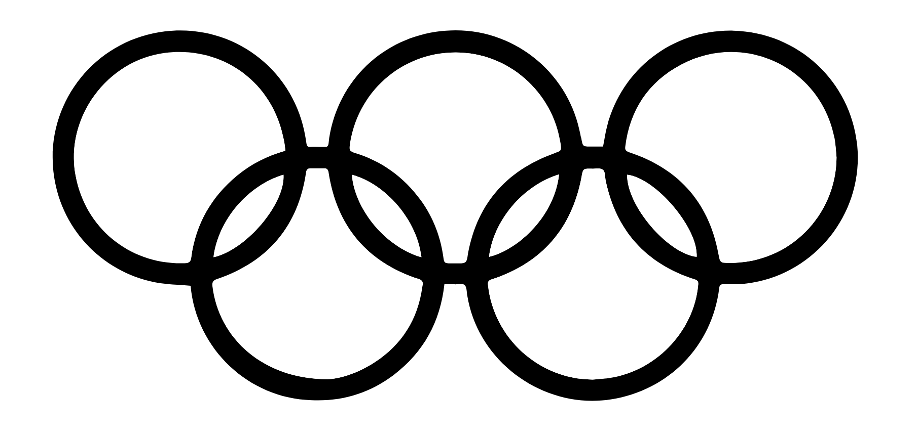

Gestalt psychology attempts to understand psychological phenomena by viewing them as organized and structured wholes rather than the sum of their constituent parts. Thus, Gestalt psychology dissociates itself from the more 'elementistic'/reductionistic/decompositional approaches to psychology like structuralism (with its tendency to analyze [mental processes](https://www.interaction-design.org/literature/topics/mental-processes) into elementary sensations) and it accentuates concepts like emergent properties, holism, and context.

The concept of symmetry – literally ‘commensurability’ – includes various ways of expressing the relation of parts (of bodies, buildings, pictures) to each other and to the whole. Though the word carries some prescriptive, academic baggage, it has since antiquity been part of the basic toolkit for explaining why certain visual configurations work the way they do. Symmetry perception is, it turns out, hard-wired in the human brain. This means that we register the presence of symmetrical features in our field of vision before we realize what we’re looking at. Since most living organisms and many natural objects are bilaterally symmetrical, symmetry perception probably has an evolutionary basis.

Considering symmetry, we subconsciously introduce some kind of order (structure) in the image and thus we are able to analyze the image in more efficient way.

**Use of symmetry**

Finding symmetries in geometric data is an important problem in geometry processing that has received significant attention in recent years. Numerous applications immediately benefit from extracted symmetry information, e.g., shape matching, segmentation, retrieval, geometry completion, beautification, meshing, or procedural modeling.

Symmetries are good candidates for describing shape. It is a powerful concept that facilitates object

detection and recognition in many situations. The more symmetric a piece of region is, the more easily it is recognized as a figure.

Symmetry is an important principle for grouping visual information in complex scenes. Symmetry greatly influences human observers' ability to categorize a scene.

## And What About Asymmetry?

Asymmetry, on the other hand, is when the look is unbalanced. They reduce the concentration of attention on some elements of design. So, asymmetry should be used with care. The use of asymmetry in your graphic or websites depends on your needs and on your goals. It depends on what you want to emphasize in the image. The Law of Symmetry is a Gestalt psychology principle that artists can use to create **visual balance**. This is one of the more complex principles, so read with intent! The mind prefers symmetry over imbalance, but this doesn’t mean that the photograph or painting should reflect a **mirror image** (symmetrical balance) opposite of the center. We can still use the law of symmetry if we have two small subjects on the left of an image, and one larger subject on the right (asymmetrical balance). This is considered **visual weight**, but it all ties into the law of symmetry.

**Problems with imperfect symmetry (and human perception)**

There are many research activities in the field of imperfect symmetry detection. There were developed metrics how to assess “level of imperfection” of this type of symmetry. The question arises how imperfect symmetry detection by means of a computer program complies with human perception where some issues related to human perception should be considered. As stated above human perception uses strategy based on Gestalt laws that control visual grouping of objects in scene.

While usage of perfect symmetry may be in many cases handled purely as a formal processing of an image where some prefect symmetries were discovered (and this information may be used e.g. for image compression without taking into account some peculiarity of human perception – picture decompression will be just an inverse activity to previous compression) the situation with imperfect symmetries is different as it may be important to consider if a detected imperfect symmetry may be also considered as a sort of (imperfect) symmetry by a human.

Let us assume the case when detected imperfect symmetry will be used for image (lossy) compression. If a case arises where the detected symmetry is not acceptable by human then the decompression may lead to rather strange image (from human point of view).

That is why it is necessary to create a mechanism (procedure) by means of which we could set up a threshold that will determine if the imperfect symmetry detected may be still considered as a sort of symmetry from human point of view.

**Use of cognition in cartography (this paragraph is for a sort of inspiration only)**

In regards to cartography, the gestalt effect of a map is **the way in which a reader perceives all of the elements of a map as a unified whole**. When applied to graphic design, gestalt encompasses many concepts including image continuity, closure, similarity, and figure-ground.

Gestalt is critically important in map design since maps are compositions of many smaller elements that combine to form a bigger picture. For there to be a sense of gestalt in a map, the different elements of a map must interact in relation to each other using various principles of map design. These principles are not applied in isolation but are used in harmony to help cartographers convey geographic information.

Good map design will take advantage of these characteristics of grouping and gestalt in creating an effective layout and will enhance differentiation in a visual hierarchy. Of course, not all aspects of gestalt or grouping are useful for all map objects.

The Gestalt ideas of perception are useful when it comes to designing an effective map- namely in considering how the various map elements will be perceived by the map user.  Concepts like Similarity (cognitively grouping objects according to their general shape) and Figure-Ground relationships (perceiving certain objects as closer, and thus more important, based on their relative size) come into play in the design of an effective map.

**Conclusion**

Symmetry is a general concept that we may find in nature (symmetries in flowers etc.), mathematics (group symmetry etc.) … We have to define what is the purpose of symmetry identification in our special case when we deal with geometric objects. As stated above the symmetry detection in this case is closely linked up with human perception. This means that not only formal points of view should be considered but also specific features of human perception (based on Gestalt laws etc.). These features may be closely linked up with the application where we try to used the detected symmetry.

The obvious question raised by our findings is “why does symmetry offer an advantage to scene perception?” Our hypothesis is that the importance of correct contour grouping is even more critical in a cluttered scene, in which any given contour may be proximal to many contours belonging to other objects. Under such conditions, where proximity leads to highly ambiguous groupings, adding symmetry cues can reduce ambiguity and lead to better grouping of contours into surfaces that comprise object parts and, in turn, the objects that make up a scene.

In the case we consider our research as simulation of human perception of symmetry we have to consider its specifics like importance of orientation of axis of symmetry etc. Also, in the case of investigation of partial symmetry we have to find certain threshold where human perception of symmetry does not correspond with the symmetry detection obtained by means of image processing through special algorithms for symmetry detection.

Symmetry detection is in principle problem of data classification (symmetry exists or not). If the result of this data classification should be linked up with the human interpretation of symmetry detection there should be also human experience with symmetry detection involved.

Let us consider (for a while) case that we should use neuronal networks for symmetry detection. This means that there should be (perhaps?) two training sets used (one obtained by means of computer-based analysis and the second one obtained by means of experiments with users) or just one training set where both points of view – computer based and human based – are considered. In such a way we obtain classification that may allow to detect symmetry detection by means of computer-based system where also human points of view will be considered.