PASSIVE VOICE

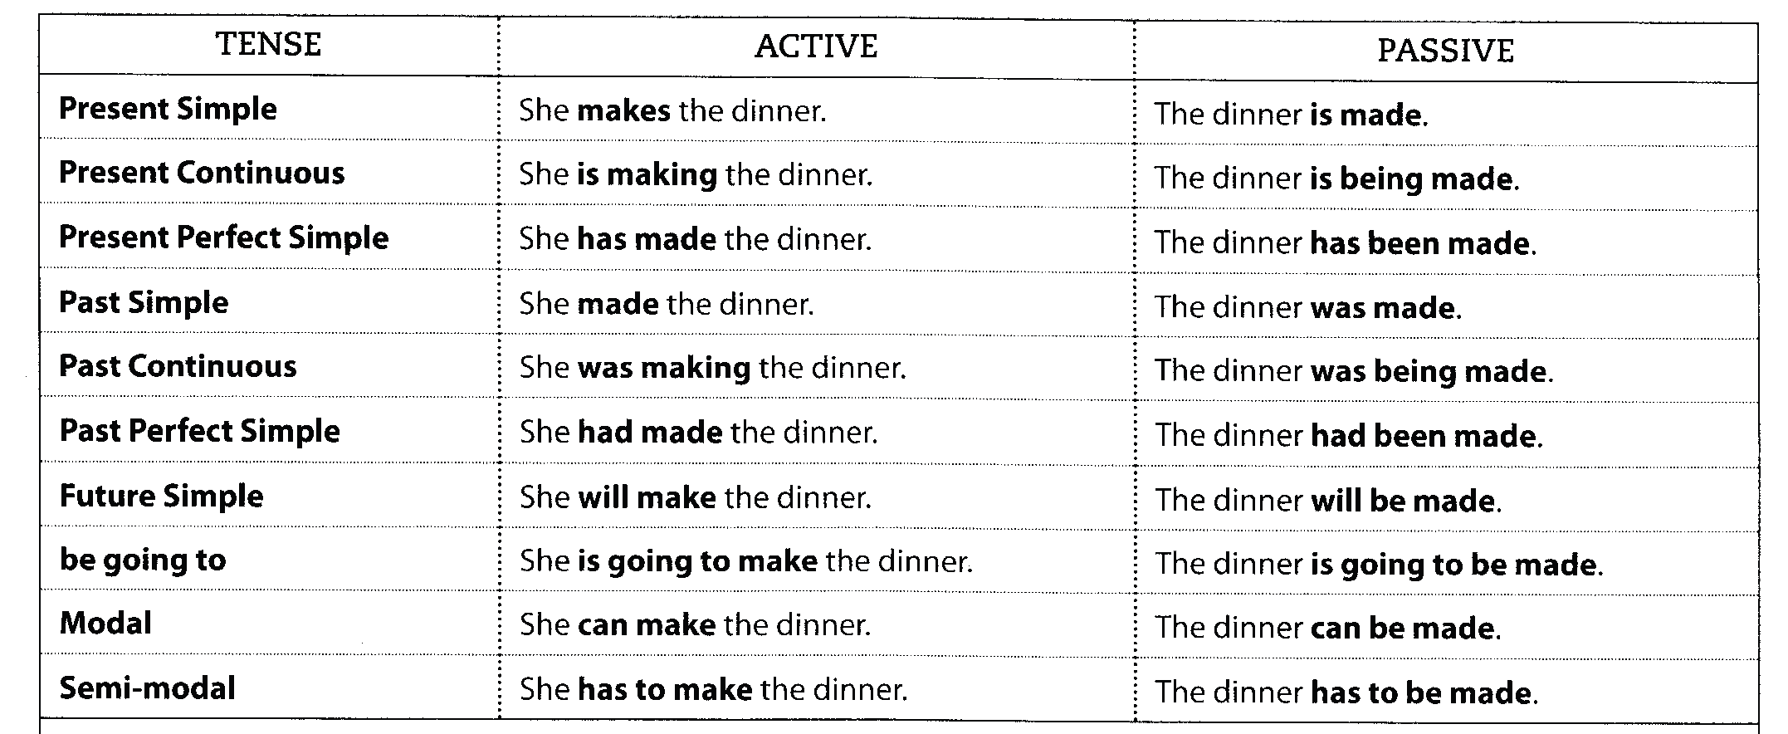

COMMON USE OF PASSIVES
- News reports: Three men have been arrested by the police. / The missing child was found by the sea early this morning.
- Academic and scientific writing: Three possibilities have been suggested and these will be examined in Chapter 3.
- Instructions and rules: This plant needs to be watered every day.This form should be filled in by the applicant.

PRESENT CONTINUOUS (am,is,are+being+v3):

1. The British Council is considering Helena for the job.
________________________________________________________
2. The police are watching the terrorists very closely.
________________________________________________________
3. The police are holding the thief for further questioning.
________________________________________________________
4 . The lawyers are discussing this case for the first time.
________________________________________________________

PAST CONTINUOUS (was,were+being+v3):

1. My mother was watering the flowers while we were having a rest.
________________________________________________________
2. We were discussing the new equipment problem when the lights went out.
________________________________________________________
3. We moved aside while the students were carrying the chairs into the room.
________________________________________________________

FUTURE SIMPLE (will+be+v3):

1. The committee will announce the names of the Nobel Prize winners.
________________________________________________________
2. They will complete the new bridge before the end of this year.
________________________________________________________
3. We will never forget the Beatles.
________________________________________________________

BE GOING TO (be going to+be+v3):

1. They are going to take me to a hospital if 1 don't get over my shock.
________________________________________________________
2. The woman is going to clean all the carpets in the house.
________________________________________________________
3. The teacher is going to send her into the garden.
________________________________________________________

PRESENT PERFECT (have,has+been+v3):

1. The tourists have made a lot of complaints about the high prices.
________________________________________________________
2. The captain of the ship has changed the course of the ship.
________________________________________________________
3. Scientists have made great progress in the conquest of space.
________________________________________________________
4. The students have put forward many ideas to solve the problem.
________________________________________________________

PAST PERFECT (had+been+v3):

1. The police had given a description of the wanted man before the arrest.
________________________________________________________
2. The earthquake had shaken the hotel violently when we heard the news.
________________________________________________________
3. The students had broken the window of the room before the exam started.
________________________________________________________

MODALS (BE+V3):

1.The students have to answer all the questions properly
_________________________________________________________
2.The teachers must check these books very carefully
_________________________________________________________
3.The students may discuss these subjects at the meeting tomorrow.
___________________________________________________________
4.All drivers should obey the new traffic laws.
___________________________________________________________
5. The police had to stop our car because we were going too fast.
____________________________________________________________

