PASSIVE

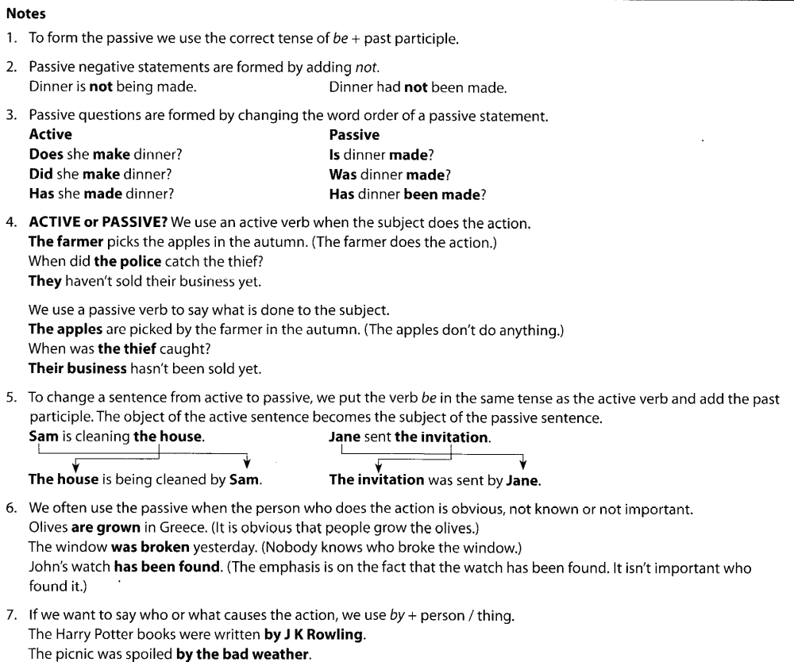

Present simple passive (am/is/are+v3)
Active: clean(s)/see(s) etc.
Somebody cleans this room every day.

Passive: am/is/are cleaned/seen etc.
This room is cleaned every day.

• Is this room cleaned every day? (does somebody clean it? - it's not important who)
• Our house is painted every summer.
• I'm not often invited to parties.
• How is this word pronounced?
• The festival is held every June by the local people.

Past simple passive (was/were+v3)
Active: cleaned/saw etc.
Somebody cleaned this room yesterday.

Passive: was/were cleaned/seen etc.
This room was cleaned yesterday.

• A lot of money was stolen in the robbery. (somebody stole it but we don't know who)
• We were asked a variety of questions to pass the test.
•'Did you go to the party?' 'No, I wasn't invited.'
• How much money was stolen?
• This house was built by my grandfather.

