ЗАДАНИЕ 5
R1(config)#interface g0/0
R1(config-if)#ip address 172.17.25.2 255.255.255.252
R1(config-if)#no shutdown
R1(config)#interface g0/1
R1(config-if)#no shutdown
R1(config)#interface g0/1.10
R1(config-subif)#encapsulation dot1Q 10
R1(config-subif)#ip address 172.17.10.1 255.255.255.0
R1(config)#interface g0/1.20
R1(config-subif)#encapsulation dot1Q 20
R1(config-subif)#ip address 172.17.20.1 255.255.255.0
R1(config)#interface g0/1.30
R1(config-subif)#encapsulation dot1Q 30
R1(config-subif)#ip address 172.17.30.1 255.255.255.0
R1(config)#interface g0/1.88
R1(config-subif)#encapsulation dot1Q 88 native
R1(config-subif)#ip address 172.17.88.1 255.255.255.0
R1(config)#interface g0/1.99
R1(config-subif)#encapsulation dot1Q 99
R1(config-subif)#ip address 172.17.99.1 255.255.255.0

S1(config)#interface vlan 99
S1(config-if)#ip address 172.17.99.10 255.255.255.0
S1(config-if)#no shutdown
S1(config)#ip default-gateway 172.17.99.1
S1(config)#vlan 10
S1(config-vlan)#name Faculty/Staff
S1(config)#vlan 20
S1(config-vlan)#name Students
S1(config)#vlan 30
S1(config-vlan)#name Guest(Default)
S1(config)#vlan 88
S1(config-vlan)#name Native
S1(config)#vlan 99
S1(config-vlan)#name Management
S1(config)#interface range FastEthernet0/11-17
S1(config-if-range)# switchport mode access
S1(config-if-range)# switchport access vlan 10
S1(config)#interface range FastEthernet0/18-24
S1(config-if-range)# switchport mode access
S1(config-if-range)# switchport access vlan 20
S1(config)#interface range FastEthernet0/6-10
S1(config-if-range)# switchport mode access
S1(config-if-range)# switchport access vlan 30
S1(config)#interface GigabitEthernet0/1
S1(config-if)# switchport mode trunk
S1(config-if)# switchport trunk native vlan 88
S1(config-if)# no shutdown

S1(config)#interface range fastEthernet0/1-5, gigabitEthernet 0/2
S1(config-if-range)#shutdown
ЗАДАНИЕ 6
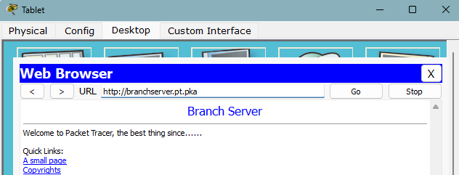
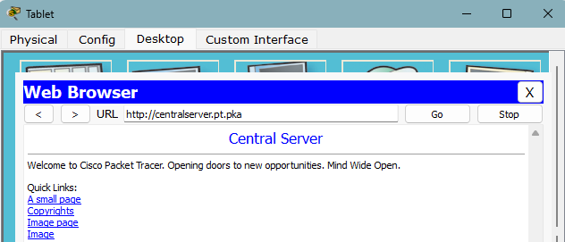
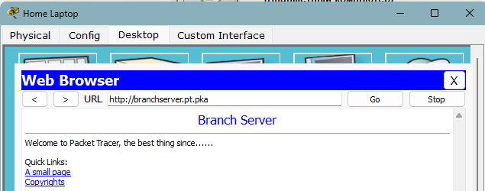
ЗАДАНИЕ 7

