Introduction

Background

Data Parallel and Distributed Data Parallel

Optimization of Distributed Data Parallel
https://arxiv.org/pdf/2006.15704介绍这篇论文中的三个技术点，提一提就好
Bucketing gradients
Overlapping computation with communication
Skipping gradient synchronization

Fully Sharded Data Parallel

Parameter Server
https://zhuanlan.zhihu.com/p/21569493
简单介绍就好

Tree-based and Ring-based All-Reduce

Implement

Distributed Data Parallel
这里作业中强调了要画系统流程图。我这一张论文的图作为参考，如果要用论文的图，要自己重画
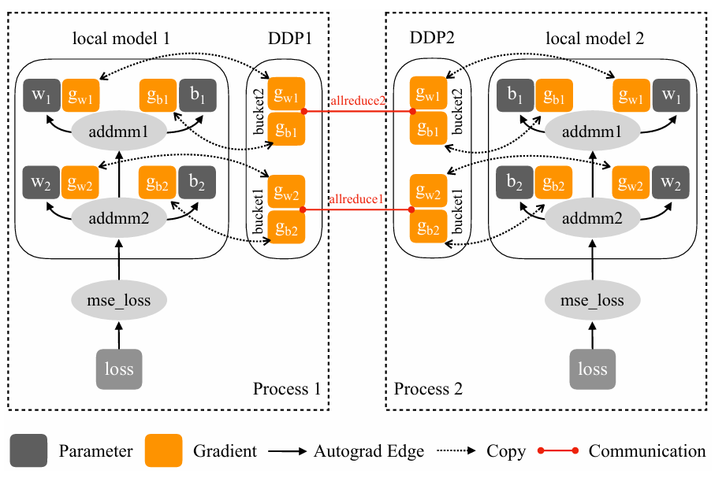

Parameter Server

Evaluation

Tree-based and Ring-based All-Reduce
1、Baseline_multi_card.py + all_reduce_train.py(Tree-based + Ring-based all-reduce)的吞吐量对比
2、润色all_reduce_train.py

Parameter Server

1、Baseline_multi_card.py、all_reduce_train.py、ps_train.py三者的吞吐量、loss收敛比较
2、润色ps_train.py

Distributed Data Parallel and Optimization
1、Baseline_multi_card.py、all_reduce_train.py、all_reduce_train_overlap.py、all_reduce_train_gradient_bucket.py、all_reduce_optimize_ddp_v1.5.py四者的吞吐量对比、loss收敛比较
2、润色all_reduce_train_overlap.py、all_reduce_train_gradient_bucket.py、all_reduce_optimize_ddp_v1.5.py

Performance of Single-GPU
1、Single_card.py、Baseline_multi_card.py、all_reduce_train.py三者的端到端、吞吐量
2、Single_card.py加上nsight分析
3、润色Single_card.py、Baseline_multi_card.py

References
- (CVPR2016) Deep Residual Learning for Image Recognition
- https://numpy.org/
- https://cupy.dev/
- https://github.com/matthias-wright/cifar10-resnet
- https://github.com/VanekPetr/ResNet-9
- https://pytorch.org/
- https://www.kaggle.com/datasets/hojjatk/mnist-dataset
- https://en.wikipedia.org/wiki/Stochastic_gradient_descent
- https://pytorch.org/docs/stable/amp.html
- https://docs.nvidia.com/nsight-systems/

