Automation Mini App Guide (Must Read)
This document is an English translation of 自动化小程序使用说明--必读.docx.
Author Xiaohongshu ID: stepccc
Tool Link: https://drive.google.com/drive/folders/1N-_xzrvTYMgO_pcRNl5jhJgFlPr6mq4l?usp=sharing
Setup Flow
1. Create your own folder in Google Drive. Copy the folder ID from the URL, such as the xxxxxx in https://drive.google.com/drive/folders/xxxxxx.
2. Open the provided folder 自动化投资记录分享-v0.1 and copy the template into your own folder.
3. Edit the template: Column A company names, Column B tickers, Column C share counts. Update pie chart ranges (Label A2:Axx, Value E2:Exx).
4. If you have one account, remove second-account rows/charts. If you have two accounts, keep both tables/charts.
5. Fill total holding cost in I21. Important: H21 is the script read position for total assets used in daily asset-change charts. Do not move it unless you also update code.
6. In Google Sheets, open Extensions -> Apps Script. In code.gs, set TARGET_FOLDER_ID to your folder ID. 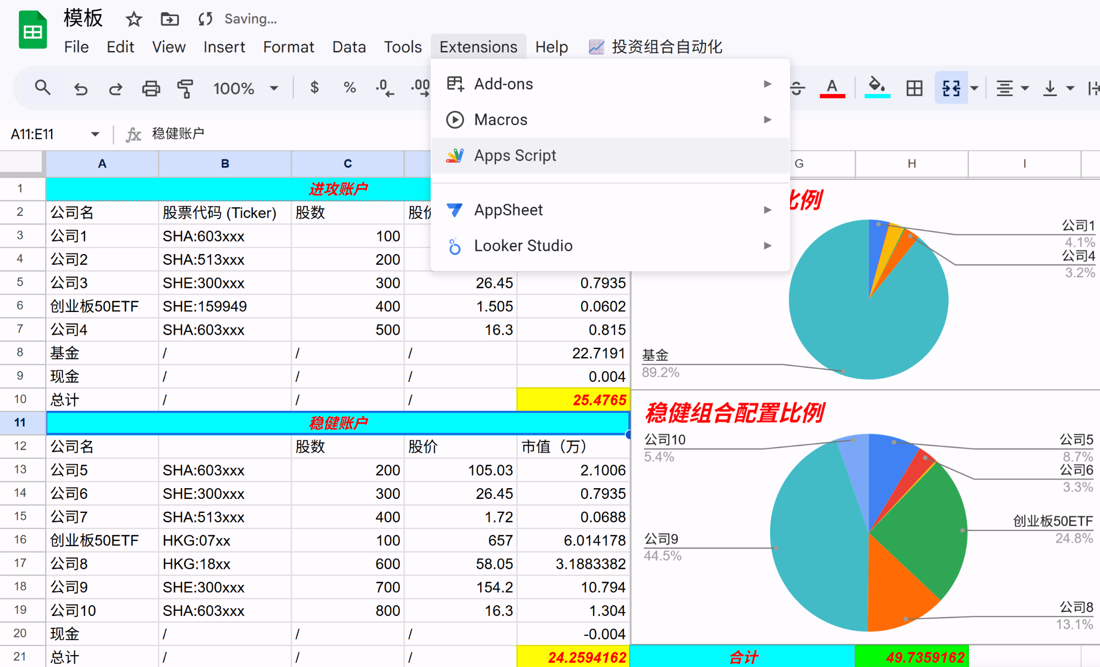
7. Run once for initialization. onOpen only adds menu buttons. Main function is runDailyPortfolioUpdate. Select it and click Run. 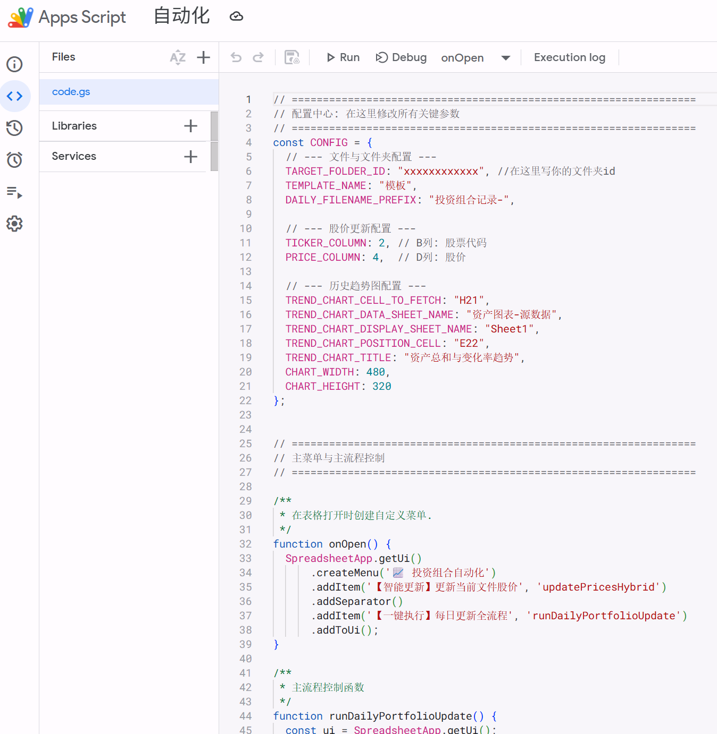
8. After verification, open Triggers and add a scheduled trigger (Add Trigger) for daily automation. 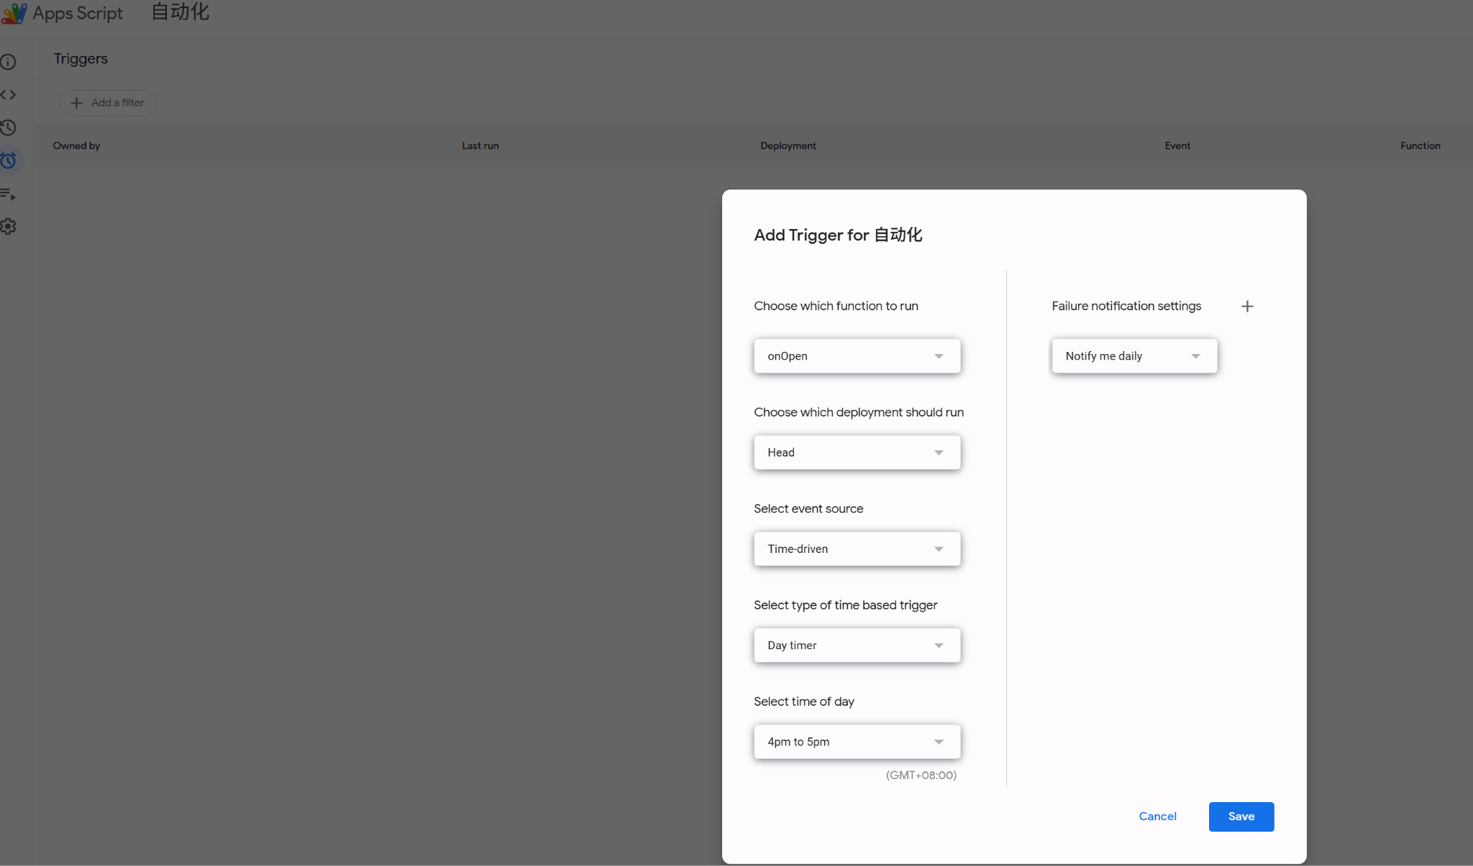
9. Asset-change charts require at least two days of data, so day 1 has no change chart. It appears from day 2. 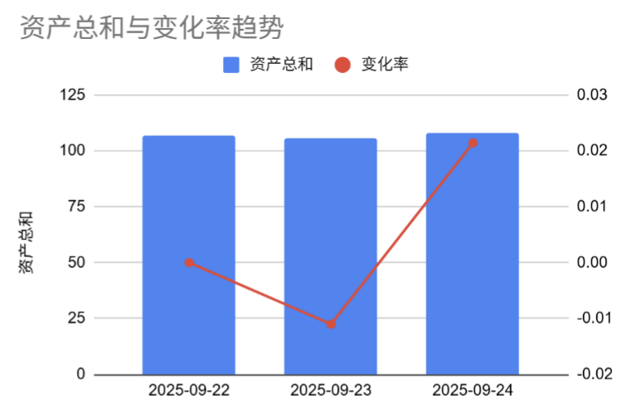
Update Log (Translated)
2025-09-25: Wrote this guide, fixed a potential trigger failure bug, and added daily/monthly asset-change summary tables (default start at J1). 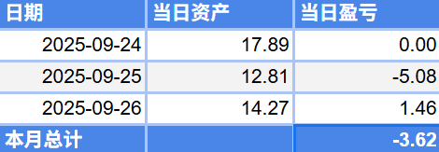
2025-09-26: Added non-trading-day logic. No new file is generated if assets are unchanged from the previous day.
2025-10-01: Added cost-change logic. Fill M2 with today cost so daily P/L accounts for deposits/additional buys.
2025-10-22: Cost input moved to I21. J/K/L/M became monthly asset statistics columns. Generated charts start at N1.

