# **T5 pure sine wave inverter**

# **T5.1 Circuit diagram**

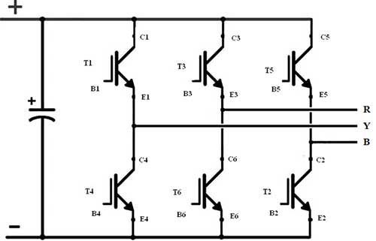

The basic circuit of inverter consists of 6 IGBTs connected like this diagram to produce 3-phase system every phase consists of 2 IGBTs each one has phase shift 180 degree which we call for example high side at 0 degree and low side for 180 degree the high side transistor is responsible for generating the positive side of the wave and the low side is responsible for generating the negative side of the wave .Each transistor of the high side has phase shift 120 degree from the next transistor and each transistor of the low side has 120 degree from the next transistor for example: the first phase high side has 0 degree; the second has 120 degree and the 240 degree and the same for low side.

**T5.2 Components**

**T5.2.1 IGBT**

The reason of using IGBT neither MOSFET nor BJT isn’t only because the high current and voltage rating but also it has their advantages like high current sensitivity at gate like BJT and high voltage sensitivity at gain like MOSFET.

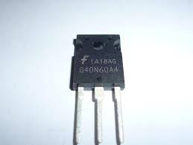

Fig. IGBT

**T5.2.2 Optocoupler driver**

The purpose of optocoupler driver is to drive the IGBT gate and isolate the power signal from the control signal in order to protect the power signal from the noise.

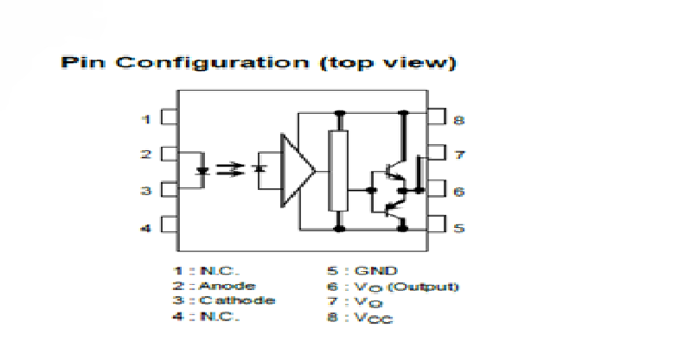

Fig. optocoupler driver

These are the main components of the main inverter circuit and now let us see the actual inverter circuit you may notice few differences from the basic circuit like the resistors and the capacitors each one has purpose like the 10k ohm resistor between the optocoupler output and the IGBT gate and the 330 ohm at the signal output in the Molex to reduce the amps ,the 10 ohm between the gate and the emitter to prevent parasitic turn on via miller capacitance stray inductance, and the capacitors connected to the driver to work as a filter for the rebels and the noise.

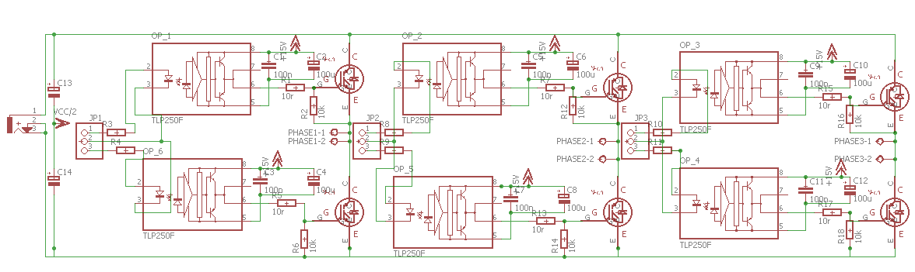

Fig. The actual inverter circuit

**The layout** 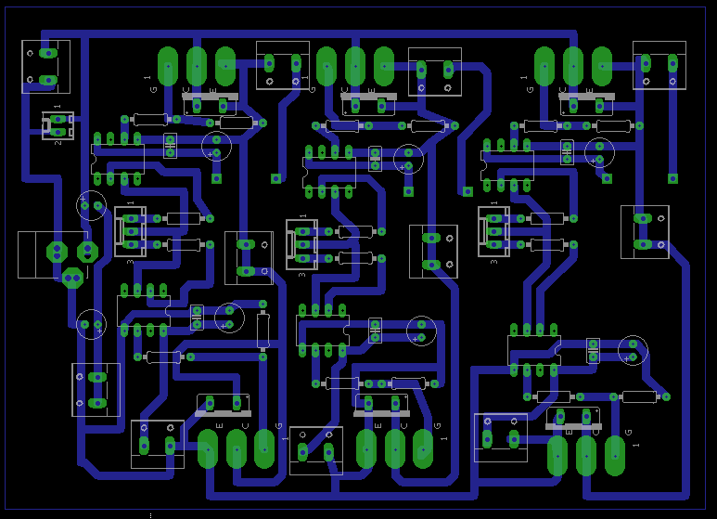

**T5.3 pilot circuit**

The pilot circuit is needed to operate and control the inverter output and here the circuit segments in this circuit we used in this circuit ATmega128 because it has two 16-bit timers (Timer1, Timer3), with each timer having 3 output compare units and also can operate in Phase and Frequency Correct (Center-Aligned PWM) mode which is enough for SVPWM signal generation.

**T5.3.1 Power supply**

The input voltage ranges from 12 to 9 volts the diode is used as a protection method from wrong connection, the 100Uf capacitors are used to reduce the rebels in the supply volt, the 100nF capacitors are used to eliminate the noise from other circuits, the regulator is used to produce 5v from the supply and the led is used as an indicator of the supply.

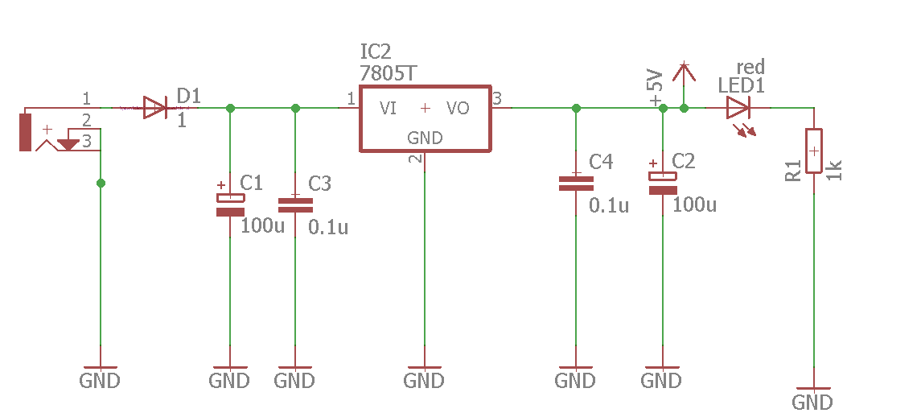

**T5.3.2 Reset circuit**

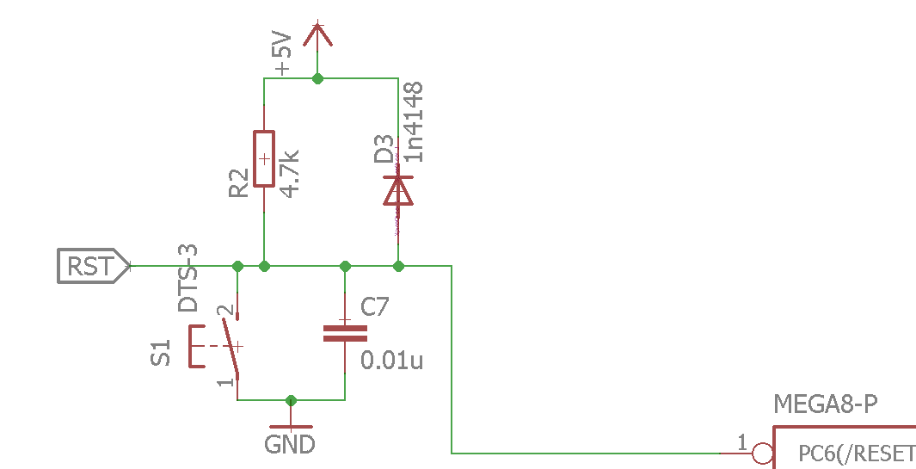

This circuit is the recommended reset circuit from Atmel.

**T5.3.3 Isp programming port**

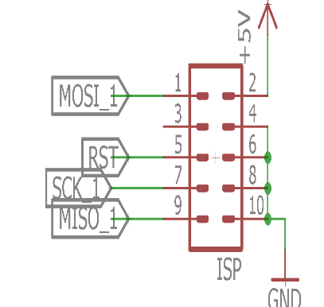

**T5.3.4 Logic circuits and Molex**

1-not gate

2- Schmitt trigger

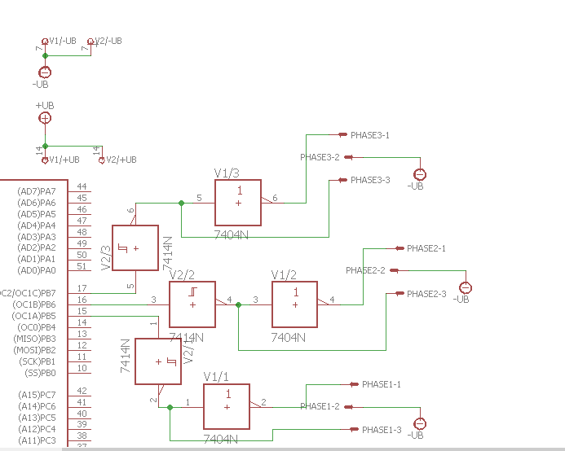

Fig. Schmitt trigger

The not gate is needed to make the phase shift 180-degree between the high and the low side of each phase the Schmitt trigger is used to make the output increase to a steady max value when the input is between 5v and 2 v and decrease to almost zero when the input is lower than 2, and the 3 pins Molex as output interface between the controller and the inverter circuit.

**T5.3.5 Clock circuit**

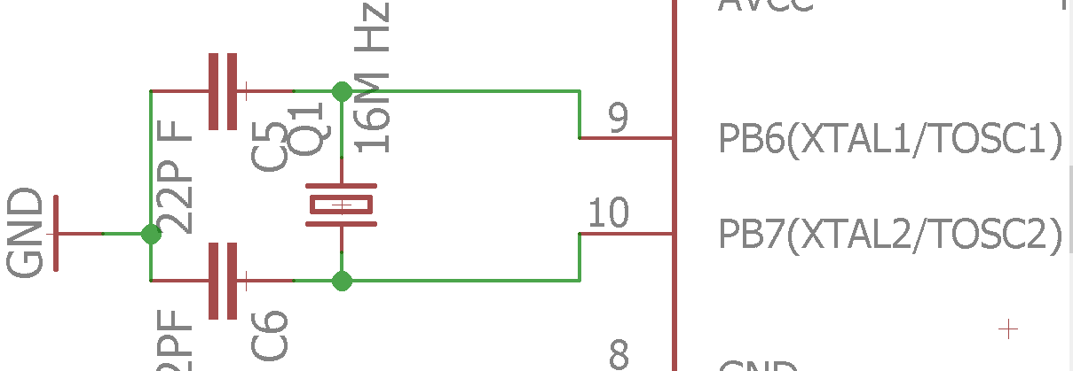

The 22 pF capacitors are needed to reduce the resonance at the start of the cycle

**T5.3.6 Data port**

The data port is needed to transfer the data collected from the co-pilot circuit which we need to vary the inverter speed, it consists of 8-bit parallel communication port to receive procced data from the co -pilot, acknowledge as confirmation flag between the co-pilot and the pilot, ready to initiate new data transfer , direction pin which indicates the direction of the motor, RST which is master reset pin between the two controllers and of course the positive and negative rail of the circuit.

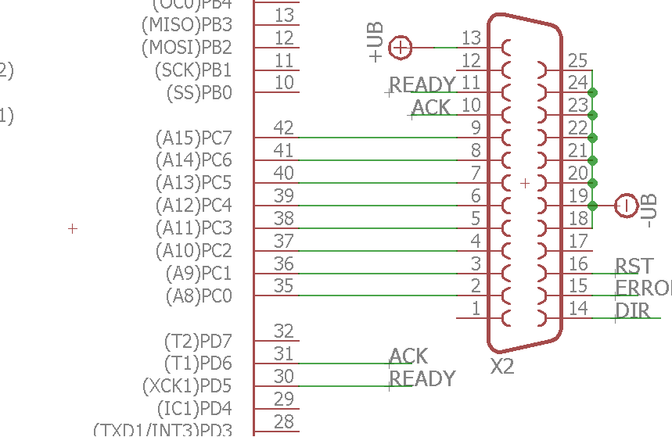

**Full circuit diagram**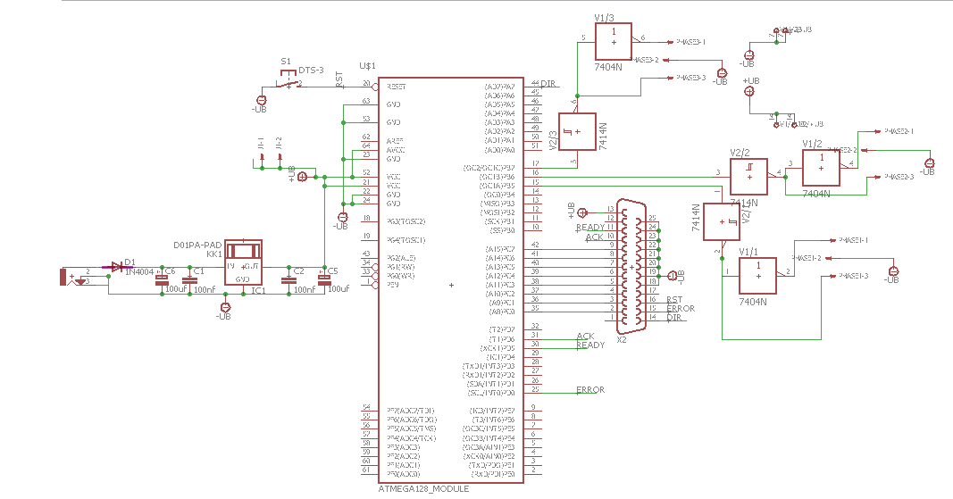

**The layout**

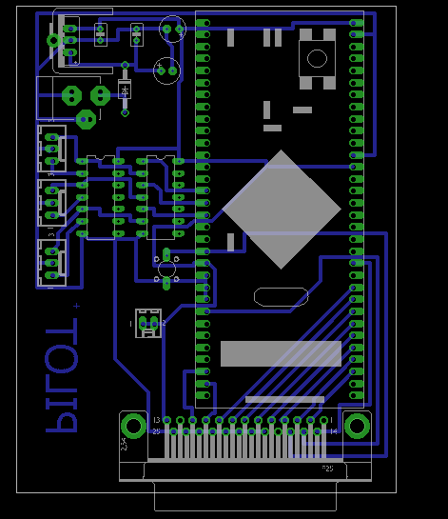

**T5.4** **co-pilot circuit**

The purpose of the co-pilot circuit is to transform the analog signal from the potentiometer into digital value stored in one single port and display the output of the inverter on LCD for this circuit we have chosen ATmega32 due to presence of large program memory size, SRAM size and number of I/O pins.

1- Clock

The clock circuit is the same like the previous circuit.

2-Data port

The same like the last circuit except that this circuit is the one which transmits the data.

3-Pedals interface

The interface between the circuit and the pedal is 3 pins one; connected to ground, one to and the last one in the middle is connected to ADC pin in microcontroller.

4-Direction interface

We use 3 position switch to display the 3 states of the motor clockwise direction, anti-clockwise direction and stop.

5-LCD Display

We use 16*2-character LCD to display voltage, frequency and speed.

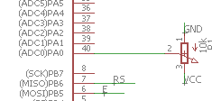

**Full circuit diagram**

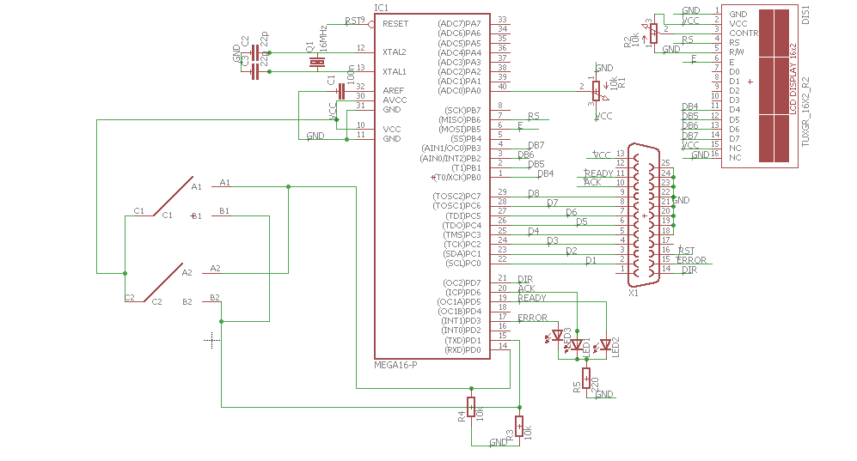

**The layout**

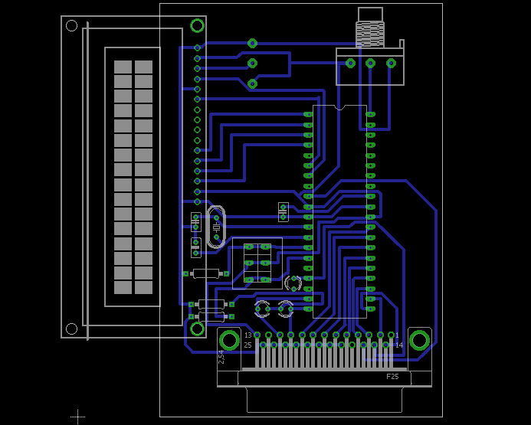

**T5.5 DC filter**

We know from the datasheet of the IGBT that the voltage level needed to open the gate is 15 V so the use of dc filter is to reduce the voltage levels difference between sources so the IGBT gates will open simultaneously. We use four dc filters one for the low side transistors and one for each transistor of the high side.

Circuit diagram

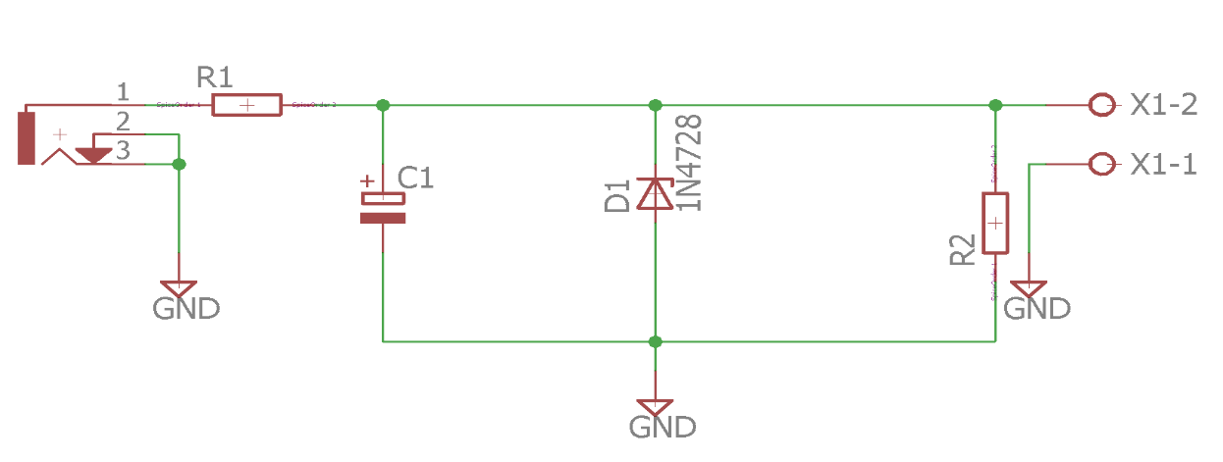

**The layout**

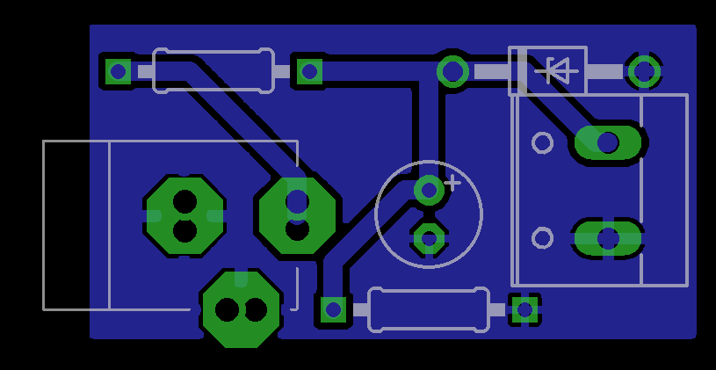

**T5.6 LC Filter circuit**

It is known that the output of the inverter is a square wave but we need sinusoidal wave so we need low pass filter circuit like LC filter which consists of inductor reactance and capacitor impulse on the inverter and motor terminals

The values of the capacitor and the inductor is given by

Where

is the cut off frequency in hertz

is mathematical =3.14

L is the inductance in Henry

C is the capacitance in Farad

For this study case the frequency from the MCU is 7000 HZ

In order to get rid of switching harmonics (up to tenth harmonic)

the cut off frequency of the filter has to be (at most) 700HZ

the available inductance in the market value is 150 u Henry

so, the needed capacitance is 374 u Farad but due to lack of such value in the market we used 8 capacitors each capacitor is 47uFarad for each phase.

**Yet such filter will not be able to sustain sine wave shape under every loading condition so a damper circuit is needed.**

**Circuit diagram**

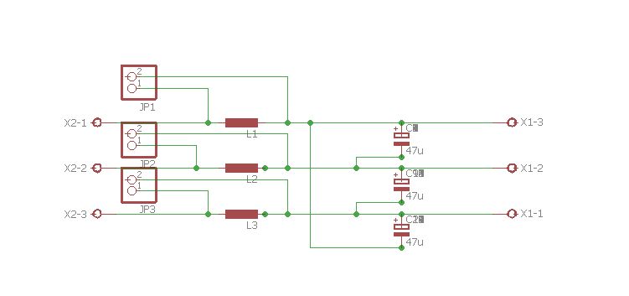

**The layout**

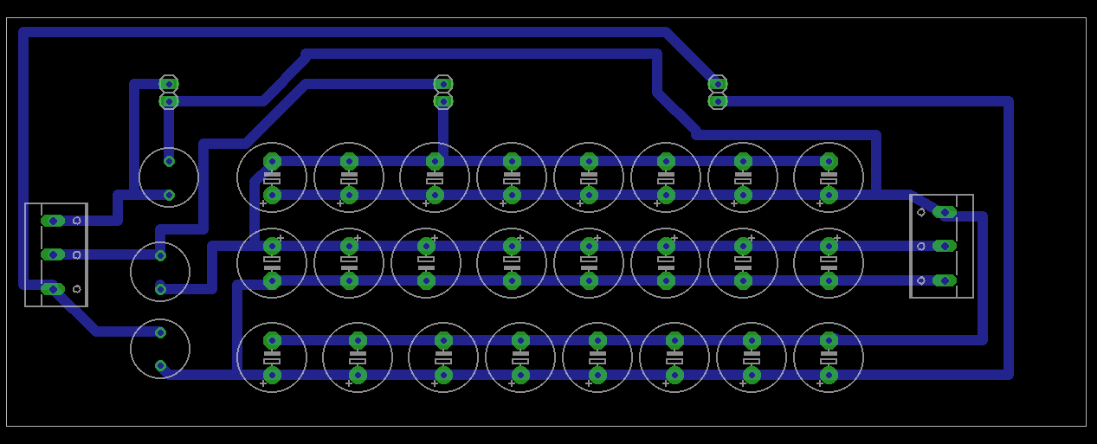

**T5.7 Damper circuit**

The presence of dumper eliminates any occasional ringing of output form and helps stabilizes its faster.

There are two kinds of damper

1- series damper:

it consists of a resistor connected in series with inductor and this arrangement is connected parallel with LC filter inductor.

Rd=sqrt(L/C)

Ld=n*L

WHERE n =2/15

2-parallel Damper:

it consists of a resistor connected in series with Capacitor and this arrangement is connected parallel with LC filter Capacitor.

Rd=sqrt(L/C)

Cd=n*C

WHERE n =4

We used in our circuit series damper because the value of the required inductor value is easier to obtain more than the required capacitor in case of parallel damper.

So:

Rd=0.63 ohm

Ld= 20u Henry

**Circuit diagram**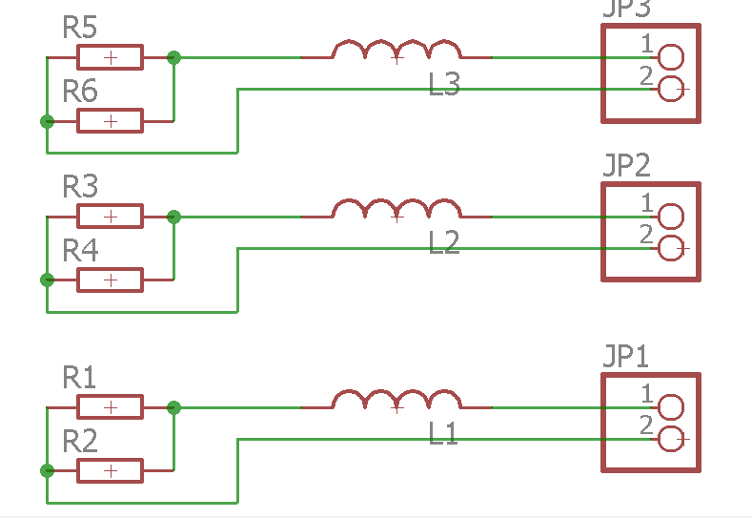

**The layout**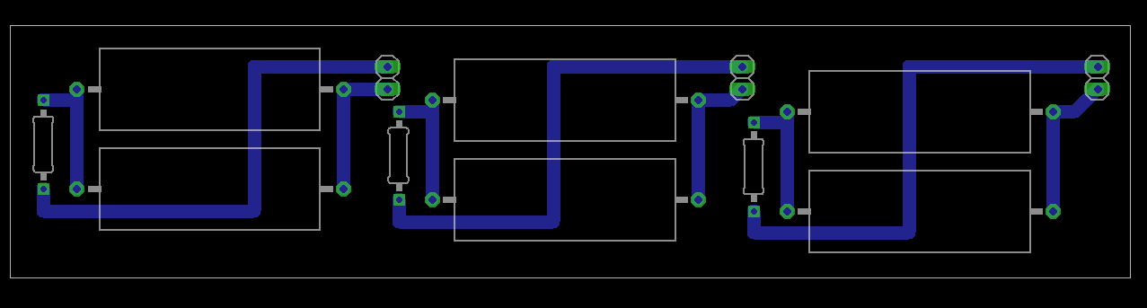

**T6 Excel sheet for inverter calculations**

**This sheet is used to calculate the amp of the motor as the power and voltage is given &to insert the frequency to be used in further equations.**

**This sheet is used to calculate both the voltage and amp as rms value**

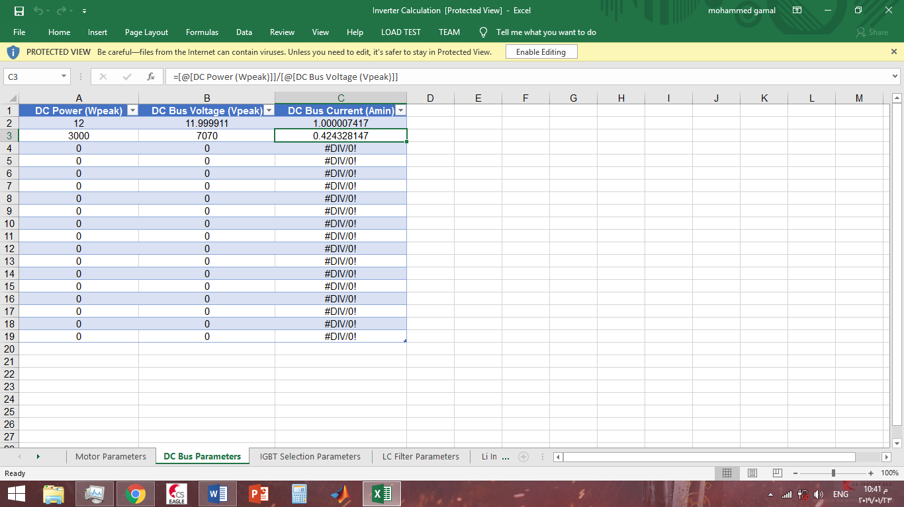

**This sheet to calculate the parameter on which we has chosen the IGBT used in the inverter circuit.**

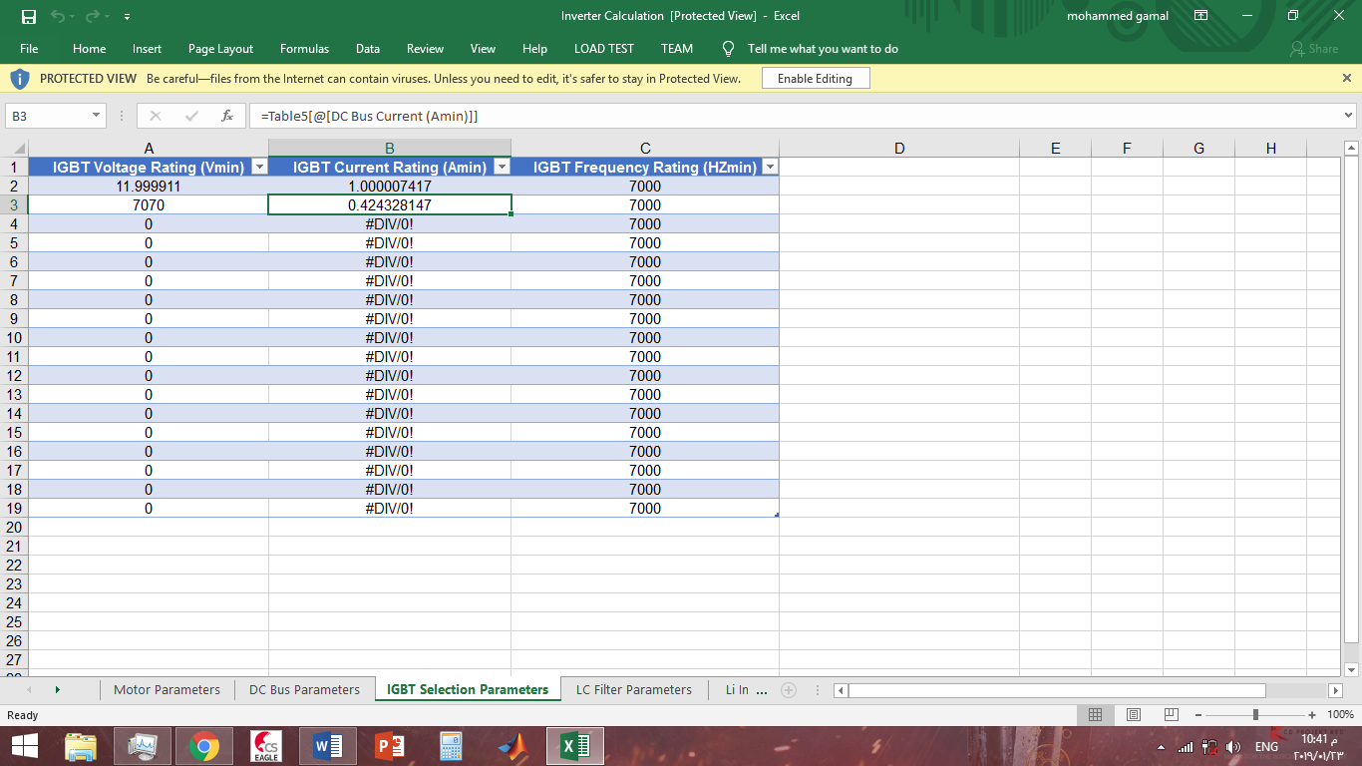

**In this sheet we calculated the parameters of the LC filter and its damper we select reactive power parentage and current ripple due to the application.** 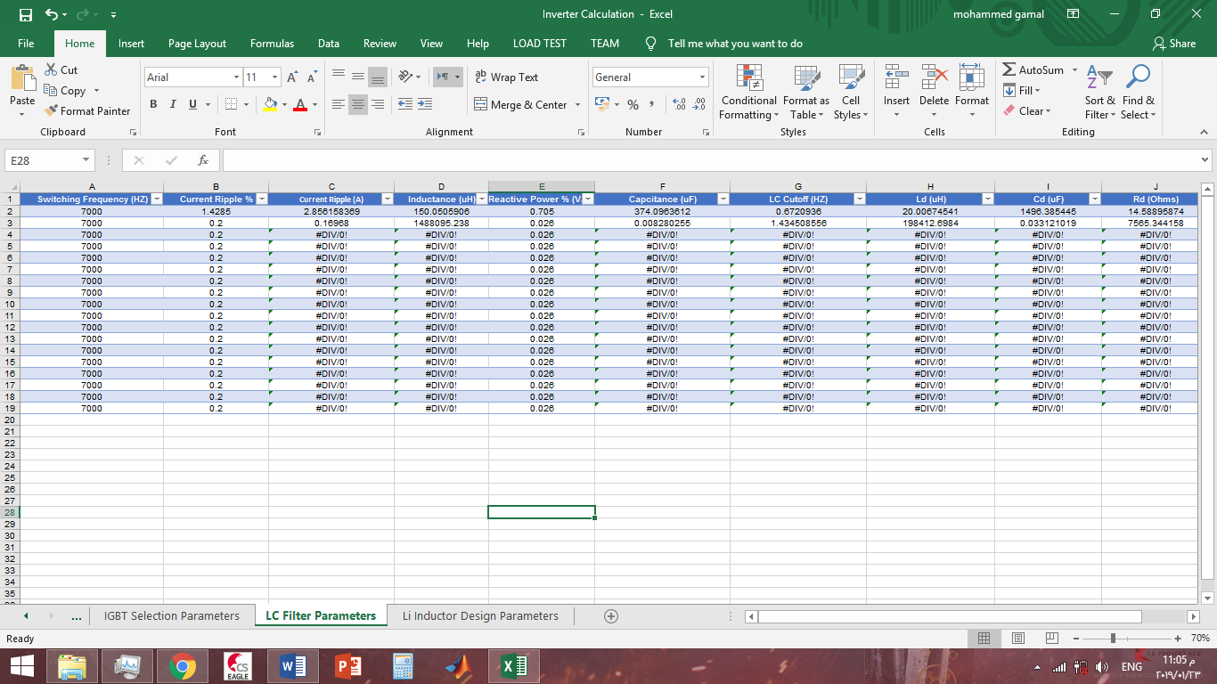

**This sheet is used to calculate the number of turns for the toroid inductor base on the available core dimensions and the calculated inductance from the previous sheet.**

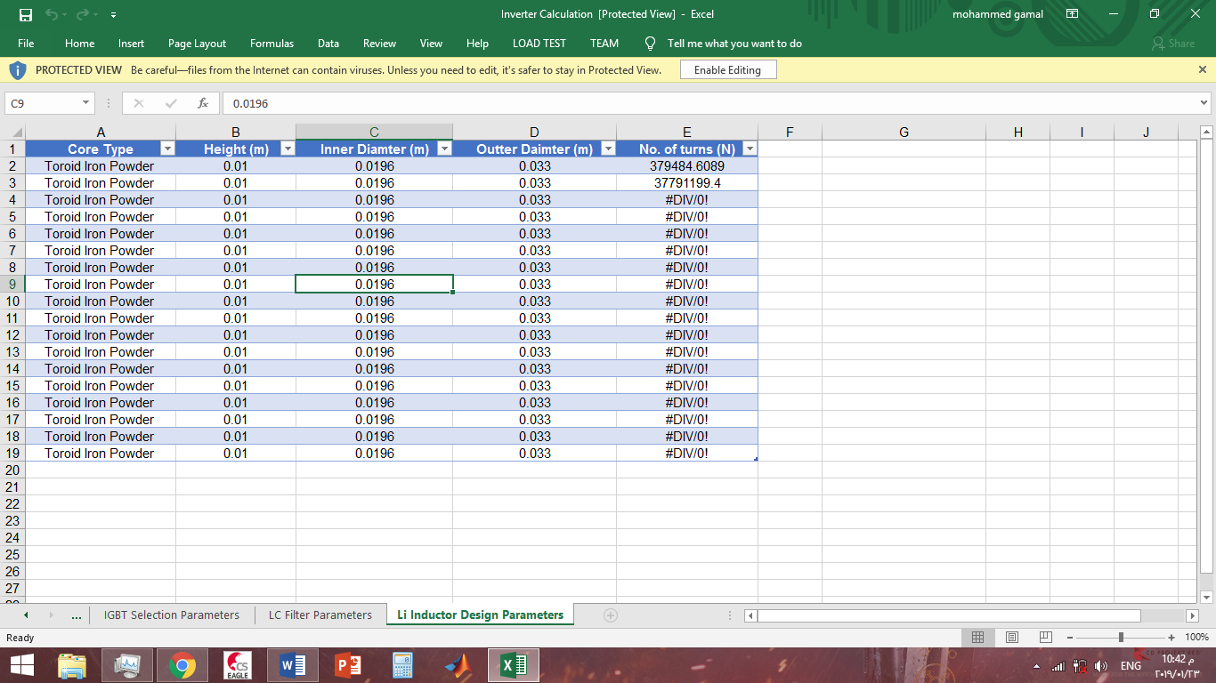

**T7 MATLAB simulation**

**in case of basis inverter, no filter applied**

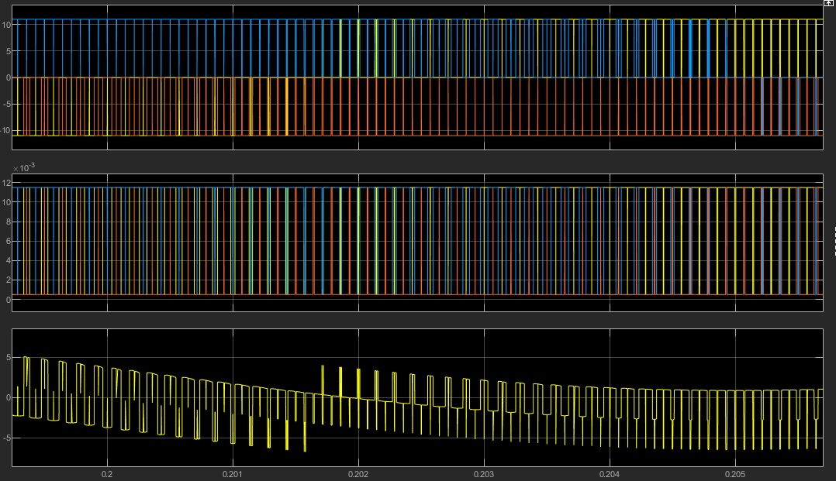

**we see that the output is square wave.**

**in case of inverter with LC filter without the damper**

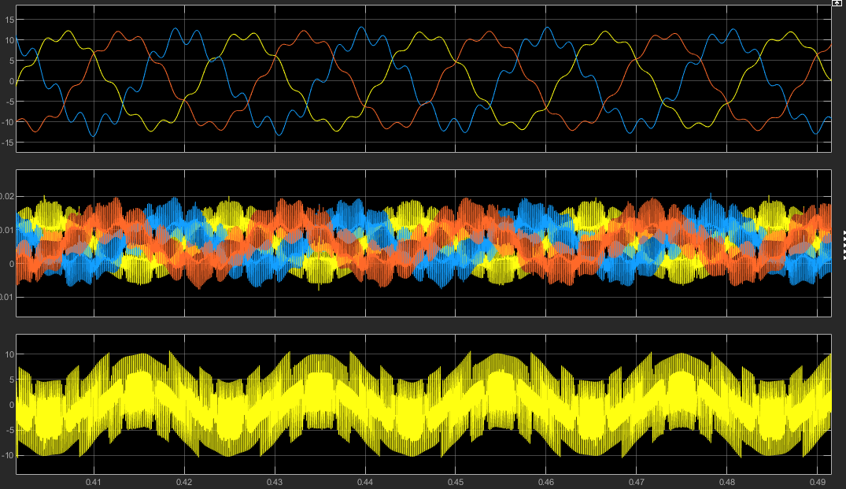

the wave form takes time to stabilize and even after stabilization the occasional ringing of output form which presents sin wave but with ripples on the peak of the wave.

**in case of the inverter with filter and damper**

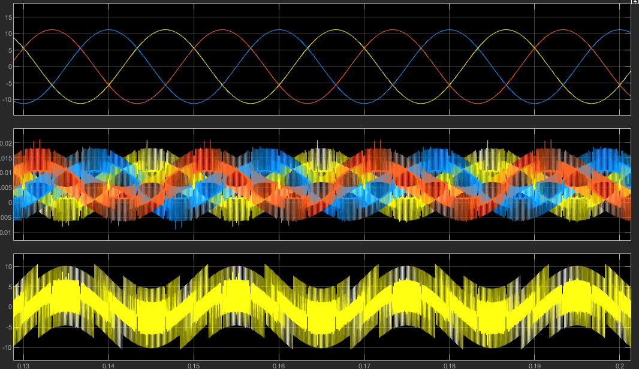

**we note the occasional ringing of output form is eliminated and the wave form is stable and presents pure sin wave from the start even on high loads.**

**T8 the advantages of Pure Sine-wave inverters**

-The output waveform is a sine-wave with very low harmonic distortion and clean power like utility supplied electricity

-Inductive loads like microwaves and motors run faster, quieter and cooler

-Reduces audible and electrical noise in fans, fluorescent lights, audio amplifiers, TV, fax and answering machines

-Prevents crashes in computers, weird print outs and glitches in monitors