**EECE 6357, Fall 2021, assignment 9**

**Due date 12/16/2021**

In this assignment you are asked to implement an active shape method to fit hand models to a series of points. You are provided with a series of .tif images that are pictures of the same hand in different positions. You need to use these pictures to build an active shape model as described by Cootes at al. in their paper “Active Shape Models – Their Training and application” (Computer Vision and Image Understanding, 61(1), pp. 38-59, 1995). You will then be provided with test files that will contain a number of points to which your program will need to fit a hand. The first step when building a model is to register all the training shapes to each other. The process you need to use is to (a) select a shape from the training set, (b) register all the other shapes to that one, (c) average the shapes after registration, (d) replace the shape you used in (a) by the average shape, (e) repeat the process until convergence. You can use any registration method we have discussed during the semester to accomplish this. As shown in Figure 1, your program will need to show me the hands before registration, after the registration process has converged, and the final average shape. The next step is to create the eigenshapes, i.e., the eigenvectors of the points’ covariance matrix. As shown in Figure 2 your program will need to show me what kind of motion the first four eigenshapes capture. You will need to show me an animation in which the eigenshapes are multiplied by a factor that ranges from -100 to 100 by steps of 10 and added to the mean shape. Figure 2 shows a snapshot of the interface when the factor is -100. The final step is to fit your shape model to a set of points you will be provided. These points will be in an Nx2 double array called xy2 that will contain the x and y coordinates of the points. **N is the number of points you need to fit your model to and you cannot assume that N is known, i.e., N could vary from testing set to testing set. Also, these points will not necessarily be evenly spaced along the contours and they may be poorly selected.** As discussed in class, fitting your model to a set of points is an iterative process and you are free to implement any interface that can display what is shown in Figure 3 and Figure 4, i.e., the target shape (the points to which the you need to fit your model), how different the target shape is from the mean shape, how your algorithm converges to the target shape, and the final result.

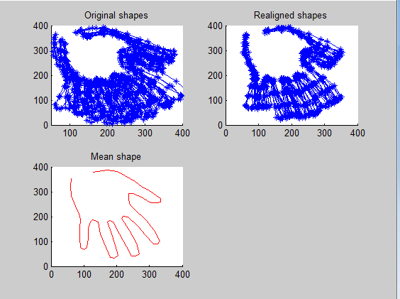

**Figure 1:** Top left panel, original shapes; top right panel shapes realigned to mean shape after the registration process has converged; bottom left, final average shape

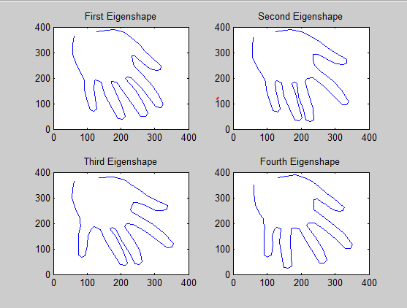

**Figure 2:** Mean shape to which each of the first four eigenshapes are added (the multiplication factor used here is -100)

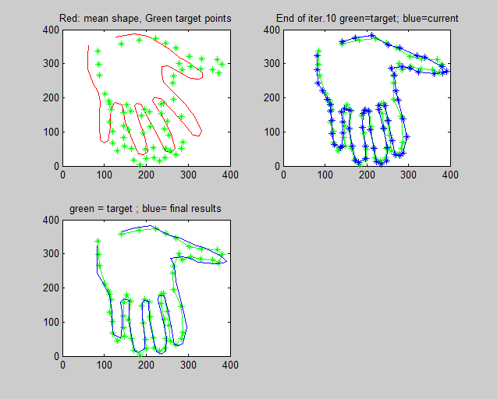

**Figure 3:** Top left: mean shape and target point; Top right fitting of model to target points after first iteration; bottom left, final results

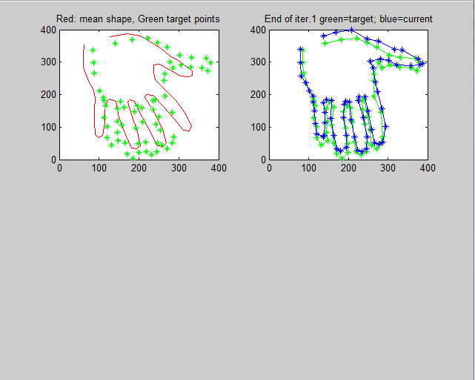

**Figure 2:** Top left: mean shape and target point; Top right fitting of model to target points after first iteration