CONFIDENTIAL REPORT

Subject: N■■■■■■■■■, the Guardian of the Ruins

Description
N■■■■■■■■■ is a nightmarish creature with a skeletal and emaciated body, characterized by tense muscles and prominent veins. It possesses a head resembling a metallic box with glowing red eyes that seem to pierce the soul of those who dare to gaze upon it. Its long, clawed arms and legs end in razor-sharp fingers, and cables or metallic tentacles emerge from its body, writhing around it like serpents ready to strike.

Origins
N■■■■■■■■■ was born from an a■■■■■■ technomantic ritual practiced by a long-lost advanced c■■■■■■■■■■■■. Obsessed with immortality and the fusion of t■■■■■■■■ with biology, this c■■■■■■■■■■■■ created cybernetic entities to serve as eternal g■■■■■■■■ of their s■■■■■■. N■■■■■■■■■ is one of the last surviving g■■■■■■■■, condemned to wander the ruins of its creators forever.

Behavior
N■■■■■■■■■ is a creature of the s■■■■■, moving silently and attacking without warning. It uses its metallic tentacles to capture its victims, immobilizing them before examining them with its glowing red eyes. Those who meet its gaze are plunged into a hypnotic trance, reliving the final moments of the lost c■■■■■■■■■■■■ - a harrowing experience that often leaves them catatonic.
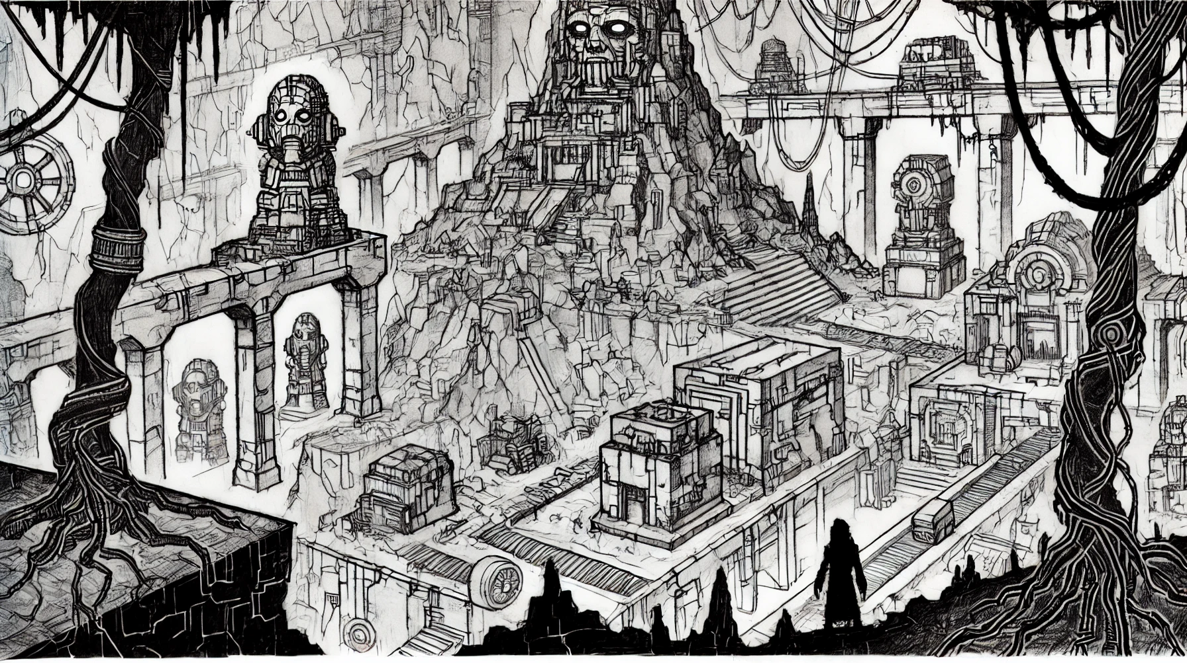

CONFIDENTIAL REPORT

Powers and Abilities
- Hypnotic Gaze: N■■■■■■■■■' eyes can hypnotize and paralyze its prey, rendering them vulnerable.
- T■■■■■■■■ Manipulation: It can interact with and control a■■■■■■ and modern t■■■■■■■■, using its tentacles to hack and manipulate systems.
- Regeneration: Its cybernetic capabilities allow it to rapidly regenerate from injuries, making it nearly impossible to kill.
- Partial Invisibility: N■■■■■■■■■ can blend into the s■■■■■, becoming almost invisible to the naked eye.

Habitat
N■■■■■■■■■ haunts the technological ruins of its c■■■■■■■■■■■■, ranging from underground labyrinths to crumbling towers, where the echoes of old machines still resonate. These places are filled with technological traps and a■■■■■■ relics, adding to the danger of venturing into its territory.

Legend
Survivors who have encountered N■■■■■■■■■ speak of it as a cursed g■■■■■■■■, doomed to protect s■■■■■■ that no longer matter to anyone. It is said that destroying N■■■■■■■■■ would free the souls trapped by its gaze, but no one has ever succeeded.

Current Relevance
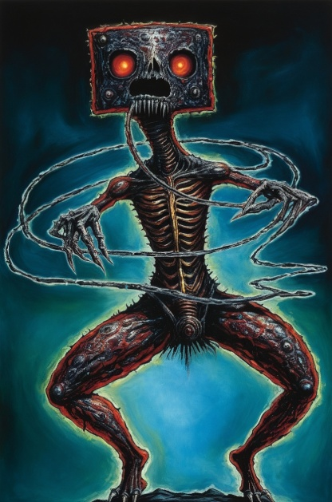
In the modern world, N■■■■■■■■■ has become an urban legend, a story told to frighten explorers and adventurers. However, some researchers of a■■■■■■ t■■■■■■■■ believe in its existence and seek to uncover the s■■■■■■ it guards, hoping that the knowledge of the lost c■■■■■■■■■■■■ could revolutionize the modern world.

