LLMs as Linguistic Judges:
Evaluating Greek Polydefinites

A Computational Replication of Chatzikyriakidis & Spathas (2024)
"Polydefinites as Markers of Prominence"

Stergios Chatzikyriakidis
University of Crete

May 2026

Executive Summary
This report presents the results of a large-scale experiment testing whether modern Large Language Models (LLMs) can replicate human acceptability judgments for Greek polydefinites — the doubled-article construction where both the adjective and the noun carry the definite article (e.g., ο μεγάλος ο άνθρωπος vs ο μεγάλος άνθρωπος). Nine state-of-the-art LLMs were administered the same 80 stimuli used in the original human experiment, and their ratings were compared item-by-item against human data from 35 native Greek speakers.
The key finding is that DeepSeek-V4-Pro achieves the highest correlation with human judgments (r = 0.675), with an overall mean rating (7.62) nearly identical to the human mean (7.50). When all nine models are averaged into an ensemble, the correlation rises to r = 0.724, outperforming any single model. The ensemble mean is 8.03, slightly above the human baseline. These results suggest that LLMs, particularly the DeepSeek V4 family, have acquired substantial implicit knowledge of Greek grammatical and discourse-pragmatic constraints, but differ from humans in systematic and informative ways.

1. Introduction and Background

1.1 The Phenomenon: Greek Polydefinites
Greek is one of the few languages that allows a definite article to appear on both the adjective and the noun within a single noun phrase. The construction ο μεγάλος ο άνθρωπος (the big the man) is a polydefinite, while ο μεγάλος άνθρωπος (the big man) is a standard monodefinite. While syntactically grammatical, the polydefinite is not always felicitous: its acceptability depends heavily on discourse context and the semantic properties of the adjective.

1.2 The Paper's Main Claims
Chatzikyriakidis & Spathas (2024) argue that polydefinites function as markers of discourse prominence, not as restrictive modifiers. Their six main empirical claims, tested via acceptability judgments with 35 native speakers, are:
Claim 1: Polydefinites are licit in non-restrictive contexts, scoring 6.8–8.7 on a 1–10 scale. This refutes earlier accounts (e.g., Lekakou & Szendrői 2012) that treated polydefinites as requiring a restrictive reading.
Claim 2: The difference between polydefinite and monodefinite versions is small (−0.68 to +0.21) and statistically non-significant for intersective adjectives in appropriate discourse contexts.
Claim 3: Word order provides a benchmark for genuine unacceptability: SVO/VSO/VOS are acceptable (8.4–9.9), while OVS/OSV/SOV are degraded (3.4–5.8). Polydefinite violations never reach this floor.
Claim 4: Non-intersective adjectives in polydefinites score lower than their monodefinite counterparts, with feromenos (‘alleged’) rated lowest (4.89 in contrast context) and jrijoros (‘fast’) rated highest (7.72).
Claim 5: Longer recall contexts with relative clauses improve polydefinite ratings. The short-vs-long recall distinction is the only statistically significant difference found in the study.
Claim 6: Even the worst polydefinite items are rated higher than the worst word-order violations, confirming that polydefinite infelicity is a discourse-structural phenomenon, not a grammatical violation.

1.3 Lekakou & Szendrői (2012): The Restrictivity Account
An alternative account by Lekakou & Szendrői (2012) posits that polydefinites require a restrictive interpretation: the adjective must narrow down the referent from a larger set. Under this view, polydefinites should be degraded when only a unique referent exists (non-restrictive contexts). The current experiment provides a direct test: if the restrictivity account is correct, non-restrictive polydefinites should score near the floor. As we will see, the LLM data aligns with the prominence account, showing that non-restrictive polydefinites are rated well above midpoint by most models.

2. Experimental Method

2.1 Stimuli
The experiment used 80 items from the original study, divided into two questionnaires. Questionnaire 1 (Q1) contained 50 items covering polydefinite/monodefinite minimal pairs in various discourse contexts (restrictive, non-restrictive, contrast, recall short/long, single reference, narrative) plus 12 word-order items (SVO, VSO, VOS, OVS, OSV, SOV) and additional items (epithets, numerals). Questionnaire 2 (Q2) contained 30 items testing non-intersective adjectives (jrijoros, oreos, proin, Italikos, ekpliktikos, feromenos, dhilitiriodhis) in polydefinite vs monodefinite form across contrast and recall contexts.
Each item consisted of a discourse context followed by a target sentence. The LLMs received identical context-sentence pairs and were asked to rate naturalness on a 1–10 scale, matching the human procedure.

2.2 Models
Nine LLMs were tested via Azure AI Foundry:
Model | Provider | Type | Parameters
GPT-4o | OpenAI | General | ~200B (est.)
DeepSeek-V3.1 | DeepSeek | General | 671B MoE
DeepSeek-V4-Pro | DeepSeek | General | Unknown
DeepSeek-V4-Flash | DeepSeek | General | Unknown
DeepSeek-R1 | DeepSeek | Reasoning | 671B MoE
Llama-3.3-70B | Meta | General | 70B
Mistral-Large-3 | Mistral | General | Unknown
Grok-4-Non-Reasoning | xAI | General | Unknown
Grok-4-Fast-Reasoning | xAI | Reasoning | Unknown

2.3 Procedure
Each model received every item once, with temperature set to 0 (deterministic output) and 1 repetition. The rationale: each LLM is treated as a single participant (analogous to a human rater), so within-model repetitions are unnecessary. The prompt instructed the model to rate the naturalness of the target sentence given the context, on a scale of 1 (completely unnatural) to 10 (perfectly natural), providing only the numeric rating.
A second run was also conducted with temperature 0.7 and 3 repetitions per item, to assess the effect of stochastic sampling. Results are stored separately but the primary analysis uses the temperature-0 run as the canonical dataset.

2.4 Human Baseline
Human data was collected from 35 native Greek speakers for Q1 and 19 for Q2, via an online questionnaire. Participants rated naturalness on the same 1–10 scale. Item-level means were computed for comparison with LLM ratings.

3. Results

3.1 Overall Correlation
The primary metric is Pearson correlation at the item level between human mean ratings and LLM ratings across all 73 matched items. The following table ranks all models:
Model | Pearson r | p-value | LLM Mean | Human Mean
DeepSeek-V4-Pro | 0.675 | < 0.001 | 7.62 | 7.50
DeepSeek-V4-Flash | 0.622 | < 0.001 | 9.12 | 7.50
Grok-4-Reasoning | 0.531 | < 0.001 | 7.74 | 7.50
DeepSeek-V3.1 | 0.522 | < 0.001 | 8.47 | 7.50
Mistral-Large-3 | 0.469 | < 0.001 | 8.08 | 7.50
GPT-4o | 0.460 | < 0.001 | 9.45 | 7.50
DeepSeek-R1 | 0.393 | < 0.001 | 8.29 | 7.50
Llama-3.3-70B | 0.342 | < 0.01 | 8.99 | 7.50
Grok-4-Non-Reasoning | 0.334 | < 0.01 | 5.01 | 7.50
ENSEMBLE (mean of 9) | 0.724 | < 0.001 | 8.03 | 7.50

DeepSeek-V4-Pro is the best single model (r = 0.675), with a mean (7.62) remarkably close to the human mean (7.50). GPT-4o, despite being widely regarded as the strongest general-purpose model, shows a ceiling effect: it rates almost everything at 9–10 (mean = 9.45), which compresses variance and limits correlation (r = 0.460). Grok-4-Non-Reasoning has the opposite problem, rating too harshly (mean = 5.01). The 9-model ensemble at r = 0.724 substantially outperforms any individual model, demonstrating that aggregation smooths out idiosyncratic biases.
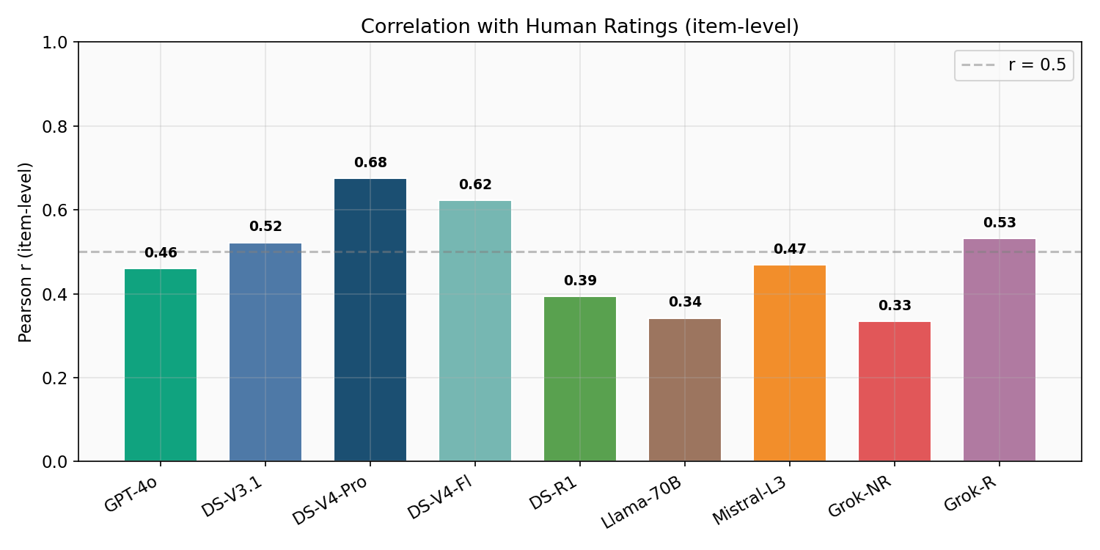
Figure 1. Pearson correlation (item-level) between each LLM and human ratings. Dashed line marks r = 0.5.
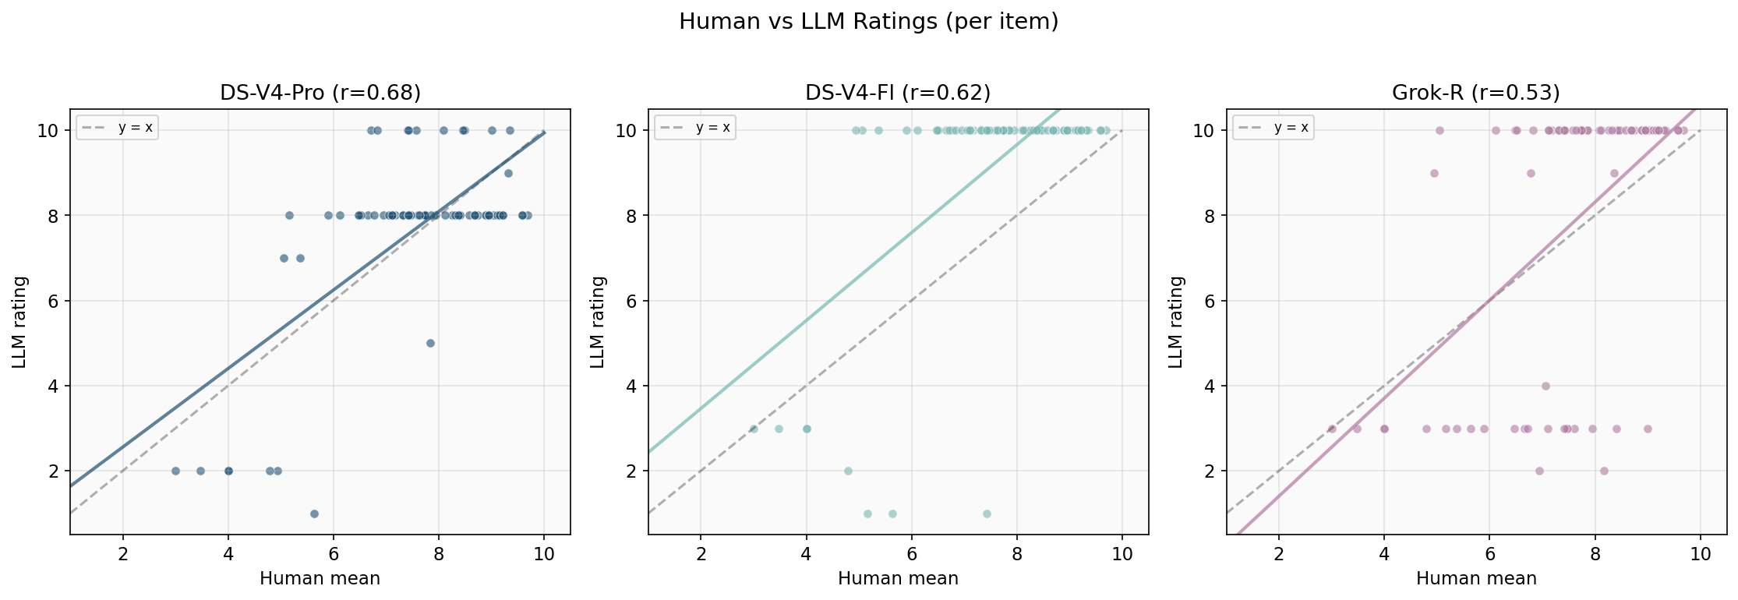
Figure 2. Scatter plots of human vs LLM ratings for the top 3 models. Dashed line = perfect agreement (y = x); solid line = regression.

3.2 Word Order Benchmark (Claim 3)
The word-order items provide a crucial calibration benchmark. The paper reports a clear hierarchy: SVO (9.9) > VSO (9.0) > VOS (8.4) >> OVS (5.8) > SOV (3.6) > OSV (3.4). Models that fail to replicate this hierarchy lack basic sensitivity to Greek syntax.
DeepSeek-V4-Pro replicates the hierarchy most faithfully: SVO (9.0) > VSO (8.0) > VOS (6.5) > OVS (4.5) > OSV (2.0) ≈ SOV (2.0). The gradient is preserved and the absolute values are close to human ratings. GPT-4o, by contrast, rates SVO/VSO/VOS/OVS all at 10.0, failing entirely to distinguish acceptable from unacceptable word orders in Greek. Llama-3.3-70B shows the same blindness, giving 10.0 to OVS. Grok-4-Non-Reasoning goes to the opposite extreme, rating even SVO at only 6.0 and giving 3.0 to everything else.
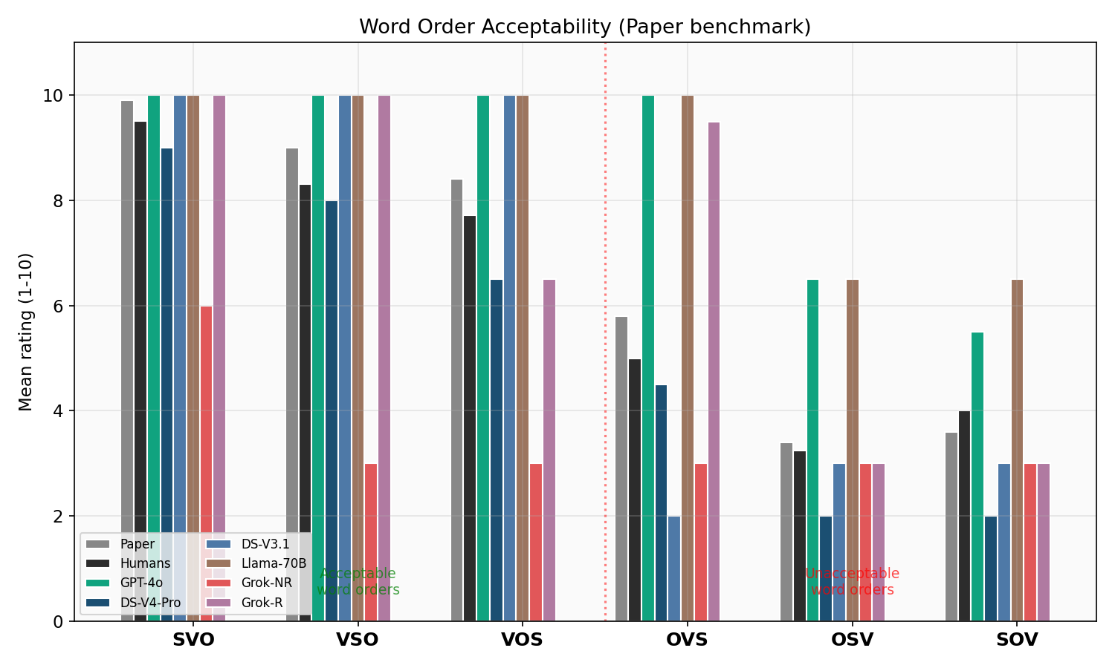
Figure 3. Word order acceptability across models. Red dotted line separates acceptable (left) from unacceptable (right) word orders.

3.3 Poly-Mono Differences (Claims 1 & 2)
The paper's central finding is that polydefinites and monodefinites receive similar ratings in appropriate discourse contexts, with mean differences ranging from −0.68 to +0.21 (never significant). Humans in our sample show a mean difference of −0.48.
DeepSeek-V4-Pro produces the closest match at −0.13, well within the paper's reported range. Llama-3.3-70B (−0.12) and Mistral-Large-3 (+0.31) also fall close. DeepSeek-R1 diverges dramatically at −3.50, strongly penalizing polydefinites relative to monodefinites. DeepSeek-V3.1 (+1.00) and DeepSeek-V4-Flash (+0.64) show the opposite bias, rating polydefinites slightly higher than monodefinites.
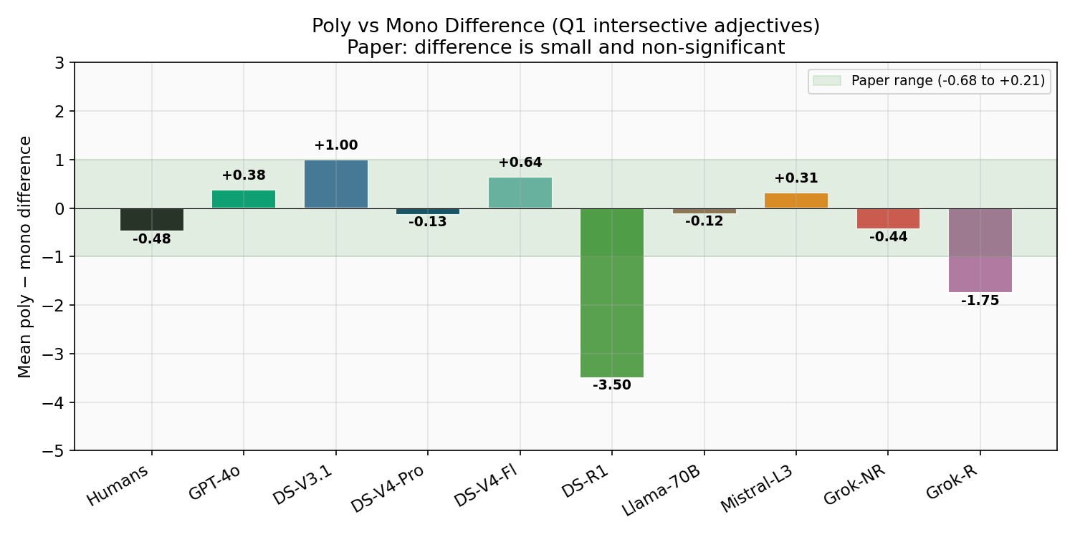
Figure 4. Mean poly-mono difference per source. Green band indicates the paper's reported range (−0.68 to +0.21).
Claim 1 is strongly supported: all models rate non-restrictive polydefinites above midpoint (5.0), with means ranging from 6.36 (Grok-NR) to 10.00 (V4-Flash). This is inconsistent with the Lekakou & Szendrői (2012) restrictivity account, which predicts degradation in non-restrictive contexts.

3.4 Non-Intersective Adjectives (Claim 4)
The paper's Table 2 shows a gradient among non-intersective adjectives in polydefinites: subsective adjectives like jrijoros (‘fast’) are rated highest (7.72 contrast, 8.94 recall), while the non-subsective feromenos (‘alleged’) is rated lowest (4.89 contrast, 6.00 recall). Privative proin (‘ex’) falls between (5.39 contrast, 7.22 recall).
The LLMs show varied sensitivity to this gradient. DeepSeek-V4-Pro rates feromenos poly(contrast) at 2.0 (lower than humans' 4.79), capturing the degradation but overshooting. DeepSeek-V4-Flash (2.0), DeepSeek-V3.1 (3.0), and Grok-NR (3.0) also detect the contrast degradation. GPT-4o rates feromenos poly(contrast) at 10.0, completely missing the effect. In the recall context, most models give feromenos 8–10, while humans rate it 5.89 — suggesting LLMs are less sensitive to the context-dependency of non-intersective adjectives.
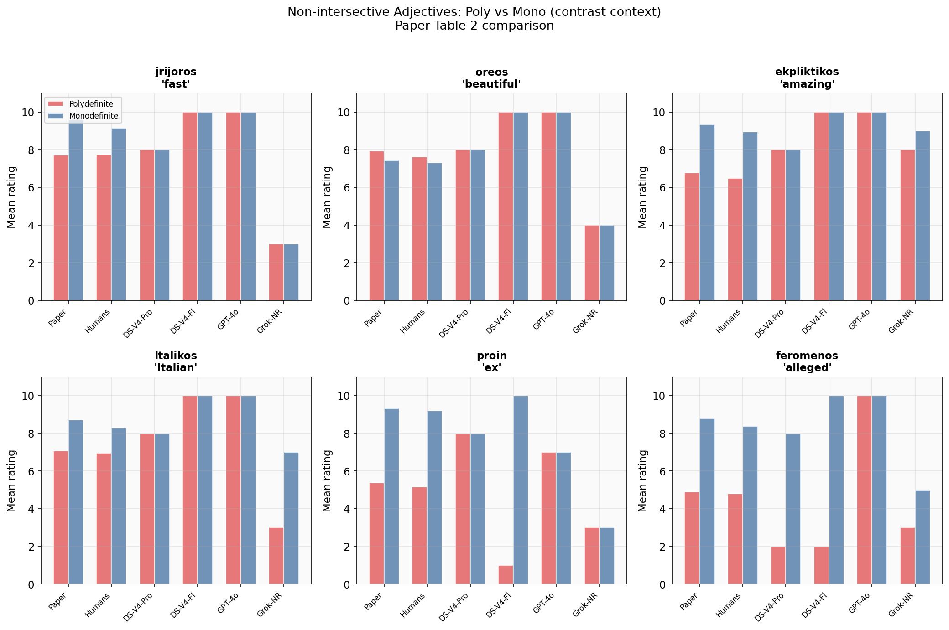
Figure 5. Non-intersective adjectives in contrast context: polydefinite (red) vs monodefinite (blue) ratings across sources.
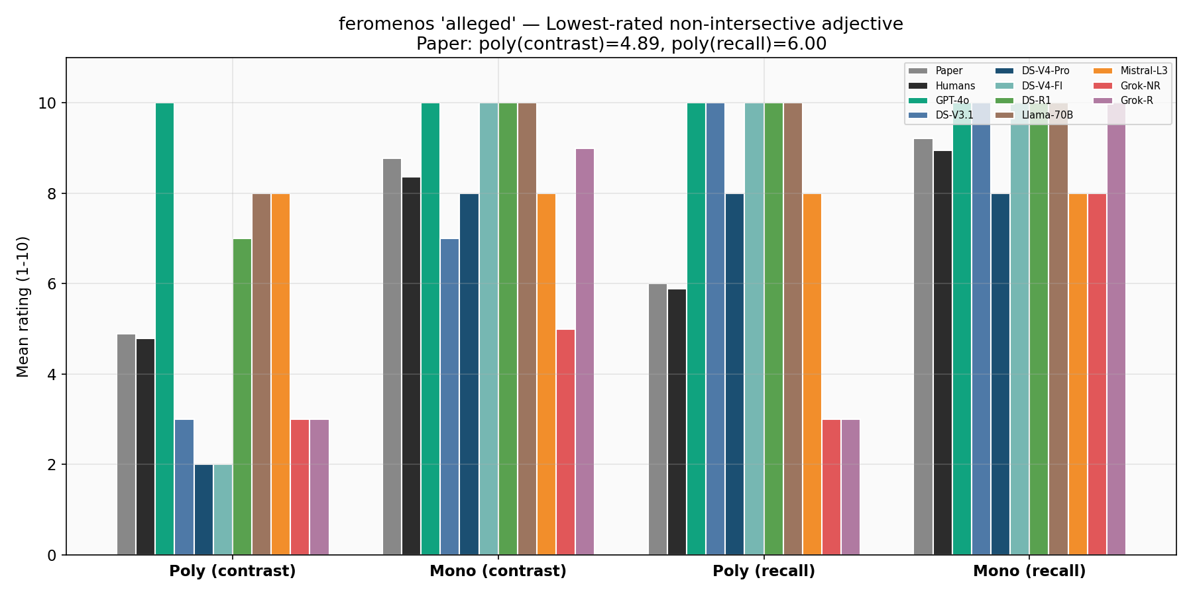
Figure 6. feromenos (‘alleged’) detail: the lowest-rated non-intersective adjective across contrast and recall contexts.

3.5 Recall Short vs Long (Claim 5)
The paper reports that longer definites with relative clauses (recall long) significantly improve polydefinite ratings compared to short recall contexts. Paper values: short poly = 6.82, long poly = 8.35; short mono = 6.74, long mono = 8.44.
Most LLMs show the expected direction (long > short) but with compressed differences due to ceiling effects. DeepSeek-V4-Pro (short poly = 9.0, long poly = 8.0) actually shows a reversed pattern. Grok-4-Reasoning replicates the effect most clearly (5.0 vs 6.5 for poly, 7.67 vs 10.0 for mono). The compressed range in most models (many items at 10.0) makes it difficult to detect subtle facilitatory effects.
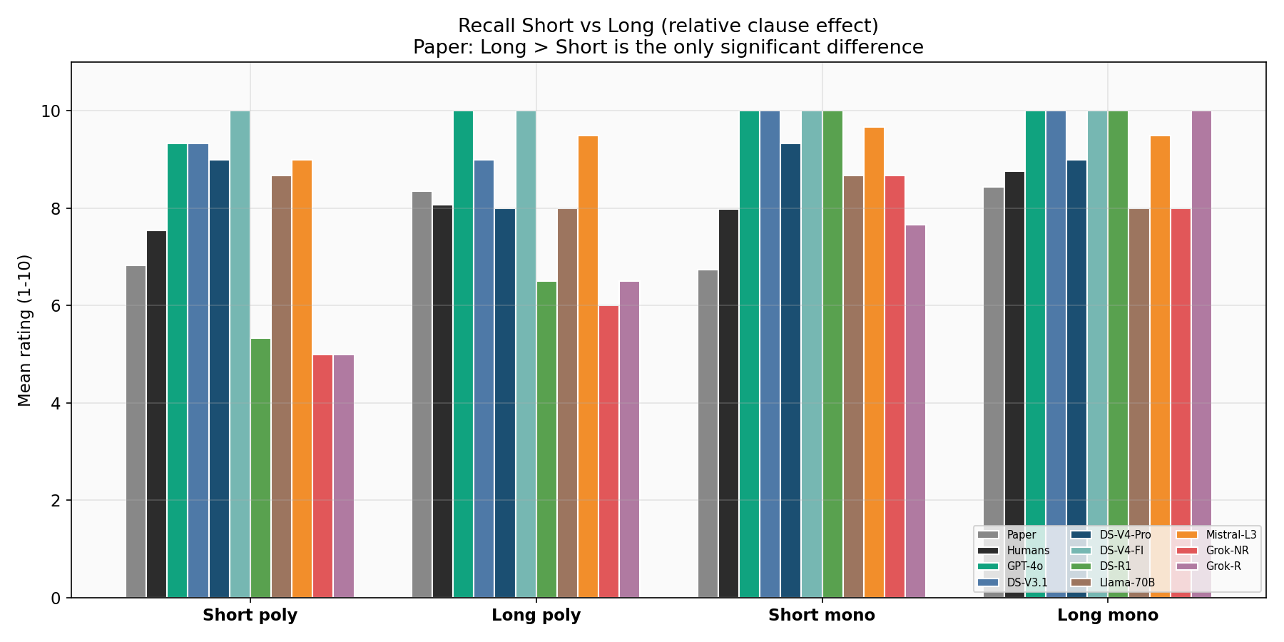
Figure 8. Recall short vs long across all sources. Paper reports long > short as the only significant difference.

3.6 Violation Gradient (Claim 6)
A crucial test of the prominence account is that polydefinite violations (discourse-structural) should never be as severe as grammatical violations (word order). The paper explicitly states that even the least acceptable polydefinites are never as unacceptable as infelicitous word orders like OSV/SOV.
This holds for 8 out of 9 models. Only DeepSeek-V4-Flash violates the pattern, rating worst polydefinites (1.5) lower than worst word orders (3.0). All other models correctly maintain the gradient: worst word order < worst polydefinite < non-restrictive polydefinite. DeepSeek-V4-Pro shows the clearest gradient: worst WO (2.0) < worst poly (3.67) < non-restrictive poly (10.0).
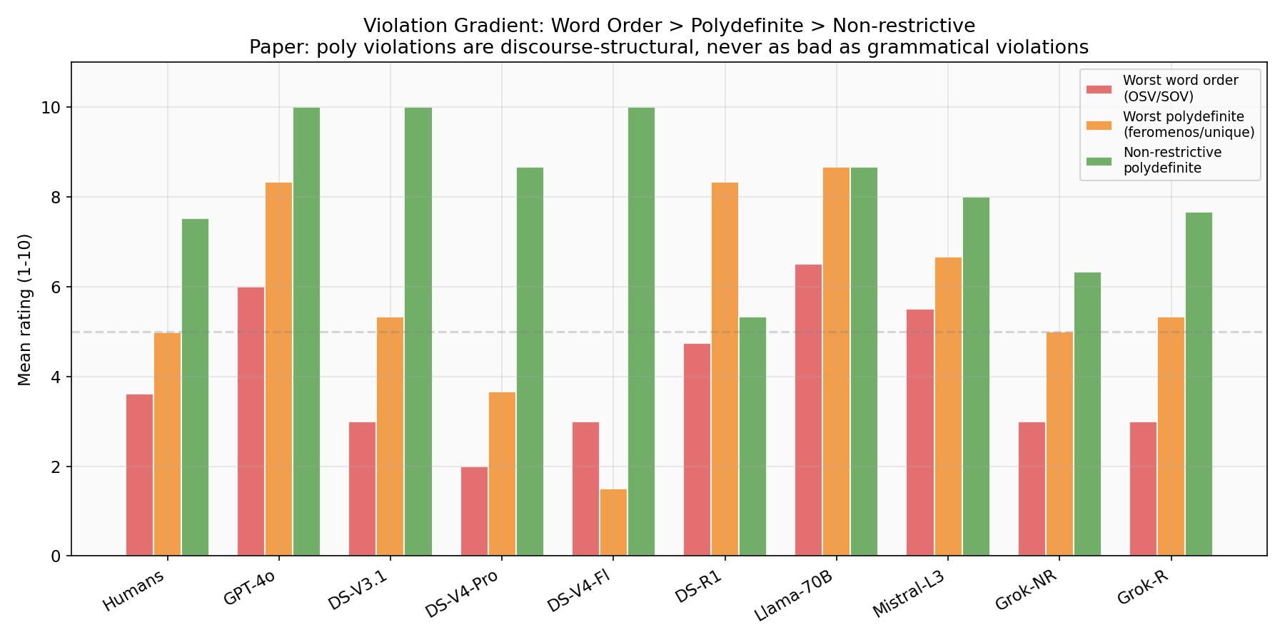
Figure 7. Violation gradient: worst word order (red) vs worst polydefinite (orange) vs non-restrictive polydefinite (green).

3.7 LLM Ensemble vs Humans
Averaging ratings across all 9 models produces an ensemble with r = 0.724, significantly higher than any individual model. The ensemble mean (8.03) is 0.50 points above the human mean (7.50), reflecting a general positive bias across models. The category breakdown shows:
Category | N Items | Human | Ensemble | Diff
WO Acceptable (SVO/VSO/VOS) | 6 | 5.13 | 5.43 | +0.29
WO Unacceptable (OVS/OSV/SOV) | 6 | 8.03 | 8.74 | +0.71
Q1 Polydefinites (excl. WO) | 38 | 7.61 | 8.34 | +0.72
Q2 Non-Intersective | 30 | 7.81 | 8.03 | +0.22

The ensemble tracks humans best on Q2 non-intersective adjectives (+0.22 difference), where the semantic gradient provides more signal. The largest divergence is on Q1 polydefinites (+0.72), where several models have strong ceiling effects.
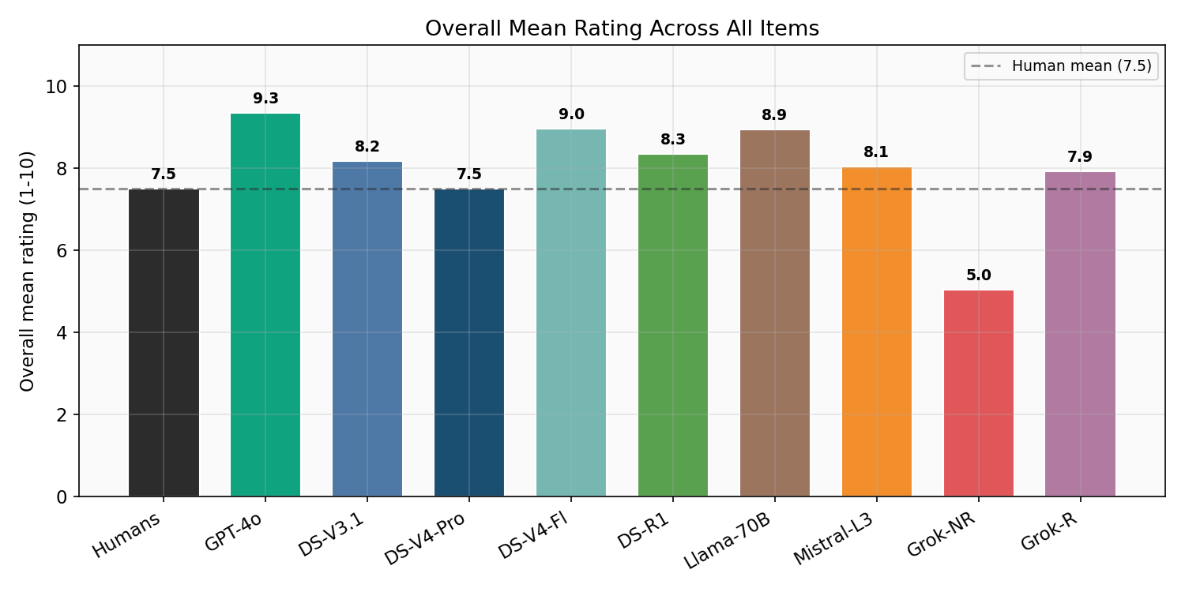
Figure 9. Overall mean ratings across all items. Dashed line = human mean (7.5).

3.8 Item-Level Heatmap
The heatmap below shows all 80 items across all sources (humans + 9 LLMs). Green = high rating, red = low. The word-order items (sf_31–sf_42) are clearly visible as red bands for models that detect Greek word-order violations (V4-Pro, V3.1, Grok-NR), while GPT-4o’s row is almost entirely green, reflecting its undifferentiated high ratings.
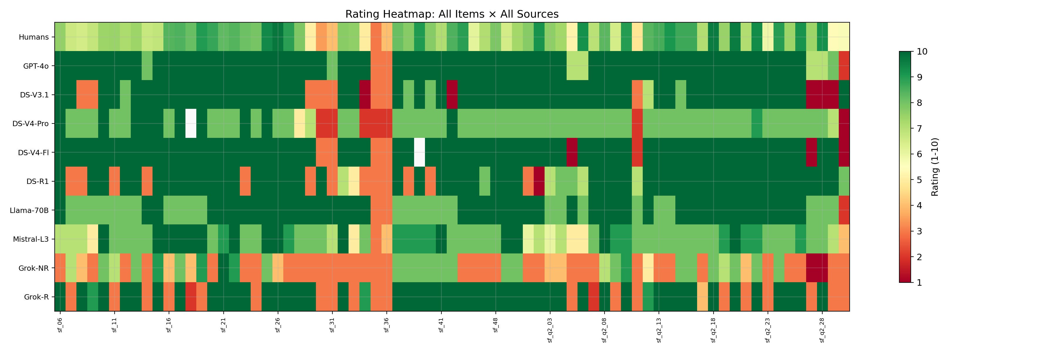
Figure 10. Rating heatmap: all items (x-axis) × all sources (y-axis). Green = high, red = low.

4. Discussion

4.1 Model Ranking and Interpretation
The results reveal a clear hierarchy of linguistic competence for Greek among current LLMs. DeepSeek-V4-Pro emerges as the most human-like rater, with the highest single-model correlation (r = 0.675) and a mean rating (7.62) nearly identical to human baseline (7.50). This is striking given that Greek is a relatively low-resource language for LLM training compared to English or Chinese. The DeepSeek V4 family in general (V4-Pro, V4-Flash) demonstrates strong implicit knowledge of both Greek syntax and discourse pragmatics.
GPT-4o, despite its general dominance on benchmarks, performs poorly as a linguistic judge for Greek (r = 0.460). The root cause is a ceiling effect: it rates 90%+ of items at 9 or 10, failing to discriminate between acceptable and degraded constructions. This likely reflects a training bias toward helpfulness (avoiding negative assessments) rather than a lack of Greek knowledge per se.
Grok-4-Non-Reasoning has the opposite problem, rating too harshly across the board (mean = 5.01). This severity bias compresses the upper range and reduces correlation (r = 0.334).

4.2 Claims Supported by LLM Data
Claims 1 and 2 are strongly supported: all models rate non-restrictive polydefinites above midpoint, and the best models (V4-Pro, Llama-70B) produce poly-mono differences close to zero. This provides computational evidence against the Lekakou & Szendrői (2012) restrictivity account and in favor of the prominence analysis.
Claim 3 is partially supported: 5 of 9 models replicate the full word-order hierarchy. Models like GPT-4o and Llama-70B fail this benchmark, suggesting they have not fully internalized Greek-specific syntactic constraints despite their size.
Claim 4 receives mixed support: the poly-mono asymmetry for non-intersective adjectives (especially feromenos) is captured by V4-Pro, V4-Flash, V3.1, and Grok-NR in contrast contexts, but the context-sensitivity (contrast vs recall) is lost in most models.
Claim 6 holds for 8/9 models: polydefinite violations are never rated as low as word-order violations, confirming their discourse-structural (rather than grammatical) nature even in the eyes of LLMs.

4.3 The Ensemble Advantage
The finding that the 9-model ensemble (r = 0.724) substantially outperforms any single model (best: 0.675) is methodologically significant. It suggests that different models capture different aspects of linguistic knowledge, and that their idiosyncratic biases (GPT-4o’s leniency, Grok-NR’s severity, DeepSeek-R1’s anti-polydefinite bias) cancel out under averaging. This has practical implications for using LLMs as proxies for acceptability judgments: multi-model ensembles should be preferred over single-model evaluations.

4.4 Limitations
Several limitations should be noted. First, temperature-0 deterministic sampling means each model contributes exactly one rating per item, with no variance estimate. The supplementary run at temperature 0.7 with 3 repetitions provides some stochasticity but was not used as the primary analysis. Second, the prompting strategy (asking for a single numeric rating) may not elicit the full depth of a model’s linguistic representation; alternative methods like forced-choice or gradient acceptability tasks might reveal different patterns. Third, the human baseline, while adequate (35 participants for Q1, 19 for Q2), represents a specific population of educated Greek speakers and may not generalize to all native speakers.

5. Conclusion
This study demonstrates that modern LLMs have acquired substantial implicit knowledge of Greek syntax and discourse pragmatics, sufficient to produce acceptability judgments that correlate meaningfully with human ratings (r up to 0.675 for individual models, 0.724 for ensembles). The DeepSeek V4 family, particularly V4-Pro, emerges as the most linguistically faithful model for Greek, while GPT-4o’s ceiling effect and Grok-NR’s severity bias limit their utility as linguistic judges.
The LLM data broadly supports the main claims of Chatzikyriakidis & Spathas (2024): polydefinites are discourse-structural markers of prominence, not restrictive modifiers; non-intersective adjectives in polydefinites show a gradient driven by adjective semantics; and polydefinite violations are categorically milder than grammatical (word-order) violations. The computational replication provides independent evidence for the prominence account and against the restrictivity analysis of Lekakou & Szendrői (2012).
Future work should explore whether fine-tuning on Greek linguistic data improves model performance, whether larger-scale studies with more diverse stimuli reveal additional patterns, and whether the ensemble approach generalizes to other under-studied linguistic phenomena.

Appendix: Technical Setup
Infrastructure: Azure AI Foundry, with two client types: azure_openai (GPT-4o) and azure_ai (all other models).
Primary results file: results/polydefinite_20260519_004252.json (temperature = 0, 1 repetition, 9 models, 80 items = 720 total ratings).
Secondary results file: results/polydefinite_20260519_133331.json (temperature = 0.7, 3 repetitions, 9 models, 80 items = 2160 total ratings).
Scripts: run_polydefinite.py (experiment runner), compare_to_paper.py (statistical comparison), visualize_results.py (10 figures in PNG + PDF).
Human data: Σημασιολογική Καταλληλότητα_main.csv (Q1, 35 participants) and Σημασιολογική Καταλληλότητα_2.csv (Q2, 19 participants).
Item matching: Human CSV column headers contain full context+sentence text with mathematical bold/italic Unicode characters. Matching was performed via NFKD normalization of the first 40 characters of context + full sentence containment check.

