HBC-2 Monitor
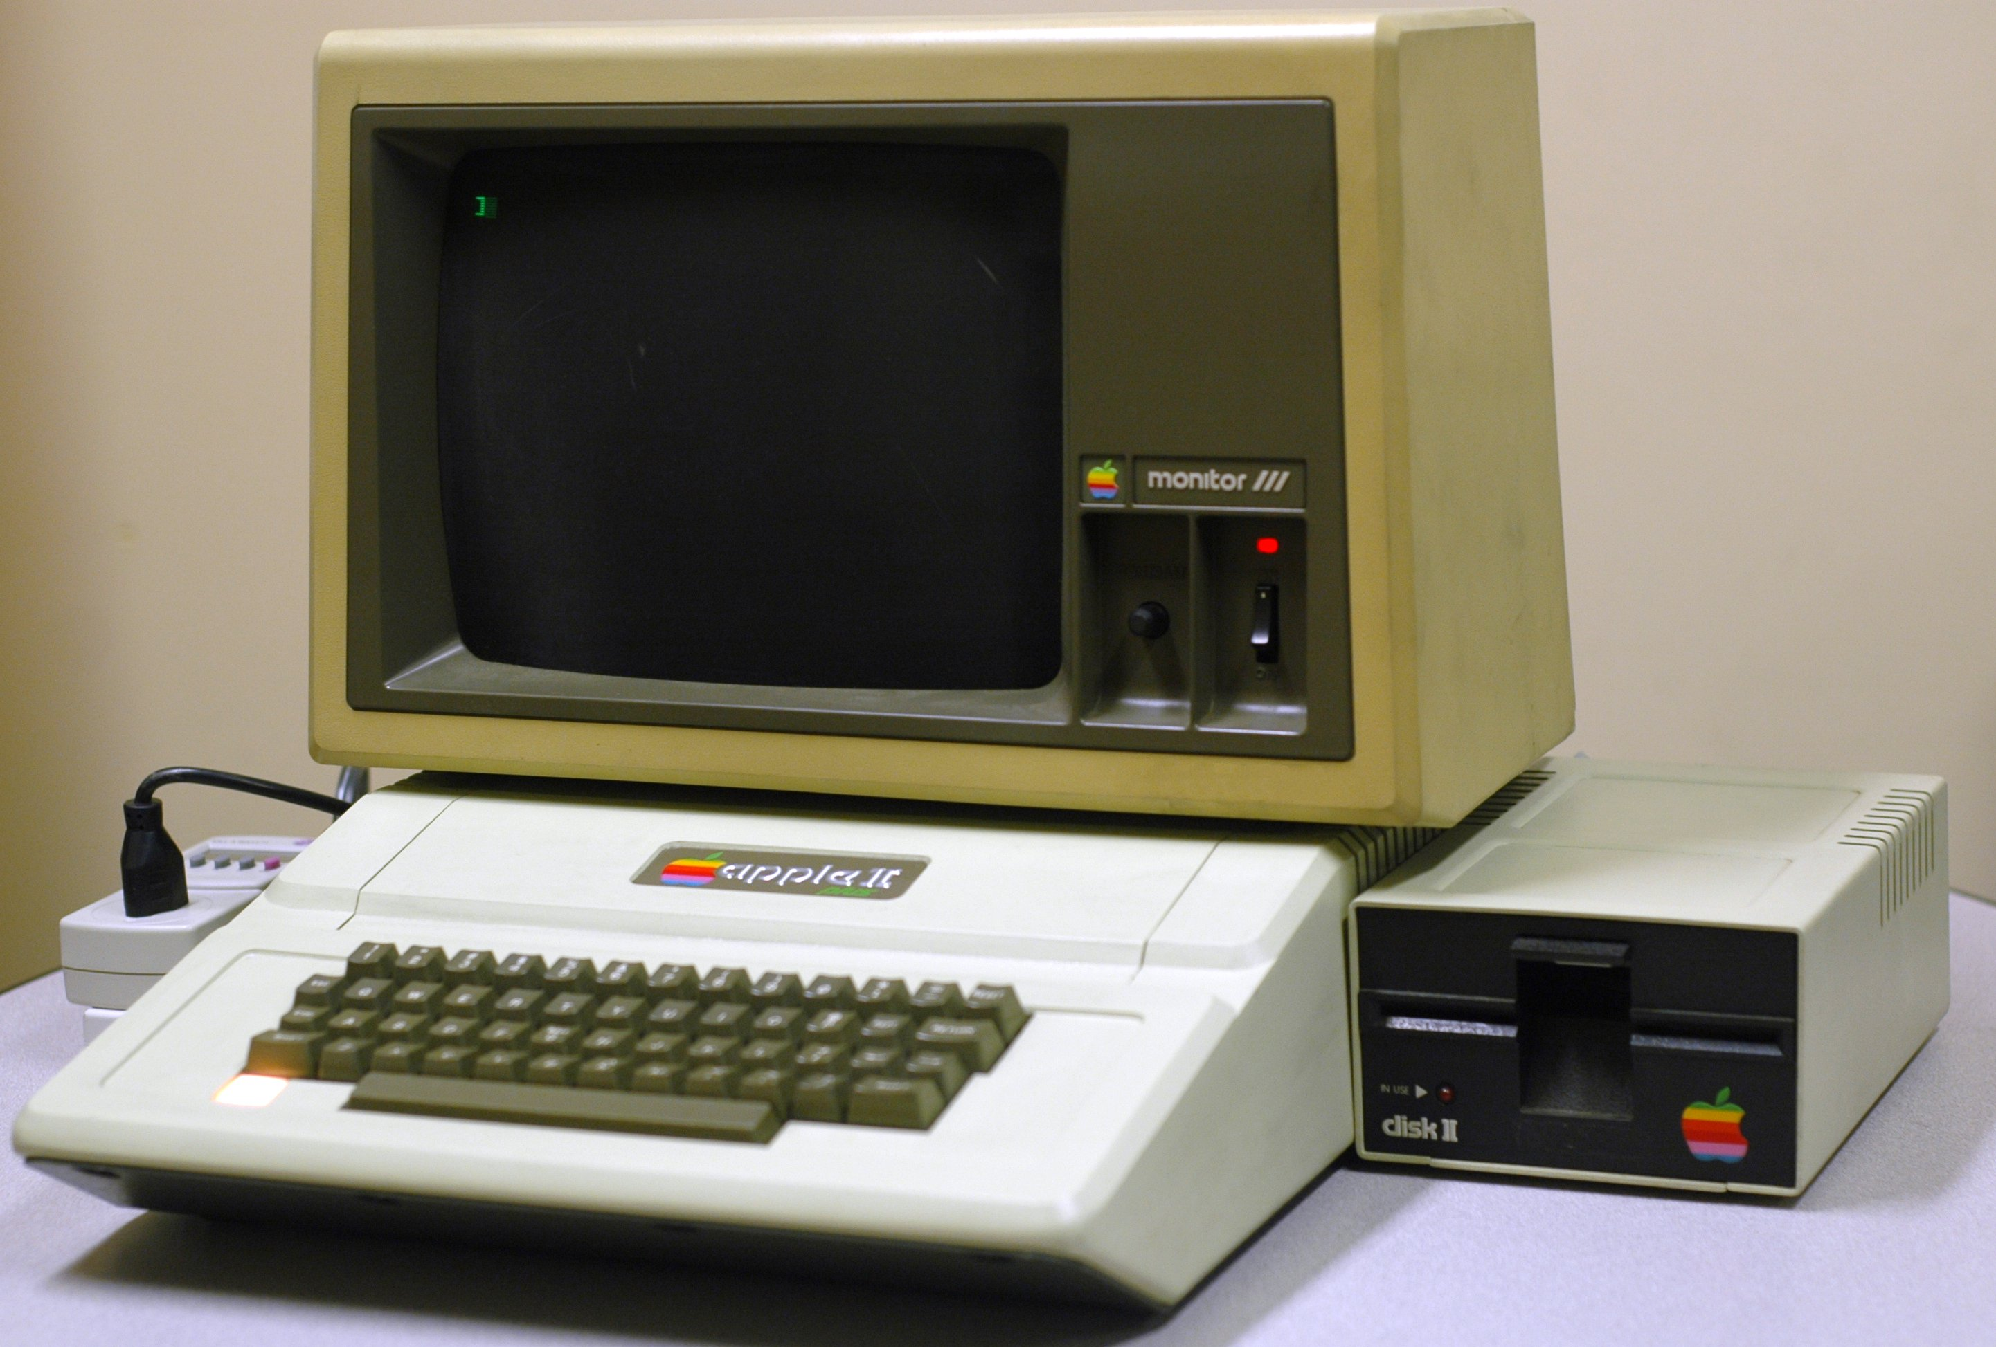
Instruction Manual

Summary

- Color palette
- Video modes
  - Colored text mode
  - Pixel mode
  - ASCII Table
- Control

Color palette

The monitor uses a 4-bit color palette, therefore 16 colors are available.

Available colors
Number | Hex | Color | RGB
0 | 0x0 | Black | #000000
1 | 0x1 | Blue | #0000AA
2 | 0x2 | Green | #00AA00
3 | 0x3 | Cyan | #00AAAA
4 | 0x4 | Red | #AA0000
5 | 0x5 | Magenta | #AA00AA
6 | 0x6 | Brown | #AA5500
7 | 0x7 | Light gray | #AAAAAA
8 | 0x8 | Bright black | #555555
9 | 0x9 | Bright blue | #5555FF
10 | 0xA | Bright green | #55FF55
11 | 0xB | Bright cyan | #55FFFF
12 | 0xC | Bright red | #FF5555
13 | 0xD | Bright magenta | #FF55FF
14 | 0xE | Bright yellow | #FFFF55
15 | 0xF | White | #FFFFFF

Video modes

The monitor has 2 video modes, to enable pixel-perfect drawings or fast character display.

Available video modes
ID | Mode | Description
0 | PIXEL | 256 * 192 px 4-bit color mode
1 | TEXT | 6 * 8 px characters in a 42 columns by 24 rows grid  Each with a 4-bit color background and a 4-bit color font

Colored text mode

This mode displays a 42 columns by 24 rows grid of characters. 95 characters can be displayed, corresponding to ASCII codes 32 to 127 (included, see the ASCII table below).

Each character has a 4-bit color background, and another 4-bit color font.

Pixel mode

Displays the whole 256 * 192 pixels monitor with 4-bit colors (see the palette above). In this mode, each byte of video memory represented 2 pixels.
This would use 24,576 bytes of memory, but for simplification this code stores each pixel in a whole byte (in the HBC-2 IDE).

ASCII Table

In colored test mode, ASCII codes 32 to 127 are the only one recognised by the monitor, corresponding to:

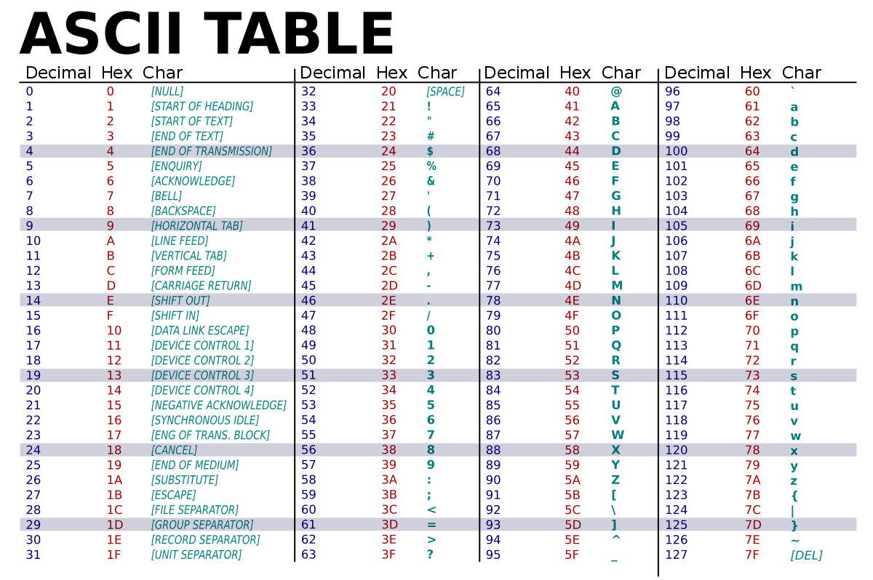
!"#$%&'()*+,-./0123456789:;<=>?@ABCDEFGHIJKLMNOPQRSTUVWXYZ[\]^_'abcdefghijklmnopqrstuvwxyz{|}~

Control

Like every peripheral, the monitor uses sockets connecting it to the IOD ports to communicate with the CPU.

List of available ports
ID | Port | Description
0 | DATA_0 | First data byte, used for color information in both video modes
1 | DATA_1 | Second data byte, used for colored text mode only
2 | POS_X | X-axis position of the designated pixel or character
3 | POS_Y | Y-axis position of the designated pixel or character
4 | CMD | Command sent by the CPU

List of available commands
ID | Command | Description
0 | NOP | No operation
1 | WRITE | Changes pixel or character information on DATA_0 and DATA_1 ports, depending on POS_X and POS_Y
2 | READ | Sends pixel or character information on DATA_0 and DATA_1 ports, depending on POS_X and POS_Y
3 | SWITCH_TO_PIXEL_MODE | Switches to pixel mode  WARNING : Does not flush the character buffer
4 | SWITCH_TO_TEXT_MODE | Switches to colored text mode  WARNING : Does not flush the pixel buffer

Any invalid command will result in NOP.

