Model 4 Report Section
Extended RoBERTa + Linguistic Feature Fusion Model
Prepared as the Model 4 subsection for the group report

Model Description
To satisfy the "extend a method" requirement, we implemented an extended transformer-based AI-text detector rather than only using an off-the-shelf model. Specifically, we used roberta-base as the backbone and extended standard fine-tuning by incorporating handcrafted linguistic features into the classification pipeline.
The evaluation dataset was constructed from all.jsonl, where human_answers were labelled as 0 and chatgpt_answers were labelled as 1. Non-empty responses were extracted into a unified dataframe with two columns: text and label, and then split into train/validation/test subsets for model development and final evaluation.
In addition to transformer embeddings, the model uses six linguistic indicators: lexical diversity, average sentence length, punctuation ratio, stopword ratio, average word length, and digit ratio. During inference, these features are fused with contextual RoBERTa representations before final binary classification.

Quantitative Results
The model was evaluated using Accuracy, Precision, Recall, and F1-score.
Metric | Value
Accuracy | 0.9994
Precision | 0.9992
Recall | 0.9989
F1-score | 0.9990

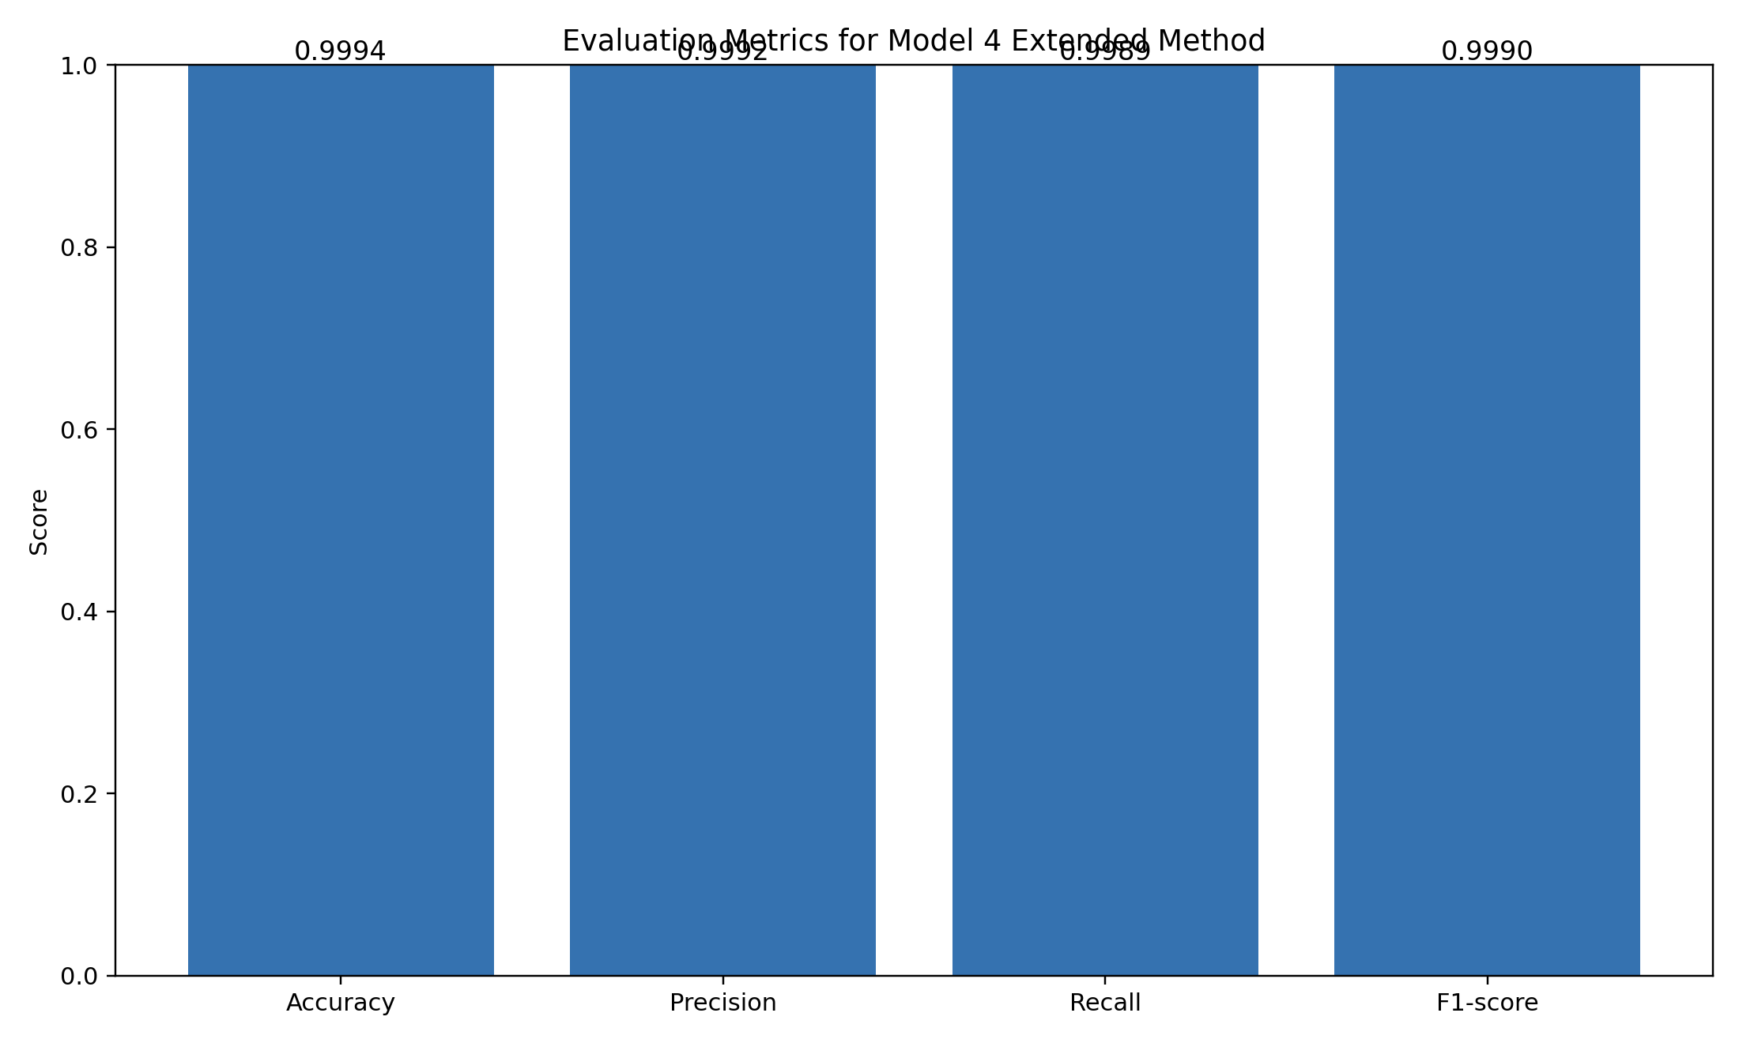
Figure X. Evaluation metrics of Model 4 on the test set.

Confusion Matrix
 | Predicted Human (0) | Predicted AI (1)
True Human (0) | 5307 | 2
True AI (1) | 3 | 2622

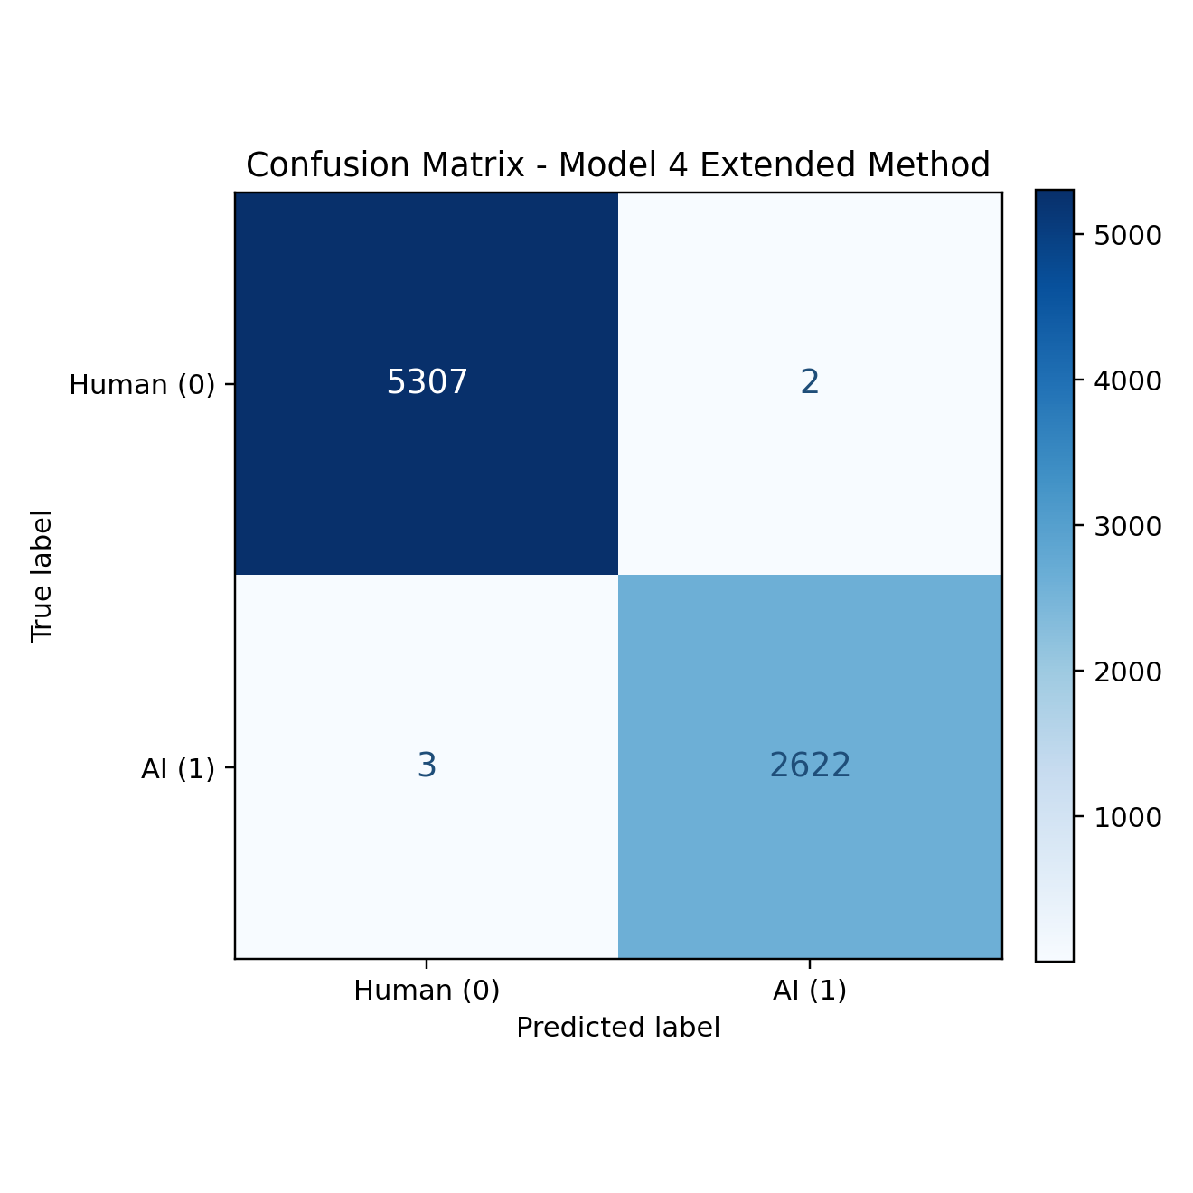
Figure Y. Confusion matrix of Model 4 extended method on the test set.

Interpretation
The results show highly balanced and strong performance across both classes. The model produced only a very small number of errors in both directions, indicating that linguistic feature fusion provides useful complementary signals beyond transformer-only representations.

