Data Selected: EA SPORTS FC 24 FULL PLAYERS DATABASE AND STATS

URL: <https://www.kaggle.com/datasets/nyagami/fc-24-players-database-and-stats-from-easports?select=all_players.csv>

This dataset contains all the male player data of the famous football game FC 24, such as the player's name, country, club, and various data in the game. In this module, I process and visualize this dataset and analyze some of the topics that soccer gamers are concerned about.

Three question:

1. Who are the top 10 players with the highest ability values(Overall player stat)?
2. What is the relationship between a player's age and ability value?
3. What percentage of the top 50 overall player ratings for each club?

**Interesting results:**

**Who are the top 10 players with the highest ability values(Overall player stat)?**

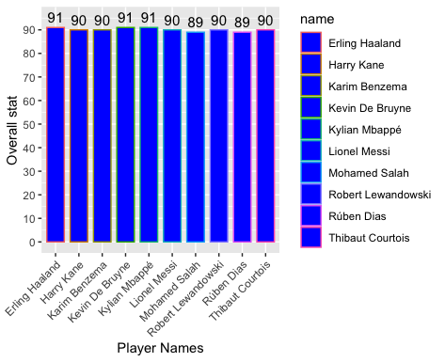

Analysis:

This graph helps players find the top ten soccer players with the highest ability values in the game, allowing them to choose the most powerful cards when building their own teams.

Problems: we can find that seven of these ten soccer players are strikers, which makes it impossible for the player to know the other positions of the soccer players when choosing cards through this visualization graphic.

Improvements: increase the number of soccer players that are filtered

**What is the relationship between a player's age and ability value?**

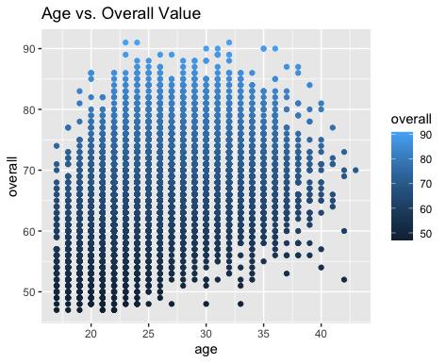

Analysis:

This scatter plot shows the relationship between age and ability value very well. Most players have an ability value below 80. Only a few players have an ability value greater than or equal to 90. Among young players (younger than 25), n ability values are generally low. Conversely, among older players (older than 35), relatively few players have low ability values. This means that as players get older, they play more matches, so their ability values are higher compared to younger players.

**What percentage of the top 50 overall player ratings for each club?**

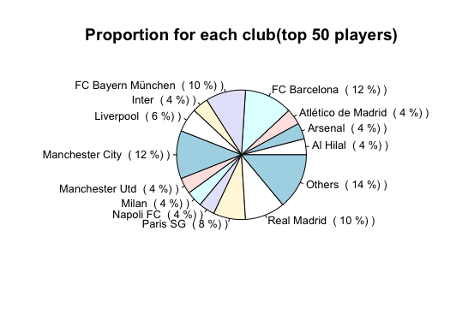

Analysis:

As a soccer fan, I was keen to find out which club was more powerful, so I decided to analyze each team's share of the top 50 soccer players in terms of ability value. To do this, I used a pie chart to visualize the data.

Findings: four clubs have a percentage of more than 10% - Bayern Munich, Barcelona, Real Madrid, and Manchester City. Therefore, a large proportion of the top soccer players come from these four clubs, which is why these four clubs have achieved significant results in international competitions. (e.g., the UEFA Champions League)

**Number of people in each position**

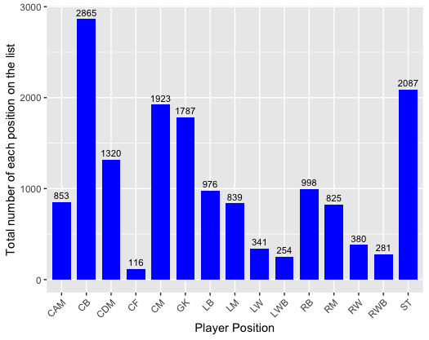

Analysis:

The number of players at each position can be analyzed by drawing a bar graph to show which position has more players. A higher number of players means there is more competition at that position, and a lower number of players means there are fewer options when we want to select a player for that position.