Sites: https://epmilanka.com/
Issue:
https://epmilanka.com/course/power-of-emotional-intelligence-in-hospitality/ :fee
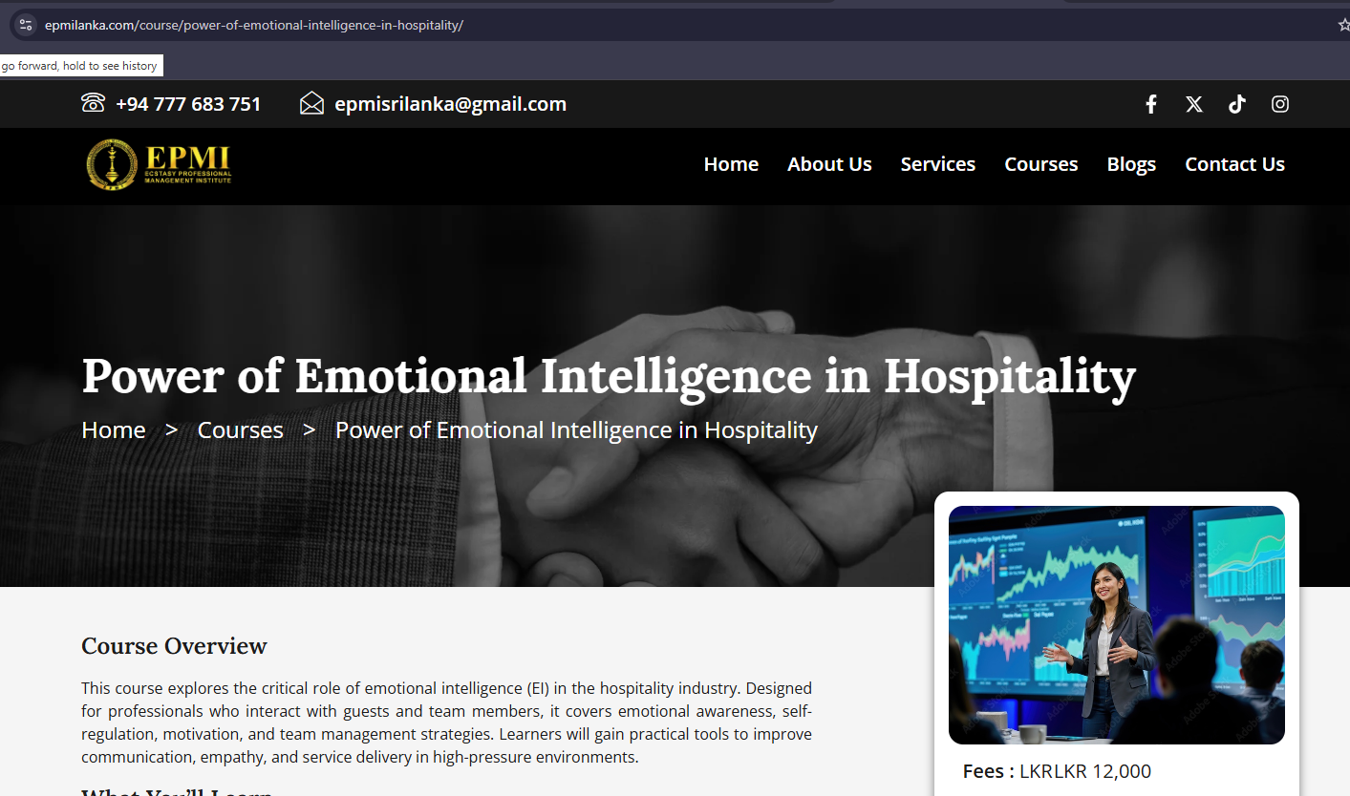

https://epmilanka.com/courses/: Not working Enroll button
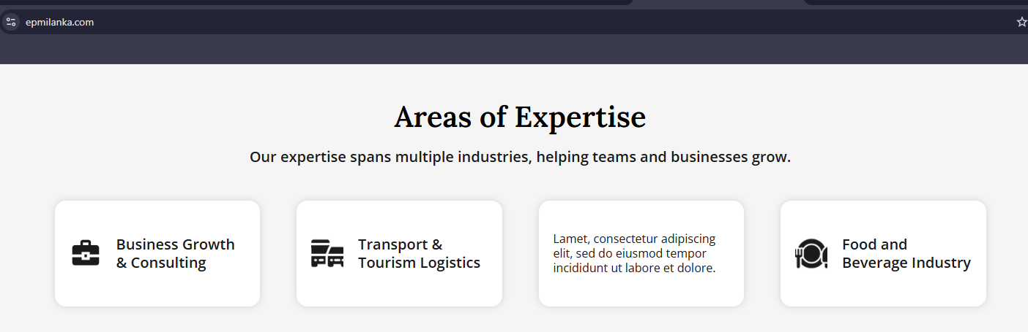
https://epmilanka.com/: Area of Expertise section

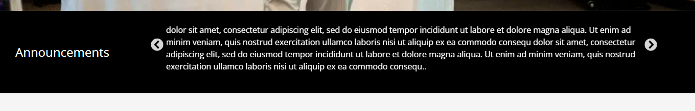
https://epmilanka.com/ : Announcements section

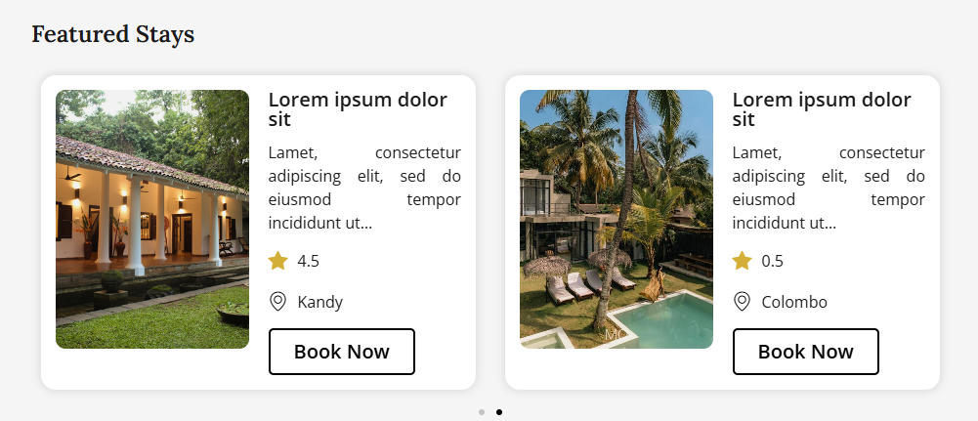
https://epmilanka.com/services/ : Travel and Hospitality button / Click Features stays Section sample data

https://epmilanka.com/contact-us/ : address not shown properly on map
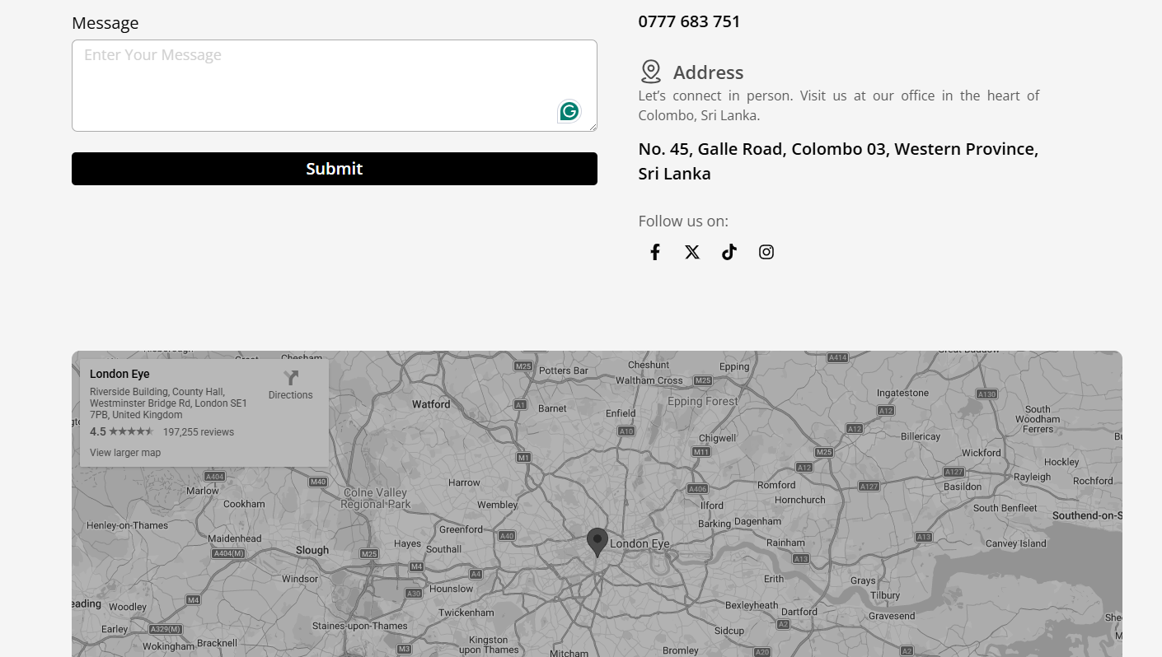
Site: https://fernandotravelz.com/ - Not working
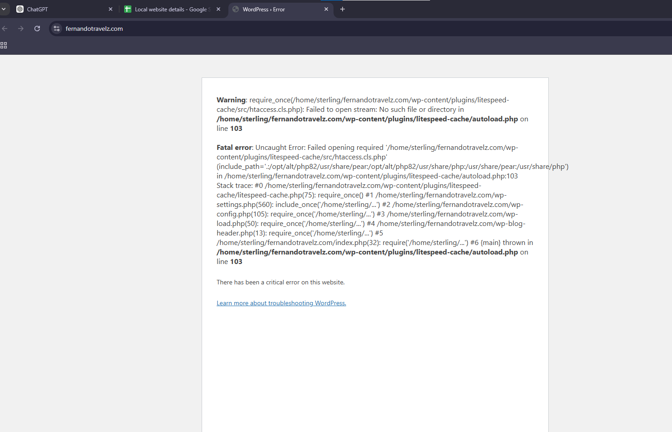

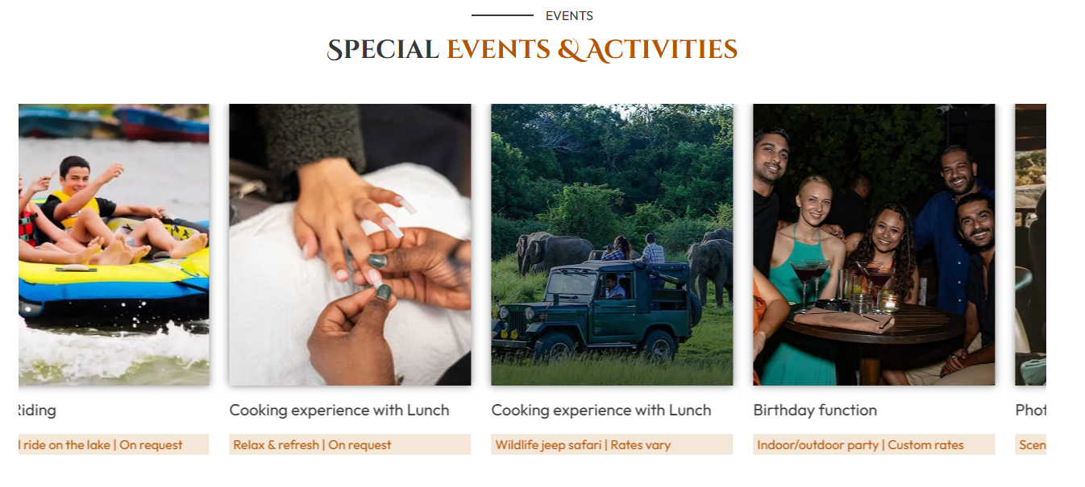
Issue: https://greenvillagesafariresort.com/ -Cooking Experience with Lunch same

Site: https://jacarandatravels.uk/ - Not working

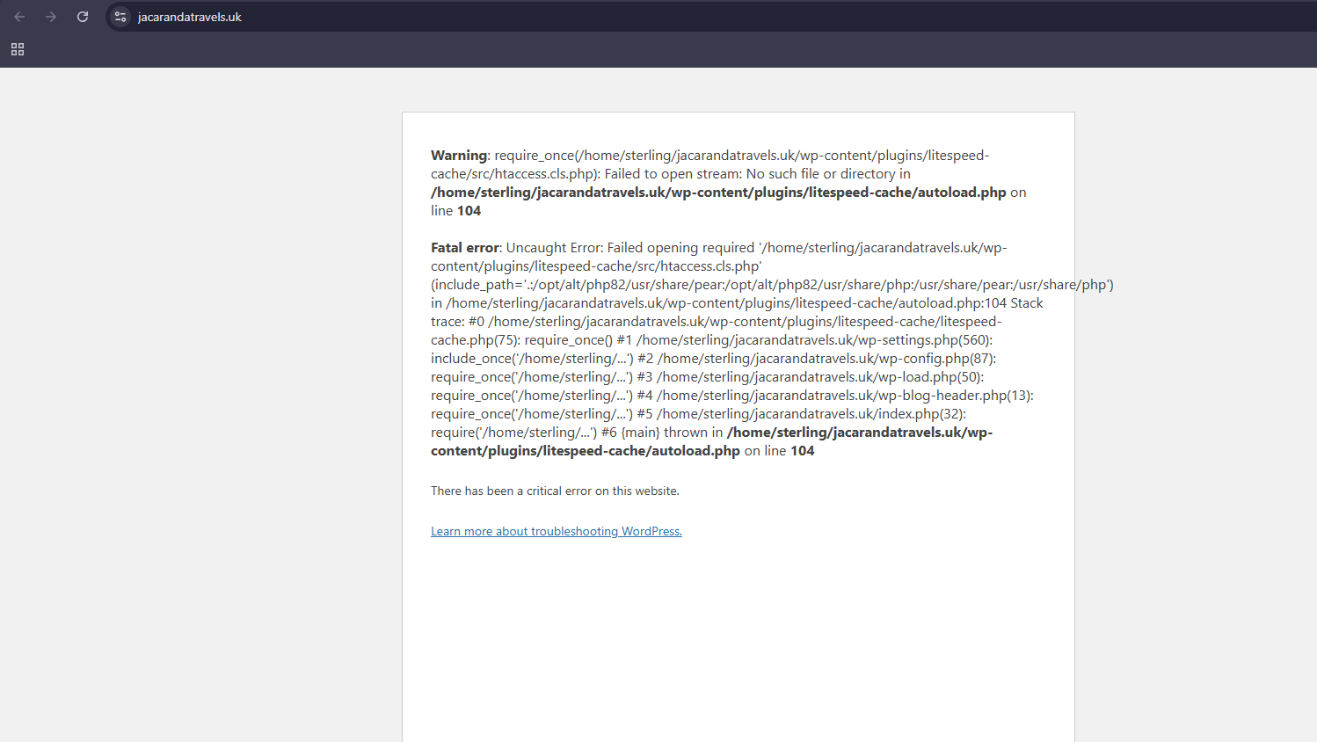

Site: https://gocolombo.sterlingbpo.com/
Issue: home page social media icon
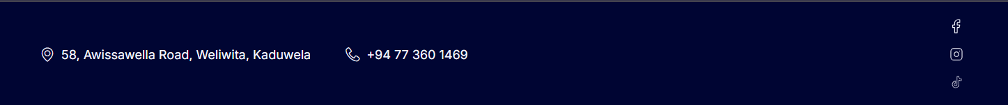

Issue: Not Working Properly
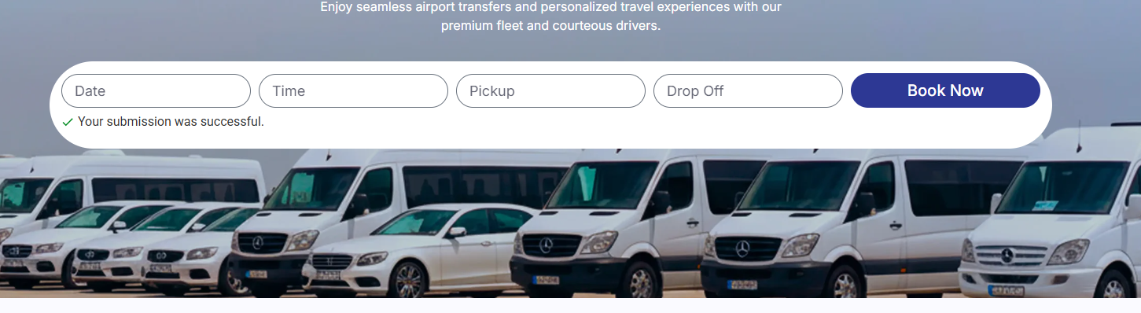

Issue: Style Issues
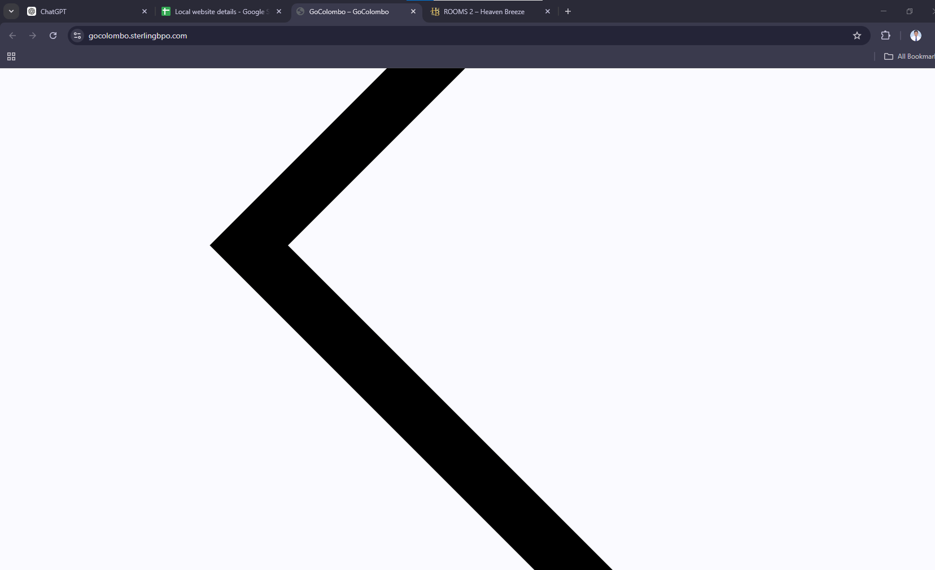

https://gocolombo.sterlingbpo.com/services/ :styles
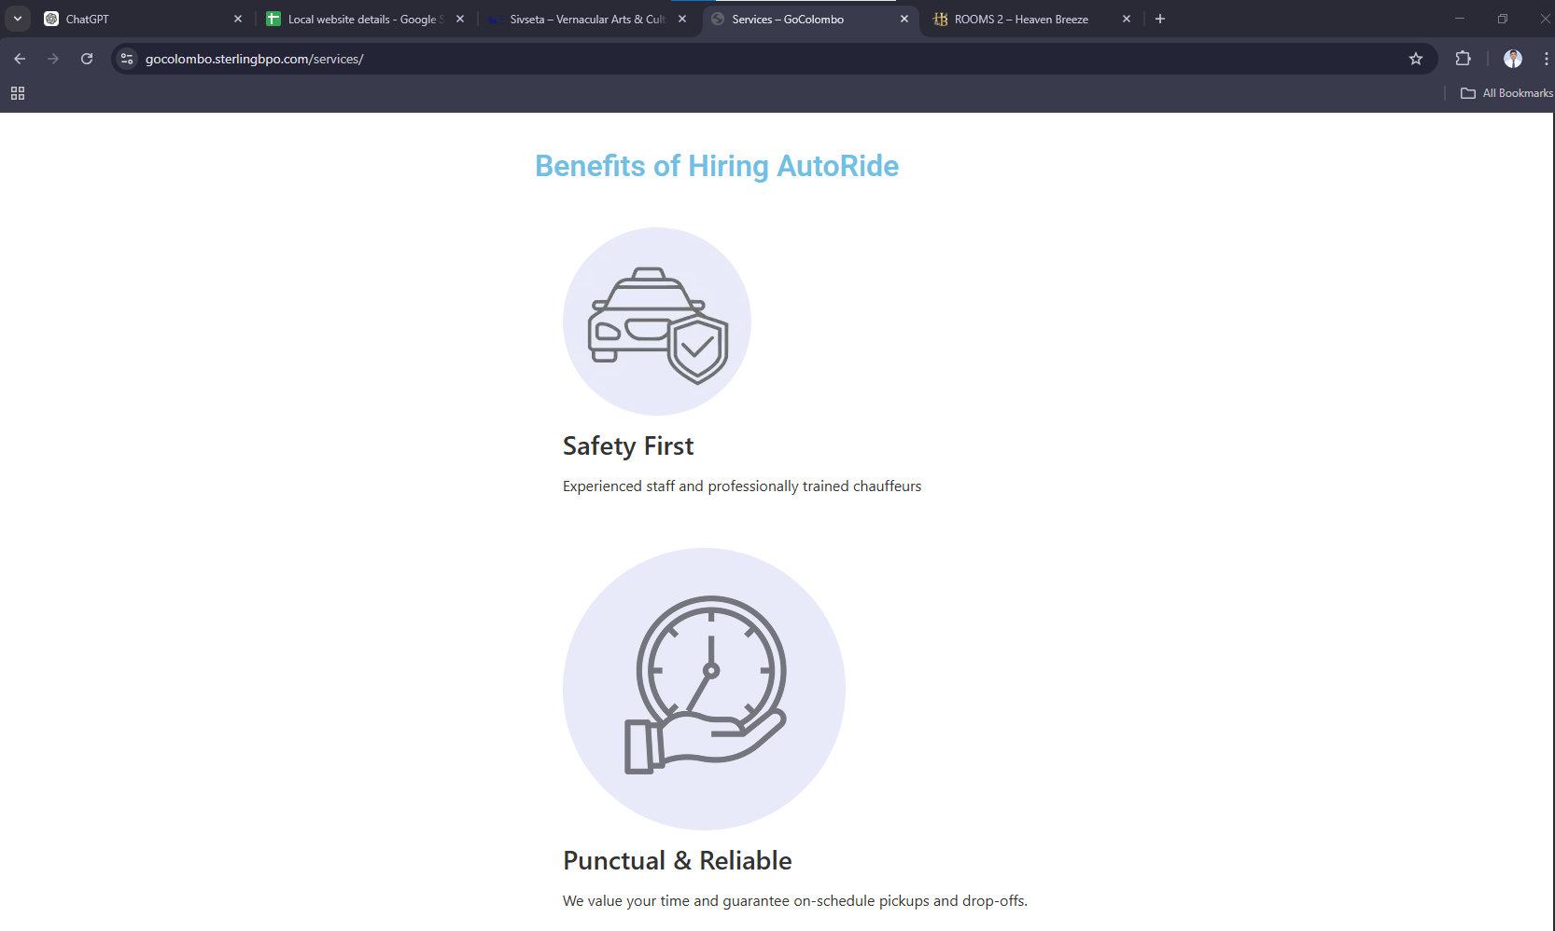

Issue : https://gocolombo.sterlingbpo.com/contact/ - Address and location shown in the map
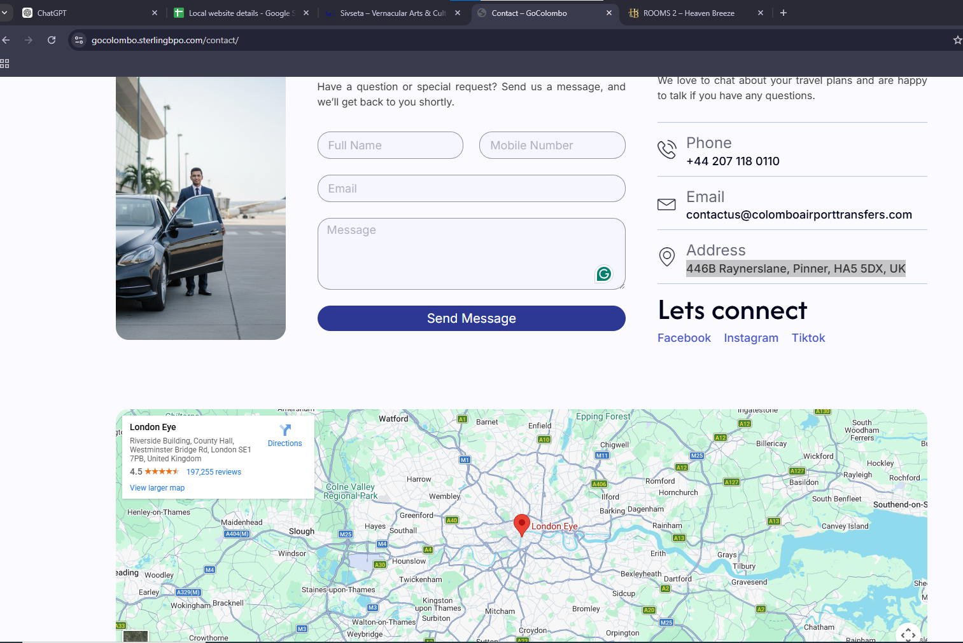

Issue: https://hospitel.sterlingbpo.com/about-us/ -Call Us part
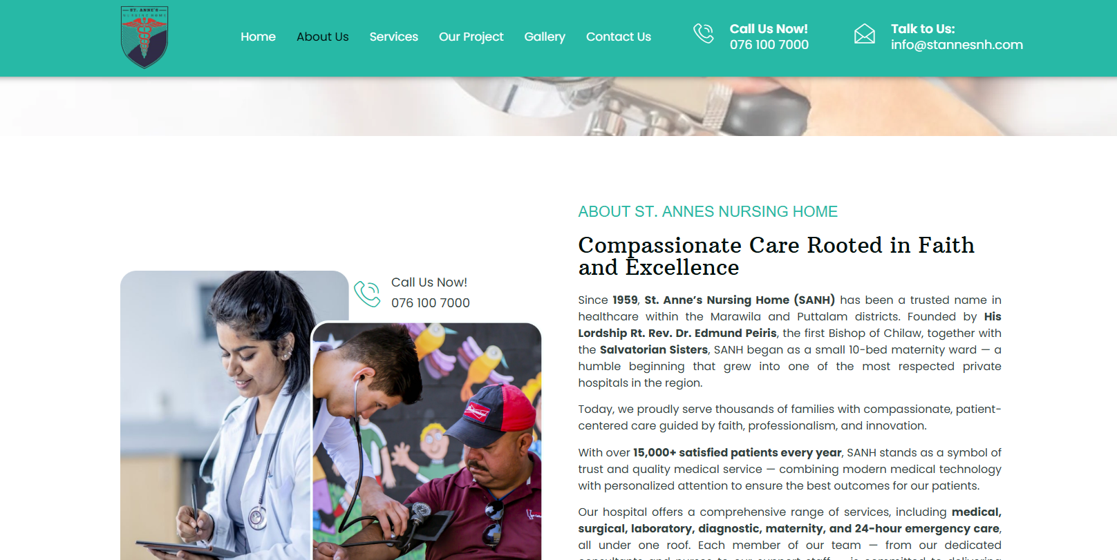

Issue: https://hospitel.sterlingbpo.com/contact-us/ - Map same location shown

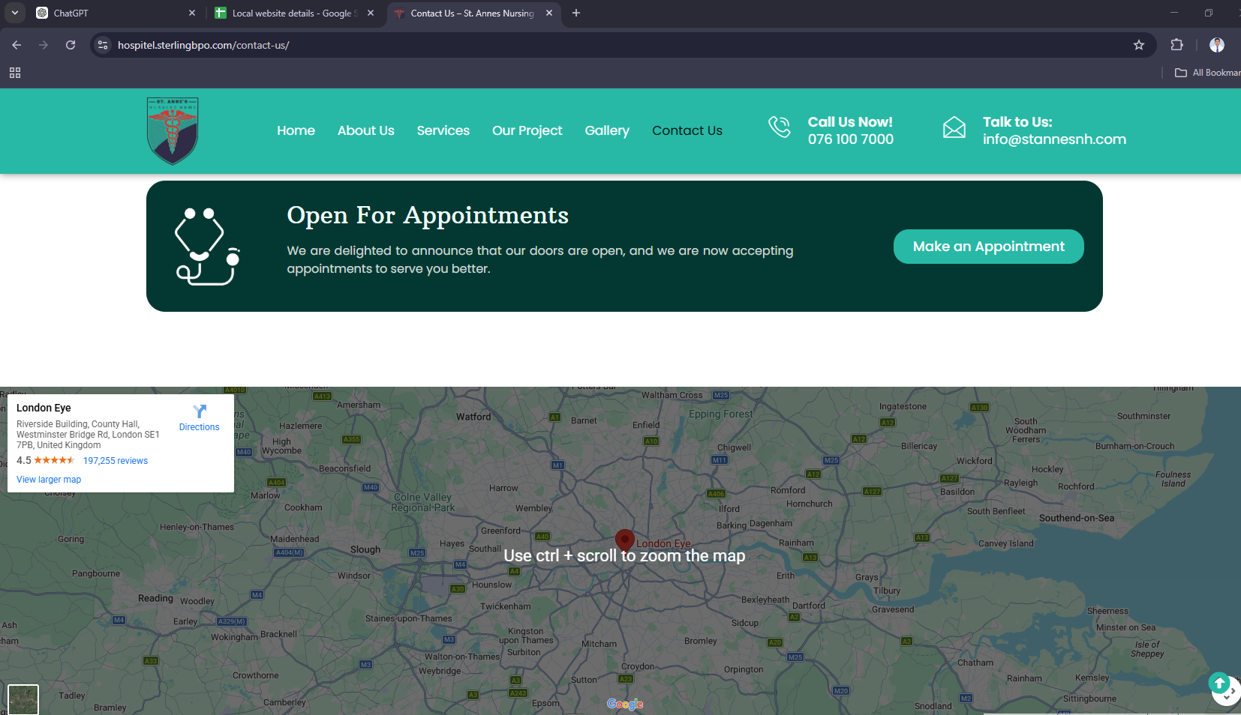

Issue: https://jacarandatravels.uk/ - not working
