Hand-in 2: The love song isn't dead, it's evolving

Purpose
In this hand-in, you will build an interactive data story about how the distribution of love songs categories have changed over time in the U.S. Billboard Top-10. The focus is not only on drawing a stream graph, but on learning how interaction changes what the reader can explore.
You will work with filtering, a year-range slider, hover interaction, animated updates and a simple Model-View-Update structure.
The starter project should already contain the page skeleton, headings, explanatory text, basic HTML containers and the dataset. Your task is to implement the visualization and interaction logic with D3.

Target wireframes
Use the wireframes below as a layout and interaction guide. Your final result does not need to match these pixel-perfect, but the main layout, interaction states and chart behaviour should be recognizable.

Wireframe 1 - Default state
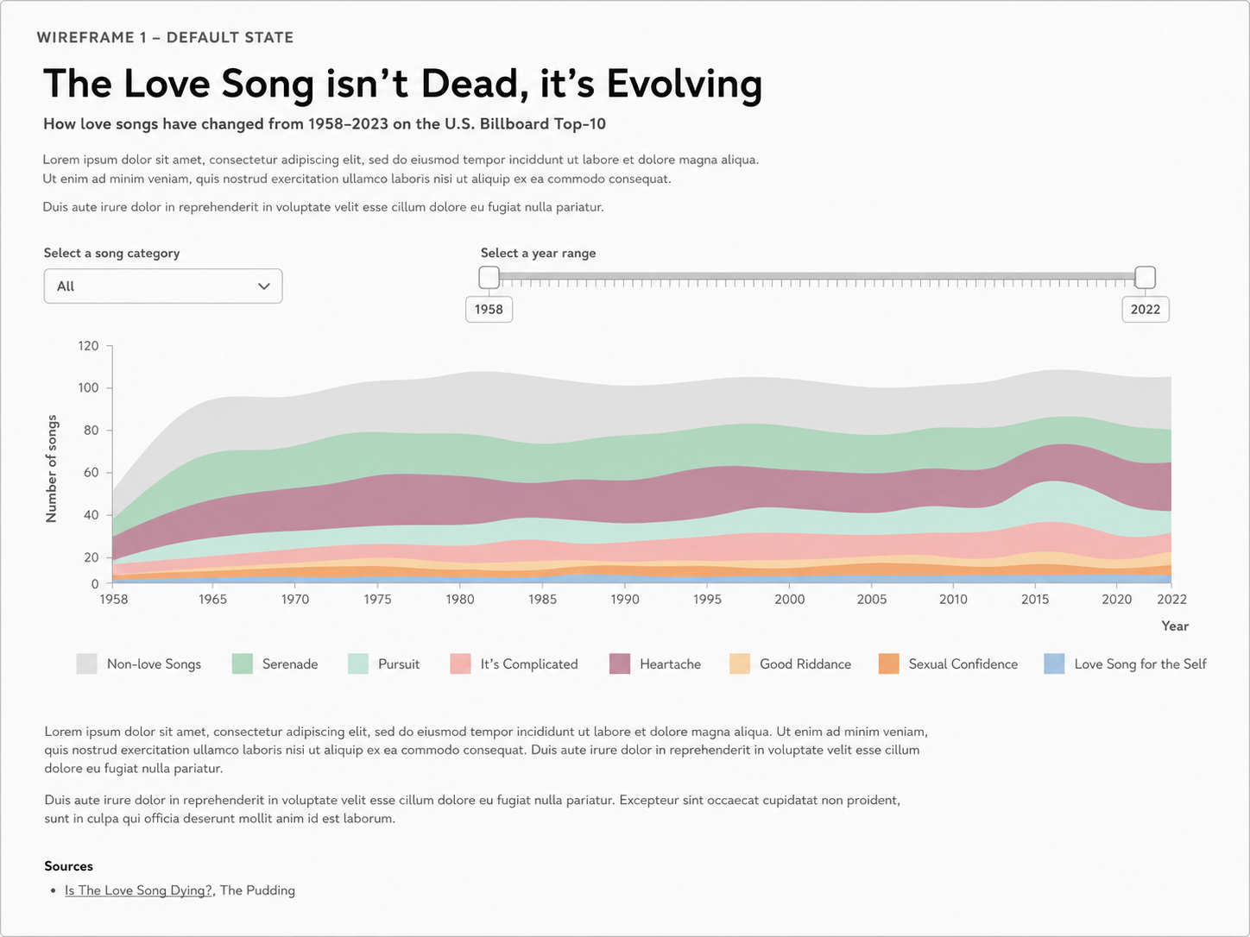
Default state: all song categories are visible and the full year range is selected.

Wireframe 2 - Hover state
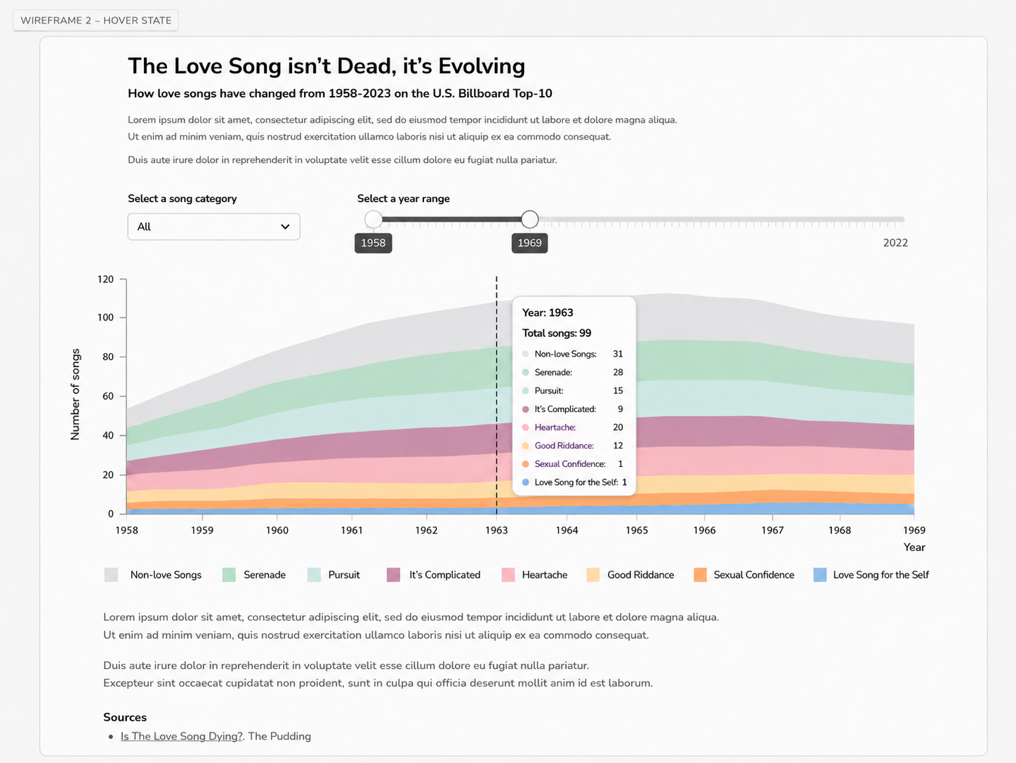
Hover state: moving the mouse over the chart shows a vertical guideline and year-specific values.

Wireframe 3 - Category filter state
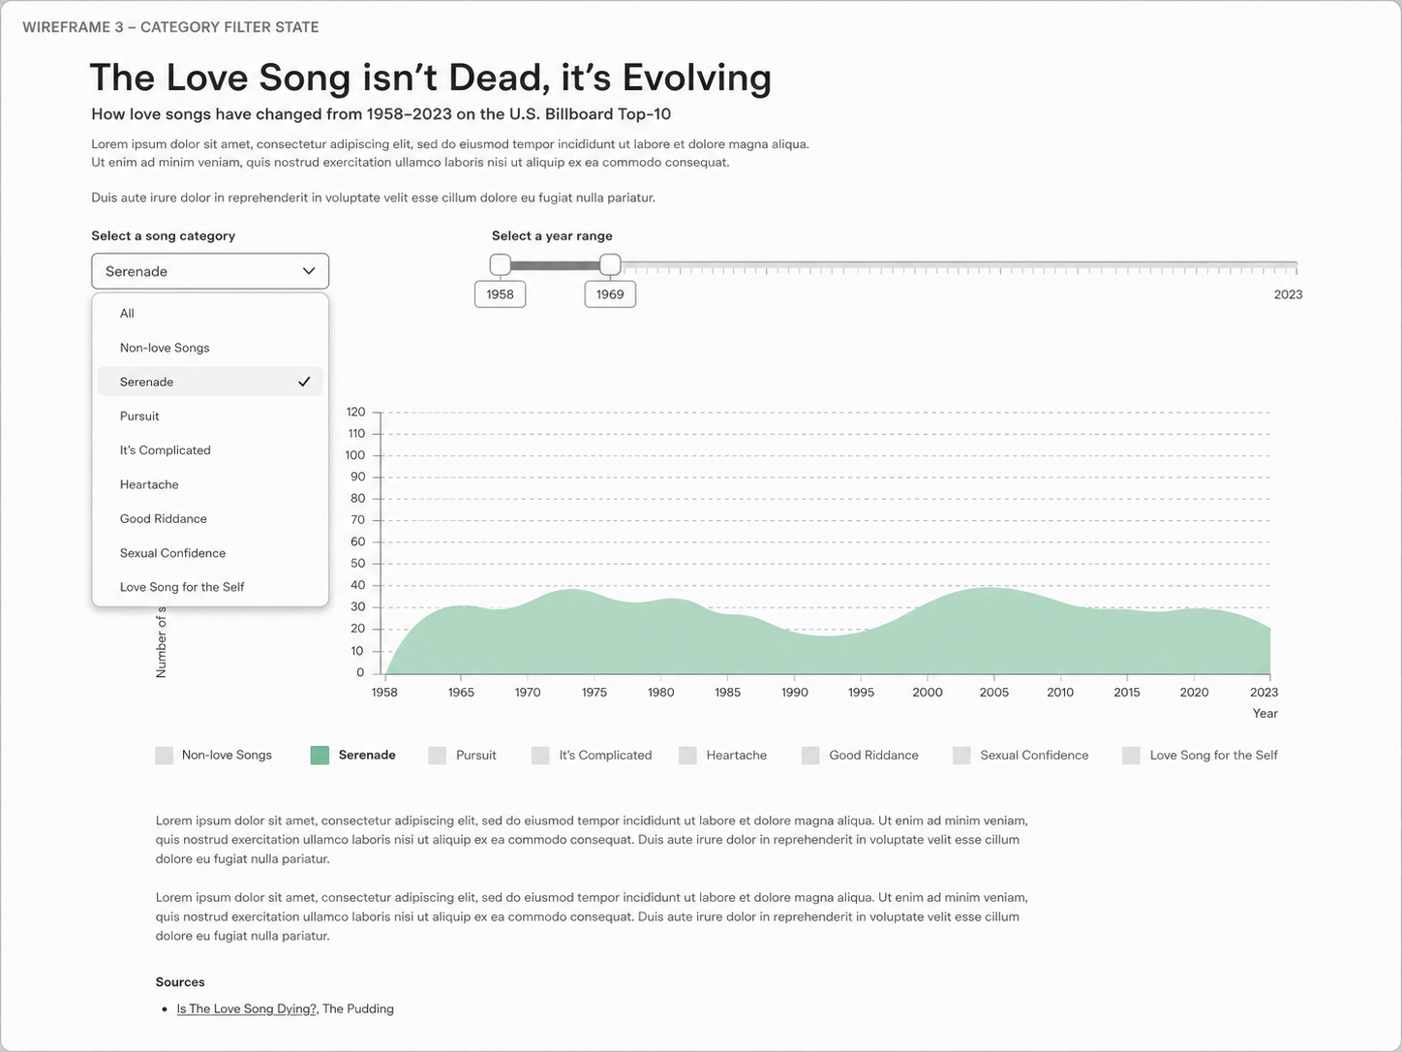
Filter state: the category dropdown allows the user to focus on one love-song category.

What is already provided
The starter project should already contain:
- A page title, introduction, explanatory text and source section.
- HTML containers for the controls, stream graph, legend and text sections.
- The dataset: love_song_categories_for_Billboard_Top_10_hits_1958_2023.csv.
- A basic file structure where visualization code can be separated from page content.
- A dropdown element and a container for the year-range slider
- A minified slider.

Step 1 - Transform the data for a stream graph
Create a grouped data structure where each row represents one year and contains the number of songs in each love-song category.

Data to use
Column | Meaning
top_10_debut_date_as_decimal | The year when the song entered the Billboard Top-10
love_song_category | The category assigned to the song

Requirements
- Convert the year column to numbers.
- Use d3.rollup() to count songs per year and per category.
- Create one object per year with values for all categories, including zero values where a category is missing.
- Calculate the total number of songs per year.

D3 concepts demonstrated
- Data transformation
- Grouping and aggregation
- d3.rollup()

Step 2 - Build the stream graph
Create the main stacked area visualization showing how different love-song categories change over time.

Visual encodings
Data | Visual channel
Year | X-position
Number of songs | Y-position / stacked height
Love-song category | Color
Change over time | Area shape

Requirements
- Create an SVG container and group using margins.
- Create an x-scale for years and a y-scale for number of songs.
- Use d3.stack() to produce stacked data from the grouped yearly data.
- Use d3.area() to draw one path per category.
- Add an x-axis and a y-axis.
- Add axis labels: Year and Number of songs.
- Create a color scale that maps each category key to a meaningful color.
- Add a legend explaining the category colors.

D3 concepts demonstrated
- d3.stack()
- d3.area()
- SVG path elements
- Axes
- Ordinal color scales
- Legends

Step 3 - Add filtering and animated updates
Make the visualization interactive by allowing the user to change the selected song category and year range.

Interaction requirements
Interaction | Expected behaviour
Category dropdown | When a category is selected, the graph updates to show only data from that category. Selecting All shows all categories again.
Year-range slider | When the year range changes, the graph and x-axis update to show only the selected years.
Transition | The stream graph and x-axis should update smoothly rather than jumping instantly.

Implementation requirements
- Store the current selected category in the model.
- Store the current selected year range in the model.
- Create an update function that receives changes and merges them into the model.
- Create a view function that redraws or updates the visualization based on the current model.
- Use transition().duration(...) when paths and axes update.

D3 concepts demonstrated
- Event handling
- Filtering data
- Transitions
- State management
- Model-View-Update pattern

Step 4 - Add hover tooltip interaction
Add a hover interaction that helps the reader inspect the exact values for a specific year.

Requirements
- Listen for mousemove events on the chart area.
- Use d3.pointer() to find the mouse position inside the chart.
- Use xScale.invert(...) to convert the mouse x-position back into a year.
- Round the year to the nearest whole year.
- Draw a vertical guide line at the hovered x-position.
- Display tooltip text with the year, total number of songs and category values.
- When a single category is selected, the tooltip should focus on that category.

D3 concepts demonstrated
- Mouse events
- d3.pointer()

Expected code structure
Your solution should separate state, initialization, update logic and rendering logic. For example:
The important idea is that user interaction should change the model, and the view should update based on the model’s content.

Completion criteria
Your hand-in is complete when:
- The page contains the provided story skeleton and interaction controls.
- The stream graph is rendered with D3 using grouped and stacked data.
- The category dropdown changes the displayed data.
- The year-range slider changes the displayed time period.
- The graph updates with transitions.
- The hover tooltip shows a vertical guide line and year-specific values.
- The code is readable and structured around state, update and view functions.
- The final layout resembles the target wireframes.

Hand-in
Zip-folder containing video-recording of your solution and the full solution code.

