Hand-in 1: The music we listened to in 2025

Purpose
In this hand-in, you will build a small data story about music consumption in 2025. The focus is not only on producing charts, but on learning how D3 turns data into SVG elements.
You are provided starter material: the page skeleton, headings, explanatory text and HTML containers are already in place. Your task is to implement Steps 1-3 by adding the visualizations with D3.

Target wireframe
Use the wireframe below as a layout guide. Your final result does not need match this pixel-perfect, but the main sections and chart positions should be recognizable.
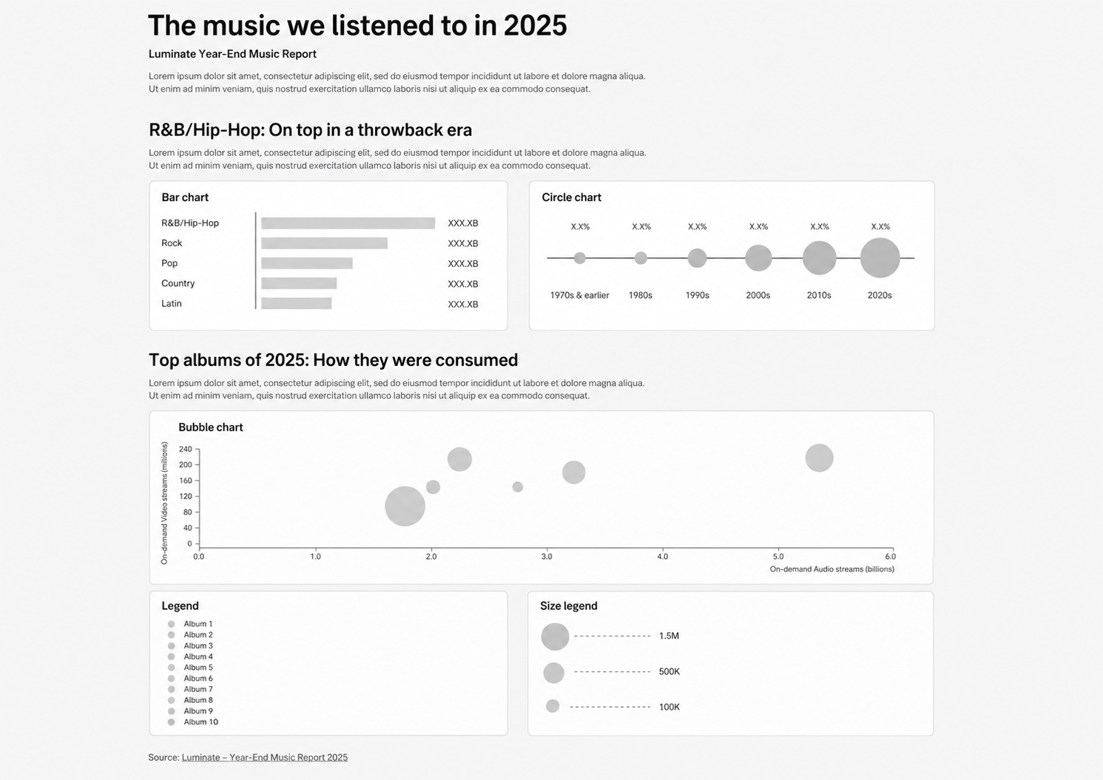

What is already provided
The starter project should already contain:
- A page title, introduction, section headings and explanatory text
- HTML containers for each visualization
- A basic file structure for separating the chart code
- The data files or starter data objects needed for the charts

Step 1 - Build the genre comparison bar chart
Create a horizontal bar chart showing the most streamed US genres by on-demand audio streams.

Data to use
Column | Meaning
genre | The genre label
audio_streaming_volume | The amount of audio streaming volume

Requirements
- Create one SVG rectangle for each genre.
- Use d3.select, selectAll, data and join to bind data to the rectangles.
- Use d3.scaleLinear() to convert streaming volume into bar width.
- Add genre labels on the left side of the chart.
- Add value labels at the end of each bar.
- Add a vertical reference line separating labels from bars.

D3 concepts demonstrated
- SVG rectangles
- Data joins
- Linear scales
- Text labels
- Basic chart layout

Step 2 - Build the release decade circle chart
Create a circle chart showing how US on-demand audio streams are distributed across release decades.

Data to use
Column | Meaning
year | The release decade
audio_stream_pct | The percentage of streams from that decade

Requirements
- Create one group (<g>) for each decade.
- Place the groups evenly across the chart using d3.scalePoint().
- Inside each group, draw one circle representing audio_stream_pct.
- Use d3.scaleSqrt() for circle radius so that circle area represents the audio-stream value.
- Draw a horizontal baseline through the circles.
- Add percentage labels above the circles and decade labels below the baseline.

D3 concepts demonstrated
- SVG circles
- Grouping with <g>
- scalePoint
- scaleSqrt

Step 3 - Build the album consumption bubble chart
Create a bubble chart showing how the top albums of 2025 were consumed across audio streams, video streams and album sales.

Visual encodings
Data | Visual channel
On-demand audio streams | X-position
On-demand video streams | Y-position
Album sales | Bubble size
Album | Color

Requirements
- Parse numeric columns before creating scales.
- Create an x-scale for audio streams and a y-scale for video streams.
- Add an x-axis and a y-axis using d3.axisBottom() and d3.axisLeft().
- Create one circle per album.
- Use d3.scaleSqrt() to encode album sales as bubble radius.
- Use d3.scaleOrdinal() to assign a color to each album.
- Add axis labels explaining what the x- and y-axes represent.
- Add a color legend for albums and a size legend for sales.

D3 concepts demonstrated
- CSV loading
- Parsing numeric data
- Linear scales
- Axes
- Ordinal color scales
- Square-root radius scales
- Legends

Expected code structure
Your solution should be structured using separate functions for each chart:
createBarChart(topUSGenres);
createCircleChart(audioStreamsByReleaseDecade);
d3.csv("/data/top_albums.csv").then(data => {
createBubbleChart(data);
});
Each chart function should be responsible for one visualization only. Avoid writing all D3 code directly in main.js.

Completion criteria
Your hand-in is complete when:
- The page contains the provided story skeleton from Step 1.
- The bar chart, circle chart and bubble chart are all rendered with D3.
- The visual encodings match the requirements described above.
- The bubble chart includes axes and legends.
- The layout resembles the wireframe.
- Your code is readable and separated into chart functions.

Hand-in
Zip-folder containing video-recording of your solution and the full solution code.

