Hand-in 3: The Boyband Blueprint

Purpose
In this hand-in, you will design and implement your own visualization based on the boyband dataset.
The focus is not only on using D3, but on making deliberate visualization design decisions. You must use geometry to create an radial visualization and develop your own visual language.
Unlike the first two hand-ins, this assignment is intentionally open-ended.
You are not intended to copy the example.
You may choose different data attributes, different marks and channels, and a different interaction design, as long as your final visualization is radial and your choices are justified.
There is no single correct solution for this hand-in. The goal is to demonstrate that you can design a visualization, implement it with D3, and argue for the choices you made.

Dataset and inspiration
You will work with the boyband dataset. The example visualization uses a pie layout to divide the circle into arcs, d3.arc() to draw the band segments, and trigonometry to position member lines and circles around the circle.
- You may use the same theme as the example: “The Boyband Blueprint”.
- You may reuse some of the same variables, such as band, height, hair length, hair color, or frosted tips.
- You may also choose other interesting variables from the dataset and build a different argument.
- Your visualization does not have to include every variable in the dataset.

Inspirational wireframes
Use the wireframes below as inspiration to possible layout and interaction states.
They are not a template that must be copied. Your own design may look different if you can justify your choices.

Wireframe 1 - Example interaction state
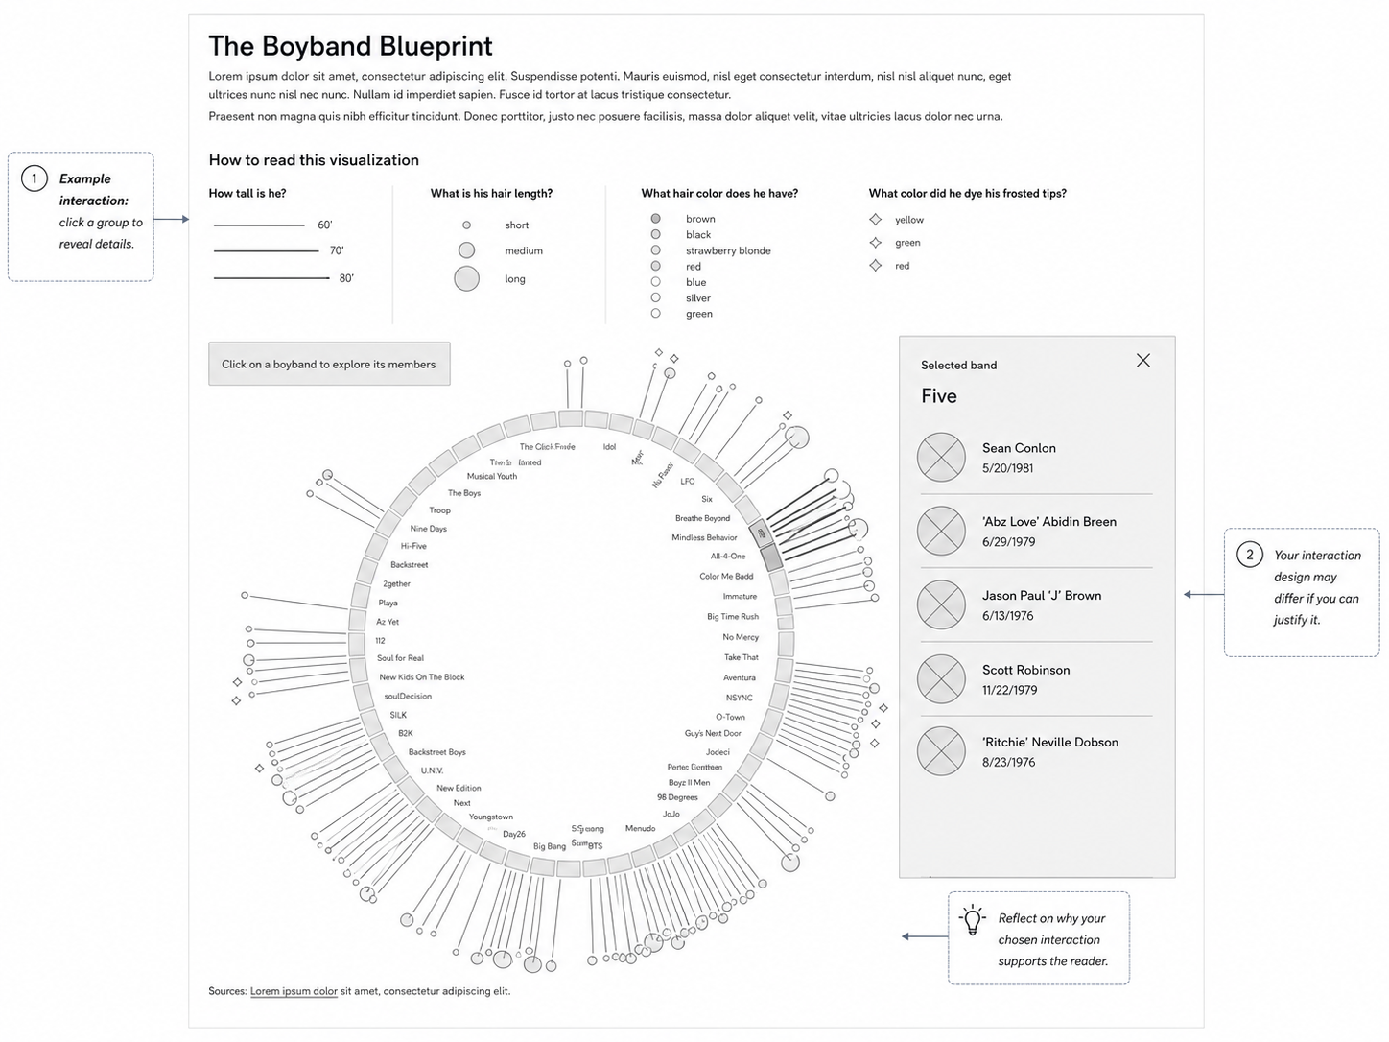
This wireframe shows one possible interaction: clicking a boyband reveals a details panel. Students may implement another interaction if they can justify it.

Wireframe 2 - Marks and channels reflection
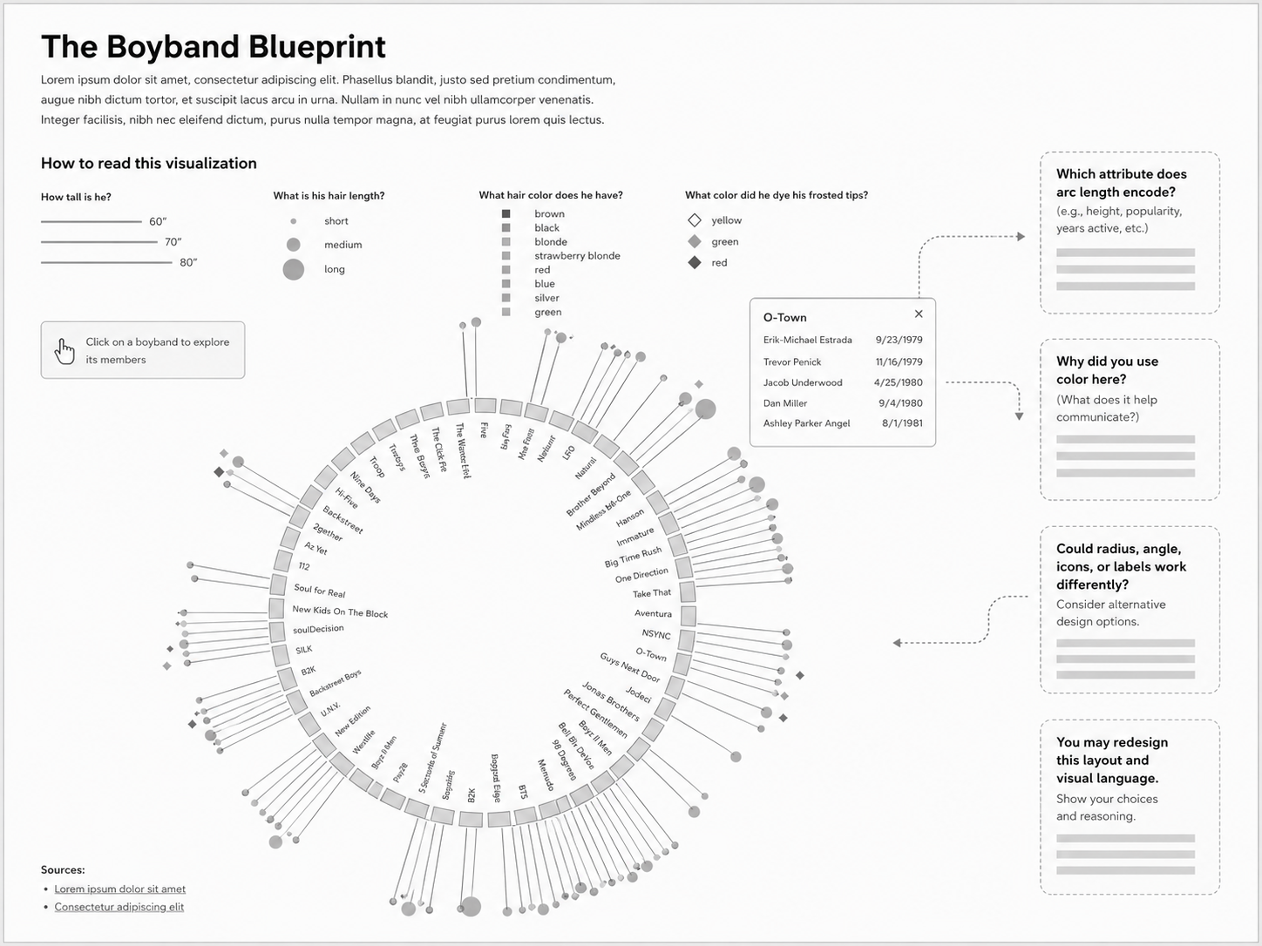
This wireframe highlights the design questions students must answer: which attributes should be encoded, which visual channels are used, and whether another layout would communicate the data better.

What is already provided
- The dataset containing boyband and member attributes.

Step 1 - Define your visualization question
Before coding, decide what your visualization should help the reader understand.
The following questions should be answered:
- My visualization will investigate
- The most important data attributes are
- The reader should first notice
- The reader should then be able to explore

Step 2 - Choose marks and channels
You must decide how data is translated into visual form.
- Possible marks: arcs, lines, circles, points, labels, icons, areas, panels, or symbols.
- Possible channels: angle, arc length, radius, distance from center, size, color, opacity, shape, orientation, or position.
- You must use at least three deliberate visual encodings.
- You must be able to explain why each encoding supports your message.

Marks and channels planning table
Data attribute | Mark | Channel | Why this choice?

Step 3 - Implement the radial geometry
Your visualization must use arcs as a meaningful structural element. The arc should not just be decorative.
- You may use d3.arc() to draw arc segments.
- You may use d3.pie() to divide data into angular segments.
- You may calculate positions around a circle using Math.sin() and Math.cos().
- You may use a full circle, partial circle, nested rings, radial labels, or another arc-based layout.
- Think carefully about label orientation, spacing, overlap, and readability.

Step 4 - Add legends and reading support
Because arc-based visualizations can be visually dense, your reader needs help understanding how to read the chart.
- Include a legend, reading guide, annotations, or explanatory labels.
- Explain the most important marks and channels.
- Make the visual hierarchy clear: what should the reader notice first, second, and third?

Step 5 - Add meaningful interaction
Your visualization must include at least one interaction. The interaction should support exploration or understanding rather than just add decoration.
- Example: click a boyband arc to reveal its members.
- Example: hover over a mark to show details.
- Example: filter by attribute.
- Your reflection must explain why the interaction helps the reader.

Step 6 - Write the reflection
Your hand-in must include a short reflection. Use the questions below:
- What question or insight did your visualization communicate?
- Which marks did you choose, and why?
- Which channels did you choose, and why?
- What does the arc structure represent in your design?
- Which attributes from the dataset did you choose to visualize, and why?
- Which attributes did you choose not to visualize, and why?
- What interaction did you implement, and how does it support the reader?
- What would you improve if you had more time?

Completion criteria
- The visualization must be radial in some form.
- The arc structure must encode or organize data meaningfully.
- You must use at least three deliberate visual encodings.
- You must include a legend, reading guide, or annotations explaining how to read the visualization.
- You must include at least one meaningful interaction.
- You must include a short reflection on marks, channels, and design decisions.
- Your code should be readable and structured into functions.

