Freddie Wittmann

Mile Stone #2

Project Report/ Explanation

**Web Site Map:**

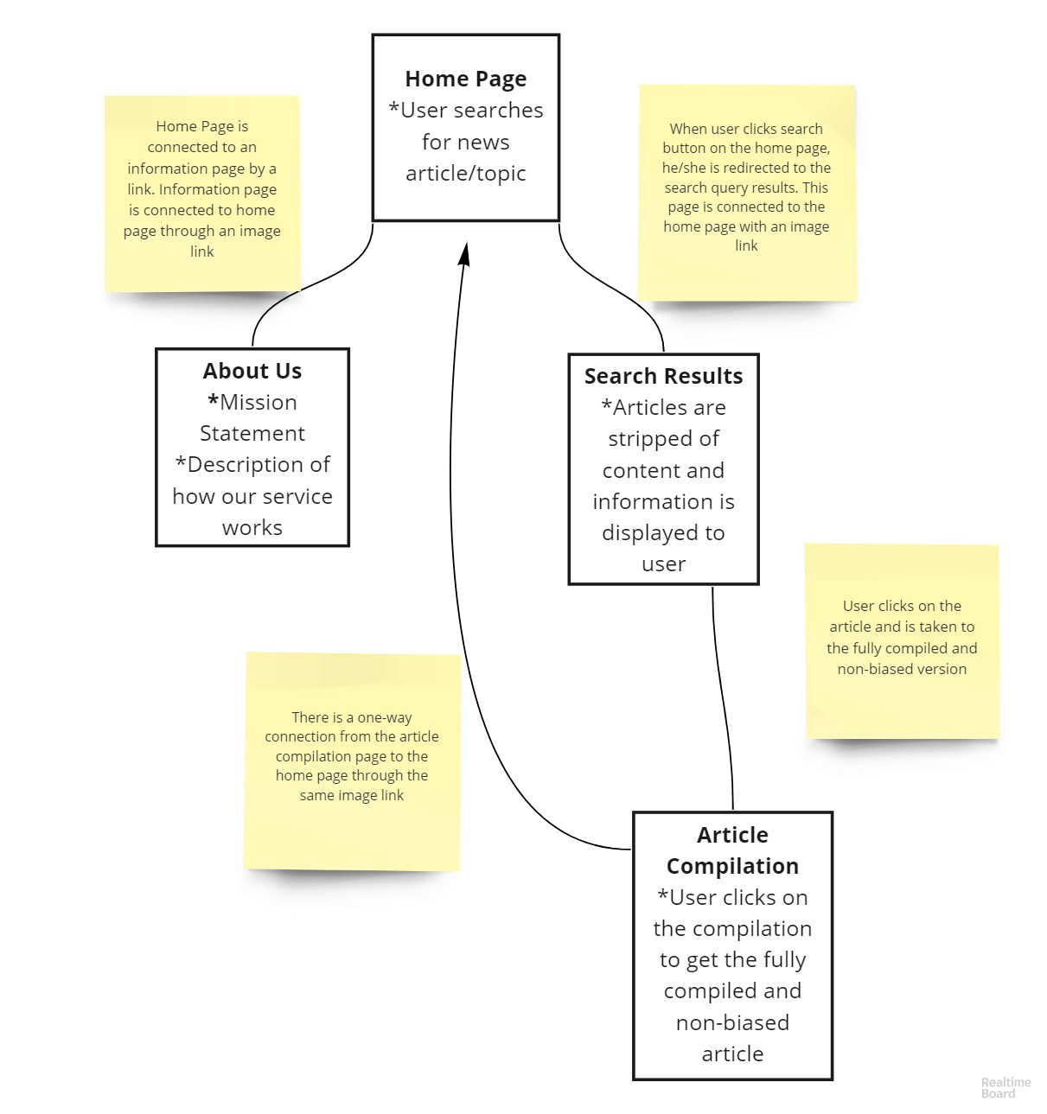

Above you will see a rudimentary layout of our intended software. As you can see, each page in the website is connected to the home page via an image link. This image link will be our “MSM” logo, of which every page will have on the top (refer to the Mission Statement component for an example of what this will look like). Each square in the layout represents a page, and each line *without* an arrow represents a two-way connection between pages. The line with the arrow shows that there is a one-way connection from the final article compilation page to the home page.

In order to get our feet wet with React, we utilized the framework to build a rudimentary interface, and provided the above layout to create a clearer picture of how the pages will connect. When referring to the website layout to make sense of the code, each individual component in the App.js file represents a separate page. For example, the ‘<MissionStatement/>’ component will be its own page in the final product.

Although this is not quite as clear as traditional HTML and CSS layouts, it enabled our team to get used to the functionality and the syntax of the React framework (and TailWind).