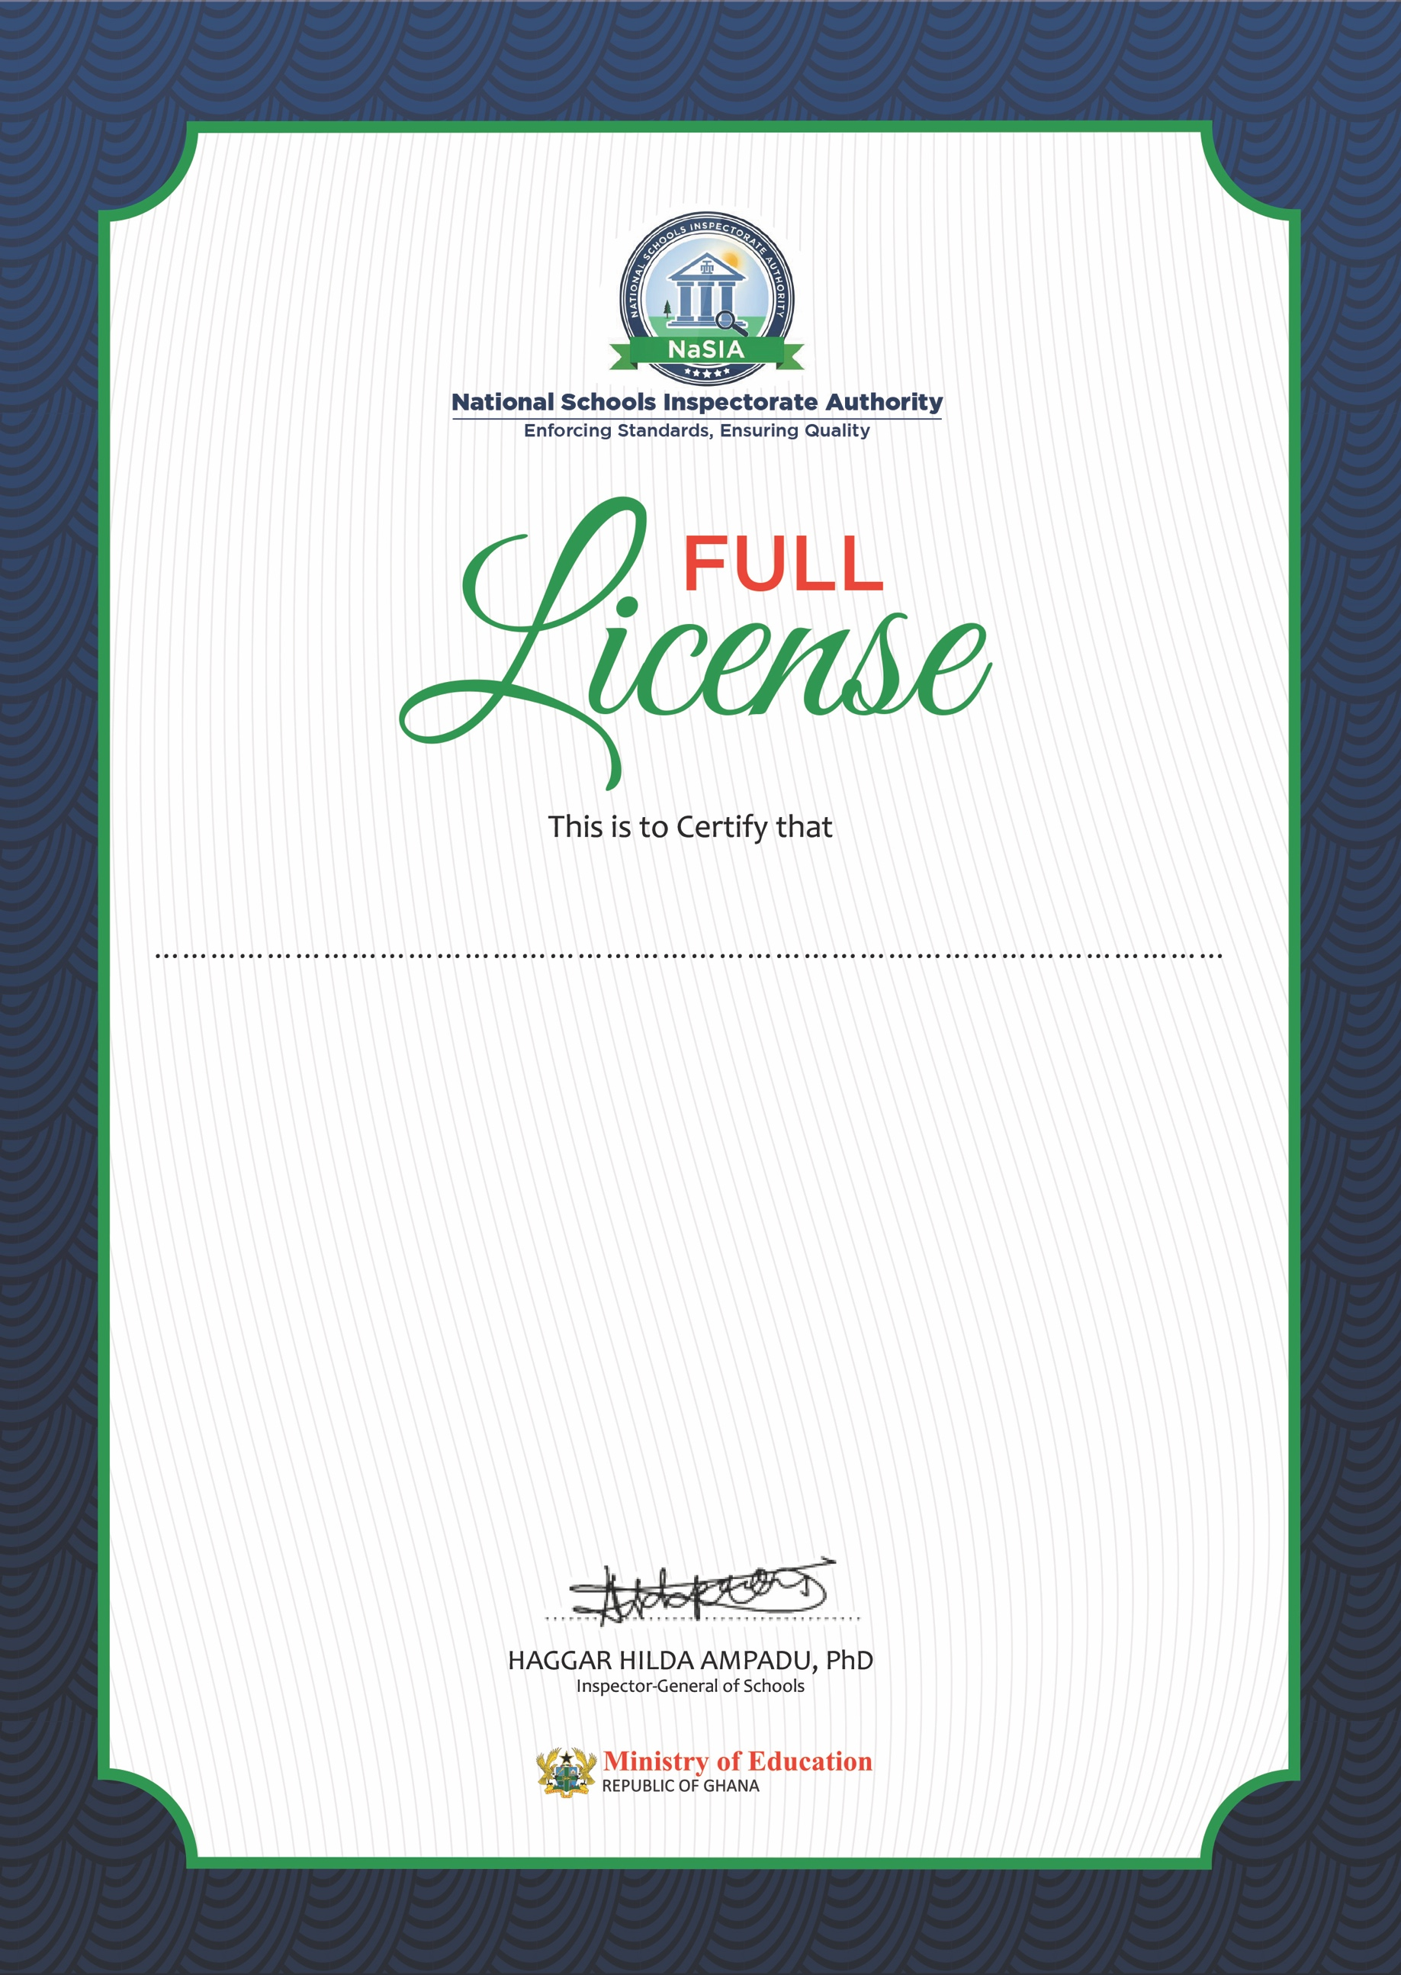

Established in Accra on 26/03/2021

is this day 26/03/2021

Issued a Full License to operate under the

Education Regulatory Bodies Act, 2020 (Act 1023)

**GA-PRV-BAS-P0078042020**

**This Full License is valid for three (3) years and is subject to payment of Annual Operation Fees**

Notwithstanding, this license shall be deemed revocable on occasion of degeneration of the school or due to performance below set standards.

**NEW NATION INTERNATIONAL SCHOOLT**