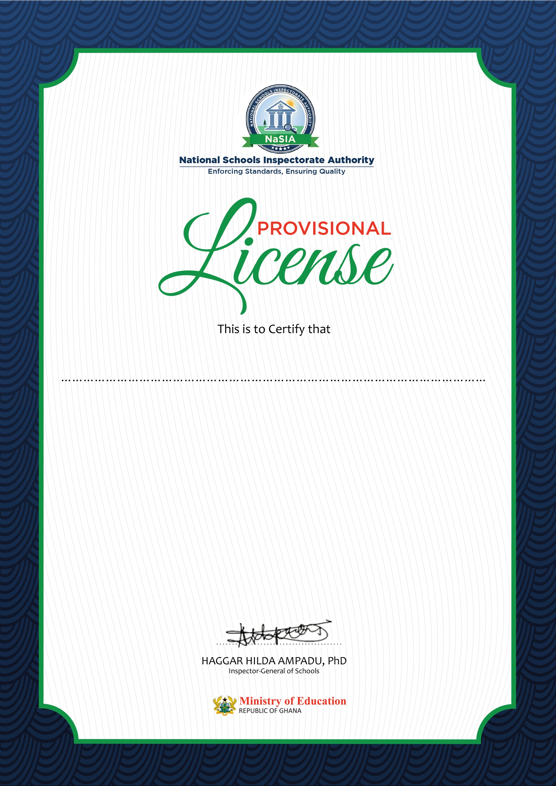

Established in Accra on 26/03/2021

is this day 26/03/2021

Provisionally licensed to operate under the

Education Regulatory Bodies Act, 2020 (Act 1023)

**GA-PRV-BAS-P0078042020**

This Provisional License is valid for one (1) year only

and expires on 23/04/2021

Notwithstanding, this license shall be deemed revocable on occasion of degeneration of the school or due to performance below set standards.

**THIS PROVISIONAL LICENSE IS SUBJECT TO ANNUAL RENEWAL**

**NEW NATION INTERNATIONAL SCHOOLT**