List of ten appliances (page 19)

* light sensor
* automatic watering
* door sensor
* mailbox sensor
* security system
* windows and door control
* lighting control
* face recognition sensor
* motion sensors
* driveway sensor

Briefly description of 3 sensors

Automatic watering

**Usage**

The main use case of automatic watering appliances is to water the lawn. But you can also use the device to water potted plants like cactuses, flowers or little trees.

**Extended features**

* measuring ground water
* watering the ground in different time periods
* calculating the right percentage of water which ground needs
* checking if somebody is nearby
* keeping the grass green

Light senor

A light senor is nothing else than a movement senor. It checks if there is any movement int the current room and if it recognises movement it turns the lights on.

**Extended features**

* checking the distance of the movement
  + example:
    - distance > 5m
      * don’t turn on
    - distance < 5m
      * turn on
* saves a bunch of electricity
* avoids forgetting to turn the light off

Mailbox sensor

**Usage**

A mailbox sensor is also nothing more than a motion detector. It is placed inside the mailbox and some of them can send you a message with the exact time when the mailbox was opened.

**Extended features**

* prevents mail theft
* reports when the package has arrived
* keep track of your packages / mails

Read through the questions and take notes

**Which of the smart home appliances mentioned in the infographic do you know?**

I think I am able to say that I nearly know every senor mentioned in the infographic. I also use sensor to build little home appliances like a temperature checker or a movement checker.

**Which of these smart home devices do you find unnecessary/useful in Austrian houses?**

Sensors like light sensors are unnecessary to some extent, in my opinion. I think we should be able to turn our lights on and off by ourselves. But on the other hand, they can be really useful if you put them in front of your house. You can find out if someone is coming or not. And it can be difficult to find the light switch outside at night.

**Do you live in a smart home? Which devices/appliances does your house/flat have?**

I live in a flat and do not really have this much smart home devices. But I like to build them on my own. It is a hobby of mine, to program microcontrollers with sensors and to get their collected data.

Explanation of geofencing (page 20/21)

Geofencing is the use of RFID or GPS technology to create virtual geographic are. It gives some software’s the opportunity to check if you currently in the created area or not.

The main usage of geofencing is to trigger an action when a device is in the created virtual area.

Examples field of use

* smart home devices tracking if the homeowner is at/enters home
* identifying people in different areas
* spying
  + tells spy when the victim entered a specific area
* health and safety
  + protecting people from hazardous areas

Suggesting some ways to gain the consumers trust (page 20/21)

* developing open-source software
  + showing code to the user
* creating readable/understandable AGB’s
* sending a confirmation to the customer how much data got deleted every month
* free trials
* having the company checked by experts

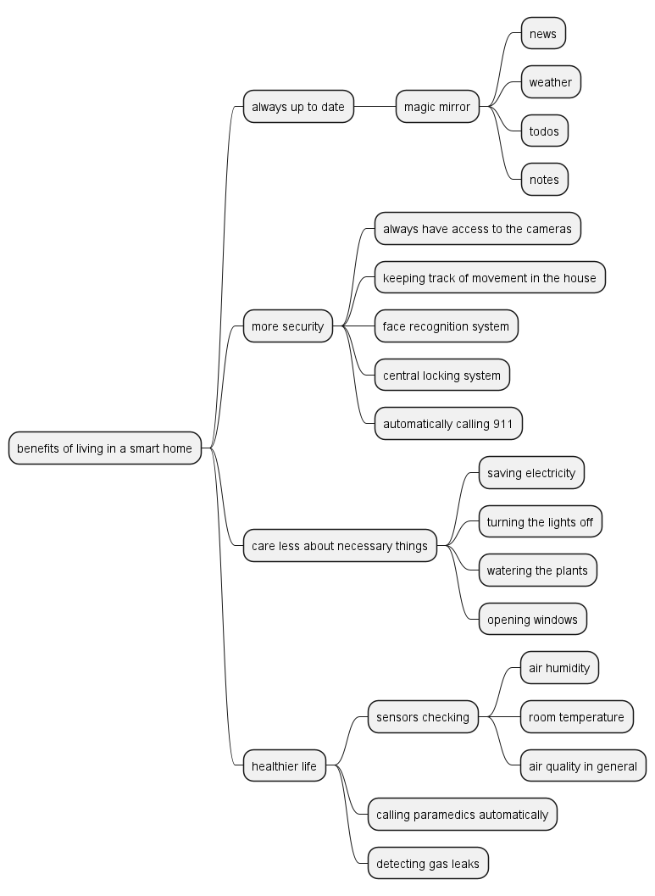

Correcte

**Added: book-pages (grammar and stuff…), bonus-challenges, mind map finished, Page 23) UE3), Page 25) 1),Ted-talk-Task --done**

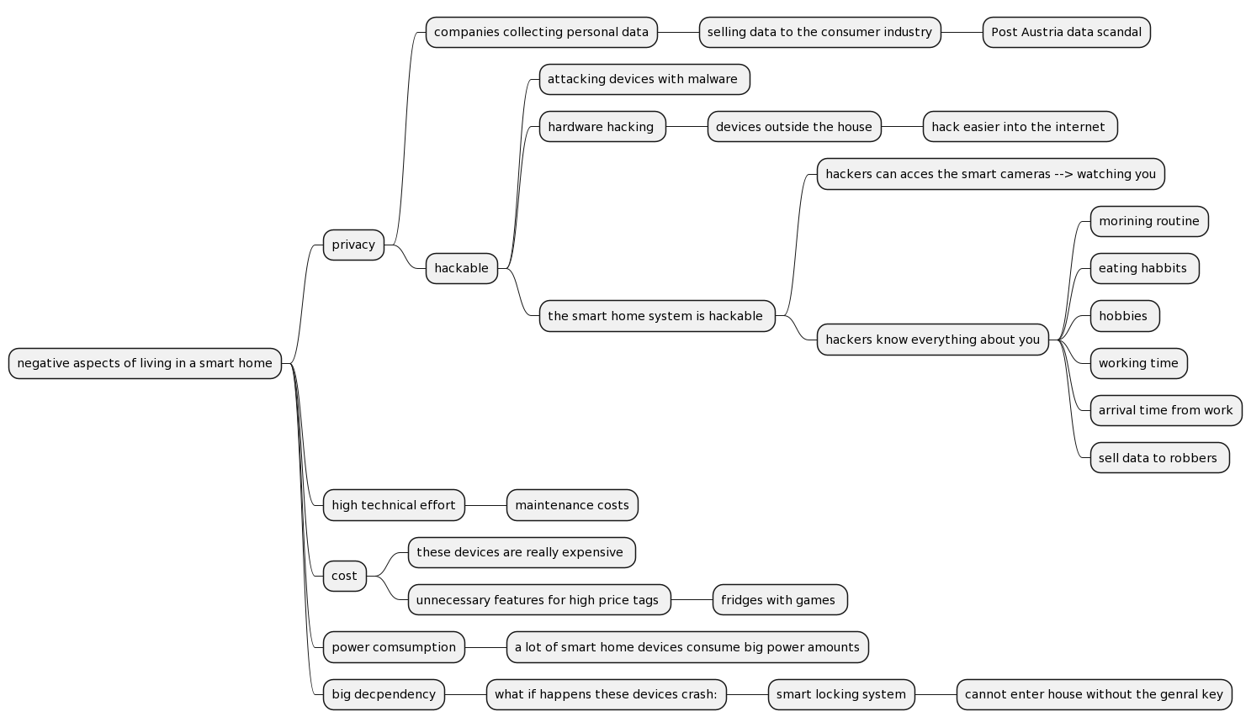NEW MARKER –Continued

MINDMAPS DONE WITH: Michael Ruep

Page 23) UE3)

1. Could you imagine living in a smart home?
   1. Definitely, I love tech and I also love to play around with tech gadgets.
   2. It would make my live a lot easier, because I have not to care about unnecessary things like turning off the lights. Instead of thinking about these things I can focus on more necessary stuff.
   3. I can feel save because of the cameras in front of the house filming everything.
2. How would you feel being surveyed by cameras 24/7?
   1. When the cameras send their data to my personal server at home, I feel safe because in this situation I am aware that I am the only one who can access the data.
   2. If the server is third party like the GOOGLE servers, I would feel a little bit unsafe because they surely selling these collected data to some pharma concerns
3. Who would benefit the most of living in a smart home
   1. Old people benefit the most of living in a smart home, because they struggle doing day-to-day tasks and it would be really helpful for them if they are supported by a home automation system.
4. To what extent living in smart home change family life
   1. Living in a smart home can help parents keep an eye on their children without having to search for them. Instead, they install a camera and can monitor them through their phone.
   2. The parents can check when their children come home, and they are also able to see if their children are home

Page 25) 1)

Note down the meanings of the following words:

* to associate
  + to connect something with something
  + Zusammenhang hertsellen 🡪 Objektorientierung
* sustainability
  + helping to preserve the planet
  + Nachhaltigkeit
* to be supposed to
  + to be supposed do something
  + (etwas machen sollen)
* to stroll around
  + to walk around (herum gehen)
* the enable somebody to do something
  + to put somebody in the position to do something
  + (jemanden in die Lage versetzen etwas zu tun)

**Ted Talk 'What Your Smart Devices Know (and Share) about You'**by Kashmir Hill and Surya Mattu (TED 2018)  
  
<https://www.ted.com/talks/kashmir_hill_and_surya_mattu_what_your_smart_devices_know_and_share_about_you>) (length: 6:30 - shortened)

1. **Listen to the talk and answer the following questions:**
2. What did Kashmir’s husband buy her?

He bought her an Amazon-Echo.

1. Which examples of internet-connected devices does she give?

Smart locks, smart toilets, smart toys, smart sex toys, smart lights

1. How many internet-connected devices did she install at home?

She installed 18 smart devices

1. What did Surya do?

He installed a router which tracked the internet traffic.

1. How long did they run the experiment?

They ran the experiment for 2 months.

1. What kind of information regarding Kashmir’s daily routine did Surya get?

He knew when the woke up and when they went to bed. He knew when they brushed their teeth.

1. Which words / phrases does Kashmir use to describe her experiences in her smart home?

She concluded that when you buy a smart device, you own the device, but the company behind the device owns the data.

1. **Discussion in class  
   Take notes.**

* What is their opinion on / attitude towards smart devices?

They think that smart devices are nice to have but you can also survive and live your life normally without them.

* What do they want to make us aware of?

That you must be aware of the fact that the companies behind these devices collect your data.

* Which aspect / part of the talk struck you the most? Why?

The aspect that Amazons Echo sends data to their servers every 3 minutes was quite shocking, because if you think about it, you can easily say that you pay them to collect your data. The buyers are their piggy bank filled with data.

* Could you imagine taking part in / doing a similar experiment? Why (not)?

Yes, it would definitely be interesting to participate in something like that, because then you can see for yourself what and how your own data is being collected.

* Do you live in a smart home / house?   
  Do you want to live in a smart home / house? Why (not)?

No currently not fully smart. We have a few smart devices but no central controller to control them. It would definitely be interesting to live in a smart home but only if the smart home system runs locally in my home and not in any 3rd party locations.

