**Unit 11- Lernbüro**

Page 144) ex3) and the following questions:

Notes ex3)

**What makes a good ad for you?**

some memorable songs, noticeable photos, regulated loudness,

**How can an ad get the interest of a prospective?**

As mentioned before there should be a memorable song in it, memorable pictures, perfectly placed lights, flawless products

**To what extend can ads be dangerous to kids?**

If the ad is showing some sexual based products or played down products like vapes or cigarettes. An ad can also trick them to fall into a scam.

**What are the pros and cons of advertising?**

**Pro’s:**

Getting in touch with new products.

Getting new customers (the company behind the ad).

Reveal products (the company behind the ad).

Finding new hobbies.

**Con’s:**

Results never guaranteed.

Tricking people into scams.

Sometimes too long and too loud.

**Are there any TV channel that do not have adverts? If yes, which ones? Why do you think there are not adverts shown?**

The only channels that don’t have ads are pay tv channels like sky. They don’t need to show ads because such channels require you to pay for them and they get their income out oft he payments.

**What kinds of media are available for advertising here in Austria?**

Basically every social media app and every tv channel which requires no payment for it. Examples: Instagram, Twitter, Snapchat, Facebook…

**Has an ad ever made you buy a product? Why (not)?**

It actually has. It was the Lieferando ad. It is very hard to ignore such ads if you are hungry and don’t like to cook.

**Do you think that there is too much advertising in our daily lives? Why (not)?**

No, people make their money with ads. In my opinion it is absolutely fair to watch an ad if you get for example a free social media service to use.

------presentation about red bull with (Micheal Ruep, Christoph Ursprung, Jonas Fröller)------

145) NR 3 (Michael, Jonas, Christoph)

A: creative ads, sponsoring (soccer, formel 1), servus tv, events

I: They claim that the drink makes you better at sports.

D: A lot of popular people drink or advertise Red Bull. The viewers want to be like their idols and need to buy Red Bull.

A:

* many sales
* popular brand,
* positioning in the store

146) 1

-positioning: positionierung

-gimmick: Witz, Gag

-franchise: vergeben von Geschäfts Konzepten bspw: Mc Donads, Burgerking, Subway

-loss-leader: Lockangebot bspw: niedriger preis

-word of mouth: Mundpropaganda bspw: einem Freund von einem Produkt berichten

-target groups: Zielgruppen bspw: Kinder

-prime time slot: beste Sendezeit

-retailer: Wiederverkäufer bspw: Der Wiederverkauf von seltenen Adidas Schuhen, welche jedoch durch einen Drittanbieter vertreiben werden und nicht mehr durch die Marke selbst, in dem Falle Adidas.

-brochure: Broschüre

-merchandiese: Fanartikel

-launch: der Drop oder der release

-sponsorship: Partnerschaft, oder auch die Förderung

**Gram 🡪 149 Two different meanings**

**Advertising Strategies 1)**

**grocery store:** a store with groceries in it. (Spar, Lidl, Hofer, Billa,….)

**an array of something:** a row of something or a collection of something

**shopping cart:** a shopping cart is a cart in which you put your shopping in

**to toss in:** to throw in

**aisle:** an aisle is a corridor

**bulk option:** If you buy 3 packs of chips you pay just for 2.

**diapers:** the underwear for babies, they can poop and piss in it.

**rack:** a rack is a structure in which you can store stuff

**to traverse:** to go through something

**to seduce sb.:** means to get someone to buy a product

**2) Mindmap**

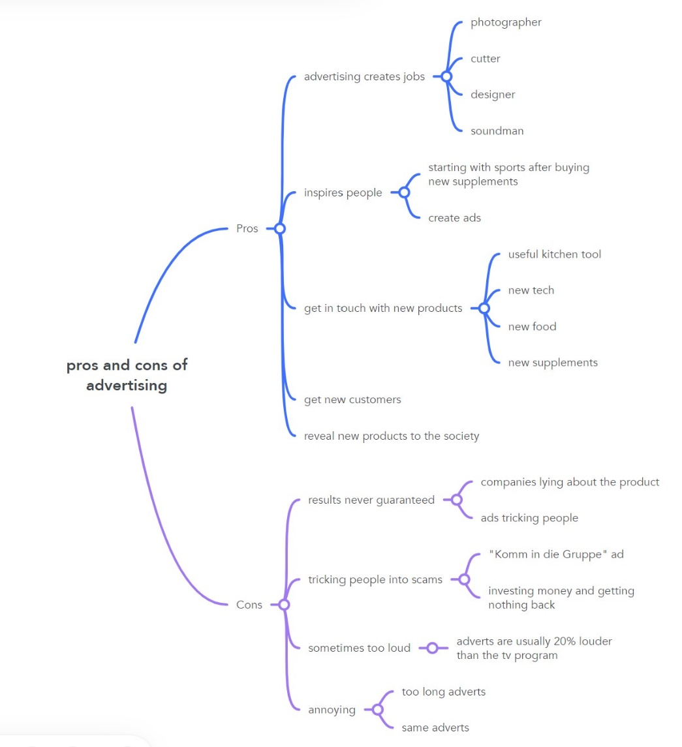

<https://www.mindmeister.com/map/24405233>

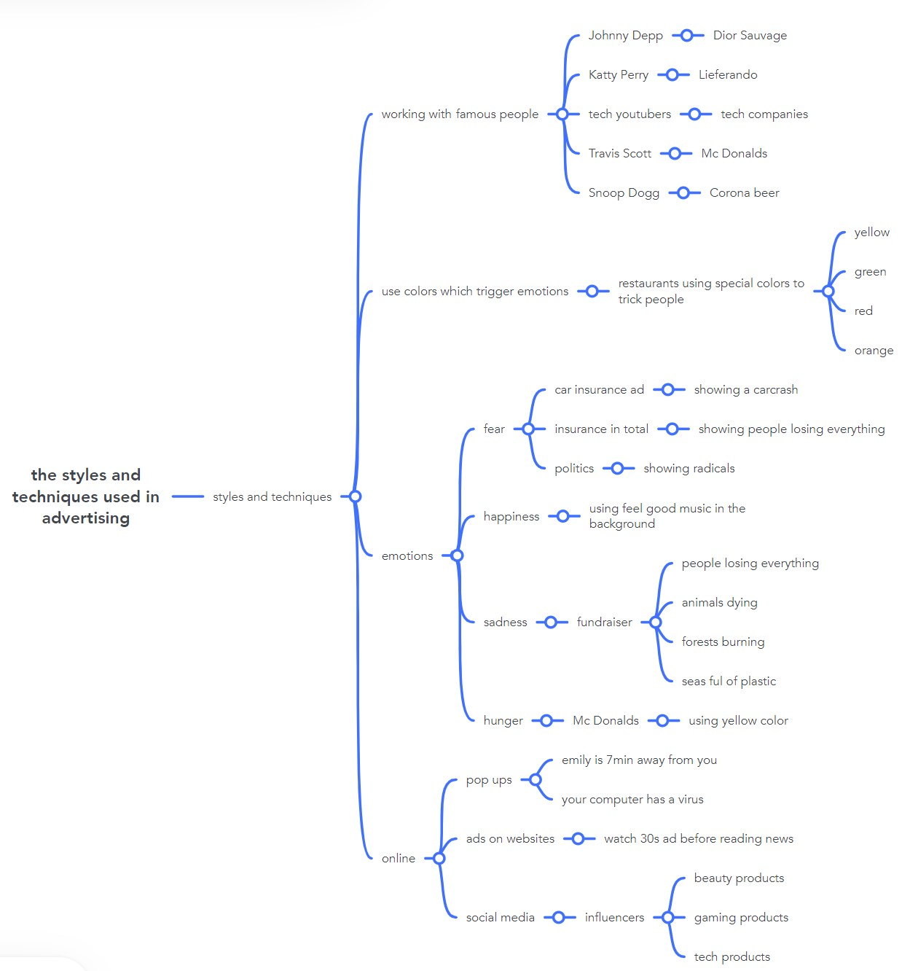

<https://www.mindmeister.com/map/24405450>

Pair Work --Done with Michael Ruep

Advertising targeting children and teenager

Name some examples of advertisements specifically tailored at children and teenagers.

* Toys R us advertisement
* Lego advertisements
* Playmobil advertisements
* Every FSK < 16 advertisement

Give reasons why marketers create adverts targeting children and young people in particular.

* Younger people are easier to manipulate
* Kids influence their parents’ buying decision
* **Pester power:** the ability of children to nag their parents about a product until the parents give in and buy it

Outline the negative impact these ads have on them and their lives:

* They think they get the same perfectly fine product as they have seen in the ad. After buying the product they realize the loss of quality in it.
* They don’t trust ads anymore.

Discuss whether children influence their parents’ buying decision

* They continuously talk about the for example speak about the new Lego product and the good quality of it.
* The little one’s cry if they don’t get what they wang
* Parents like to have happy children and buy them the product they spoke about before.

Discuss whether personalized advertising on social media platforms should regulated or even banned.

* On one side the personalized ads can help you find the products you have always wanted.
* On the other side you can say that the personalized advertisements are kind of creepy.
  + Imagine you just spoke about a product and that same product appears in the next minute on your TikTok For-You page or on your Instagram staring page.
* It should definitely be regulated but banning the personalized advertisements is definitely not an option for me because I ‘d rather see a personalized ad than some 3rd party advertisement.

Talk about your experience with targeted ads

* I once spoke about a new iPhone that will be released. 2h after the conversation I have got only iPhone advertisements on my Instagram starting page.
* I have found out about new products and also bought new products because of the personalized ads.

Say how much you care about your online activities constantly being tracked and analysed.

* I don’t really care about it. I mean the social media platforms are free and you had to accept the usage agreement. They also need to make their money somehow, if you don’t pay for the app in money you have to pay with your data. All in all, its and fair trade for me.

Tell your partner what you do to keep your personal data as private as possible

* Using VPNs
* Using proxies
* Using tracker blocker
* Don’t accept cookies

Pair Work done with Michael Ruep

What will advertisements look like in the future?

* Ads could be played in your head via a brain chip
* Metaverse advertisements (ads in the virtual world)
* more immersive ads
* AI generated and animated ads

How far will tech shape ads?

* More 3D advertisements like the ones shown on the TimeSquare Screens
  + <https://www.youtube.com/shorts/5y7hsPDplWA>
* Advertisements like shown in the video
  + in cities
  + shops
* Technology will shape advertisements pretty far

Personal opinion on the video “Bizarre Glimps into the Future” & Statement

* Video not working
* This Statement make kind of sense for me.
  + Other ad-free places are the internet with an adblocker or just your home
  + If you let advertising get you it will but ignoring them and staying away from them is also a possible solution avoiding every type of advertisement.
* Maybe there will be ads which manipulate our dreams soon
* Kind of scarry thinking about that