**Medientechnik**

* What changed since the last time?
  + UI-Improved
  + Room-Access working now
  + Fixed changes of the attributes
  + Attributes added for room_access table
  + Room access table created
  + Users have certain rights and cannot access or delete rooms that they don’t own
  + Switch for lights added
* Python script for sensor-readings added (python script: capacitive-soil-sensor-folder)
  + <https://github.com/Stevan06v/capacitive-soil-pico.git>

ToDos

* Access the sensor data 🡪 visualize the sensor data
* Fix room access
* Fix maps CSS
* 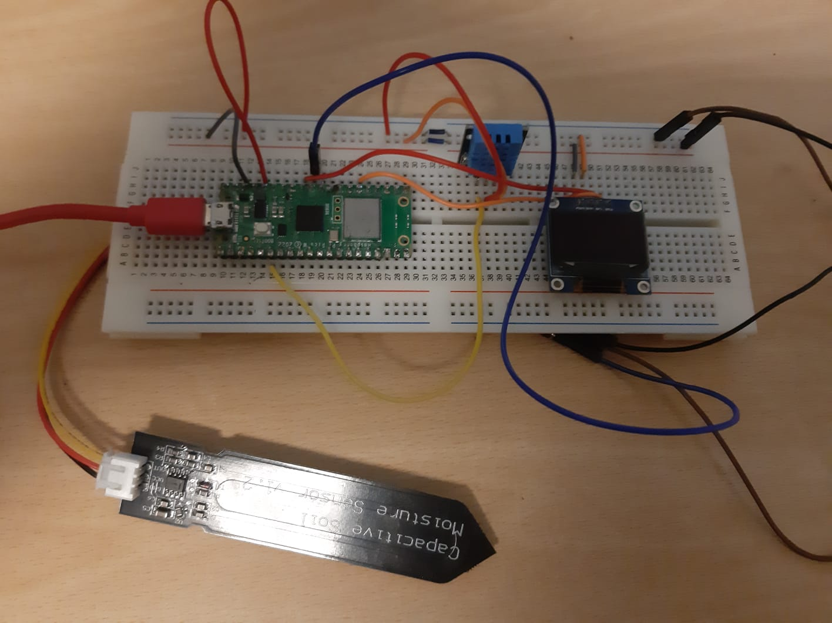Remove guest login page completely

