Practicum Final Exam – Odd Semester Year 2021/2022
Subject |  |  | ISYS6169001 – Database Systems |  |  | 
Class | : | BO01 / BP01 |  | Start Date | : 13 January 2022
Lecturer | : | D1167 – Ir. Yosafati Hulu, M.M. |  | Start Time | : 13:20
Lecturer | : |  |  | End Date | : 13 January 2022
Lecturer | : |  |  | End Time | : 15.20

PERATURAN UJIAN:
Exam Regulations:
- Mahasiswa tidak diperbolehkan berdiskusi dan/atau bekerja sama dengan peserta ujian lainnya
Student is not allowed to discuss and/or work together with other exam participants
- Mahasiswa tidak diperbolehkan untuk membuka dan menyalin dari BUKU atau CATATAN, VIDEO dari pengajar (recording kelas, VBL, Youtube, dsb) dan REFERENSI lainnya
Student isn't allowed to open and copy from any resources such as notes, videos (class recording, VBL, Youtube, etc) and other references
- Mahasiswa tidak diperbolehkan membuka dan menyalin jawaban dari internet (google, stackoverflow, dsb)
Student isn't allowed to open and copy answer from the internet (google, stackoverflow, etc)
- Asisten BERHAK memberi nilai 0 (NOL) bagi peserta ujian yang melakukan segala bentuk kecurangan
Assistant is able to give 0 (ZERO) score for exam participant who does any cheating actions
- Kumpulkan jawaban tepat pada waktunya, apabila terlambat mengumpulkan maka jawaban tidak akan dikoreksi dan nilai mahasiswa adalah 0
Submit the answer on time, if not, then the answer will not be checked, and the students will receive 0 (ZERO)
- Bila Anda tidak membaca peraturan ini, maka Anda dianggap telah membaca dan menyetujuinya
If you have missed to read these regulations, so you are considered to have read and agreed on it



SOFTWARE YANG DIGUNAKAN:
Software will be used:
- SQL Server Developer 2019
- SQL Server Management Studio 18.9.1

FILE YANG DIKUMPULKAN:
File must be collected:
- [Last 6 digit of Student Id].SQL query answer

PERHATIAN!
Attention!
- Bagi yang mengerjakan tidak sesuai dengan soal, maka akan diberikan nilai NOL (0)
For those who do not work in accordance with the exam case will be marked as ZERO (0)
- Bagi yang mengerjakan tidak sesuai dengan software dan versi yang telah ditetapkan, maka akan tetap dikoreksi dengan software dan versi yang telah ditetapkan
For those who do not work in accordance with the software and specific version will be corrected by the predefined software and version
- Kompres semua jawaban yang akan diunggah. Pastikan format pengumpulan nama file dan ekstensi sesuai dengan format berikut: [NIM]-[NAMA].zip
Compress all file that will be uploaded. Make sure the format for collecting file name and extension according to the following format: [NIM]-[NAME].zip

Tabel Relasional
Relational Table

Holiday Tour

Holiday Tour is a famous ticket agent in Indonesia. Holiday Tour provides tickets transaction for every customer who wants to buy ticket and will be handled by a staff. The customer can choose more than one destination in a ticket transaction. Below is a picture of Entity Relationship Diagram (ERD) from Holiday Tour:

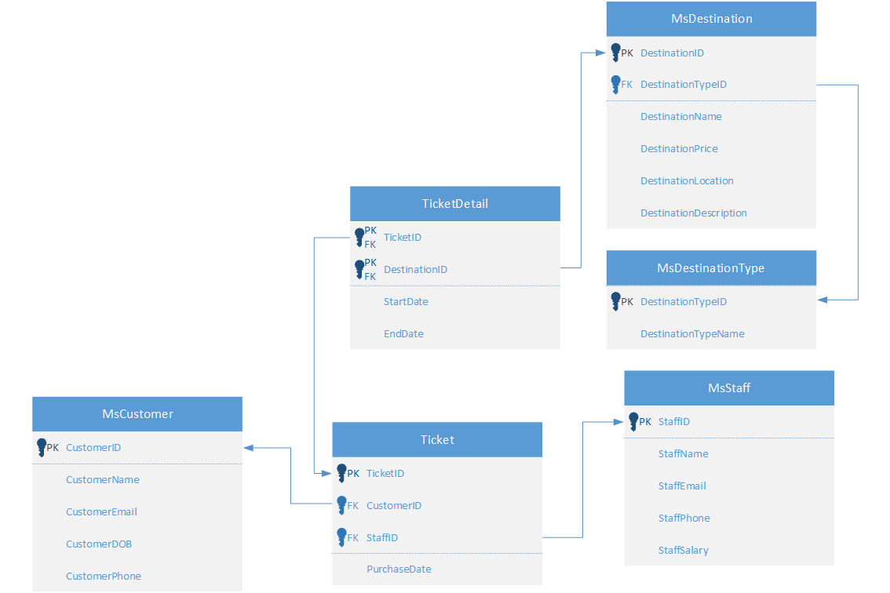

*Note:
Before taking the exam, please open the create+insert.sql file (attached with the case folder) then executes it on SSMS.
Soal
Case

- Display All Staff Information for every staff whose email contains word ‘@gmail’.
(LIKE)
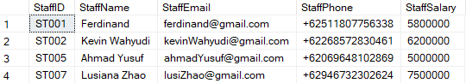

- Display CustomerID, CustomerName, CustomerEmail, CustomerPhone, and PurchaseDate for every ticket which purchased in April.
(JOIN, DATENAME, MONTH)
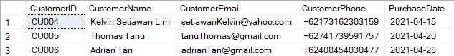

- Display DestinationID, DestinationName, DestinationLocation, and Total Visit (obtained from total destinations is visited then add the word ‘ Times’ after it) for every destination which Total Visit is greater than or equals three times and sort by Total Visit descendingly.
(CAST, COUNT, JOIN, GROUP BY, HAVING, ORDER BY)
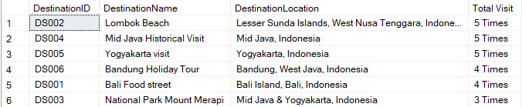

- Display TicketID, CustomerID, CustomerName, StaffID, StaffName, PurchaseDate, Total Destination (obtained from total destinations the customer visited), and Total Days (obtained from calculating day from start date to end date of all destination customer visited) for every ticket that purchased in 4th of month (April). Then, combine it with TicketID, CustomerID, CustomerName, StaffID, StaffName, PurchaseDate, Total Destination (obtained from total destinations the customer visited), and Total Days (obtained from calculating day from start date to end date of all destination customer visited) for every ticket that purchased in 6th of month (June).
(COUNT, SUM, DATEDIFF, DAY, DATEPART, MONTH, GROUP BY, UNION)
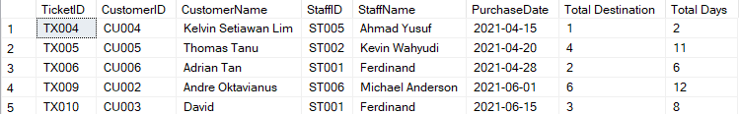

- Display CustomerID, CustomerName, CustomerEmail, Phone Number (Obtained from CustomerPhone replacing ‘+62’ with ‘0’), DestinationID, and DestinationName for every customer who never visit the destination and customer whose email contains word ‘yahoo’.
(STUFF, NOT EXISTS, LIKE)
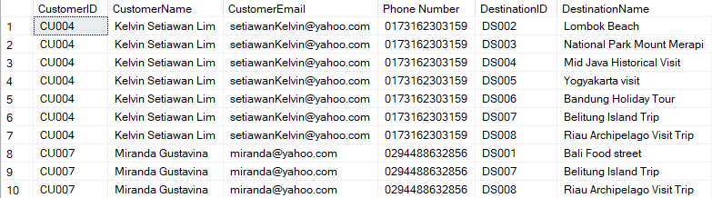

- Display CustomerID, CustomerName, CustomerEmail, CustomerDOB, CustomerPhone, and Total Spending (obtained from summing each destination price multiplied with calculating days from start date to end date the customer in that destination) for every ticket which Total Spending between 1500000 and 5000000 and CustomerID ends with odd number.
(SUM, DATEDIFF, DAY, BETWEEN, RIGHT, GROUP BY, alias subquery)
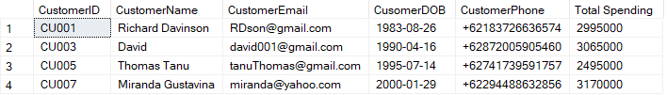

- Display a view named ‘Yogyakarta_Vacation_List’ to display DestinationTypeName (Obtained from lowering all character in DestinationTypeName), DestinationName, DestinationPrice, DestinationLocation, and DestinationDescription for every destination which contains word ‘Yogyakarta’.
(CREATE VIEW, LOWER, LIKE)

- Create a view named ‘economic_customer’ to display CustomerID, CustomerPhone, CustomerEmail, and CustomerName for every customer who did visit a destination which price is above the average all of destination price and purchased the ticket in even month. For final output, the is no duplicate row.
(CREATE VIEW, DISTINCT, AVG, MONTH)
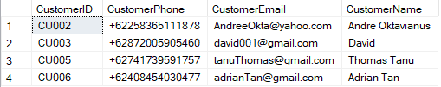

- Add a column on table ticket named ‘TicketStatus’ with varchar data type and the length is 15. After that, add a constraint the TicketStatus must be either ‘Completed’ or ‘Canceled’.
(ALTER TABLE, ADD, ADD CONSTRAINT, LIKE)
Before alter:
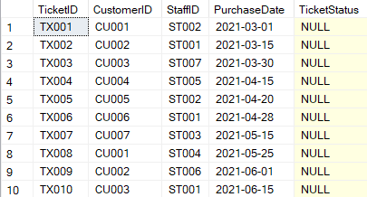
After alter:

- Update destination price from MsDestination table by adding 10% of current DestinationPrice for every destination that happened to be visited at the first week of the month and had destination type is ‘Panorama’ or ‘Family Tour’.
(UPDATE, DATEPART, DAY, IN)
Before update:
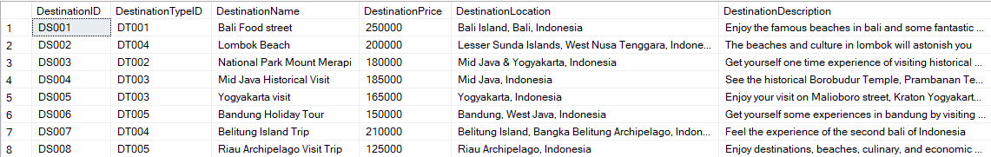
After update:
