**“Contactus”**

**User Manual**

**By Steve Bulgin and Nadia Siraj**

**“Contactus” User Manual**

**Introduction: ‘**Contactus’ in an application created by Nadia Siraj and Steven Bulgin for a final project for PROG3180. The goal of this app is to provide a simple, easy to use application for storing contact information on your phone.

**Instructions:**

* **Starting App:** Once the app is installed on your device click the Contactus icon and the app will load.
* **Adding Contacts:** to add a contact click the Add tab in the bottom menu bar. 

Then fill out the form. Name fields are required. Others are optional. Email and phone numbers must be valid. Click “Save” when finished and the contact will be saved

* **Viewing Stored Contacts:** To view stored contacts click Contacts tab



This will generate a list of stored contacts. You may filter the list of contacts by entering part of the contacts name in the search field located at the top of the list or scroll to find the contact you are interested in.

* **Viewing Specific Contact:** By clicking on the intended contacts name in the list you will be taken to a full list of their contact details.
* **Editing Contact Information:** On the contacts details screen you will have a button to allow you to edit a contacts information. On clicking yo will be presented with a prefilled for of the contacts existing information which you may update. Click the “Update” to store the changes.
* **Deleting a Contact:** On clicking “Edit” on a persons contact details you will, along with updating have an option to “Delete” a contact. 

Important: Only click the delete button if you intend to permanently remove a contact.

* **Removing All Contacts:** To remove all existing contacts click the “Settings” tab.



Then click the “Show Advanced Settings” link.

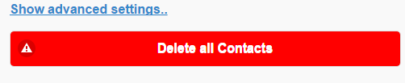

This will produce a button, “Delete all Contacts. On clicking you will be prompted to confirm you wish to delete all stored contacts. On confirmation all contacts will be deleted.

Important: Only click button if you intend to remove all stored contacts.

* **Switching App Themes:** To switch themes click the “Settings” tab. You will be greeted by a selection of theme options

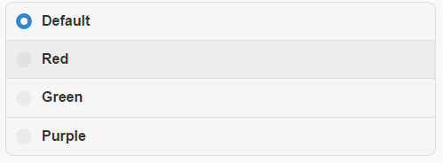

On clicking a new theme will be set.

**Future Developments:** Potential future improvements may include the ability of the user to add and store custom fields to suit their needs, camera and photo upload options, links to contacts social media accounts, and the ability to add businesses and filter them seperately from personal contacts.