1.

Code:

#include <iostream>

using namespace std ;

void main()

{

int \*a ;

try

{

a = new(std::nothrow) int[500000000] ;

if (a == NULL)

{

throw "Can't get memory!\n" ;

}

}

catch(char \*err)

{

cout << err ;

}

try

{

int b[20] = {0}, n ;

cout << "enter n: " ;

cin >> n ;

if (n < 0)

throw -1 ;

else if(n >= 20)

throw 1 ;

cout << b[n] << endl ;

}

catch(int n)

{

switch(n)

{

case 1: cout << "上越界！" << endl ; break ;

case -1: cout << "下越界！" << endl ; break ;

}

}

try

{

int \*c = NULL;

if(!c)

throw "空指针！\n" ;

delete []c ;

}

catch(char\* err)

{

cout << err ;

}

}

Result:

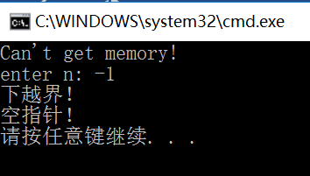

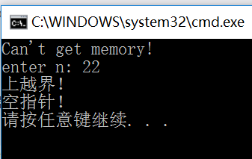

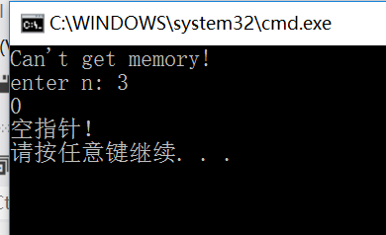

2.

Code:

#include<iostream>

#include<algorithm>

#include<string>

#include<fstream>

using namespace std ;

struct STU

{

string name ;

int score ;

} ;

bool cmp(STU s1, STU s2)

{

if(s1.score > s2.score)

return 1 ;

else if(s1.score < s2.score)

return 0 ;

else

{

return (s1.name < s2.name) ;

}

}

void main()

{

STU stu[20] ;

ifstream In("score.txt", ios::in) ;

try

{

if(In == NULL)

{

throw "Can't get memory!\n" ;

}

for(int i = 0; i < 20; i++)

{

In >> stu[i].name ;

In >> stu[i].score ;

}

sort(stu, stu + 20, cmp) ;

cout << " Name | Score" << endl ;

for(int i = 0; i < 20; i++)

{

cout << stu[i].name << " | ";

cout << " " << stu[i].score << endl ;

cout << "-----------|-------" << endl ;

}

}

catch(char \*err)

{

cout << err ;

}

}文件“score.txt”中内容为：

2016011206 70

2016011199 67

2016011014 100

2016011046 55

2016011009 70

2016011242 64

2016011233 52

2016011207 64

2016011163 40

2016011087 88

2016050012 52

2016011184 78

2011011190 46

2016011086 64

2016011085 61

2016050008 30

2016011011 55

2016011073 76

2016050009 13

2016011239 73

（这是我们大物考试的真实成绩，将学号视作姓名）

Result:

