1.

Code:

#include <iostream>

#include <iomanip>

using namespace std ;

int main()

{

int a[10][21] = {0} ;

a[0][10] = 1 ;

for (int i = 1; i < 10; i++)

for (int j = 1; j < 20; j++)

{

a[i][j] = a[i-1][j-1] + a[i-1][j+1] ;

}

for (int i = 0; i < 10; i++)

{

for (int j = 0; j <20; j++)

{

if (a[i][j] == 0)

cout << " " ;

else cout << setw(3) << a[i][j] ;

}

cout << endl ;

}

return 0 ;

}

Result:

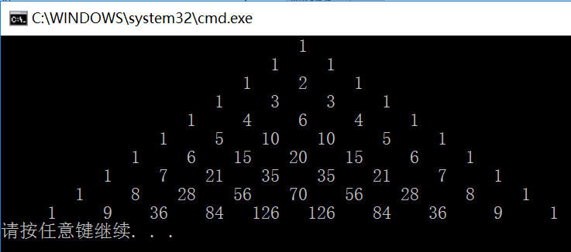

2.

Code:

#include <iostream>

using namespace std ;

int main()

{

int \*a = new int[100], (\*b)[25] = new int[20][25], (\*c)[8][5] = new int[9][8][5], m, n, cnt = 0 ;

cin >> m >> n ;

for (int i = 0; i < 100; i++)

{

a[i] = i ;

cnt += a[i] ;

}

cout << "The sum of a is " << cnt << endl ;

cnt = 0 ;

for (int i = 0; i < 20; i++)

for (int j = 0; j < 25; j++)

b[i][j] = i \* 25 + j, cnt += b[i][j] ;

cout << "The sum of b is " << cnt << endl ;

cnt = 0 ;

for (int i = 0; i < 9; i++)

for (int j = 0; j < 8; j++)

for (int k = 0; k < 5; k++)

c[i][j][k] = 100 \* i + 10 \* j + k, cnt += c[i][j][k] ;

cout << "The sum of c is " << cnt << endl ;

cnt = 0 ;

int \*\*d = new int\*[m] ;

for ( int i = 0; i < m; i++)

d[i] = new int[n] ;

for (int i = 0; i < m; i++)

for (int j = 0; j < n; j++)

d[i][j] = i \* n + j, cnt += d[i][j] ;

cout << "The sum of d is " << cnt << endl ;

cnt = 0 ;

delete a;

delete []b ;

delete []c ;

for ( int i = m - 1; i >= 0; i--)

delete d[i] ;

delete d ;

}

Result:

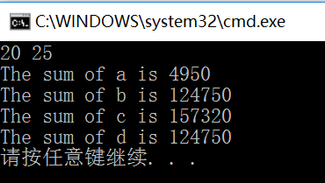

3.

Code:

#include <iostream>

using namespace std ;

int search(int a, int\* cnt, int n)

{

for (int i = 0; i < n; i++)

if (a == cnt[i])

return 0 ;

return 1 ;

}

void print(int a1, int a2, int a3)

{

switch(a1)

{

case 1 : cout << "红" ; break ;

case 2 : cout << "黄" ; break ;

case 3 : cout << "蓝" ; break ;

case 5 : cout << "白" ; break ;

case 7 : cout << "黑" ; break ;

default : break ;

}

switch(a2)

{

case 1 : cout << "红" ; break ;

case 2 : cout << "黄" ; break ;

case 3 : cout << "蓝" ; break ;

case 5 : cout << "白" ; break ;

case 7 : cout << "黑" ; break ;

default : break ;

}

switch(a3)

{

case 1 : cout << "红" ; break ;

case 2 : cout << "黄" ; break ;

case 3 : cout << "蓝" ; break ;

case 5 : cout << "白" ; break ;

case 7 : cout << "黑" ; break ;

default : break ;

}

cout << endl ;

}

int main()

{

int a1, a2, a3, c[5] = {1, 2, 3, 5, 7}, cnt[125] = {0}, cnti = 0 ;

for (int i = 0 ; i < 5 ; i++)

{

{

a1 = c[i] ;

for (int j = 0; j < 5; j++)

{

if (c[j] == a1)

continue ;

a2 = c[j] ;

for (int k = 0; k < 5; k++)

{

if (c[k] == a1 || c[k] == a2)

continue ;

a3 = c[k] ;

if (search(a1 \* a2 \* a3, cnt, 125))

{

cnt[cnti] = a1 \* a2 \* a3 ;

cnti++ ;

print(a1, a2, a3) ;

}

}

}

}

}

cout << cnti << endl ;

}

Result:

