- Short Answer Questions
- Q1: Explain the primary differences between TensorFlow and PyTorch. When would you choose one over the other?
- Execution Model
- TensorFlow: Static computation graph (define-then-run)
- PyTorch: Dynamic computation graph (define-by-run, more intuitive)
- Debugging
- TensorFlow: Harder to debug due to static graph
- PyTorch: Easier debugging with native Python tools (e.g., print, pdb)
- Deployment
- TensorFlow: Better for production, mobile, and cross-platform deployment
- PyTorch: Improving, but traditionally more research-focused
- Community & Adoption
- TensorFlow: Backed by Google, widely used in industry
- PyTorch: Backed by Meta, dominant in academia and research

When to Choose
- Choose TensorFlow:
  - Need production-ready tools
  - Targeting mobile/web deployment
  - Using Google Cloud ecosystem
- Choose PyTorch:
- Rapid prototyping
- Research and experimentation
- Prefer Pythonic, flexible code
- Q2: Use Cases for Jupyter Notebooks in AI Development
- Interactive Experimentation: Ideal for testing models, visualizing data, and tweaking hyperparameters in real-time.
- Documentation and Tutorials: Combines code, output, and markdown to create readable, shareable learning materials or project walkthroughs.
- Q3: spaCy vs Basic Python String Operations in NLP
spaCy enhances NLP tasks by offering:
- Tokenization, POS tagging, and Named Entity Recognition (NER) out of the box, using trained statistical models.
- Language-specific pipelines that understand context, grammar, and semantics—far beyond simple .split() or regex.

- Comparative Analysis

- Target Application
- Scikit- Learn
      - Best for classical ML (e.g., regression, classification, clustering)
      - Ideal for structured/tabular data.
      - Not designed for deep learning
- Tensorflow:
- Built for deep learning (e.g., CNNs, RNNs, transformers).
- Suited for unstructured data (images, text, audio)
- Scales well for large datasets and production.

- Ease of Use for Beginners
  - Scikit-Learn:
- Simple, consistent API (fit, predict, transform).
- Minimal setup, fast to prototype.
- Great for learning ML fundamentals.
  - Tensorflow:
- Steeper learning curve (especially low-level API).
- Easier with Keras (high-level wrapper).
- Requires understanding of tensors and computational graphs.
- Community Support.
  - Scikit-Learn:
- Strong academic and data science community).
- Extensive documentation and tutorials.
- Stable and mature library.
  - Tensorflow:
- Massive global community, backed by Google.
- Rich ecosystem (TensorBoard, TFLite, TF Hub)
- Frequent updates, large number of learning resources.

Part 2: Practical Implementation (50%)
Handwritten Model
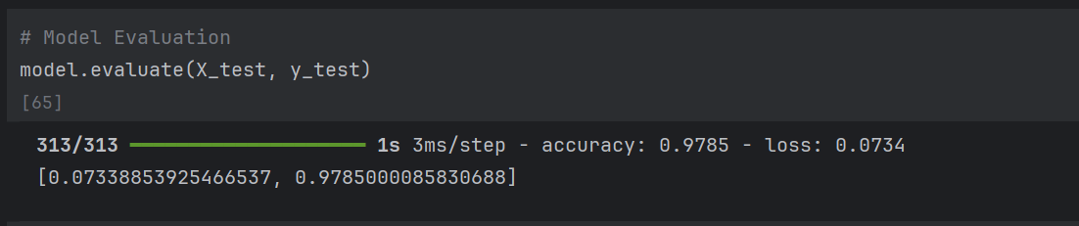
Iris Model
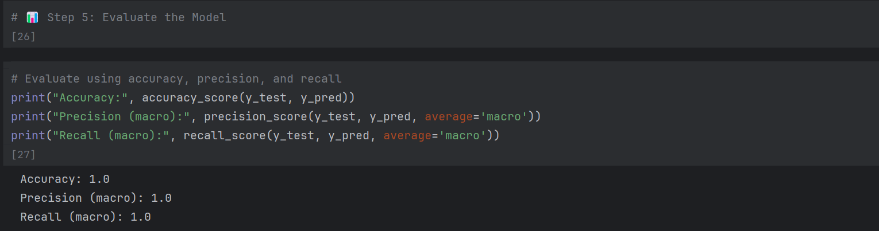

NER results
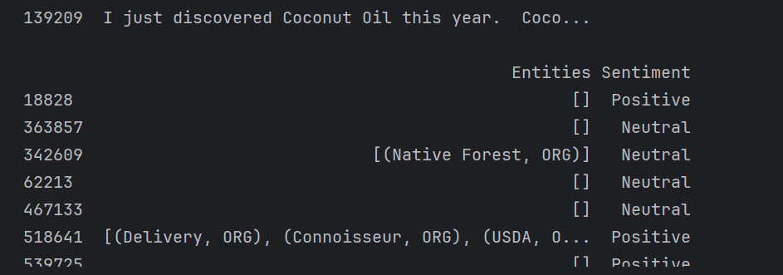

Part 3: Ethics & Optimization
1. Ethical Considerations
a) Potential Biases
MNIST Model
• Class imbalance: Some digits (e.g., ‘1’, ‘7’) may appear more frequently, leading to skewed predictions.
• Handwriting style bias: Model may perform poorly on digits written in styles not well represented in the training set (e.g., regional or age-based variations).
Amazon Reviews Model
• Sentiment bias: Overrepresentation of positive or negative reviews can skew predictions.
• Demographic bias: Language patterns from certain regions or dialects may be misclassified.
• Product category bias: Sentiment may vary by category (e.g., electronics vs. books), but model may not account for this.
b) Mitigation Tools
TensorFlow Fairness Indicators
• Analyze model performance across slices (e.g., gender, age, product category).
• Identify disparities in accuracy, precision, recall across subgroups.
• Visualize fairness metrics to guide retraining or data augmentation.
spaCy’s Rule-Based Systems
• Customize token patterns to reduce bias in entity recognition or sentiment tagging.
• Apply consistent rules across dialects or product categories to normalize interpretation.
• Combine with statistical models to override biased predictions in edge cases

2. Troubleshoot Challenge
Sample Buggy Code
model = tf.keras.Sequential([
tf.keras.layers.Dense(128, input_shape=(28, 28)),
tf.keras.layers.Dense(10, activation='softmax')
])

model.compile(optimizer='adam', loss='binary_crossentropy', metrics=['accuracy'])
Issues:
- Input shape mismatch: input_shape=(28, 28) expects 2D input, but Dense layers need 1D.
- Incorrect loss function: binary_crossentropy is wrong for multi-class classification

Fixed Code:
model = tf.keras.Sequential([
tf.keras.layers.Flatten(input_shape=(28, 28)), # Flatten 2D input
tf.keras.layers.Dense(128, activation='relu'),
tf.keras.layers.Dense(10, activation='softmax') # 10 classes
])

model.compile(optimizer='adam', loss='sparse_categorical_crossentropy', metrics=['accuracy'])
Explanation
Flatten() converts 28x28 input into 784-dim vector
'sparse_categorical_crossentropy is correct when labels are integers (0–9).

