Use Case Model
for the
So Long Sucker Simulator

Submitted by

Sarah Loewy
COP 4331

March 23, 2009
Table of Contents

Title Page

1.0 System Summary 1
1.1 Overview of System Purpose and Context........................................................1
1.2 Motivation and Business Case...........................................................................1
1.3 System Operation...............................................................................................2
1.3.1 System Operation: Use Case Diagram 2
1.3.2 System Operation: Sections 3
1.3.3 System Operation: Activity Diagram 4
1.4 System Interfaces...............................................................................................5
1.4.1 Physical Design and Actor Interfaces 5
2.0 Use Case Specifications 6
2.1 Take Pile............................................................................................................6
2.2 Take Prisoner(s).................................................................................................7
3.0 Glossary.........................................................................................................................8
4.0 Appendix A: Rules of Play 9
5.0 Sources 11

Table of Figures

Title Page

Figure 1.3.1 Use Case Diagram for So Long Sucker Simulator 2
Figure 1.3.3 Activity Diagram for So Long Sucker Simulator 4
Figure 1.4.1 Physical Design and Actor Interfaces [see Source 4] 5
Figure 2.1. Collaboration Diagram for Take Pile 6
Figure 2.2. Collaboration Diagram for Transfer Prisoner(s) 7

1.0 System Summary

1.1 Overview of System Purpose and Context

This document describes the functional requirements (use cases) and design constraints (non-functional requirements) of the So Long Sucker Simulator as viewed from the perspective of the client, Seminole Casino, and the system’s typical end user, the customer. Its purpose is to formally capture and present an operational view of the So Long Sucker Simulator and to enumerate the system requirements as understood by the developer, COP 4331.

1.2 Motivation and Business Case

Seminole Casino, has observed declining sales in the last three quarters due to a fresh variant on poker introduced by its competitors within the last year. In an effort to maintain customer interest, analysts researched past games developed and conducted studied on rates of play. Among the top of the games chosen by customers in the study was So Long Sucker, a game developed by Jon Nash and a few of his friends in the early '50s [see Source 1].

Before introducing the new game, Seminole Casino marketers have requested a simulation of the game to test profitability, customer interest, and as a training mechanism for possible dealers. The remainder of this section and the next present a functional description and external design of the So Long Sucker Simulator, the proposed new poker variant designed to achieve the business goals recommended by Seminole Casino Marketing.

1.3 System Operation

1.3.1 System Operation: Use Case Diagram
Figure 1.3.1 presents a functional model of the envisioned So Long Sucker Simulator. User-oriented functions (use cases) are identified by blue oval bubbles appearing inside the box denoting the physical and logical boundary of the system. All entities shown outside the system box represent actors, that is, independent agents that must interact with the system to accomplish all use cases defined by the diagram. As shown in the figure, there are three actors: the Player In Turn, Player Out Of Turn, and the Dealer.
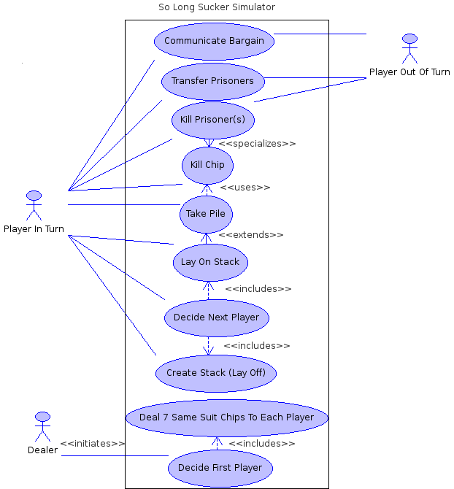
Figure 1.3.1 Use Case Diagram for So Long Sucker Simulator

1.3.2 System Operation: Sections

[Para.1] The Dealer starts a game by giving each player 7 chips of one color (or suit), each player receiving a distinct color. This is followed by the Dealer deciding the first player to move randomly. [See Appendix A.1]

[Para.2] The Player In Turn may move by playing a chip of any suit onto the playing area (laying off), or on top of any existing chip(s) in the playing area (laying on). [See Appendix A.2.1]

[Para.3] If two chips of the same color are played on the same stack, the player with that color assigned must then kill one chip of his choice of that pile, and take the rest. Then he gets the next move, making him the Player In Turn. [See Appendix A.2.2]

[Para.4] The Player In Turn or a Player Out Of Turn may kill or transfer to another player any prisoner in hand at any time. Such transfers are unconditional and cannot be retracted. A player may not transfer chips of his own color. [See Appendix A.2.5]

[Para.5] Provided that no capture occurred and the Player In Turn was not defeated, after completing his moves the Player In Turn may decide the next player, including himself. His choice of player cannot be associated with a color represented in the stack just played upon. If all players are represented in the stack, then the move goes to the player whose most recently played chip is furthest down in the stack. [See Appendix A.3.3.1 and Appendix A.3.3.2]

[Para.6] Coalitions (bargains), or agreements to cooperate, are permitted, and may take any form. No penalty for failure to live up to an agreement is to be inflicted. The Player In Turn and any number of Players Out Of Turn are freely allowed to confer during the game. [See Appendix A.4]

[Para.7] The game is over when all but one player has been defeated. [See Appendix A.6.1]

1.3.3 System Operation: Activity Diagram

Figure 1.3.3 presents a control flow model of the envisioned So Long Sucker Simulator. System actions are identified by bubbles appearing inside the box denoting the physical and logical boundary of the system. Boxes define the steps of a process associated with a system action. Directed arcs denote flow of control. Diamonds represent conditional flow while fork and join represent concurrent flow.

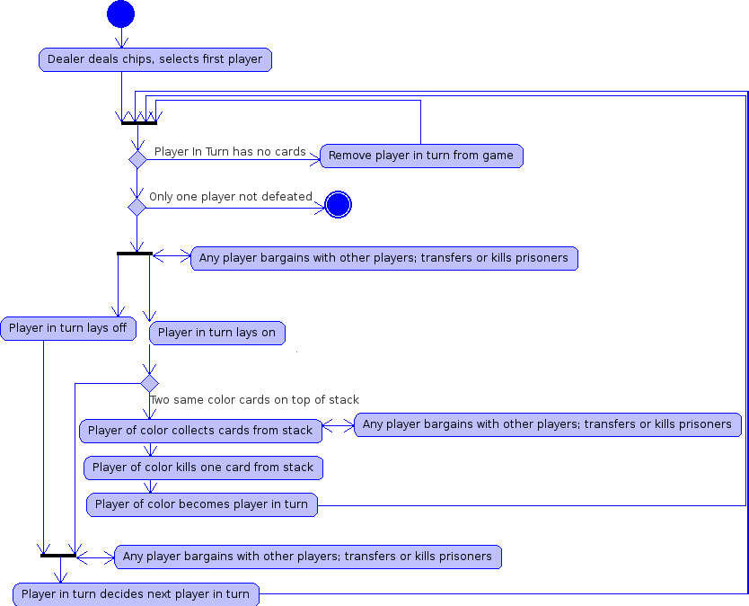
Figure 1.3.3 Activity Diagram for So Long Sucker Simulator

1.4 System Interfaces

1.4.1 Physical Design and Actor Interfaces

Figure 1.4.1 illustrates the physical design of the proposed So Long Sucker System.

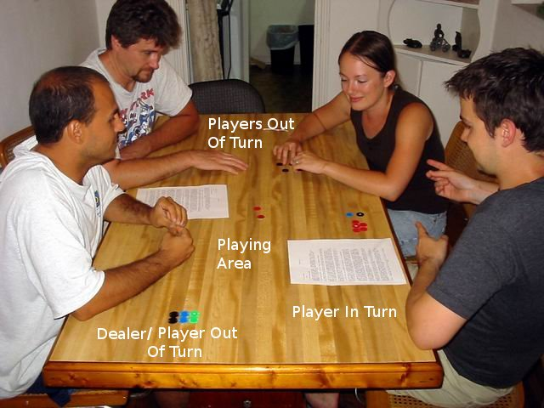
Figure 1.4.1 Physical Design and Actor Interfaces [see Source 4]

2.0 Use Case Specifications

This section gives the detailed specifications for a subset of the use cases given above in 1.3.1, System Operation: Use Case Diagram. These refer to the interaction scenarios between the actors, the Player In Turn, the Players Out Of Turn, and the Dealer, and the So Long Sucker Simulator.

2.1 Take Pile

ID: UC1

Purpose
The purpose of the Take Pile use case is to shift control from the Player In Turn to the player whose color matches the pile which has two cards of the same color on top.

Pre-conditions
A stack must have two cards of the same color on top.

Player of Color
1b. Kill Chip
“Dead Box”
Pile
1a. Collect Pile

Figure 2.1. Collaboration Diagram for Take Pile

Scenario (See Figure 2.1)
- The player whose color matches the pile which has two cards of the same color on top must:
(a) Collect the pile with the matching colored cards on top.
(b) Kill a card to the “dead box” from the pile with the matching colored cards on top.

Post-condition
The player whose color matches the pile which has two cards of the same color on top is now the Player In Turn and continues with his turn.

2.2 Transfer Prisoner(s)

ID: UC2

Purpose
The purpose of the Transfer Prisoner(s) use case is to provide an interface for any player to freely give prisoner(s) in his hand to any other player at any time.

Pre-conditions
The player who wishes to transfer prisoner(s) must possess said prisoner(s) and the player he wishes to give the prisoner(s) must not be defeated (i.e. no player can re-enter the game).
Any Player
1. Pass prisoner(s)
Playing Area
2. Accept prisoner(s)
Selected Player

Figure 2.2. Collaboration Diagram for Transfer Prisoner(s)

Scenario (See Figure 2.2)
- The player passes the prisoner(s) to the player he selects for transfer.
- The receiving player accepts the prisoner(s).

Post Condition
The player has fewer chips due to transferral, and the player he selected has more chips.

3.0 Glossary

Dealer: This refers to the actor who starts a game with the So Long Sucker Simulator and fulfills no other role.

Player In Turn: This refers to the actor who has been given the move.

Player Out Of Turn: This refers to any actor who is playing the game but is not the Player In Turn.

Stack: This refers to any pile of chips in the playing area.

Laying Off: This refers to the action of placing a chip within the playing area, but not on any currenlty existing stack, thus creating a new one.

Laying On: This refers to the action of placing a chip on a particular stack.

Prisoner: This refers to any chip that is held by a player other than the original owner. [See Appendix A.2.4]

Kill: This refers to the condition of any chip that has been forced out of play. [See Appendix A.2.3]

Defeat: This refers to the condition of the Player In Turn when he has no chips in his possession (and hence is unable to play). Defeat is not final until every player holding prisoners has refused to rescue him by transferring chips. [See Appendix A.2.6]

Bargain: This refers to any agreement made among players during the game.

Dead Box: This refers to the collection of killed chips. [See Appendix A.2.3]

4.0 Appendix A: Rules of Play
The following is a list of rules of play taken directly from source [1].
- Starting a game:
  - Give each player 7 chips of one color (Cards of one suit from a deck work equally well).
  - Give different players different color chips.
  - Decide the first player to move randomly.
- Playing the game:
  - Move by playing a chip of any color onto the playing area, or on top of any existing chip(s) in the playing area.
  - Chips are captured by playing two chips of the same color consecutively on one pile. The player designated by that color must kill one chip of his choice out of that pile, and take the rest. Then he gets the next move.
  - A chip is killed by placing it in the "dead box." A player may kill chips of his own color only out of a captured pile.
  - A chip is a prisoner when held by a player other than the original owner.
  - Any prisoner in a player's possession may be killed or transferred to another player at any time. Such transfers are unconditional and cannot be retracted. A player may not transfer chips of his own color.
  - A player is defeated when given the move, but has no chips in his possession (and hence is unable to play).
    - Defeat is not final until every player holding prisoners has refused to rescue him by transferring chips.
    - The move then returns to the player who gave the defeated player the move.
    - The defeated player's chips remain in play as prisoners, but are ignored in determining the order of play.
    - If a pile is captured by the chips of a defeated player, the entire pile is killed, and the move rebounds to the capturing player.
  - Players must keep their chips in view at all times.
- Order of play:
  - If a capture occurs: the player whose color made the capture gets the next move.
  - If a player is defeated: move returns to the player who gave the defeated player the move.
  - Otherwise, the next player to move is decided by last player to have moved as follows:
    - They may give the move to any player (including themselves) whose color is not represented in the pile just played upon.
    - If all players are represented in that pile, the move goes to the player whose most-recently-played chip is furthest down in the pile.
- Strategy:
  - Coalitions, or agreements to cooperate, are permitted, and may take any form.
  - No penalty for failure to live up to an agreement.
  - Players are freely allowed to confer only at the table during the game-- no secret or prior agreements are allowed.
- Winning the game:
  - The winner is the last surviving player (after the others have been defeated).
  - A player can win even if they hold no chips and all of their chips have been killed.

5.0 Sources
- http://en.wikipedia.org/wiki/So_Long_Sucker
- Formatting borrowed from Dr. Workman's UCM-CoffeeMaker.doc
- Outline borrowed from Dr. Workman's Lec7-UseCaseModeling.ppt, which summarizes The Unified Software Development Process, by Rumbaugh, Jacobson, and Booch, Addison-Wesley, 1999, 0-201-57169-2.
- Figure 1.4.1 from: http://www.boardgamegeek.com/boardgame/8304

