SoLongSucker User Guide

Written by:
Steven Braeger
Sarah Loewy
Andrew Marsh

COP 4331
Spring 2009

Table of Contents
1.0 Overview of Application 3
2.0 Model of the Virtual World 4
2.1 Rules of the Game 4
2.2 Interaction with the Virtual World 5
3.0 Description of User Interface 7
3.1 Input File Specification 7
3.2 Output File Specification 8
3.3 Interactive Inputs 9
4.0 Describe Installation and Configuration Requirements 10

List of Figures
Illustration 1: Use Case Diagram 6
Illustration 2: Screenshot of Interactive Input 9

- Overview of Application

This user guide is intended to provide the end user with all the information needed to use and implement this software, the So Long Sucker simulation. The purpose of the application started when Nash Simulations, Inc. , (hereafter referred to as “Nash Sims”), had observed a number of its most valuable employees becoming fed up with company practices regarding software development, and many of them have left for greener pastures at many of their competitors. Additionally, many of those whom Human Resources (HR) has convinced to stay, (even those not as valuable to the team) enjoy massively overweighted salaries and bonuses. In the face of decreased product quality and increasing labor costs, upper management tasked us to investigate this problem. After performing a detailed internal investigation into the details of HR, we discovered that 45%-65% of the employee defection cases could have been resolved with more effective and more competitive employment offers. In addition, 70% of the employees whom Upper Management identified as likely overcompensated were, in fact overcompensated. Of these, 10% were overcompensated due to payroll errors (with a fix to be suggested in document A4352), and 90% were overcompensated due to middle management fear of social rejection and lack of confidence to reject employee demands.
As a means of solving this problem, we decided to come up with a way to better train HR staff to bargain with potential and current employees. By training an artificial intelligence
system to effectively bargain for resources, we aim to discover an optimum bargaining strategy that will be an effective algorithm to teach to HR executives. Furthermore, this system must be extensible to bargain with potential applicants automatically. Therefore, we decided that a simulation of a simple game based on economics professor John Nash's thesis work with collective bargaining would be the best choice as a general framework to teach the tools required. The specific game, called So Long Sucker, was chosen because it is well known to us, was created by John Nash himself, and is well-known for the bargaining behavior it teaches, as well as the ability to break and create bargains.
By implementing several simple strategies for bargaining in a market of players, such as “offer kind deals” or “offer cutthroat deals” or other strategies, and collecting relevant statistical data on which strategies functioned the best in particular games, we aim to discover which strategies are best in a dynamic labor market.
The simulation provides multiple AI's used to represent different user tendencies. One can implement a game with any number of the different AI's to gain an understanding of game strategy. The data that will be reported in the log file posted at the end of the report is where one can find all the information about the simulated games. Also worth noting is that this game is only designed for one user type, the end user. It was designed with a single actor in mind.

- Model of the Virtual World

2.1 Rules of the Game
Flow of the game:
- Assign each player a designated color.
- Give each player 7 chips of their given color.
- Randomly decide which player will make the first move. Play begins.
- Play continues until only one player remains.

Winning/Losing:
- If it becomes a player's turn, and that player has no chips to play, that player is removed from the game.
- The last player who has not been removed from the game is declared the winner.

Order of Play(within a move):
- A move is performed by placing a chip onto the table. This involves either placing a chip on a pile (laying on) or creating a new pile (laying off).
- The move is then given to another player based on a number of options.
a)If a player is defeated, the move goes to the player who just gave the defeated player the move and play continues.
b) If a capture has just occurred, the player whose color made the capture must make the next move and play continues.
c) If all players are represented in the stack, the move goes to the player whose most recently played chip is farthest down in that pile and play continues.
d) Otherwise, the player with the current move can select any player whose chip is not in that pile. If the current player lays off, any other player can be selected for the next move and play continues.

Captures:
- A capture occurs when two consecutive chips of the same color are played on the same pile.
- The player making the capture takes all the chips in the pile.
- One of the chips in the pile must be killed.
- Play continues with the player whose color made the capture as listed in the rules for Order of Play.

Bargaining:
- A bargain can occur at any time during the game.
- A bargain must be discussed openly at the playing table.
- A bargain can be accepted or denied at any time during the game.
- Any player can decide to not uphold the bargain without a penalty.

2.2 Interaction with the Virtual World
The use case model can be seen below. The playing table is represented by the virtual world, where all interactions in the game take place. The rules in the previous section explain how the game is played, but the diagram below breaks it down into separate use cases:
Deal Chips
- Deal 7 chips to each player
- Only occurs once
Bargaining
- Can occur at any time
- Between any 2 players
- Either accepted or rejected
Transfer Prisoners
- Often follows an accepted bargain
- Between any 2 players
Kill Chip
- Normally involves killing a prisoner
- Special case involves killing one's own chip
Player Move
- Isolated only to current player
- Involves playing a chip
- Rules determine next player to move

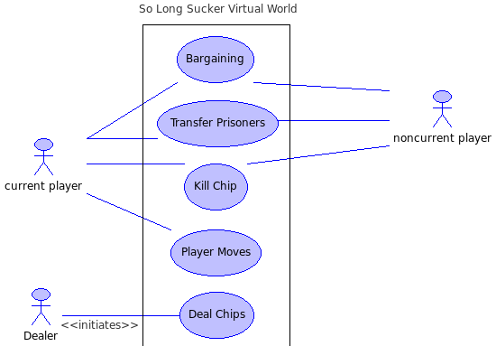Illustration 1: Use Case Diagram
- Description of User Interface

3.1 Input File Specification

This section describes the input file specifications relevant to successfully create a test run of the software. This software follows the Object Oriented Design Data specification. Specifically, the input file format serializes each set that will be needed to create and simulate any number of games.

Relevant tags:
SoLongSucker{ }SoLongSucker
This tag initializes and runs exactly one execution of the simulated environment.
It has only one property: numChips, which specifies the number of chips each player in the game has.
NancyNice{ }NancyNice
This tag initializes and runs exactly one Player with the AI strategy of NancyNice.
JacobJerk{ }JacobJerk
This tag initializes and runs exactly one Player with the AI strategy of JacobJerk.
RandyRandom{ }RandyRandom
This tag initializes and runs exactly one Player with the AI strategy of RandyRandom.

Text 1: SoLongSucker{ numPlayers: 5 numChipsPerPlayer: 7 JacobJerk{ }JacobJerk RandyRandom{ }RandyRandom RandyRandom{ }RandyRandom NancyNice{ }NancyNice NancyNice{ }NancyNice}SoLongSucker
SoLongSucker{

numPlayers: 5

numChipsPerPlayer: 7

JacobJerk{ }JacobJerk

RandyRandom{ }RandyRandom
}SoLongSucker

RandyRandom{ }RandyRandom

NancyNice{ }NancyNice

NancyNice{ }NancyNice

}SoLongSucker

3.2 Output File Specification

PlayersMessage{ agent[ 0 ] = JacobJerk
agent[ 1 ] = NancyNice
agent[ 2 ] = NancyNice

}PlayersMessage

TIME: 1 SENDER: RECVR: ChipMsg{ Handler: 1
Description: The turn has been given to 1
chip: 1}ChipMsg

It is now Player 1's turn.Player 1 rejected a bargain!

TIME: 1 SENDER: RECVR: BargainMsg{ }BargainMsg

TIME: 2 SENDER: RECVR: ChipMsg{ Handler: 1
Description: The turn has been given to 0
chip: 0}ChipMsg

It is now Player 0's turn.Player 0 rejected a bargain!

TIME: 2 SENDER: RECVR: ChipMsg{ Handler: 1
Description: The turn has been given to 4

//....Many more of the above.....
Simulation Statistics:

Number of events : 15
0
Time of Last event : 18
0
Total simulation time : 18
0
Simulation Winner: JacobJerk
Number of Turns: 20
Figure 1: Example Output File

3.3 Interactive Inputs
The interactive user interface, considering that this is a discrete event simulator, is very little. To begin, the user will be prompted to enter the input file controlling the simulation. It will then be prompted to enter the desired file containing the output from the simulation. A screen-shot of this process is here:

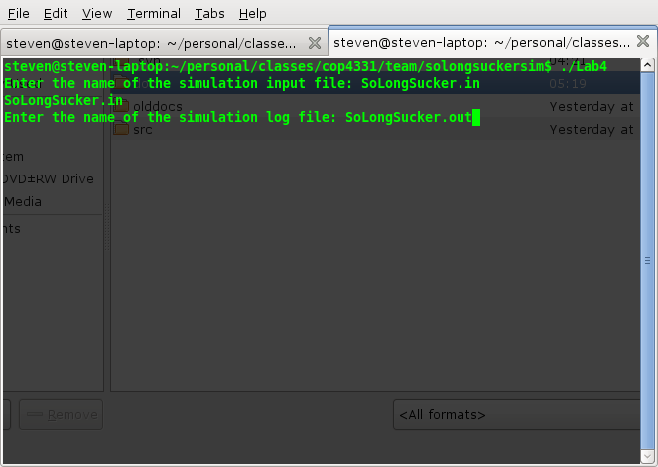Illustration 2: Screenshot of Interactive Input

- Describe Installation and Configuration Requirements

Installation Procedure:
This section provides an in-depth guide on how to compile the source files on UCF's Olympus server. It should also be noted that no other configurations will be needed to run the software. The Olympus server already contains a gcc compiler, which is all that is needed to compile this software.
- Upload the source code into a directory on the server and navigate to that directory using the command line.
- Type: make. This will compile the source code using the makefile and will also produce an executable application called SoLongSuckerApp.
- Type: ./SoLongSuckerApp. This will run the application.
- The prompt will now display: Enter the name of the simulation input file: Type the name of the input file to be simulated (parameters for the input file are given above).
- The next prompt will display: Enter the name of the simulation log file: Type any name desired for the log file. The log file created will contain all the messages and data produced in the simulation.

